Strengths would define any internal

asset (expertise, motivation, technology,

finance, business model, etc.)

that will help to meet demands and to

1.3

Recommendation

A strategy is a course of action to which valuable resources (including one’s own energies) will be committed (. Based on the SWOT analysis done the following were identified as Strength, Weaknesses, Opportunities and Threats and recommendations are made for each factor identified:

Strength:

Fage is a market leader using original nutritious recipe originated since its inception. Its grown since the years and increased their market. Blue Ocean strategy of looking at customers and non-customers will have to be implemented to ensure Fage retains its loyal customers through continual feedback from its customers. By knowing what its customers need Fage will be able 10

to provide for its customers. Understanding what satisfies its customers and being able to introduce new products will attract new customers.

Weaknesses:

Fage has poor brand awareness and poor marketing strategy. Their product is more expensive as compared to its competitors. Declining market share in Greece as consumers shift to cheaper private label options.

Recommendation

A best-cost provider strategy: which implies giving customers more value for the money by combining an emphasis on low-cost with an emphasis on upscale differentiation will be the best option to address the weakness identified. The target is to have the lowest costs and prices relative to producers of products with comparable quality and features like Chobani and big brands entering the yogurt market. Fage will also need to encourage innovation amongst its employees to ensure that new ideas are brought in into the company in the form of marketing its product. A clear vision of the company will need to be communicated with its employees to ensure good marketing of Fage products. It’s through innovation that a company is able to have good brand awareness and market its products

Opportunities:

Greek yogurt market is experiencing exceptional growth with potential global expansion. Convert new customer to be Fage loyalties through programs. Blue ocean strategy of looking into customers and non-customers can best be implemented for globalisation and increase share market for Fage. Through understanding customer needs, being able to satisfy the need, will help attract new customers as the brand grows.

Threats:

There are low barriers to entry into an already saturated market. Yogurt customers prefer promotions. To address this Fage will have to use social and online marketing strategy to offer its promotions to new and old customers. A loyalty program can be introduced by Fage as a form of appreciation to their loyal customers. They will also need to implement a method of getting feedback from their customers to ensure customer satisfaction through a market niche strategy.

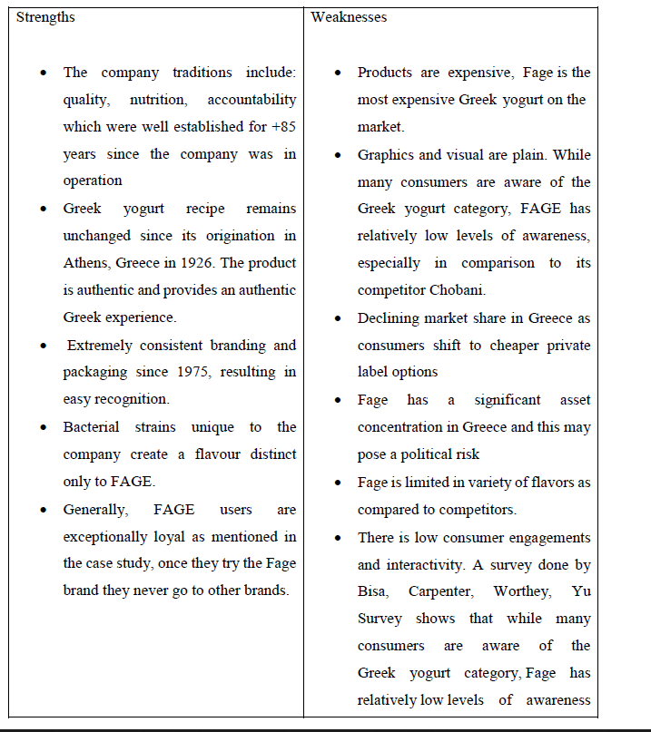

|  |  |
| --- | --- |
| STRENGTH  Strengths would define any internal  asset (expertise, motivation, technology,  finance, business model, etc.)  that will help to meet demands and to  fight of threats. What are we good at in  project management? How are we doing  competitively? Moreover, what are our  resources? Weaknesses describe internal  deficits (lack of motivation, lack of  transport facilities, problems in distribution  of services or products, low reputation,  etc.) that hinder the organization  in meeting its demands. In this context,  one may consider the following  questions: what are we doing badly?  What annoys our clients most?  What are our advantages? What do we do well?, How are  we doing competitively? What are our resources? Are  there any internal assets (know-how, motivation,  technology, finance, business links) which will help to  meet demands and to fight off threats?  Well-trained man-power , well established  knowledge base, good contact to target  group, technology, etc.  **Step 1**  **Information gathering** ‐ record all strengths that exist currently. Then  consecutively, record all weaknesses that exist currently.  Now, three new banks — all backed by powerful SA business personalities — are opening their digital doors, offering something entirely different. So what can they offer that’s new, and how much of a threat is this for the ‘big four’ banks?  Financial services used to change slowly.  But these three new banks are backed by formidable business personalities with deep pockets.  Discovery Bank is part of the wider group run by CEO Adrian Gore, which began as a health-care company in 1993. Discovery boasts Remgro associate Rand Merchant Investments (RMI) as its anchor shareholder.  Tyme Bank is controlled by African Rainbow Capital (ARC), an investment company controlled by the eclectic Ubuntu-Botho group headed by Patrice Motsepe. As the Forbes rich list has it, Motsepe is one of the 1,000 wealthiest individuals in the world, with a fortune of $2.4bn. Before it was bought by Motsepe’s company, TymeBank was owned by the Commonwealth Bank of Australia (CBA), one of the world’s top 10 retail banks.  As for Bank Zero, the most entrepreneurially based of the three, it shows how far the Reserve Bank has come that it got the green light. Bank Zero is run by a maverick group of former FNB executives, most of them with strong technology backgrounds, with a few family and friends as shareholders. The chair and figurehead is the former FNB boss Michael Jordaan, based in Stellenbosch.  Somewhat ironically, Jordaan is Motsepe’s partner in the data-only telecom network Rain. The Bank Zero CEO, Yatin Narsai (former head of FNB retail), runs the business day-to-day from Bryanston.  Discussing the rationale for the bank in an interview with the *FM*, Narsai says SA ranks among the five countries with the highest bank fees in the world. "This is intolerable in such an unequal society, but then the rest of the bottom five were similarly unequal countries in Latin America," he says.  Capitec has more than 10-million customers, who will have been enticed, in part, by the much lower cost of banking. And yet the big four still have 83% of all bank deposits in the country and 92% of all mortgages, which shows how concentrated the market still is.  Harry Botha, a banks analyst at Avior Capital, says it could take three to five years for the challenger banks to make material inroads into the large banks’ earnings.  **Discovery, TymeBank and Bank Zero** are pursuing a branchless model, with their apps being their shop window. This means SA isn’t far behind the rest of the world: the first app-only current account in the UK was introduced by Starling Bank just two years ago. Perhaps if the Reserve Bank had been more open-minded, SA could have beaten them to the punch.  Only Investec has operated without branches — but to a narrow spectrum of high net worth clients. To see what sort of riches are up for grabs, consider Capitec’s trajectory. In its first year on the JSE in 2002, Capitec made revenue of R270m, with just a smattering of clients. By August 2018, it was clocking up R9.3bn in operating income with its 10.5-million customers. Its share price has reacted accordingly: R10 000 invested in the bank at the beginning would now be worth R7.2m.  Fees were a big part of this success. Capitec has a nominal monthly fee of R5, with R1 charged for each digital transaction.  As many of Capitec’s transactional clients earn interest of 5% on their deposits, they often get more money coming in than they pay in fees.  Gore says banks operate on three legs: fees, interest and  rewards. Some banks (like Capitec and the other newcomers) will offer competitive fees and attractive interest rates on accounts  but no rewards programme; while the large banks pay little  or no interest on current accounts but have decent rewards  programmes.  Discovery Bank’s lower-income clients (those earning  less than R300,000 a year) will pay between R149 and  R186 a month in fees; middle-income customers will  pay between R213 and R240; and higher-income clients  will pay between R275 and R440.  Discovery Bank will match Capitec’s 5% interest rate on positive current account, and add an extra 1.5% for those in the top tier of the Vitality programme.  The three new banks are not just aiming for the tech-savvy. TymeBank’s former parent, CBA, has a larger market cap than the entire SA banking sector, though it took a softly-softly approach to the new bank. Even before Tyme was registered, it offered money transfer services from Pick n Pay.  Though Tyme doesn’t have any of its own branches, it will have 750 points of sale through Pick n Pay and Boxer stores. This gives it reach into the main urban areas, as well as the rural areas where few banking services are typically available. Boxer customers are more likely to be unbanked, so could prove the most fertile hunting ground for Tyme.  Most transactions are free if carried out at Pick n Pay or Boxer, and cost only R2 if done elsewhere, and the bank pays up to 10% interest on positive balances. TymeBank has such low costs because it is cloud-based and highly scalable, and has minimised the bells and whistles. Incredibly, there are just 125 staff keeping the bank running. Clients can join through the TymeBank website, but by far the most popular recruitment tool has been self-service kiosks, which provide a new card within five minutes.  CEO Sandile Shabalala says the bank will start offering loans next year. It plans to offer keener lending rates because, like Capitec, it will be able to cross-subsidise its transaction and deposit books from its loan income. The tipping point for Tyme, at which it becomes profitable, is 2-million customers and 700,000 loans.  "We would like to bring in an equity partner as we prefer to hold minority positions in companies, not the 73% we currently hold, but it is not an imperative," he says.  We were able to issue 1-million cards to members of the Zion Christian Church to facilitate cashless transactions," he says.  For now though, Pick n Pay stores are more than happy to offer excess cash to TymeBank customers at no charge. The retailer’s deputy CEO, Richard van Rensburg, says Capitec also recommends its customers draw money at Pick n Pay tills because it is far cheaper than using an ATM. And a central feature of TymeBank is its access to the information gathered by Pick n Pay on the 11-million members of its Smart Shopper programme, which provides rewards points on all purchases, not just at Pick n Pay. And unlike Discovery, that benefit is not confined to healthy foods. In a much less judgmental way, all purchases qualify.  You might have expected Pick n Pay to have cold feet after the failure of its Go Banking venture with Nedbank in the mid-2000s. But Van Rensburg argues that Go Banking offered similar services to Nedbank, whereas TymeBank has developed products exclusively for digital clients. He says he would not try to set up a bank as a subsidiary of a retailer again, but an alliance between a retailer and a bank makes sense.  Pick n Pay CEO Richard Brasher is also the founder of Tesco Bank, which is owned by the UK’s largest supermarket chain.  ///////////////////////////  Motsepe and his team are facing some other strong personalities over at Bank Zero. Jordaan may just be the nonexecutive chair of Bank Zero, but with his deep knowledge of new technologies, the market seems confident that his bank will be impressive from the start.  Narsai, as head of FNB retail, is even more deeply entrenched in IT than Jordaan. "I am impressed that TymeBank has signed up 120,000 customers in a few months," he says. "[It shows] there is pent-up demand for a good-value, no-frills bank account. But we will be offering considerably more sophisticated functionality."  Other FNB renegades at Bank Zero are chief risk officer Lezanne Human (who also moonlights as the informal head of public affairs), and co-founder and CFO Liné Wiid. Bank Zero, as a mutual bank, will focus on deposits and transactional banking and will not offer loans for the foreseeable future.  "The intention is to keep capital as lean as possible, and considerable capital is needed to roll out loans," says Narsai. It will also focus on the business banking market, where margins are still chunky.  Narsai promises a "creative" solution for clients who might go modestly into the red. But he also hopes to nurture a savings culture through attractive interest rates. Initially, the team had planned to focus on high-margin areas, particularly remittances from neighbouring countries, but they soon realised they had the capability to launch a full-service bank.  Jordaan tells the *FM* that Bank Zero, launching in the second half of 2019, will make money through the interest it charges, fees on third-party transactions and commissions on prepaid products such as airtime. "But with our low break-even you can expect lots of zeros where other banks charge fees," says Jordaan.  Mark Elliott, president of Mastercard Southern Africa, says he is working with Bank Zero to develop a new kind of card that can deliver better security, which is appropriate for today’s increasingly mobile and digital customers.  Bank Zero also keeps costs down by using the cloud, but the heart of the business will be its IBM LinuxOne enterprise server, which uses (free) open-source software. Perhaps Bank Zero’s most serious competitor, at least in the small to medium business sector, could be Mercantile, once it is revitalised under Capitec’s ownership.  Narsai says most banks opt for off-the-shelf IT systems, where both the risk and capital requirements are significant. Bank IT managers naturally gravitate towards packages conforming to past norms, which tend to create a "me too" starting point.  "We have preferred to build our platform to clearly defined bank specifications. We are very comfortable doing this with our deep expertise. And we can design from the ground up for today’s issues such as regulation and cybercrime," he says.  Capitec’s Fourie warns, however, that while new fintech technology providers might be adding value, they fall short on two issues — handling volume and maintaining security. It’ll be interesting to see how Bank Zero navigates this.  **For Jordaan, it’s a natural evolution**. Now living in Stellenbosch, he became CEO of FNB when he was just 36, creating an institution that grabbed plaudits as "the world’s most innovative bank" in 2012.  //////////////////////////////////////////////  PPPPPPPPPPPPPPPPPPPPPPPPPPPPPPPPPPP  He says he thrived in the entrepreneurial FirstRand culture fostered by the three founders — GT Ferreira, Laurie Dippenaar and Paul Harris — who embraced start-up ventures such as Discovery and Outsurance. This inspired him to become a backer of small business.  Jordaan left FNB in 2013, because he says 10 years of commuting from Stellenbosch to Johannesburg was enough. There was no love lost between him and Discovery (another FirstRand subsidiary at the time), which he called the enfant terrible of the group and a disrupter, in the days when that was still a swear word.  Jordaan says all the Bank Zero shareholders are active as executives or active directors, with skin in the game.  "Without a big corporate shareholder, we can take a much longer-term view," he says. "We have a cohesive strategy to bring significant customer benefits without the pressure to produce short-term profits."  Mutual banks might have a bad name after the collapse of VBS last year under a mountain of fraud, but one of the benefits of the structure is that it allows customers to become shareholders.  If Bank Zero’s model is simple,    The launch included a 70-page "thought leadership" document with chapters on such warm and fuzzy notions as "shared value", "behaviour change" and "people-centric" design. Still, Discovery Bank’s CEO, Barry Hore, promises that the app will be simple to use, once clients get used to it. "It is multifunctional, a bank branch in the palm of the hand," he says.  Interesting features of its model include Discovery Pay, which allows clients to pay any other client without needing to register the person as a beneficiary. Pharmacy co-payments can also be automatically deducted from the bank account.  To date FNB has been the leading bank for innovative features, such as registering as a customer using a selfie from your phone. But Hore says the Discovery platform will ensure that bank customers never need to visit a branch, even to open an account, and from day one cardless capabilities such as Samsung Pay, Garmin Pay and FitBit Pay will be available.  The Discovery Bank app went live this week, and the first stage is to migrate former clients of Discovery Card (which was backed by the FNB platform) into the bank. It will necessarily be a slow process to avoid anything going wrong. But by June, the first 10,000 clients are expected to be onboard.  Discovery’s advantage is that unlike the other two new banks, it is already a household brand. It also has a good chance of capturing the majority of its credit card clients (bought back from FNB) and a sizeable slice of its medical aid and insurance clients. Already, the group’s Vitality programme has cult status among some, and if you believe their marketing, physically fit people are less likely to be financially irresponsible. And the ability to cross-sell was an important reason for setting up the bank in the first place.For those who are on the main Vitality Health programme (Discovery medical aid members or life policyholders), and who hold a Discovery bank account, there will be plenty of benefits. For example, those on the higher Vitality status can get free membership at Virgin Active or Planet Fitness gyms, while the discounts for flights on Kulula can be up to 75%. There are also cash-back rewards for healthy food at Woolworths and Pick n Pay.  Hore insists you don’t have to be a gym bunny to get a good deal from the bank — people with no other Discovery product still get a 25% discount on fuel and healthy food. But these are the frills. Discovery has not yet revealed how it plans to recoup the considerable start-up costs. It has spent close to R4.5bn between developing the bank systems (which, like those of Standard Bank, are based on SAP products) and buying back the Discovery credit card from FNB. Gore says Discovery could not opt for a simpler cloud-based solution, as Tyme Bank has done, because its system needs to accommodate the complex links between the bank and its Vitality programme and the company’s health, life, investment and insurance businesses.  This suggests it will take longer for Gore’s bank to make a profit than either of its more nimble competitors, Bank Zero and TymeBank, and the marketing spend will be higher. Discovery estimates it could take five years to turn profitable. Gore says the bank has been built from the ground up with the latest technology and features — including the most advanced fingerprint and facial recognition systems — as well as the ability to add accounts with a few clicks. But he is pinning much hope on the behavioural approach and rewards system, which he believes is the differentiator. OOOOOOOO  Gore challenges the view, expressed by FirstRand CEO Alan Pullinger recently, that SA’s banks already use a behavioural approach to assess the quality of their clients when it comes to risk. "We don’t agree," says Gore. Most banks reward clients for taking out more products, which specifically increases their debt and credit levels, he says. This means there are now 8-million more credit-active consumers than employed people — a big risk to society.  "We don’t push products, but encourage [customers] to follow key behaviour to secure financial health. They get the tools to help them through the Vitality Money programme," he says. Still, it’s clear that Discovery Bank won’t be matching the costs of TymeBank and Bank Zero item-for-item, at least for the average client. Instead, its sales proposition is to help clients achieve financial health and then reward them. Hore says it will set personalised goals based on an individual’s circumstances, and will have a wider product range on day one than its rivals. Discovery will offer credit, transactional products and savings products.  The bank will also offer dynamic interest rates. This means that its best customers (not necessarily its richest), could pay 6% below the market rate for debt and earn 2% more for savings. Hore says Discovery’s "shared value" approach is not meant to punish those who don’t achieve perfection, but rather to nudge people to make better choices.  If the bank takes off as Gore expects, there is plenty of scope to export this model too. While Gore says the bank will start as a purely SA venture, he isn’t ruling out exporting a banking version of the Vitality Shared Value model at a later point.  Discovery Bank might be branchless, but it will have a handful of hi-tech walk-in centres. It will rely heavily on its network of agents and brokers to push clients towards the bank.  This network of brokers and agents is something that TymeBank and Bank Zero don’t have. While Bank Zero is entirely app based, Tyme at least enjoys some advertising through its black and yellow machines at Pick n Pay stores, and has started flighting prime-time TV adverts to lure clients.  But the fact that TymeBank already has 120,000 clients is evidence that perhaps the time is now right. Narsai says that while 20Twenty had a huge marketing budget and a limited range of products, the architecture was quite primitive by today’s standards and the benefit from lower fees was limited.  **WHAT IT MEANS**  Three new banks are set to change the face of SA banking with a leaner, cheaper business model  "At least, in most cases, the big four banks still own the relationship with the customer and can persuade them to stay. Botha says they can be expected to increase their credit spreads on loans to make up for the lost fee income. Capitec is likely to be the least affected, says Chetty, given that it already has a competitive current account with low fees.  /////////////////////////////////////////////  Based on their SWOT analysis, the four entrepreneurs outline potential projects as  follows:  • Find an external accountant or firm to help run the business.  • Hire someone to develop a company Web site, focusing on our experience and  past projects.  • Develop a marketing plan.  • Develop a strong proposal to get the large project the current client mentioned.  • Plan to promote the company at two major conferences this year.  ///////////////  Some people like to perform a SWOT analysis by using mind mapping, a technique  that uses branches radiating from a core idea to structure thoughts and ideas. The human  brain does not work in a linear fashion. People come up with many unrelated ideas. By  putting those ideas down in a visual mind map format, you can often generate more ideas  than by just creating lists. You can create mind maps by hand, using sticky notes, using  presentation software such as Microsoft PowerPoint, or by using mind mapping software.  Figure 4-2 shows a sample mind map for the SWOT analysis presented earlier. This  diagram was created using MindView 4.0 Business Edition software by MatchWare  Strengths – focus on IT, SQA, DFSS, CMMI; strong brand  name; good reputation, HELP line, free updates, cost  advantages from proprietary know-how, access to distribution  networks, etc.      **4.5 SWOT Analysis**  **POTENTIAL RESOURCE STRENGTHS AND COMPETITIVE CAPABILITIES**  A powerful strategy supported by good skills and expertise in key areas  A strong financial condition; ample financial resources to grow the business  Strong brand-name image/company reputation  A widely recognized market leader and an attractive customer base  Ability to take advantage of economies of scale and/or learning and experience curve effects  Proprietary technology/superior technology skills/important patents  Cost advantage  Strong advertising and promotion  Product innovation skills  Proven skills in improving production processes  A reputation for good customer service  Better product quality relative to rivals  Wide geographic coverage and distribution capability  Alliance/joint ventures with other firms  //  **Signs of Competitive Strength**  Important resource strengths, core competencies, and competitive capabilities  A distinctive competence in a competitively important value chain activity  Strong market share (or a leading market share)  A pace-setting or distinctive strategy  Growing customer base and customer loyalty  Above average market visibility  In a favourably situated strategic group  Well positioned in attractive market segments  Strongly differentiated products  Cost advantages  Above average profit margins  Above average technological and innovation capability  A creative, entrepreneurial alert management  In position to capitalise on emerging market opportunities  /////////////  **Strengths** 􀂃 Largest market in Africa with prosperous economy for the region.  􀂃 Regional hub role as supply base for neighbouring countries.  􀂃 Free trade policies and tax incentives.  􀂃 3G and data services available from two operators, Vodacom and MTN.  􀂃 Greater liberalisation encouraged through invitation of mobile virtual network  operators (MVNOs).  􀂃 Strong annual growth in the mobile sector of 16.8% in 2007 and 10.7% in 2008,  with a penetration rate of more than 100% by the end of 2008.  􀂃 Sharp reduction in broadband prices due to competition from MTN, Vodacom  and WiMAX operators, leading to greater accessibility  􀂃 Broad political stability is likely to persist, due to the ANC's dominance at a  national and provincial level.  􀂃 Relatively strong, independent institutions, including the judiciary and security  services.  //////////////////  The government has pursued a prudent fiscal policy since 1994, allowing it to  increase public expenditure at a time of economic downturn.  􀂃 The state has rich mineral resources and is the continent's financial hub.  􀂃 Despite a decrease in profitability, South Africa's banking sector has remained  stable amid the global recession and subsequent recovery.  Strengths:  • As experienced professionals, we have numerous contacts in the film industry.  • Two of us have strong sales and interpersonal skills.  • Two of us have strong technical skills and are familiar with several filmmaking  software tools.  • We all have impressive samples of completed projects.  Before selecting projects to pursue, it is important for organizations to follow a strategic  planning process. Many organizations perform a SWOT analysis to help identify potential projects  based on their strengths, weaknesses, opportunities, and threats. IT projects should  support the organization’s overall business strategy. Common techniques for selecting projects  include focusing on broad organizational needs, categorizing projects, performing financial  analyses, developing weighted scoring models, and using balanced scorecards | WEAKNESS  What could be improved? What is done badly? What  should be avoided? Are there any Internal deficits  hindering the organization in meeting demands?  Lack of motivation, lack of transport  facilities, problems in distribution of  services or products, low reputation (the  lack of a particular strength)  **Step 1**  **Information gathering** ‐ record all strengths that exist currently. Then  consecutively, record all weaknesses that exist currently.  Twenty years after Douw Steyn launched the direct-to-consumer insurer Auto & General in 1985, insurance was still largely sold through brokers, and index funds still accounted for a tiny portion of investment assets.  Banking changed even more slowly. More than 25 years after the launch of the internet, most banks still distribute a large portion of their products through a branch network. These branches will still be perfectly recognizable to anyone visiting SA for the first time in 30 years. None of the big banks will rock the boat; they  want to protect their collective income. That era has  come to an end.  It’s been a long time coming. After Saambou and Fidelity  Bank collapsed in the early 2000s, the SA Reserve Bank was  for a long time reluctant to let new banks open.  But, globally, this is the trend. No-one should have been  surprised by Standard Bank’s announcement two weeks  ago that it was closing up to 15% of its branch network  — or 91 branches. Botha says Standard’s natural  market share has fallen thanks to the success of  Capitec and FNB, in different parts of its client base.  TymeBank chair Coen Jonker tells the *FM*: "The banks  have done their best to protect their legacy income  streams for years, and the transactional fees on simply  taking money in and out of accounts is the hardest to  justify. As new banks we won’t have that legacy to  defend."  The big four banks have long operated as if they were  an informal cartel. Even the one entrant in the past 20  years to grow to large-bank status, Capitec, has  adopted a traditional branch-based distribution model.  /////////////////  Cash withdrawals are more expensive at R6 for the first  R1 000 at a Capitec ATM, or a flat R1.60 at till points  of retailers like Pick n Pay or Shoprite.  These new banks would appear, in part, to be targeting  that market. However, Chetty says clients who have a  loan with Capitec are unlikely to move their  transactional accounts to the new banks in a hurry.  "Banking will never be free," says Capitec CEO Gerrie  Fourie in an interview with the *FM*. "Even at Capitec, we have a high fixed-cost base."  Interestingly, Capitec is the only bank that is actually  increasing its branch footprint, even though 2.2-million  clients have migrated to the app and 4-million to the  USSD (SMS-based) transactional platform.  As many of Capitec’s transactional clients earn interest  of 5% on their deposits, they often get more money  coming in than they pay in fees.  These new banks would appear, in part, to be targeting  that market. However, Chetty says clients who have a  loan with Capitec are unlikely to move their  transactional accounts to the new banks in a hurry.  "Banking will never be free," says Capitec CEO Gerrie Fourie in an interview with the *FM*. "Even at Capitec, we have a high fixed-cost  base." Interestingly, Capitec is the only bank that is actually  increasing its branch footprint, even though 2.2-million  clients have migrated to the app and 4-million to the  USSD (SMS-based) transactional platform.  At the moment, Capitec has 840 branches, though many are smaller than those of the big banks. The branches have proven invaluable  as the predominant sales point for the half-a-million Sanlam  funeral policies sold through Capitec over the past year.  Avior’s Botha says SA is still a long way from a zero-fee  banking regime, even among the new entrants. But fixed  monthly fees and charges for electronic transactions  could come to an end sooner rather than later.  Discovery Bank will charge both sets of fees — at least  for now.  Gore says Discovery will not attempt to beat the market  on fees, for a combined current account and credit card.  For a pure transactional account the fee will be R60 to  R120, but as Discovery has no ATMs, cash withdrawal  fees will behigher.  ///////////////////  Mutual banks might have a bad name after the collapse of VBS last year under a mountain of fraud, but one of the benefits of the structure is that it allows customers to become shareholders.  Discovery Bank’s is the opposite.  Chetty says Bank Zero needs to develop a brand and requires a professional marketing campaign to do it. None of the team has marketing experience except for Jordaan, and that won’t be enough to build a brand — even with his Steve Jobs-style charisma.  While there’s electricity in the air in the banking sector for the first time in years, it won’t be a one-way bet. There is, after all, the cautionary tale of SA’s first digital bank, 20Twenty, which launched in 2001 using Saambou as the backbone. 20Twenty never got to critical mass, with just 40,000 clients, and closed in 2006.  Back then, there were fewer smartphones (it was the age of BlackBerry) and the environment wasn’t inherently as friendly for digital products as it is today. 20Twenty, for example, operated largely through a call centre, and the customer experience was often indifferent.  Already they’re scrambling, introducing innovations like joining up with just a selfie. But they may have left it too late to ride the tsunami of change.  Based on their SWOT analysis, the four entrepreneurs outline potential  projects as  follows:  • Find an external accountant or firm to help run the business.  • Hire someone to develop a company Web site, focusing on our  experience and past projects.  • Develop a marketing plan.  • Develop a strong proposal to get the large project the current client  mentioned.  • Plan to promote the company at two major conferences this year.  ////////////////////  Some people like to perform a SWOT analysis by using mind mapping, a technique  that uses branches radiating from a core idea to structure thoughts and ideas. The human  brain does not work in a linear fashion. People come up with many unrelated ideas. By  putting those ideas down in a visual mind map format, you can often generate more ideas  than by just creating lists. You can create mind maps by hand, using sticky notes, using  presentation software such as Microsoft PowerPoint, or by using mind mapping software.  Figure 4-2 shows a sample mind map for the SWOT analysis presented earlier. This  diagram was created using MindView 4.0 Business Edition software by MatchWare  Weaknesses – weak IT (or, technology in general) focus, no  SQA, DFSS, CMMI; weak brand name, poor reputation, lack of  access to distribution networks, etc.      **POTENTIAL RESOURCE WEAKNESSES AND COMPETITIVE DEFICIENCIES**  No clear strategic direction  Obsolete facilities  A weak balance sheet; burdened with too much debt  Higher overall unit costs relative to key competitors  Missing some key skills or competencies/lack of management depth  Sub-par profitability  Plagued with internal operating problems  Falling behind in Research & Development  Too narrow a product line relative to rivals  Weak brand image or reputation  Weaker dealer or distribution network than key rivals  Sub-par marketing skills relative to rivals  Short on financial resources to fund promising strategic initiatives  Lots of under-utilised plant capacity  Behind on product quality  /////  **Signs of Competitive Weakness**  Confronted with competitive disadvantages  Losing ground to rival firms  Below average growth in revenues  Short on financial resources  A slipping reputation with customers  Trailing in product development and product innovation capability  In a strategic group destined to lose ground  Weak in areas where there is the most market potential  A higher cost producer  Too small to be a major factor in the market place  Not in good position to deal with emerging threats  Weak product quality  Lacking skills, resources, and competitive capabilities in key areas  Weaker distribution capability than rivals  ////////////////  Domestic market remains highly price sensitive and dependent on government  spending.  􀂃 Poor IT infrastructure outside major urban areas.  􀂃 Human capacity – South Africa is facing a brain drain in technical and entrepreneurial  ICT skills.  accessibility  **Weaknesses** 􀂃 Dominance of Telkom has hindered development in fixed-line and internet  sectors, and prices remain high.  􀂃 South Africa's telecoms regulator, the Independent Communications Authority  of South Africa (ICASA), has been criticised for not doing enough to help  liberalise the market; government also accused of hindering rather than aiding  telecoms policies.  􀂃 Limited competition in the fixed-line sector, despite the launch of limited  services by second national operator Neotel in May 2008.  􀂃 Broadband market, although occupied by a handful of operators, is largely  dominated by incumbent operator Telkom  Persistently high levels of poverty have led to political disenfranchisement and  the attraction of new political groupings.  􀂃 Corruption allegations against ANC leader Jacob Zuma and the ANC's  aggressive campaign to stop the court case against him has tainted the party's  image and has raised suspicions over its excessive influence over the judicial  system.  􀂃 Currency volatility over recent years has hampered industry planning.  􀂃 Lack of investment in education under apartheid has left a legacy of high  structural unemployment and poverty, which will take a generation to  meaningfully reduce.  //////////////  PPPPPPPP  Weaknesses:  • None of us have accounting or financial experience.  • We have no clear marketing strategy for products and services.  • We have little money to invest in new projects.  • We have no company Web site and limited use of technology to run the business.  Before selecting projects to pursue, it is important for organizations to follow a strategic  planning process. Many organizations perform a SWOT analysis to help identify potential projects  based on their strengths, weaknesses, opportunities, and threats. IT projects should  support the organization’s overall business strategy. Common techniques for selecting projects  include focusing on broad organizational needs, categorizing projects, performing financial  analyses, developing weighted scoring models, and using balanced scorecards |
| OPPORTUNITIES  Opportunities describe any external circumstances  or trends that favor the  demand for an organization’s specific  competence. For example, what  changes in economic, political, or technological  factors (development of new  markets for high quality products, new  technologies that favor our product,  etc.)? Do we expect to see in demand  in the near future? The project’s success probability depends on whether its  strengths not only match the key success  requirements for operating in the  target environment but also exceed of  those of project threats. Threats define  any external circumstance or trend (establishment  of strong competitors, government  deficit, or regulations that limit  free distribution of our products or buying  our services, etc.) that will unfavorably  influence demand for an organization’s  competence. Table 2 summarizes  some of the key questions and  typical answers in each area. Dell Computer  Corp. can be viewed as an example  of how an IT company can use a  SWOT analysis to carve out a strong  business strategy. Dell recognized that  its strength was selling directly to consumers  and keeping its costs lower than  those of other hardware vendors. As for  weaknesses, the company acknowledged  that it lacked solid dealer rela- tionships. Identifying opportunities was  an easier task. Dell looked at the marketplace  and saw that customers increasingly  valued convenience and  one-stop shopping and that they knew  what they wanted to purchase. Dell also  saw the Internet as a powerful marketing  tool. On the threat side, Dell realized  that competitors like IBM and  Compaq Computer Corp. had stronger  brand names, which put Dell in a  weaker position with dealers. Dell developed  a business strategy that included  mass customization and  just-in-time manufacturing (letting customers  design their own computers and  custom-building systems). Dell also  stuck with its direct sales plan  What are the good tasks? What are the interesting trends?  What changes do we expect to see in the market over the  next few years? Are are any external circumstances or  trends that favors the demand for an organization’s  specific competence?  Changes in technology and market that  favor your products or services, changes in  government policy related to your industry,  changes in social patterns, population  profiles, lifestyle, etc., local, national, &  international events increasing purchasing  power.  **Step 2**  **What may be** ‐ record all opportunities that subsist at some point.  Opportunities are likely future strengths. After that, record all threats that  subsist at some point. Threats are likely potential weaknesses.  **Step 3**  **Plan of action** ‐ assess your SWOT matrix with an outlook to making an action  plan to deal with each of the four parts.  For two decades, SA’s banking sector has remained largely the same. The advent of Capitec, in 2001, showed that customers were desperate for something different.  In the past few months, three new banks have launched with a leaner, cheaper business model that will change the face of SA banking — Discovery Bank, TymeBank and Bank Zero.  Narsai says he personally will save R2 000 a month from his personal and business accounts, when Bank Zero goes live and he can move accounts. "Low fees will become the new normal and I hope that penalty fees will disappear altogether," he says.  Standard Bank CEO Sim Tshabalala called it "realigning the retail and business banking model to the changing needs of customers". And, of course, the convenience of digital banking makes so much more sense than travelling to a branch and queuing.  But if it won’t compete on fees, Discovery Bank will be second to none with its Vitality Money rewards programme, and the sophisticated way in which it encourages the right financial behaviour.  It is almost an accident that Motsepe’s ARC took full control of the bank after CBA pulled out suddenly to retreat to its home market and cut exposure to emerging markets.  Johan van Zyl, the co-CEO of ARC (and chair of Sanlam) says he was pleased CBA was the controlling shareholder while the bank was being registered because it is a bureaucratic, by-the-book organization with huge experience of banking regulation.  Van Zyl says the Reserve Bank does not want TymeBank to become a Sanlam group company as it wants to keep banks and insurers as separate as possible. TymeBank, he says, will ride the wave away from cash transactions to digital payments. "We expect the amount of cash in the system to be cut back by two-thirds over the next three years. Increasingly shareholders in the Ubuntu-Botho group find carrying cash dangerous.  Though price alone might not be enough to propel the new banks into profit, they are launching at a time of considerable unhappiness over bank fees. It is easier than ever, through apps, to compare fees.  Says Botha: "The big banks will cut fees, but only gradually — they need to cut costs first before they can afford to do so.  Some people like to perform a SWOT analysis by using mind mapping, a technique  that uses branches radiating from a core idea to structure thoughts and ideas. The human  brain does not work in a linear fashion. People come up with many unrelated ideas. By  putting those ideas down in a visual mind map format, you can often generate more ideas  than by just creating lists. You can create mind maps by hand, using sticky notes, using  presentation software such as Microsoft PowerPoint, or by using mind mapping software.  Figure 4-2 shows a sample mind map for the SWOT analysis presented earlier. This  diagram was created using MindView 4.0 Business Edition software by MatchWare  Based on their SWOT analysis, the four entrepreneurs outline potential projects as  follows:  • Find an external accountant or firm to help run the business.  • Hire someone to develop a company Web site, focusing on our experience and  past projects.  • Develop a marketing plan.  • Develop a strong proposal to get the large project the current client mentioned.  • Plan to promote the company at two major conferences this year.  Opportunities – arrival of new technologies and new services,  new markets, international customers, an unfilled customer  need, better trade regulations, etc.    **POTENTIAL COMPANY OPPORTUNITIES**  Serving additional customer groups or expanding into new geographic markets or product segments  Expanding the company’s product line to meet a broader range of customer needs  Transferring company skills or technological know-how to new products or businesses  Integrating forward or backward  Falling trade barriers in attractive foreign markets  Openings to take market share away from rival firms  Ability to grow rapidly because of strong increases in market demand  Acquisition of rival firms  Alliances or joint ventures that expand the firm’s market coverage and competitive capability  Openings to exploit emerging new technologies  Market openings to extend the company’s brand name or reputation to new geographic areas .  /////////////////////////////////  Broadband usage should accelerate as Telkom's rival operators launch new  ADSL packages and as WiMAX services proliferate; Telkom continues to report  growing demand for broadband services.  􀂃 Neotel finally launched fixed telephony and internet offerings in May 2008;  Neotel's network is now being extended and residential services launched.  􀂃 Substantial room for growth in the fixed-line and internet markets, which should  benefit Neotel.  􀂃 Launch of SEACOM cable in 2009 should reduce broadband costs.  􀂃 Wireless broadband services providing viable alternative to Telkom-controlled  ADSL market.  􀂃 Telkom planning to re-enter the mobile market with its own mobile venture.  􀂃 Deployment of fibre networks by MTN and Vodacom will enable these operators  to compete directly against Telkom.    􀂃 Reduction or scrapping of import duties on many classes of computer products.  􀂃 Improved capital expenditure on IT and infrastructure.  􀂃 Security products market showing strong growth.  􀂃 Government IT projects.  /////////////////  The establishment of the Congress of the People, a splinter group of the ANC,  bodes well for South Africa's democratic environment over the longer term.  􀂃 As a regional powerhouse, South Africa is likely to gain a permanent seat on  any reconfigured UN Security Council.  //////////////  􀂃 Currency volatility over recent years has hampered industry planning.  􀂃 Lack of investment in education under apartheid has left a legacy of high  structural unemployment and poverty, which will take a generation to  meaningfully reduce.  ///////////////////////////////////  Opportunities:  • A current client has mentioned a large project she would like us to bid on.  • The film industry continues to grow.  • There are two major conferences this year where we could promote our  company.  Before selecting projects to pursue, it is important for organizations to follow a strategic  planning process. Many organizations perform a SWOT analysis to help identify potential projects  based on their strengths, weaknesses, opportunities, and threats. IT projects should  support the organization’s overall business strategy. Common techniques for selecting projects  include focusing on broad organizational needs, categorizing projects, performing financial  analyses, developing weighted scoring models, and using balanced scorecards | THREATS  **Step 2** What is our competition doing? What are the obstacles?  What future changes will affect our organization? Is  changing technology threatening our position? Do we  have management support? Sufficient resources? Are we  using the right tools, software, and platform? Are there  any external circumstances or trends which will  unfavorably influence demand for an organization's  competence?  Establishment of strong competitors, lack of  cash at household level, governmental  regulations that limit free distribution of our  product.  **What may be** ‐ record all opportunities that subsist at some point.  Opportunities are likely future strengths. After that, record all threats that  subsist at some point. Threats are likely potential weaknesses.  Until now, none of the large banks has been prepared to jeopardise their lucrative income stream from transactional fees with a price war. But now they will have no choice.  No-one can ignore the competitive threat of cheap banking.  The question, however, is what the existing big four  banks — FNB, Standard Bank, Absa and Nedbank —  will do to counter the threat. "The big banks ignored  Capitec in the early 2000s," says Louis Chetty, head of  financials at Stanlib, "and lost considerable market  share. I am sure they will not make the same mistake  again."  TymeBank chair Coen Jonker tells the *FM*: "The banks  have done their best to protect their legacy income  streams for years, and the transactional fees on simply taking money in and out of accounts is the hardest to justify. As new  banks we won’t have that legacy to defend."  This means it will be the big four who will bear the brunt of the industry disruption.  **Step 3**  **Plan of action** ‐ assess your SWOT matrix with an outlook to making an action  plan to deal with each of the four parts.  Some people like to perform a SWOT analysis by using mind mapping, a technique  that uses branches radiating from a core idea to structure thoughts and ideas. The human  brain does not work in a linear fashion. People come up with many unrelated ideas. By  putting those ideas down in a visual mind map format, you can often generate more ideas  than by just creating lists. You can create mind maps by hand, using sticky notes, using  presentation software such as Microsoft PowerPoint, or by using mind mapping software.  Figure 4-2 shows a sample mind map for the SWOT analysis presented earlier. This  diagram was created using MindView 4.0 Business Edition software by MatchWare  Based on their SWOT analysis, the four entrepreneurs outline potential projects as  follows:  • Find an external accountant or firm to help run the business.  • Hire someone to develop a company Web site, focusing on our experience and  past projects.  • Develop a marketing plan.  • Develop a strong proposal to get the large project the current client mentioned.  • Plan to promote the company at two major conferences this year.  Threats – shifts in consumer tastes away from proposed  solutions/technologies, substitute products, worse trade,  regulations, trade barriers      **POTENTIAL EXTERNAL THREATS TO A COMPANY’S WELL-BEING**  Likely entry of potent new competitors  Loss of sales to substitute products  Slowdowns in market growth  Adverse shifts in foreign exchange rates and trade policies of foreign governments  Costly new regulatory requirements  Vulnerability to recession and business cycle  Growing bargaining power of customers or suppliers  A shift in buyer needs and tastes away from the industry’s product  Vulnerability to industry driving forces  ///////  Non-market factors such as weak regulatory environment and continuing controversy  about Black Economic Empowerment (BEE) Charter.  􀂃 Slowdown in global economy.  //////////////////  Mobile number portability (MNP) will make migration between operators easier,  thus adding pressure to retain existing customers.  􀂃 Government attitude to international cable landing rights could hamper  investment, delaying improvements to international connectivity.  /////////////////  Land reform: the willing buyer/willing seller principle may be dropped in order to  speed up the process, although a Zimbabwe-style 'land grab' is unlikely.  􀂃 The growing influence of the country's left-wing factions poses an ongoing risk  to South Africa's relatively market-friendly institutions  The government's Black Economic Empowerment initiative should increase  equality in the participation and ownership of financial resources, although over  the medium term the costs of compliance will be high.  􀂃 High levels of HIV/AIDS will reduce long-term growth.  􀂃 Following the 2009 elections, the government is taking a more populist stance,  significantly increasing fiscal spending, potentially widening the inflation  targeting bands and nationalising key industries.  The government's Black Economic Empowerment (BEE) initiative sets industry  targets for equity ownership, managerial involvement and skills development,  which will need to be met by firms wishing to deal with government agencies.  While supportive of long-term growth, additional short-term compliance costs  will be generated.  􀂃 HIV/AIDS tends to strike victims during their most economically active years,  which will increase social costs for industry.  ///////  Threats:  • Other individuals or companies can provide the services we can.  • Customers might prefer working with more established individuals and  organizations.  • There is high risk in the film business.  Before selecting projects to pursue, it is important for organizations to follow a strategic  planning process. Many organizations perform a SWOT analysis to help identify potential projects  based on their strengths, weaknesses, opportunities, and threats. IT projects should  support the organization’s overall business strategy. Common techniques for selecting projects  include focusing on broad organizational needs, categorizing projects, performing financial  analyses, developing weighted scoring models, and using balanced scorecards |

**11.1.2 STRATEGIC AND CHANGE MANAGEMENT [100]**

**QUESTION ONE [60]**

Read the following article and answer the questions that follow

**Can SA’s new challenger banks knock out the ‘big four’?**

**28 MARCH 2019 STEPHEN CRANSTON**

[**https://www.businesslive.co.za/fm/features/cover-story/2019-03-28-can-sas-new-challenger-banks-knock-out-the-big-four/**](https://www.businesslive.co.za/fm/features/cover-story/2019-03-28-can-sas-new-challenger-banks-knock-out-the-big-four/)



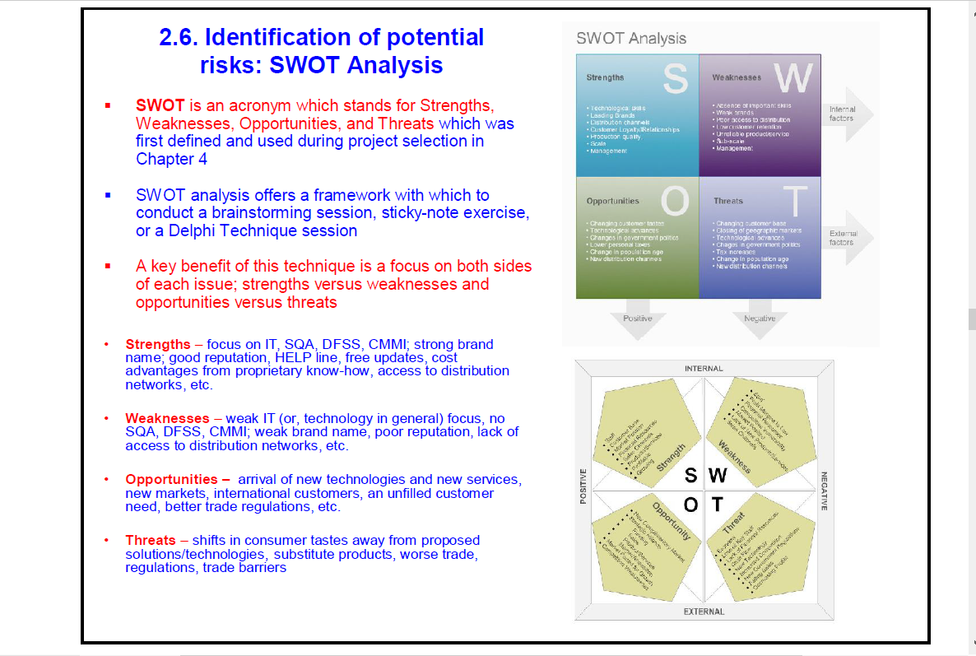

**SWOT Analysis**

The discussion on product selection may be summed up in terms of

a “SWOT” analysis. “SWOT” stands for Strength, Weakness,

Opportunities and Threats For a small entrepreneur, the strength

lies n the form of an assured and continuous supply of inputs,

sound finance, stable market, good connections and support

among others. Weakness may include supply interruptions, rising

input and labour costs, irregular market, low labour productivity and

financial problems. Opportunities could be in the form of new

market, export orders, import replacement, government incentives

budgetary concessions, etc. Threat could take the shape of

unexpected entry of competitors, including well established units

with brand names, introduction of cheaper or better substitutes,

change in the tastepreferences, rates of obsolescence of

technology restrictions by government, to mention a few. The

entrepreneur should organise his resources to improve strength,

reduce weakness, scize opportunities and anticipate threats.

After listing the positive and negative points of the product to be

selected, the entrepreneur ought to ask the following questions to

himself :

(a) Can I produce it ?

(b) Can I market it ?

(c) Is it worth producing and marketing ?

If the answers are in the affirmative you should go ahead without

any hesitation.

Let us end this Lesson with a quotation from Akio Morita, the

cofounder of the world renowned electronics company SONY.

Japan : “ .. being able to make unique products are not enough to

keep a business going. You have to sell the products, and to do

that you have to show the potential buyer the real value of what you

are shelling”.

NBNBNBNB

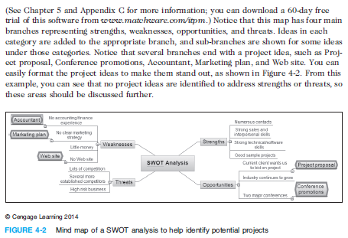

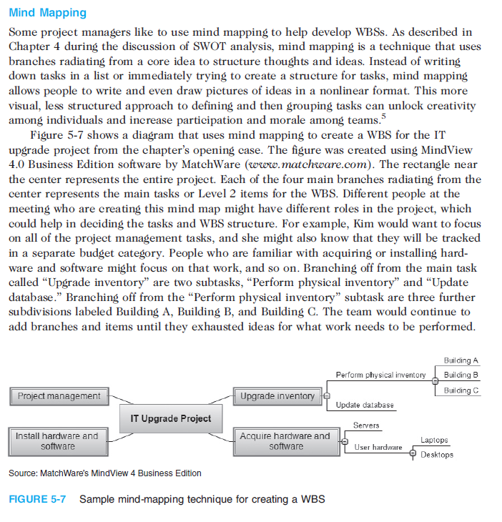

NBNBNBNBNBNBN



NBNBNBNBNBNB

RARARARARARRRRRRRRRRRRRRRRRRRRRRRRR

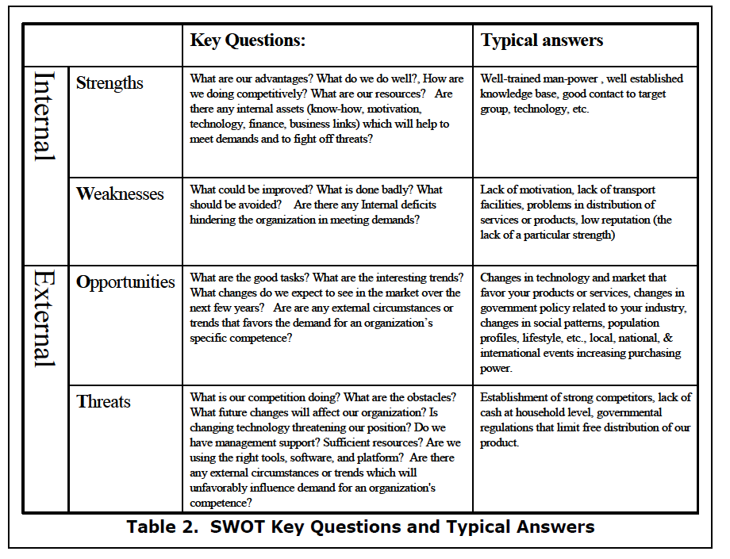

RARARARARARRRRRRRRRRRRRRRRRRRRRRRRRRRRR

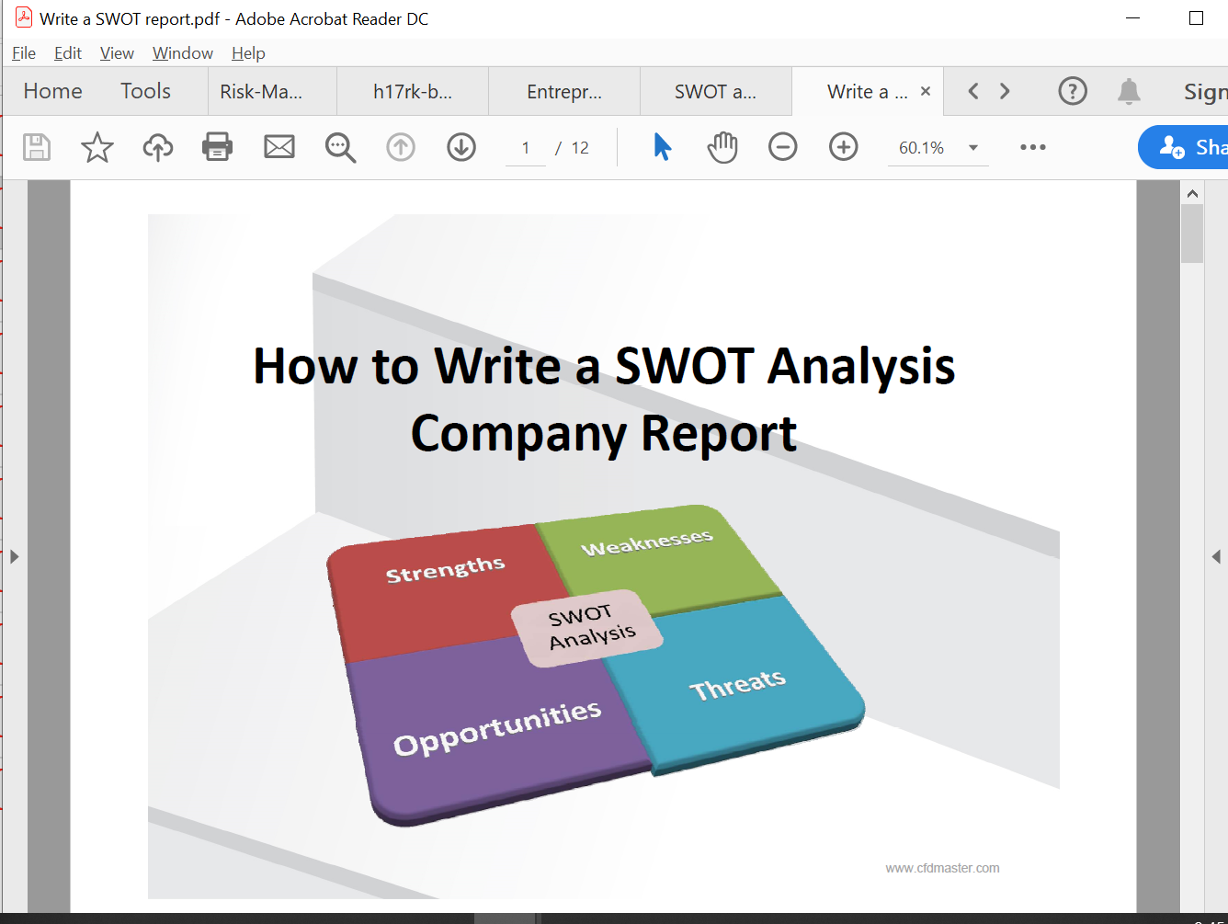

RARARARARRRRRRRRRRRRRRRRRRRRRRRRRRRRRRRRRRRRRRRRR

www.cfdmaster.com

**Writing the SWOT analysis**

A SWOT analysis centers wholly on the four components incorporated in the

short form, permitting companies to recognize the powers influencing a plan,

action, or proposal. Recognizing these negative and positive impacting

aspects, can assist companies more efficiently communicate what

components of a plan should be identified.

While planning a SWOT analysis, persons normally make a table divide into

four columns in order to list every impacting aspect alongside for contrast.

Strengths and weaknesses will not normally match scheduled threats and

opportunities, even if some correlation ought to exist because they are joined

together somehow.

The initial two letters in the short form, Strengths and Weaknesses, denote

internal factors,which imply the experience and resources readily accessible

to you. Cases of areas normally considered comprise:

• Monetary resources, for instance funding, sources of revenue and investment

opportunities.

• Physical resources, for instance your business’s location, equipment and facilities.

• Human resources, for instance employees, target audiences and volunteers.

• Current processes, for instance employee programs, software systems and

department hierarchies.

**External factors**

Each company, individual and organization is affected and influenced by

outside forces. Whether linked indirectly or directly to a threat or

opportunity, each of these aspects is vital to take notice of and file. External

factors usually reference stuff you or your business does not control, for

instance:

• Market trends, for instance new technology and products or changes in audience

requirements.

• Economic trends, for instance local, international and national monetary trends.

• Funding, for instance legislature, donations and other foundations.

• Demographics, for instance a target audience’s race, age, culture and gender.

**Conclusion**

SWOT Analysis is an uncomplicated; however, helpful structures for analyzing

your business’s concentrate on your strengths, reduce threats, and take the

utmost possible benefit of opportunities accessible to you.

SWOT Analysis can be utilized to “beginning” plan formulation, or in a more

refined approach as a sober policy tool. You can as well make use of it to find

a perceptive of your opponents, which can present you the insights you

require to come up with a successful and coherent viable position.

While doing your SWOT Analysis, be rigorous and realistic. Use it at the

correct stage, and complement it with other alternative‐production tools

where fitting.

Make use of SWOT like a guide and not a recommendation.



RARARARARARRRRRRRRRRRRRRRRRRRRRRRRR

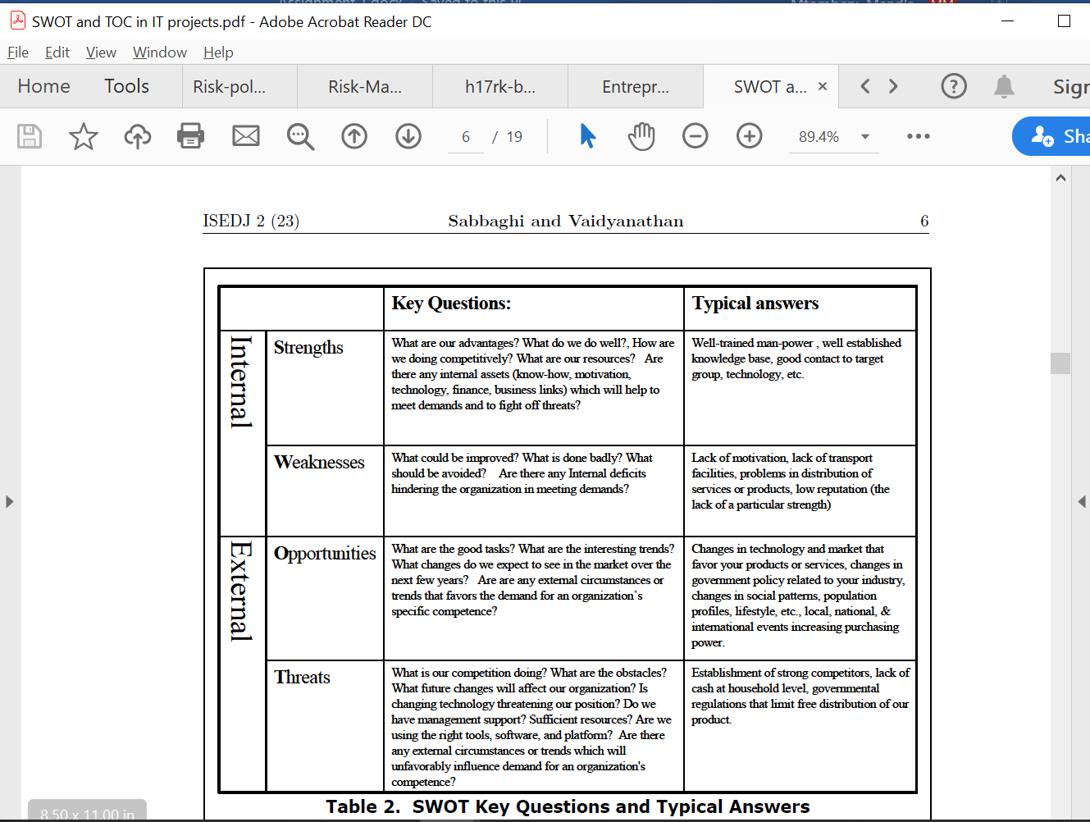

RARARARARARRRRRRRRRRRRRRRRRRRRRRRRRRRRR



RARARARARRRRRRRRRRRRRRRRRRRRRRRRRRRRRRRRRRRRRRRRR

NBNBNBNBNBNBNBNBNB



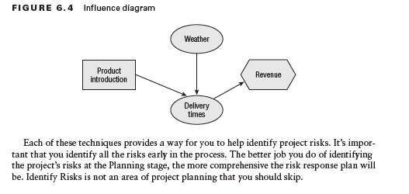

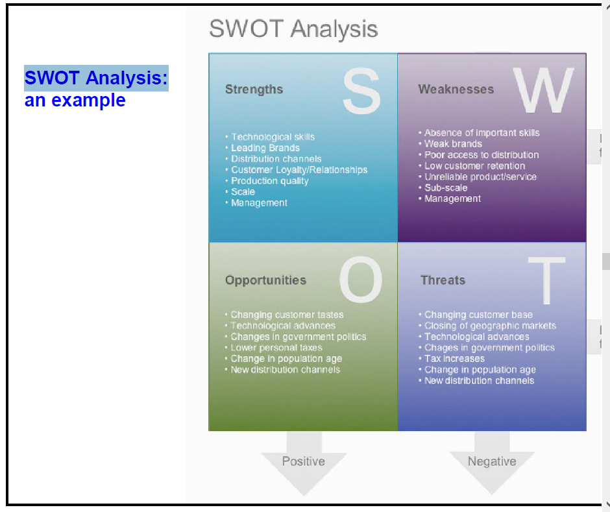

**BBBBBBBBBBBBBBBBBBBBBBBBBBBBBBBBBBBBBBB**

**11.1.2 STRATEGIC AND CHANGE MANAGEMENT [100]**

**QUESTION ONE [60]**

Read the following article and answer the questions that follow

**Can SA’s new challenger banks knock out the ‘big four’?**

For two decades, SA’s banking sector has remained largely the same. The advent of Capitec, in 2001, showed that customers were desperate for something different. Now, three new banks — all backed by powerful SA business personalities — are opening their digital doors, offering something entirely different. So what can they offer that’s new, and how much of a threat is this for the ‘big four’ banks?

**28 MARCH 2019 STEPHEN CRANSTON**

Financial services used to change slowly. Twenty years after Douw Steyn launched the direct-to-consumer insurer Auto & General in 1985, insurance was still largely sold through brokers, and index funds still accounted for a tiny portion of investment assets.

Banking changed even more slowly. More than 25 years after the launch of the internet, most banks still distribute a large portion of their products through a branch network. These branches will still be perfectly recognizable to anyone visiting SA for the first time in 30 years. None of the big banks will rock the boat; they want to protect their collective income. That era has come to an end. In the past few months, three new banks have launched with a leaner, cheaper business model that will change the face of SA banking — Discovery Bank, TymeBank and Bank Zero.

It’s been a long time coming. After Saambou and Fidelity Bank collapsed in the early 2000s, the SA Reserve Bank was for a long time reluctant to let new banks open. But these three new banks are backed by formidable business personalities with deep pockets.

Discovery Bank is part of the wider group run by CEO Adrian Gore, which began as a health-care company in 1993. Discovery boasts Remgro associate Rand Merchant Investments (RMI) as its anchor shareholder.

Tyme Bank is controlled by African Rainbow Capital (ARC), an investment company controlled by the eclectic Ubuntu-Botho group headed by Patrice Motsepe. As the Forbes rich list has it, Motsepe is one of the 1,000 wealthiest individuals in the world, with a fortune of $2.4bn. Before it was bought by Motsepe’s company, TymeBank was owned by the Commonwealth Bank of Australia (CBA), one of the world’s top 10 retail banks.

As for Bank Zero, the most entrepreneurially based of the three, it shows how far the Reserve Bank has come that it got the green light. Bank Zero is run by a maverick group of former FNB executives, most of them with strong technology backgrounds, with a few family and friends as shareholders. The chair and figurehead is the former FNB boss Michael Jordaan, based in Stellenbosch.

Somewhat ironically, Jordaan is Motsepe’s partner in the data-only telecom network Rain. The Bank Zero CEO, Yatin Narsai (former head of FNB retail), runs the business day-to-day from Bryanston.

Discussing the rationale for the bank in an interview with the *FM*, Narsai says SA ranks among the five countries with the highest bank fees in the world. "This is intolerable in such an unequal society, but then the rest of the bottom five were similarly unequal countries in Latin America," he says.

No-one can ignore the competitive threat of cheap banking. Narsai says he personally will save R2 000 a month from his personal and business accounts, when Bank Zero goes live and he can move accounts. "Low fees will become the new normal and I hope that penalty fees will disappear altogether," he says.

The question, however, is what the existing big four banks — FNB, Standard Bank, Absa and Nedbank — will do to counter the threat. "The big banks ignored Capitec in the early 2000s," says Louis Chetty, head of financials at Stanlib, "and lost considerable market share. I am sure they will not make the same mistake again."

Capitec has more than 10-million customers, who will have been enticed, in part, by the much lower cost of banking. And yet the big four still have 83% of all bank deposits in the country and 92% of all mortgages, which shows how concentrated the market still is.

Harry Botha, a banks analyst at Avior Capital, says it could take three to five years for the challenger banks to make material inroads into the large banks’ earnings.

**Discovery, TymeBank and Bank Zero** are pursuing a branchless model, with their apps being their shop window. This means SA isn’t far behind the rest of the world: the first app-only current account in the UK was introduced by Starling Bank just two years ago. Perhaps if the Reserve Bank had been more open-minded, SA could have beaten them to the punch.

But, globally, this is the trend. No-one should have been surprised by Standard Bank’s announcement two weeks ago that it was closing up to 15% of its branch network — or 91 branches. Botha says Standard’s natural market share has fallen thanks to the success of Capitec and FNB, in different parts of its client base.

Standard Bank CEO Sim Tshabalala called it "realigning the retail and business banking model to the changing needs of customers". And, of course, the convenience of digital banking makes so much more sense than travelling to a branch and queuing.

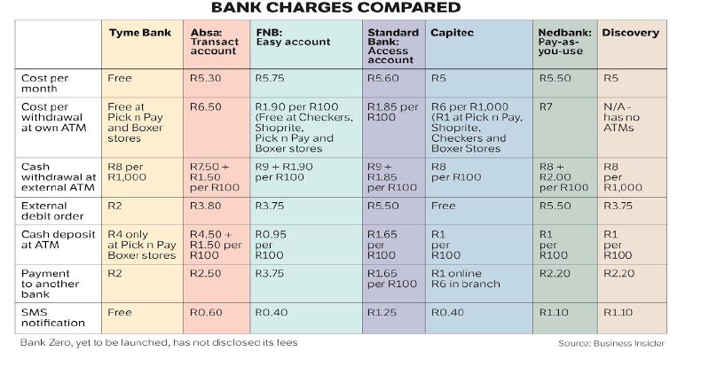

TymeBank chair Coen Jonker tells the *FM*: "The banks have done their best to protect their legacy income streams for years, and the transactional fees on simply taking money in and out of accounts is the hardest to justify. As new banks we won’t have that legacy to defend."

The big four banks have long operated as if they were an informal cartel. Even the one entrant in the past 20 years to grow to large-bank status, Capitec, has adopted a traditional branch-based distribution model.

Only Investec has operated without branches — but to a narrow spectrum of high net worth clients. To see what sort of riches are up for grabs, consider Capitec’s trajectory. In its first year on the JSE in 2002, Capitec made revenue of R270m, with just a smattering of clients. By August 2018, it was clocking up R9.3bn in operating income with its 10.5-million customers. Its share price has reacted accordingly: R10 000 invested in the bank at the beginning would now be worth R7.2m.

Fees were a big part of this success. Capitec has a nominal monthly fee of R5, with R1 charged for each digital transaction. Cash withdrawals are more expensive at R6 for the first R1 000 at a Capitec ATM, or a flat R1.60 at till points of retailers like Pick n Pay or Shoprite. As many of Capitec’s transactional clients earn interest of 5% on their deposits, they often get more money coming in than they pay in fees.

These new banks would appear, in part, to be targeting that market. However, Chetty says clients who have a loan with Capitec are unlikely to move their transactional accounts to the new banks in a hurry. "Banking will never be free," says Capitec CEO Gerrie Fourie in an interview with the *FM*. "Even at Capitec, we have a high fixed-cost base."

Interestingly, Capitec is the only bank that is actually increasing its branch footprint, even though 2.2-million clients have migrated to the app and 4-million to the USSD (SMS-based) transactional platform.

At the moment, Capitec has 840 branches, though many are smaller than those of the big banks. The branches have proven invaluable as the predominant sales point for the half-a-million Sanlam funeral policies sold through Capitec over the past year.

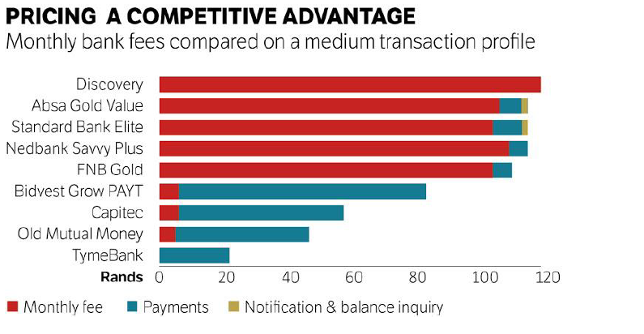

NBNBNBNBNBN

Avior’s Botha says SA is still a long way from a zero-fee banking regime, even among the new entrants. But fixed monthly fees and charges for electronic transactions could come to an end sooner rather than later.

Discovery Bank will charge both sets of fees — at least for now.

Gore says banks operate on three legs: fees, interest and rewards. Some banks (like Capitec and the other newcomers) will offer competitive fees and attractive interest rates on accounts but no rewards programme; while the large banks pay little or no interest on current accounts but have decent rewards programmes.

Gore says Discovery will not attempt to beat the market on fees, for a combined current account and credit card.

* Discovery Bank’s lower-income clients (those earning less than R300,000 a year) will pay between R149 and R186 a month in fees; middle-income customers will pay between R213 and R240; and higher-income clients will pay between R275 and R440. For a pure transactional account the fee will be R60 to R120, but as Discovery has no ATMs, cash withdrawal fees will be higher.

But if it won’t compete on fees, Discovery Bank will be second to none with its Vitality Money rewards programme, and the sophisticated way in which it encourages the right financial behaviour.

Discovery Bank will match Capitec’s 5% interest rate on positive current account, and add an extra 1.5% for those in the top tier of the Vitality programme.

The three new banks are not just aiming for the tech-savvy. TymeBank’s former parent, CBA, has a larger market cap than the entire SA banking sector, though it took a softly-softly approach to the new bank. Even before Tyme was registered, it offered money transfer services from Pick n Pay.

Though Tyme doesn’t have any of its own branches, it will have 750 points of sale through Pick n Pay and Boxer stores. This gives it reach into the main urban areas, as well as the rural areas where few banking services are typically available. Boxer customers are more likely to be unbanked, so could prove the most fertile hunting ground for Tyme.

Most transactions are free if carried out at Pick n Pay or Boxer, and cost only R2 if done elsewhere, and the bank pays up to 10% interest on positive balances. TymeBank has such low costs because it is cloud-based and highly scalable, and has minimised the bells and whistles. Incredibly, there are just 125 staff keeping the bank running. Clients can join through the TymeBank website, but by far the most popular recruitment tool has been self-service kiosks, which provide a new card within five minutes.

CEO Sandile Shabalala says the bank will start offering loans next year. It plans to offer keener lending rates because, like Capitec, it will be able to cross-subsidise its transaction and deposit books from its loan income. The tipping point for Tyme, at which it becomes profitable, is 2-million customers and 700,000 loans.

It is almost an accident that Motsepe’s ARC took full control of the bank after CBA pulled out suddenly to retreat to its home market and cut exposure to emerging markets.

Johan van Zyl, the co-CEO of ARC (and chair of Sanlam) says he was pleased CBA was the controlling shareholder while the bank was being registered because it is a bureaucratic, by-the-book organisation with huge experience of banking regulation.

"We would like to bring in an equity partner as we prefer to hold minority positions in companies, not the 73% we currently hold, but it is not an imperative," he says.

Van Zyl says the Reserve Bank does not want TymeBank to become a Sanlam group company as it wants to keep banks and insurers as separate as possible. TymeBank, he says, will ride the wave away from cash transactions to digital payments.

"We expect the amount of cash in the system to be cut back by two-thirds over the next three years. Increasingly shareholders in the Ubuntu-Botho group find carrying cash dangerous. We were able to issue 1-million cards to members of the Zion Christian Church to facilitate cashless transactions," he says.

For now though, Pick n Pay stores are more than happy to offer excess cash to TymeBank customers at no charge. The retailer’s deputy CEO, Richard van Rensburg, says Capitec also recommends its customers draw money at Pick n Pay tills because it is far cheaper than using an ATM. And a central feature of TymeBank is its access to the information gathered by Pick n Pay on the 11-million members of its Smart Shopper programme, which provides rewards points on all purchases, not just at Pick n Pay. And unlike Discovery, that benefit is not confined to healthy foods. In a much less judgmental way, all purchases qualify.

You might have expected Pick n Pay to have cold feet after the failure of its Go Banking venture with Nedbank in the mid-2000s. But Van Rensburg argues that Go Banking offered similar services to Nedbank, whereas TymeBank has developed products exclusively for digital clients. He says he would not try to set up a bank as a subsidiary of a retailer again, but an alliance between a retailer and a bank makes sense.

Pick n Pay CEO Richard Brasher is also the founder of Tesco Bank, which is owned by the UK’s largest supermarket chain.

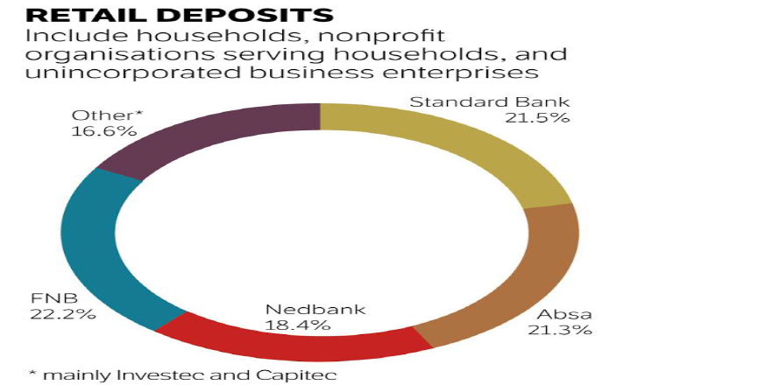

NBNBNBBNB

Motsepe and his team are facing some other strong personalities over at Bank Zero. Jordaan may just be the nonexecutive chair of Bank Zero, but with his deep knowledge of new technologies, the market seems confident that his bank will be impressive from the start.

Narsai, as head of FNB retail, is even more deeply entrenched in IT than Jordaan. "I am impressed that TymeBank has signed up 120,000 customers in a few months," he says. "[It shows] there is pent-up demand for a good-value, no-frills bank account. But we will be offering considerably more sophisticated functionality."

Other FNB renegades at Bank Zero are chief risk officer Lezanne Human (who also moonlights as the informal head of public affairs), and co-founder and CFO Liné Wiid. Bank Zero, as a mutual bank, will focus on deposits and transactional banking and will not offer loans for the foreseeable future.

"The intention is to keep capital as lean as possible, and considerable capital is needed to roll out loans," says Narsai. It will also focus on the business banking market, where margins are still chunky.

Narsai promises a "creative" solution for clients who might go modestly into the red. But he also hopes to nurture a savings culture through attractive interest rates. Initially, the team had planned to focus on high-margin areas, particularly remittances from neighbouring countries, but they soon realised they had the capability to launch a full-service bank.

Jordaan tells the *FM* that Bank Zero, launching in the second half of 2019, will make money through the interest it charges, fees on third-party transactions and commissions on prepaid products such as airtime. "But with our low break-even you can expect lots of zeros where other banks charge fees," says Jordaan.

Mark Elliott, president of Mastercard Southern Africa, says he is working with Bank Zero to develop a new kind of card that can deliver better security, which is appropriate for today’s increasingly mobile and digital customers.

Bank Zero also keeps costs down by using the cloud, but the heart of the business will be its IBM LinuxOne enterprise server, which uses (free) open-source software. Perhaps Bank Zero’s most serious competitor, at least in the small to medium business sector, could be Mercantile, once it is revitalised under Capitec’s ownership.

Narsai says most banks opt for off-the-shelf IT systems, where both the risk and capital requirements are significant. Bank IT managers naturally gravitate towards packages conforming to past norms, which tend to create a "me too" starting point.

"We have preferred to build our platform to clearly defined bank specifications. We are very comfortable doing this with our deep expertise. And we can design from the ground up for today’s issues such as regulation and cybercrime," he says.

Capitec’s Fourie warns, however, that while new fintech technology providers might be adding value, they fall short on two issues — handling volume and maintaining security. It’ll be interesting to see how Bank Zero navigates this.

**For Jordaan, it’s a natural evolution**. Now living in Stellenbosch, he became CEO of FNB when he was just 36, creating an institution that grabbed plaudits as "the world’s most innovative bank" in 2012.

He says he thrived in the entrepreneurial FirstRand culture fostered by the three founders — GT Ferreira, Laurie Dippenaar and Paul Harris — who embraced start-up ventures such as Discovery and Outsurance. This inspired him to become a backer of small business.

Jordaan left FNB in 2013, because he says 10 years of commuting from Stellenbosch to Johannesburg was enough. There was no love lost between him and Discovery (another FirstRand subsidiary at the time), which he called the enfant terrible of the group and a disrupter, in the days when that was still a swear word.

Jordaan says all the Bank Zero shareholders are active as executives or active directors, with skin in the game.

"Without a big corporate shareholder, we can take a much longer-term view," he says. "We have a cohesive strategy to bring significant customer benefits without the pressure to produce short-term profits."

Mutual banks might have a bad name after the collapse of VBS last year under a mountain of fraud, but one of the benefits of the structure is that it allows customers to become shareholders.

If Bank Zero’s model is simple, Discovery Bank’s is the opposite.

The launch included a 70-page "thought leadership" document with chapters on such warm and fuzzy notions as "shared value", "behaviour change" and "people-centric" design. Still, Discovery Bank’s CEO, Barry Hore, promises that the app will be simple to use, once clients get used to it. "It is multifunctional, a bank branch in the palm of the hand," he says.

Interesting features of its model include Discovery Pay, which allows clients to pay any other client without needing to register the person as a beneficiary. Pharmacy co-payments can also be automatically deducted from the bank account.

To date FNB has been the leading bank for innovative features, such as registering as a customer using a selfie from your phone. But Hore says the Discovery platform will ensure that bank customers never need to visit a branch, even to open an account, and from day one cardless capabilities such as Samsung Pay, Garmin Pay and FitBit Pay will be available.

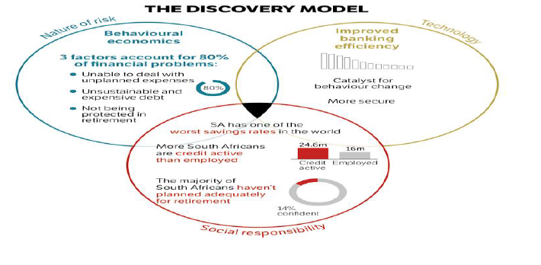

The Discovery Bank app went live this week, and the first stage is to migrate former clients of Discovery Card (which was backed by the FNB platform) into the bank. It will necessarily be a slow process to avoid anything going wrong. But by June, the first 10,000 clients are expected to be onboard.

Discovery’s advantage is that unlike the other two new banks, it is already a household brand. It also has a good chance of capturing the majority of its credit card clients (bought back from FNB) and a sizeable slice of its medical aid and insurance clients. Already, the group’s Vitality programme has cult status among some, and if you believe their marketing, physically fit people are less likely to be financially irresponsible. And the ability to cross-sell was an important reason for setting up the bank in the first place.For those who are on the main Vitality Health programme (Discovery medical aid members or life policyholders), and who hold a Discovery bank account, there will be plenty of benefits. For example, those on the higher Vitality status can get free membership at Virgin Active or Planet Fitness gyms, while the discounts for flights on Kulula can be up to 75%. There are also cash-back rewards for healthy food at Woolworths and Pick n Pay.

Hore insists you don’t have to be a gym bunny to get a good deal from the bank — people with no other Discovery product still get a 25% discount on fuel and healthy food. But these are the frills. Discovery has not yet revealed how it plans to recoup the considerable start-up costs. It has spent close to R4.5bn between developing the bank systems (which, like those of Standard Bank, are based on SAP products) and buying back the Discovery credit card from FNB. Gore says Discovery could not opt for a simpler cloud-based solution, as Tyme Bank has done, because its system needs to accommodate the complex links between the bank and its Vitality programme and the company’s health, life, investment and insurance businesses.

This suggests it will take longer for Gore’s bank to make a profit than either of its more nimble competitors, Bank Zero and TymeBank, and the marketing spend will be higher. Discovery estimates it could take five years to turn profitable. Gore says the bank has been built from the ground up with the latest technology and features — including the most advanced fingerprint and facial recognition systems — as well as the ability to add accounts with a few clicks. But he is pinning much hope on the behavioural approach and rewards system, which he believes is the differentiator. OOOOOOOO

Gore challenges the view, expressed by FirstRand CEO Alan Pullinger recently, that SA’s banks already use a behavioural approach to assess the quality of their clients when it comes to risk. "We don’t agree," says Gore. Most banks reward clients for taking out more products, which specifically increases their debt and credit levels, he says. This means there are now 8-million more credit-active consumers than employed people — a big risk to society.

"We don’t push products, but encourage [customers] to follow key behaviour to secure financial health. They get the tools to help them through the Vitality Money programme," he says. Still, it’s clear that Discovery Bank won’t be matching the costs of TymeBank and Bank Zero item-for-item, at least for the average client. Instead, its sales proposition is to help clients achieve financial health and then reward them. Hore says it will set personalised goals based on an individual’s circumstances, and will have a wider product range on day one than its rivals. Discovery will offer credit, transactional products and savings products.

The bank will also offer dynamic interest rates. This means that its best customers (not necessarily its richest), could pay 6% below the market rate for debt and earn 2% more for savings. Hore says Discovery’s "shared value" approach is not meant to punish those who don’t achieve perfection, but rather to nudge people to make better choices.

If the bank takes off as Gore expects, there is plenty of scope to export this model too. While Gore says the bank will start as a purely SA venture, he isn’t ruling out exporting a banking version of the Vitality Shared Value model at a later point.

Discovery Bank might be branchless, but it will have a handful of hi-tech walk-in centres. It will rely heavily on its network of agents and brokers to push clients towards the bank.

This network of brokers and agents is something that TymeBank and Bank Zero don’t have. While Bank Zero is entirely app based, Tyme at least enjoys some advertising through its black and yellow machines at Pick n Pay stores, and has started flighting prime-time TV adverts to lure clients. Chetty says Bank Zero needs to develop a brand and requires a professional marketing campaign to do it. None of the team has marketing experience except for Jordaan, and that won’t be enough to build a brand — even with his Steve Jobs-style charisma.

While there’s electricity in the air in the banking sector for the first time in years, it won’t be a one-way bet. There is, after all, the cautionary tale of SA’s first digital bank, 20Twenty, which launched in 2001 using Saambou as the backbone. 20Twenty never got to critical mass, with just 40,000 clients, and closed in 2006.

But the fact that TymeBank already has 120,000 clients is evidence that perhaps the time is now right. Narsai says that while 20Twenty had a huge marketing budget and a limited range of products, the architecture was quite primitive by today’s standards and the benefit from lower fees was limited.

**WHAT IT MEANS**

Three new banks are set to change the face of SA banking with a leaner, cheaper business model

Back then, there were fewer smartphones (it was the age of BlackBerry) and the environment wasn’t inherently as friendly for digital products as it is today. 20Twenty, for example, operated largely through a call centre, and the customer experience was often indifferent.

Though price alone might not be enough to propel the new banks into profit, they are launching at a time of considerable unhappiness over bank fees. It is easier than ever, through apps, to compare fees. Until now, none of the large banks has been prepared to jeopardise their lucrative income stream from transactional fees with a price war. But now they will have no choice.

Says Botha: "The big banks will cut fees, but only gradually — they need to cut costs first before they can afford to do so. "At least, in most cases, the big four banks still own the relationship with the customer and can persuade them to stay. Botha says they can be expected to increase their credit spreads on loans to make up for the lost fee income. Capitec is likely to be the least affected, says Chetty, given that it already has a competitive current account with low fees.

This means it will be the big four who will bear the brunt of the industry disruption. Already they’re scrambling, introducing innovations like joining up with just a selfie. But they may have left it too late to ride the tsunami of change.

[**https://www.businesslive.co.za/fm/features/cover-story/2019-03-28-can-sas-new-challenger-banks-knock-out-the-big-four/**](https://www.businesslive.co.za/fm/features/cover-story/2019-03-28-can-sas-new-challenger-banks-knock-out-the-big-four/)

////////////////

**11.1.2 STRATEGIC AND CHANGE MANAGEMENT [100]**

**QUESTION ONE [60]**

Read the following article and answer the questions that follow

**Can SA’s new challenger banks knock out the ‘big four’?**

For two decades, SA’s banking sector has remained largely the same. The advent of Capitec, in 2001, showed that customers were desperate for something different. Now, three new banks — all backed by powerful SA business personalities — are opening their digital doors, offering something entirely different. So what can they offer that’s new, and how much of a threat is this for the ‘big four’ banks?

**28 MARCH 2019 STEPHEN CRANSTON**

Financial services used to change slowly. Twenty years after Douw Steyn launched the direct-to-consumer insurer Auto & General in 1985, insurance was still largely sold through brokers, and index funds still accounted for a tiny portion of investment assets.

Banking changed even more slowly. More than 25 years after the launch of the internet, most banks still distribute a large portion of their products through a branch network. These branches will still be perfectly recognizable to anyone visiting SA for the first time in 30 years. None of the big banks will rock the boat; they want to protect their collective income. That era has come to an end. In the past few months, three new banks have launched with a leaner, cheaper business model that will change the face of SA banking — Discovery Bank, TymeBank and Bank Zero.

It’s been a long time coming. After Saambou and Fidelity Bank collapsed in the early 2000s, the SA Reserve Bank was for a long time reluctant to let new banks open. But these three new banks are backed by formidable business personalities with deep pockets.

Discovery Bank is part of the wider group run by CEO Adrian Gore, which began as a health-care company in 1993. Discovery boasts Remgro associate Rand Merchant Investments (RMI) as its anchor shareholder.

Tyme Bank is controlled by African Rainbow Capital (ARC), an investment company controlled by the eclectic Ubuntu-Botho group headed by Patrice Motsepe. As the Forbes rich list has it, Motsepe is one of the 1,000 wealthiest individuals in the world, with a fortune of $2.4bn. Before it was bought by Motsepe’s company, TymeBank was owned by the Commonwealth Bank of Australia (CBA), one of the world’s top 10 retail banks.

As for Bank Zero, the most entrepreneurially based of the three, it shows how far the Reserve Bank has come that it got the green light. Bank Zero is run by a maverick group of former FNB executives, most of them with strong technology backgrounds, with a few family and friends as shareholders. The chair and figurehead is the former FNB boss Michael Jordaan, based in Stellenbosch.

Somewhat ironically, Jordaan is Motsepe’s partner in the data-only telecom network Rain. The Bank Zero CEO, Yatin Narsai (former head of FNB retail), runs the business day-to-day from Bryanston.

Discussing the rationale for the bank in an interview with the *FM*, Narsai says SA ranks among the five countries with the highest bank fees in the world. "This is intolerable in such an unequal society, but then the rest of the bottom five were similarly unequal countries in Latin America," he says.

No-one can ignore the competitive threat of cheap banking. Narsai says he personally will save R2 000 a month from his personal and business accounts, when Bank Zero goes live and he can move accounts. "Low fees will become the new normal and I hope that penalty fees will disappear altogether," he says.

The question, however, is what the existing big four banks — FNB, Standard Bank, Absa and Nedbank — will do to counter the threat. "The big banks ignored Capitec in the early 2000s," says Louis Chetty, head of financials at Stanlib, "and lost considerable market share. I am sure they will not make the same mistake again."

Capitec has more than 10-million customers, who will have been enticed, in part, by the much lower cost of banking. And yet the big four still have 83% of all bank deposits in the country and 92% of all mortgages, which shows how concentrated the market still is.

Harry Botha, a banks analyst at Avior Capital, says it could take three to five years for the challenger banks to make material inroads into the large banks’ earnings.

**Discovery, TymeBank and Bank Zero** are pursuing a branchless model, with their apps being their shop window. This means SA isn’t far behind the rest of the world: the first app-only current account in the UK was introduced by Starling Bank just two years ago. Perhaps if the Reserve Bank had been more open-minded, SA could have beaten them to the punch.

But, globally, this is the trend. No-one should have been surprised by Standard Bank’s announcement two weeks ago that it was closing up to 15% of its branch network — or 91 branches. Botha says Standard’s natural market share has fallen thanks to the success of Capitec and FNB, in different parts of its client base.

Standard Bank CEO Sim Tshabalala called it "realigning the retail and business banking model to the changing needs of customers". And, of course, the convenience of digital banking makes so much more sense than travelling to a branch and queuing.



TymeBank chair Coen Jonker tells the *FM*: "The banks have done their best to protect their legacy income streams for years, and the transactional fees on simply taking money in and out of accounts is the hardest to justify. As new banks we won’t have that legacy to defend."

The big four banks have long operated as if they were an informal cartel. Even the one entrant in the past 20 years to grow to large-bank status, Capitec, has adopted a traditional branch-based distribution model.

Only Investec has operated without branches — but to a narrow spectrum of high net worth clients. To see what sort of riches are up for grabs, consider Capitec’s trajectory. In its first year on the JSE in 2002, Capitec made revenue of R270m, with just a smattering of clients. By August 2018, it was clocking up R9.3bn in operating income with its 10.5-million customers. Its share price has reacted accordingly: R10 000 invested in the bank at the beginning would now be worth R7.2m.

Fees were a big part of this success. Capitec has a nominal monthly fee of R5, with R1 charged for each digital transaction. Cash withdrawals are more expensive at R6 for the first R1 000 at a Capitec ATM, or a flat R1.60 at till points of retailers like Pick n Pay or Shoprite. As many of Capitec’s transactional clients earn interest of 5% on their deposits, they often get more money coming in than they pay in fees.

These new banks would appear, in part, to be targeting that market. However, Chetty says clients who have a loan with Capitec are unlikely to move their transactional accounts to the new banks in a hurry. "Banking will never be free," says Capitec CEO Gerrie Fourie in an interview with the *FM*. "Even at Capitec, we have a high fixed-cost base."

Interestingly, Capitec is the only bank that is actually increasing its branch footprint, even though 2.2-million clients have migrated to the app and 4-million to the USSD (SMS-based) transactional platform.

At the moment, Capitec has 840 branches, though many are smaller than those of the big banks. The branches have proven invaluable as the predominant sales point for the half-a-million Sanlam funeral policies sold through Capitec over the past year.



Avior’s Botha says SA is still a long way from a zero-fee banking regime, even among the new entrants. But fixed monthly fees and charges for electronic transactions could come to an end sooner rather than later.

Discovery Bank will charge both sets of fees — at least for now.

Gore says banks operate on three legs: fees, interest and rewards. Some banks (like Capitec and the other newcomers) will offer competitive fees and attractive interest rates on accounts but no rewards programme; while the large banks pay little or no interest on current accounts but have decent rewards programmes.

Gore says Discovery will not attempt to beat the market on fees, for a combined current account and credit card.

* Discovery Bank’s lower-income clients (those earning less than R300,000 a year) will pay between R149 and R186 a month in fees; middle-income customers will pay between R213 and R240; and higher-income clients will pay between R275 and R440. For a pure transactional account the fee will be R60 to R120, but as Discovery has no ATMs, cash withdrawal fees will be higher.

But if it won’t compete on fees, Discovery Bank will be second to none with its Vitality Money rewards programme, and the sophisticated way in which it encourages the right financial behaviour.

Discovery Bank will match Capitec’s 5% interest rate on positive current account, and add an extra 1.5% for those in the top tier of the Vitality programme.

The three new banks are not just aiming for the tech-savvy. TymeBank’s former parent, CBA, has a larger market cap than the entire SA banking sector, though it took a softly-softly approach to the new bank. Even before Tyme was registered, it offered money transfer services from Pick n Pay.

Though Tyme doesn’t have any of its own branches, it will have 750 points of sale through Pick n Pay and Boxer stores. This gives it reach into the main urban areas, as well as the rural areas where few banking services are typically available. Boxer customers are more likely to be unbanked, so could prove the most fertile hunting ground for Tyme.

Most transactions are free if carried out at Pick n Pay or Boxer, and cost only R2 if done elsewhere, and the bank pays up to 10% interest on positive balances. TymeBank has such low costs because it is cloud-based and highly scalable, and has minimised the bells and whistles. Incredibly, there are just 125 staff keeping the bank running. Clients can join through the TymeBank website, but by far the most popular recruitment tool has been self-service kiosks, which provide a new card within five minutes.

CEO Sandile Shabalala says the bank will start offering loans next year. It plans to offer keener lending rates because, like Capitec, it will be able to cross-subsidise its transaction and deposit books from its loan income. The tipping point for Tyme, at which it becomes profitable, is 2-million customers and 700,000 loans.

It is almost an accident that Motsepe’s ARC took full control of the bank after CBA pulled out suddenly to retreat to its home market and cut exposure to emerging markets.

Johan van Zyl, the co-CEO of ARC (and chair of Sanlam) says he was pleased CBA was the controlling shareholder while the bank was being registered because it is a bureaucratic, by-the-book organisation with huge experience of banking regulation.

"We would like to bring in an equity partner as we prefer to hold minority positions in companies, not the 73% we currently hold, but it is not an imperative," he says.

Van Zyl says the Reserve Bank does not want TymeBank to become a Sanlam group company as it wants to keep banks and insurers as separate as possible. TymeBank, he says, will ride the wave away from cash transactions to digital payments.

"We expect the amount of cash in the system to be cut back by two-thirds over the next three years. Increasingly shareholders in the Ubuntu-Botho group find carrying cash dangerous. We were able to issue 1-million cards to members of the Zion Christian Church to facilitate cashless transactions," he says.

For now though, Pick n Pay stores are more than happy to offer excess cash to TymeBank customers at no charge. The retailer’s deputy CEO, Richard van Rensburg, says Capitec also recommends its customers draw money at Pick n Pay tills because it is far cheaper than using an ATM. And a central feature of TymeBank is its access to the information gathered by Pick n Pay on the 11-million members of its Smart Shopper programme, which provides rewards points on all purchases, not just at Pick n Pay. And unlike Discovery, that benefit is not confined to healthy foods. In a much less judgmental way, all purchases qualify.

You might have expected Pick n Pay to have cold feet after the failure of its Go Banking venture with Nedbank in the mid-2000s. But Van Rensburg argues that Go Banking offered similar services to Nedbank, whereas TymeBank has developed products exclusively for digital clients. He says he would not try to set up a bank as a subsidiary of a retailer again, but an alliance between a retailer and a bank makes sense.

Pick n Pay CEO Richard Brasher is also the founder of Tesco Bank, which is owned by the UK’s largest supermarket chain.



Motsepe and his team are facing some other strong personalities over at Bank Zero. Jordaan may just be the nonexecutive chair of Bank Zero, but with his deep knowledge of new technologies, the market seems confident that his bank will be impressive from the start.

Narsai, as head of FNB retail, is even more deeply entrenched in IT than Jordaan. "I am impressed that TymeBank has signed up 120,000 customers in a few months," he says. "[It shows] there is pent-up demand for a good-value, no-frills bank account. But we will be offering considerably more sophisticated functionality."

Other FNB renegades at Bank Zero are chief risk officer Lezanne Human (who also moonlights as the informal head of public affairs), and co-founder and CFO Liné Wiid. Bank Zero, as a mutual bank, will focus on deposits and transactional banking and will not offer loans for the foreseeable future.

"The intention is to keep capital as lean as possible, and considerable capital is needed to roll out loans," says Narsai. It will also focus on the business banking market, where margins are still chunky.

Narsai promises a "creative" solution for clients who might go modestly into the red. But he also hopes to nurture a savings culture through attractive interest rates. Initially, the team had planned to focus on high-margin areas, particularly remittances from neighbouring countries, but they soon realised they had the capability to launch a full-service bank.

Jordaan tells the *FM* that Bank Zero, launching in the second half of 2019, will make money through the interest it charges, fees on third-party transactions and commissions on prepaid products such as airtime. "But with our low break-even you can expect lots of zeros where other banks charge fees," says Jordaan.

Mark Elliott, president of Mastercard Southern Africa, says he is working with Bank Zero to develop a new kind of card that can deliver better security, which is appropriate for today’s increasingly mobile and digital customers.

Bank Zero also keeps costs down by using the cloud, but the heart of the business will be its IBM LinuxOne enterprise server, which uses (free) open-source software. Perhaps Bank Zero’s most serious competitor, at least in the small to medium business sector, could be Mercantile, once it is revitalised under Capitec’s ownership.

Narsai says most banks opt for off-the-shelf IT systems, where both the risk and capital requirements are significant. Bank IT managers naturally gravitate towards packages conforming to past norms, which tend to create a "me too" starting point.

"We have preferred to build our platform to clearly defined bank specifications. We are very comfortable doing this with our deep expertise. And we can design from the ground up for today’s issues such as regulation and cybercrime," he says.

Capitec’s Fourie warns, however, that while new fintech technology providers might be adding value, they fall short on two issues — handling volume and maintaining security. It’ll be interesting to see how Bank Zero navigates this.

**For Jordaan, it’s a natural evolution**. Now living in Stellenbosch, he became CEO of FNB when he was just 36, creating an institution that grabbed plaudits as "the world’s most innovative bank" in 2012.

He says he thrived in the entrepreneurial FirstRand culture fostered by the three founders — GT Ferreira, Laurie Dippenaar and Paul Harris — who embraced start-up ventures such as Discovery and Outsurance. This inspired him to become a backer of small business.

Jordaan left FNB in 2013, because he says 10 years of commuting from Stellenbosch to Johannesburg was enough. There was no love lost between him and Discovery (another FirstRand subsidiary at the time), which he called the enfant terrible of the group and a disrupter, in the days when that was still a swear word.

Jordaan says all the Bank Zero shareholders are active as executives or active directors, with skin in the game.

"Without a big corporate shareholder, we can take a much longer-term view," he says. "We have a cohesive strategy to bring significant customer benefits without the pressure to produce short-term profits."

Mutual banks might have a bad name after the collapse of VBS last year under a mountain of fraud, but one of the benefits of the structure is that it allows customers to become shareholders.

If Bank Zero’s model is simple, Discovery Bank’s is the opposite.

The launch included a 70-page "thought leadership" document with chapters on such warm and fuzzy notions as "shared value", "behaviour change" and "people-centric" design. Still, Discovery Bank’s CEO, Barry Hore, promises that the app will be simple to use, once clients get used to it. "It is multifunctional, a bank branch in the palm of the hand," he says.

Interesting features of its model include Discovery Pay, which allows clients to pay any other client without needing to register the person as a beneficiary. Pharmacy co-payments can also be automatically deducted from the bank account.

To date FNB has been the leading bank for innovative features, such as registering as a customer using a selfie from your phone. But Hore says the Discovery platform will ensure that bank customers never need to visit a branch, even to open an account, and from day one cardless capabilities such as Samsung Pay, Garmin Pay and FitBit Pay will be available.



The Discovery Bank app went live this week, and the first stage is to migrate former clients of Discovery Card (which was backed by the FNB platform) into the bank. It will necessarily be a slow process to avoid anything going wrong. But by June, the first 10,000 clients are expected to be onboard.

Discovery’s advantage is that unlike the other two new banks, it is already a household brand. It also has a good chance of capturing the majority of its credit card clients (bought back from FNB) and a sizeable slice of its medical aid and insurance clients. Already, the group’s Vitality programme has cult status among some, and if you believe their marketing, physically fit people are less likely to be financially irresponsible. And the ability to cross-sell was an important reason for setting up the bank in the first place.For those who are on the main Vitality Health programme (Discovery medical aid members or life policyholders), and who hold a Discovery bank account, there will be plenty of benefits. For example, those on the higher Vitality status can get free membership at Virgin Active or Planet Fitness gyms, while the discounts for flights on Kulula can be up to 75%. There are also cash-back rewards for healthy food at Woolworths and Pick n Pay.

Hore insists you don’t have to be a gym bunny to get a good deal from the bank — people with no other Discovery product still get a 25% discount on fuel and healthy food. But these are the frills. Discovery has not yet revealed how it plans to recoup the considerable start-up costs. It has spent close to R4.5bn between developing the bank systems (which, like those of Standard Bank, are based on SAP products) and buying back the Discovery credit card from FNB. Gore says Discovery could not opt for a simpler cloud-based solution, as Tyme Bank has done, because its system needs to accommodate the complex links between the bank and its Vitality programme and the company’s health, life, investment and insurance businesses.

This suggests it will take longer for Gore’s bank to make a profit than either of its more nimble competitors, Bank Zero and TymeBank, and the marketing spend will be higher. Discovery estimates it could take five years to turn profitable. Gore says the bank has been built from the ground up with the latest technology and features — including the most advanced fingerprint and facial recognition systems — as well as the ability to add accounts with a few clicks. But he is pinning much hope on the behavioural approach and rewards system, which he believes is the differentiator. OOOOOOOO

Gore challenges the view, expressed by FirstRand CEO Alan Pullinger recently, that SA’s banks already use a behavioural approach to assess the quality of their clients when it comes to risk. "We don’t agree," says Gore. Most banks reward clients for taking out more products, which specifically increases their debt and credit levels, he says. This means there are now 8-million more credit-active consumers than employed people — a big risk to society.

"We don’t push products, but encourage [customers] to follow key behaviour to secure financial health. They get the tools to help them through the Vitality Money programme," he says. Still, it’s clear that Discovery Bank won’t be matching the costs of TymeBank and Bank Zero item-for-item, at least for the average client. Instead, its sales proposition is to help clients achieve financial health and then reward them. Hore says it will set personalised goals based on an individual’s circumstances, and will have a wider product range on day one than its rivals. Discovery will offer credit, transactional products and savings products.

The bank will also offer dynamic interest rates. This means that its best customers (not necessarily its richest), could pay 6% below the market rate for debt and earn 2% more for savings. Hore says Discovery’s "shared value" approach is not meant to punish those who don’t achieve perfection, but rather to nudge people to make better choices.

If the bank takes off as Gore expects, there is plenty of scope to export this model too. While Gore says the bank will start as a purely SA venture, he isn’t ruling out exporting a banking version of the Vitality Shared Value model at a later point.

Discovery Bank might be branchless, but it will have a handful of hi-tech walk-in centres. It will rely heavily on its network of agents and brokers to push clients towards the bank.

This network of brokers and agents is something that TymeBank and Bank Zero don’t have. While Bank Zero is entirely app based, Tyme at least enjoys some advertising through its black and yellow machines at Pick n Pay stores, and has started flighting prime-time TV adverts to lure clients. Chetty says Bank Zero needs to develop a brand and requires a professional marketing campaign to do it. None of the team has marketing experience except for Jordaan, and that won’t be enough to build a brand — even with his Steve Jobs-style charisma.

While there’s electricity in the air in the banking sector for the first time in years, it won’t be a one-way bet. There is, after all, the cautionary tale of SA’s first digital bank, 20Twenty, which launched in 2001 using Saambou as the backbone. 20Twenty never got to critical mass, with just 40,000 clients, and closed in 2006.

But the fact that TymeBank already has 120,000 clients is evidence that perhaps the time is now right. Narsai says that while 20Twenty had a huge marketing budget and a limited range of products, the architecture was quite primitive by today’s standards and the benefit from lower fees was limited.

**WHAT IT MEANS**

Three new banks are set to change the face of SA banking with a leaner, cheaper business model

Back then, there were fewer smartphones (it was the age of BlackBerry) and the environment wasn’t inherently as friendly for digital products as it is today. 20Twenty, for example, operated largely through a call centre, and the customer experience was often indifferent.

Though price alone might not be enough to propel the new banks into profit, they are launching at a time of considerable unhappiness over bank fees. It is easier than ever, through apps, to compare fees. Until now, none of the large banks has been prepared to jeopardise their lucrative income stream from transactional fees with a price war. But now they will have no choice.

Says Botha: "The big banks will cut fees, but only gradually — they need to cut costs first before they can afford to do so. "At least, in most cases, the big four banks still own the relationship with the customer and can persuade them to stay. Botha says they can be expected to increase their credit spreads on loans to make up for the lost fee income. Capitec is likely to be the least affected, says Chetty, given that it already has a competitive current account with low fees.

This means it will be the big four who will bear the brunt of the industry disruption. Already they’re scrambling, introducing innovations like joining up with just a selfie. But they may have left it too late to ride the tsunami of change.

[**https://www.businesslive.co.za/fm/features/cover-story/2019-03-28-can-sas-new-challenger-banks-knock-out-the-big-four/**](https://www.businesslive.co.za/fm/features/cover-story/2019-03-28-can-sas-new-challenger-banks-knock-out-the-big-four/)





**SWOT Analysis**

The discussion on product selection may be summed up in terms of

a “SWOT” analysis. “SWOT” stands for Strength, Weakness,

Opportunities and Threats For a small entrepreneur, the strength

lies n the form of an assured and continuous supply of inputs,

sound finance, stable market, good connections and support

among others. Weakness may include supply interruptions, rising

input and labour costs, irregular market, low labour productivity and

financial problems. Opportunities could be in the form of new

market, export orders, import replacement, government incentives

budgetary concessions, etc. Threat could take the shape of

unexpected entry of competitors, including well established units

with brand names, introduction of cheaper or better substitutes,

change in the tastepreferences, rates of obsolescence of

technology restrictions by government, to mention a few. The

entrepreneur should organise his resources to improve strength,

reduce weakness, scize opportunities and anticipate threats.

After listing the positive and negative points of the product to be

selected, the entrepreneur ought to ask the following questions to

himself :

(a) Can I produce it ?

(b) Can I market it ?

(c) Is it worth producing and marketing ?

If the answers are in the affirmative you should go ahead without

any hesitation.

Let us end this Lesson with a quotation from Akio Morita, the

cofounder of the world renowned electronics company SONY.

Japan : “ .. being able to make unique products are not enough to

keep a business going. You have to sell the products, and to do

that you have to show the potential buyer the real value of what you

are shelling”.

NBNBNBNB





NBNBNBNBNBNBN



NBNBNBNBNBNB

RARARARARARRRRRRRRRRRRRRRRRRRRRRRRR



RARARARARARRRRRRRRRRRRRRRRRRRRRRRRRRRRR



RARARARARRRRRRRRRRRRRRRRRRRRRRRRRRRRRRRRRRRRRRRRR

www.cfdmaster.com

**Writing the SWOT analysis**

A SWOT analysis centers wholly on the four components incorporated in the

short form, permitting companies to recognize the powers influencing a plan,

action, or proposal. Recognizing these negative and positive impacting

aspects, can assist companies more efficiently communicate what

components of a plan should be identified.

While planning a SWOT analysis, persons normally make a table divide into

four columns in order to list every impacting aspect alongside for contrast.

Strengths and weaknesses will not normally match scheduled threats and

opportunities, even if some correlation ought to exist because they are joined

together somehow.

The initial two letters in the short form, Strengths and Weaknesses, denote

internal factors,which imply the experience and resources readily accessible

to you. Cases of areas normally considered comprise:

• Monetary resources, for instance funding, sources of revenue and investment

opportunities.

• Physical resources, for instance your business’s location, equipment and facilities.

• Human resources, for instance employees, target audiences and volunteers.

• Current processes, for instance employee programs, software systems and

department hierarchies.

**External factors**

Each company, individual and organization is affected and influenced by

outside forces. Whether linked indirectly or directly to a threat or

opportunity, each of these aspects is vital to take notice of and file. External

factors usually reference stuff you or your business does not control, for

instance:

• Market trends, for instance new technology and products or changes in audience

requirements.

• Economic trends, for instance local, international and national monetary trends.

• Funding, for instance legislature, donations and other foundations.

• Demographics, for instance a target audience’s race, age, culture and gender.

**Conclusion**

SWOT Analysis is an uncomplicated; however, helpful structures for analyzing

your business’s concentrate on your strengths, reduce threats, and take the

utmost possible benefit of opportunities accessible to you.

SWOT Analysis can be utilized to “beginning” plan formulation, or in a more

refined approach as a sober policy tool. You can as well make use of it to find

a perceptive of your opponents, which can present you the insights you

require to come up with a successful and coherent viable position.

While doing your SWOT Analysis, be rigorous and realistic. Use it at the

correct stage, and complement it with other alternative‐production tools

where fitting.

Make use of SWOT like a guide and not a recommendation.



/////////////////

Dear Student

Listed below are assignment guidelines: Those specific to your assignment questions as well as general guidelines.

1. The assignment should not exceed 8000 words.

2. The assignment covers all areas of the syllabus, emphasising the need for students to integrate the knowledge across the various chapters in the module guide and the prescribed textbooks.

3. Students must focus on responding to the requirements of each question; this requires an analysis of each question in order to ascertain these requirements.

4. Students must present relevant information in their responses, correctly referenced, in a logical and coherent manner so that the question is answered.

5. Question 1 is a case study and students are reminded that the answers to case study questions are not necessarily found in the case study. The case study presents a scenario and the questions require that this scenario (or context) be considered.

**6. Question 1:**

6.1 Question 1.1 requires a SWOT analysis of a challenger bank and a traditional bank. These can be presented in a table. However, students must not use one word bullets in each of the quadrants.

6.2 In question 1.2 a justified response is required to the statement.

6.3 In question 1.3, begin by explaining what a business model is before presenting an evaluation of the business model of any one of the challenger banks.

6.4 Question 1.4 requires a critical discussion of the entry ’strategies’ employed by the challenger banks.

6.5 There are two parts to question 1.5:

6.5.1. In question 1.5.1 the discussion must focus on what strategies the traditional banks can employ to counter the challenger banks.

6.5.2 Question 1.5.2 requires a discussion of the elements of change management that the traditional banks should undertake in responding to the challenger banks.

7**. Question 2:**

7.1 In question 2.1, students discuss why strategy is important to any organisation and explain why strategic intent is the first step of the strategic management process(SMP). Students should begin by defining the concepts of strategy and strategic intent before discussing the reasons why strategy is crucial. Reference should also be made to the SMP when explaining why strategic intent is important.

7.2 Question 1.2 requires a discussion of each of the mentioned drivers of strategy implementation – organisational structure, control systems, reward systems and organisational culture.

8. **Question 3:**

This question requires a critical discussion of why CSR and sustainable business practices make good business sense.

**Questions:**

1.1 Undertake a SWOT analysis of a challenger bank and a traditional ‘big four’ bank. (16)

1.2 “The big four banks have long operated as if they were an informal cartel”.

Do you agree with this view? Justify your answer. (6)

Banking changed even more slowly. More than 25 years after the launch of the internet, most banks still distribute a large portion of their products through a branch network. These branches will still be perfectly recognizable to anyone visiting SA for the first time in 30 years. None of the big banks will rock the boat; they want to protect their collective income. That era has come to an end. In the past few months, three new banks have launched with a leaner, cheaper business model that will change the face of SA banking — Discovery Bank, TymeBank and Bank Zero.

The question, however, is what the existing big four banks — FNB, Standard Bank, Absa and Nedbank — will do to counter the threat. "The big banks ignored Capitec in the early 2000s," says Louis Chetty, head of financials at Stanlib, "and lost considerable market share. I am sure they will not make the same mistake again."

Capitec has more than 10-million customers, who will have been enticed, in part, by the much lower cost of banking. And yet the big four still have 83% of all bank deposits in the country and 92% of all mortgages, which shows how concentrated the market still is.

Harry Botha, a banks analyst at Avior Capital, says it could take three to five years for the challenger banks to make material inroads into the large banks’ earnings.



TymeBank chair Coen Jonker tells the *FM*: "The banks have done their best to protect their legacy income streams for years, and the transactional fees on simply taking money in and out of accounts is the hardest to justify. As new banks we won’t have that legacy to defend."

The big four banks have long operated as if they were an informal cartel. Even the one entrant in the past 20 years to grow to large-bank status, Capitec, has adopted a traditional branch-based distribution model.

Only Investec has operated without branches — but to a narrow spectrum of high net worth clients.

Interestingly, Capitec is the only bank that is actually increasing its branch footprint, even though 2.2-million clients have migrated to the app and 4-million to the USSD (SMS-based) transactional platform.

At the moment, Capitec has 840 branches, though many are smaller than those of the big banks. The branches have proven invaluable as the predominant sales point for the half-a-million Sanlam funeral policies sold through Capitec over the past year.



NBNBNBNBNBN

Avior’s Botha says SA is still a long way from a zero-fee banking regime, even among the new entrants. But fixed monthly fees and charges for electronic transactions could come to an end sooner rather than later.

Discovery Bank will charge both sets of fees — at least for now.

Gore says banks operate on three legs: fees, interest and rewards. Some banks (like Capitec and the other newcomers) will offer competitive fees and attractive interest rates on accounts but no rewards programme; while the large banks pay little or no interest on current accounts but have decent rewards programmes.

Gore says Discovery will not attempt to beat the market on fees, for a combined current account and credit card.

* Discovery Bank’s lower-income clients (those earning less than R300,000 a year) will pay between R149 and R186 a month in fees; middle-income customers will pay between R213 and R240; and higher-income clients will pay between R275 and R440. For a pure transactional account the fee will be R60 to R120, but as Discovery has no ATMs, cash withdrawal fees will be higher.

Though Tyme doesn’t have any of its own branches, it will have 750 points of sale through Pick n Pay and Boxer stores. This gives it reach into the main urban areas, as well as the rural areas where few banking services are typically available. Boxer customers are more likely to be unbanked, so could prove the most fertile hunting ground for Tyme.

Most transactions are free if carried out at Pick n Pay or Boxer, and cost only R2 if done elsewhere, and the bank pays up to 10% interest on positive balances.

It is almost an accident that Motsepe’s ARC took full control of the bank after CBA pulled out suddenly to retreat to its home market and cut exposure to emerging markets.

Johan van Zyl, the co-CEO of ARC (and chair of Sanlam) says he was pleased CBA was the controlling shareholder while the bank was being registered because it is a bureaucratic, by-the-book organisation with huge experience of banking regulation.

.

"We expect the amount of cash in the system to be cut back by two-thirds over the next three years. Increasingly shareholders in the Ubuntu-Botho group find carrying cash dangerous. We were able to issue 1-million cards to members of the Zion Christian Church to facilitate cashless transactions," he says.

For now though, Pick n Pay stores are more than happy to offer excess cash to TymeBank customers at no charge. The retailer’s deputy CEO, Richard van Rensburg, says Capitec also recommends its customers draw money at Pick n Pay tills because it is far cheaper than using an ATM.



NBNBNBBNB

Bank Zero, as a mutual bank, will focus on deposits and transactional banking and will not offer loans for the foreseeable future.

"The intention is to keep capital as lean as possible, and considerable capital is needed to roll out loans," says Narsai. It will also focus on the business banking market, where margins are still chunky.

. "But with our low break-even you can expect lots of zeros where other banks charge fees," says Jordaan.

Mark Elliott, president of Mastercard Southern Africa, says he is working with Bank Zero to develop a new kind of card that can deliver better security, which is appropriate for today’s increasingly mobile and digital customers.

Bank Zero also keeps costs down by using the cloud, but the heart of the business will be its IBM LinuxOne enterprise server, which uses (free) open-source software. Perhaps Bank Zero’s most serious competitor, at least in the small to medium business sector, could be Mercantile, once it is revitalised under Capitec’s ownership.

Narsai says most banks opt for off-the-shelf IT systems, where both the risk and capital requirements are significant. Bank IT managers naturally gravitate towards packages conforming to past norms, which tend to create a "me too" starting point.

"We have preferred to build our platform to clearly defined bank specifications. We are very comfortable doing this with our deep expertise. And we can design from the ground up for today’s issues such as regulation and cybercrime," he says.

"Without a big corporate shareholder, we can take a much longer-term view," he says. "We have a cohesive strategy to bring significant customer benefits without the pressure to produce short-term profits."

Interesting features of its model include Discovery Pay, which allows clients to pay any other client without needing to register the person as a beneficiary. Pharmacy co-payments can also be automatically deducted from the bank account.



Hore insists you don’t have to be a gym bunny to get a good deal from the bank — people with no other Discovery product still get a 25% discount on fuel and healthy food. But these are the frills. Discovery has not yet revealed how it plans to recoup the considerable start-up costs. It has spent close to R4.5bn between developing the bank systems (which, like those of Standard Bank, are based on SAP products) and buying back the Discovery credit card from FNB. Gore says Discovery could not opt for a simpler cloud-based solution, as Tyme Bank has done, because its system needs to accommodate the complex links between the bank and its Vitality programme and the company’s health, life, investment and insurance businesses.

This suggests it will take longer for Gore’s bank to make a profit than either of its more nimble competitors, Bank Zero and TymeBank, and the marketing spend will be higher. Discovery estimates it could take five years to turn profitable. Gore says the bank has been built from the ground up with the latest technology and features — including the most advanced fingerprint and facial recognition systems — as well as the ability to add accounts with a few clicks. But he is pinning much hope on the behavioural approach and rewards system, which he believes is the differentiator. OOOOOOOO

Gore challenges the view, expressed by FirstRand CEO Alan Pullinger recently, that SA’s banks already use a behavioural approach to assess the quality of their clients when it comes to risk. "We don’t agree," says Gore. Most banks reward clients for taking out more products, which specifically increases their debt and credit levels, he says. This means there are now 8-million more credit-active consumers than employed people — a big risk to society.

"We don’t push products, but encourage [customers] to follow key behaviour to secure financial health.

Discovery Bank might be branchless, but it will have a handful of hi-tech walk-in centres.

Chetty says Bank Zero needs to develop a brand and requires a professional marketing campaign to do it. None of the team has marketing experience except for Jordaan, and that won’t be enough to build a brand — even with his Steve Jobs-style charisma.

While there’s electricity in the air in the banking sector for the first time in years, it won’t be a one-way bet.

**WHAT IT MEANS**

Three new banks are set to change the face of SA banking with a leaner, cheaper business model

20Twenty, for example, operated largely through a call centre, and the customer experience was often indifferent.

Though price alone might not be enough to propel the new banks into profit, they are launching at a time of considerable unhappiness over bank fees. It is easier than ever, through apps, to compare fees. Until now, none of the large banks has been prepared to jeopardise their lucrative income stream from transactional fees with a price war. But now they will have no choice.

Says Botha: "The big banks will cut fees, but only gradually — they need to cut costs first before they can afford to do so. "At least, in most cases, the big four banks still own the relationship with the customer and can persuade them to stay. Botha says they can be expected to increase their credit spreads on loans to make up for the lost fee income.

This means it will be the big four who will bear the brunt of the industry disruption. Already they’re scrambling, introducing innovations like joining up with just a selfie. But they may have left it too late to ride the tsunami of change.

[**https://www.businesslive.co.za/fm/features/cover-story/2019-03-28-can-sas-new-challenger-banks-knock-out-the-big-four/**](https://www.businesslive.co.za/fm/features/cover-story/2019-03-28-can-sas-new-challenger-banks-knock-out-the-big-four/)

lllllllllllllllllllllllllll

But the fact that TymeBank already has 120,000 clients is evidence that perhaps the time is now right. Narsai says that while 20Twenty had a huge marketing budget and a limited range of products, the architecture was quite primitive by to day’s standards and the benefit from lower fees was limited. WHAT IT MEANS Three new banks are set to change the face of SA banking with a leaner, cheaper business model Back then, there were fewer smartphones (it was the age of BlackBerry) and the environ ment wasn’t inherently as friendly for digital products as it is today. 20Twenty, for example, operated largely through a call centre, and the customer experience was often indifferent. Though price alone might not be enough to propel the new banks into profit, they are launching at a time of considerable unhappiness over bank fees. It is easier than ever, through apps, to compare fees. Until now, none of the large banks has been prepared to jeopardise their lucrative income stream from transactional fees with a price war. But now they will have no choice.

Says Botha: "The big banks will cut fees, but only gradually — they need to cut costs first before they can afford to do so. "At least, in most cases, the big four banks still own the relationship with the customer and can persuade them to stay. Botha says they can be expected to increase their credit spreads on loans to make up for the lost fee income. Capitec is likely to be the least affected, says Chetty, given that it already has a competitive current account with low fees. This means it will be the big four who will bear the brunt of the industry disruption. Already they’re scrambling, introducing innovations like joining up with just a selfie. But they may have left it too late to ride the tsunami of change.

//////////

The question, however, is what the existing big four banks — FNB, Standard Bank, Absa and Nedbank — will do to counter the threat. "The big banks ignored Capitec in the early 2000s," says Louis Chetty, head of financials at Stanlib, "and lost considerable market share. I am sure they will not make the same mistake again." Capitec has more than 10-million customers, who will have been enticed, in part, by the much lower cost of banking. And yet the big four still have 83% of all bank deposits in the country and 92% of all mortgages, which shows how concentrated the market still is. Harry Botha, a banks analyst at Avior Capital, says it could take three to five years for the challenger banks to make material inroads into the large banks’ earnings. Discovery, TymeBank and Bank Zero are pursuing a branchless model, with their apps being their shop window. This means SA isn’t far behind the rest of the world: the first app-only current account in the UK was introduced by Starling Bank just two years ago. Perhaps if the Reserve Bank had been more open-minded, SA could have beaten them to the punch.

But, globally, this is the trend. No- one should have been surprised by Standard Bank’s announcement two weeks ago that it was closing up to 15% of its branch network — or 91 branches. Botha says Standard’s natural ma rket share has fallen thanks to the success of Capitec and FNB, in different parts of its client base. Standard Bank CEO Sim Tshabalala called it "realigning the retail and business banking model to the changing needs of customers". And, of course, the convenience of digital banking makes so much more sense than travelling to a branch and queuing. TymeBank chair Coen Jonker tells the FM : "The banks have done their best to protect their legacy income streams for years, and the transactional fees on simply taking money in and out of accounts is the hardest to justify. As new banks we won’t have that legacy to defend." The big four banks have long operated as if they were an informal cartel. Even the one entrant in the past 20 years to grow to large-bank status, Capitec, has adopted a traditional branch-based distribution model. Only Investec has operated without branches — but to a narrow spectrum of high net worth clients. To see what sort of riches are up for grabs, consider Capitec’s trajectory. In its first year on the JSE in 2002, Capitec made revenue of R270m, with just a smattering of clients. By August 2018, it was clocking up R9.3bn in operating income with its 10.5-million customers. Its share price has reacted accordingly: R10 000 invested in the bank at the beginning would now be worth R7.2m.

Fees were a big part of this success. Capitec has a nominal monthly fee of R5, with R1 charged for each digital transaction. Cash withdrawals are more expensive at R6 for the first R1 000 at a Capitec ATM, or a flat R1.60 at till points of retailers like Pick n Pay or

////////

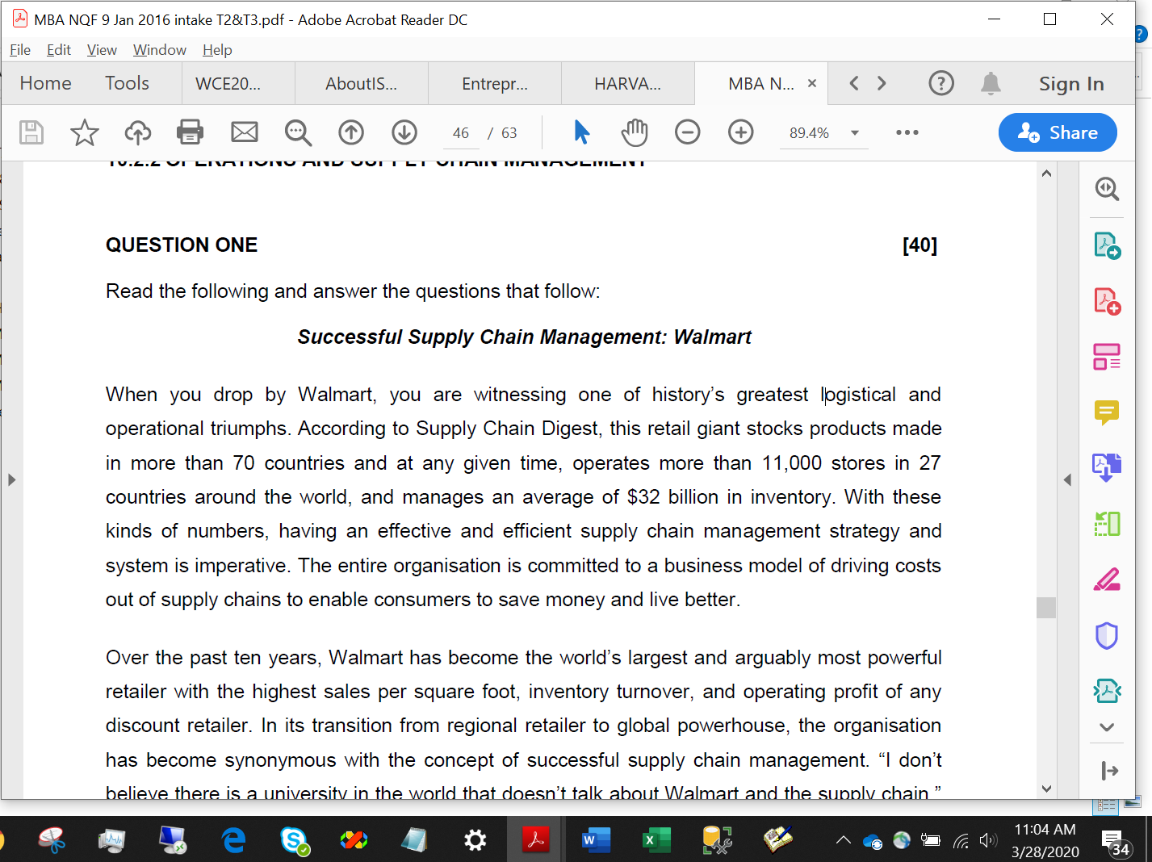

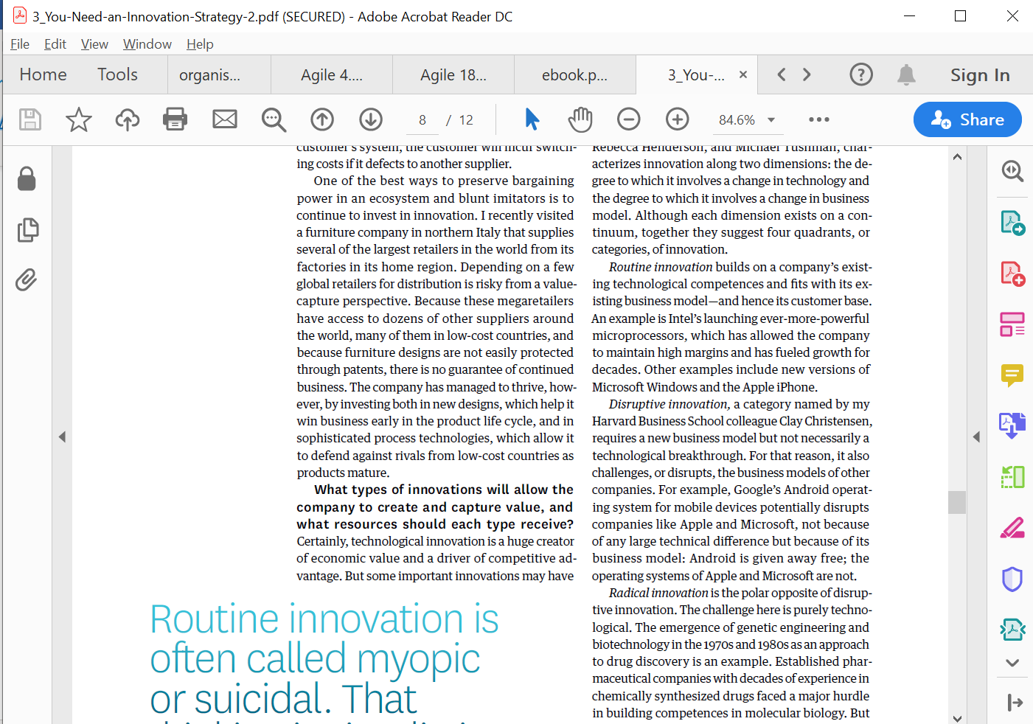

1.3 Evaluate the business model of the challenger banks mentioned in the article. (12)

1.3Business model of one challenger bank

**Business modeling.** The information flow among business functions is modeled in

a way that answers the following questions: What information drives the business

process? What information is generated? Who generates it? Where does the information

go? Who processes it? Business modeling is described in more detail in Chapter

10.

6.3 In question 1.3, begin by explaining what a business model is before presenting an evaluation of the business model of any one of the challenger banks.

3_You-Need-an-Innovation-Strategy-2(2).pdf

Business models for Open innovation.pdf

EBusiness and ECommerce Management Chaffey.pdf

Sep12_7000100100122798705.pdf

**11.1.2 STRATEGIC AND CHANGE MANAGEMENT [100]**

**QUESTION ONE [60]**

Read the following article and answer the questions that follow

**Can SA’s new challenger banks knock out the ‘big four’?**

The advent of Capitec, in 2001, showed that customers were desperate for something different. Now, three new banks — all backed by powerful SA business personalities — are opening their digital doors, offering something entirely different. So what can they offer that’s new, and how much of a threat is this for the ‘big four’ banks?

**28 MARCH 2019 STEPHEN CRANSTON**

None of the big banks will rock the boat; they want to protect their collective income. That era has come to an end. In the past few months, three new banks have launched with a leaner, cheaper business model that will change the face of SA banking — Discovery Bank, TymeBank and Bank Zero.

But these three new banks are backed by formidable business personalities with deep pockets.

Discovery Bank is part of the wider group run by CEO Adrian Gore, which began as a health-care company in 1993. Discovery boasts Remgro associate Rand Merchant Investments (RMI) as its anchor shareholder.

**Discovery, TymeBank and Bank Zero** are pursuing a branchless model, with their apps being their shop window. This means SA isn’t far behind the rest of the world: the first app-only current account in the UK was introduced by Starling Bank just two years ago. Perhaps if the Reserve Bank had been more open-minded, SA could have beaten them to the punch. Discovery Bank will charge both sets of fees — at least for now.

Gore says banks operate on three legs: fees, interest and rewards. Some banks (like Capitec and the other newcomers) will offer competitive fees and attractive interest rates on accounts but no rewards programme; while the large banks pay little or no interest on current accounts but have decent rewards programmes.

Gore says Discovery will not attempt to beat the market on fees, for a combined current account and credit card.

* Discovery Bank’s lower-income clients (those earning less than R300,000 a year) will pay between R149 and R186 a month in fees; middle-income customers will pay between R213 and R240; and higher-income clients will pay between R275 and R440. For a pure transactional account the fee will be R60 to R120, but as Discovery has no ATMs, cash withdrawal fees will be higher.

But if it won’t compete on fees, Discovery Bank will be second to none with its Vitality Money rewards programme, and the sophisticated way in which it encourages the right financial behaviour.

Discovery Bank will match Capitec’s 5% interest rate on positive current account, and add an extra 1.5% for those in the top tier of the Vitality programme. He says he thrived in the entrepreneurial FirstRand culture fostered by the three founders — GT Ferreira, Laurie Dippenaar and Paul Harris — who embraced start-up ventures such as Discovery and Outsurance. This inspired him to become a backer of small business.

Jordaan left FNB in 2013, because he says 10 years of commuting from Stellenbosch to Johannesburg was enough. There was no love lost between him and Discovery (another FirstRand subsidiary at the time), which he called the enfant terrible of the group and a disrupter, in the days when that was still a swear word.

Discovery Bank’s CEO, Barry Hore, promises that the app will be simple to use, once clients get used to it. "It is multifunctional, a bank branch in the palm of the hand," he says.

Interesting features of its model include Discovery Pay, which allows clients to pay any other client without needing to register the person as a beneficiary. Pharmacy co-payments can also be automatically deducted from the bank account.

To date FNB has been the leading bank for innovative features, such as registering as a customer using a selfie from your phone. But Hore says the Discovery platform will ensure that bank customers never need to visit a branch, even to open an account, and from day one cardless capabilities such as Samsung Pay, Garmin Pay and FitBit Pay will be available.

The Discovery Bank app went live this week, and the first stage is to migrate former clients of Discovery Card (which was backed by the FNB platform) into the bank. It will necessarily be a slow process to avoid anything going wrong. But by June, the first 10,000 clients are expected to be onboard.

Discovery’s advantage is that unlike the other two new banks, it is already a household brand. It also has a good chance of capturing the majority of its credit card clients (bought back from FNB) and a sizeable slice of its medical aid and insurance clients. Already, the group’s Vitality programme has cult status among some, and if you believe their marketing, physically fit people are less likely to be financially irresponsible. And the ability to cross-sell was an important reason for setting up the bank in the first place.For those who are on the main Vitality Health programme (Discovery medical aid members or life policyholders), and who hold a Discovery bank account, there will be plenty of benefits. For example, those on the higher Vitality status can get free membership at Virgin Active or Planet Fitness gyms, while the discounts for flights on Kulula can be up to 75%. There are also cash-back rewards for healthy food at Woolworths and Pick n Pay.

Hore insists you don’t have to be a gym bunny to get a good deal from the bank — people with no other Discovery product still get a 25% discount on fuel and healthy food. But these are the frills. Discovery has not yet revealed how it plans to recoup the considerable start-up costs. It has spent close to R4.5bn between developing the bank systems (which, like those of Standard Bank, are based on SAP products) and buying back the Discovery credit card from FNB. Gore says Discovery could not opt for a simpler cloud-based solution, as Tyme Bank has done, because its system needs to accommodate the complex links between the bank and its Vitality programme and the company’s health, life, investment and insurance businesses.

This suggests it will take longer for Gore’s bank to make a profit than either of its more nimble competitors, Bank Zero and TymeBank, and the marketing spend will be higher. Discovery estimates it could take five years to turn profitable. Gore says the bank has been built from the ground up with the latest technology and features — including the most advanced fingerprint and facial recognition systems — as well as the ability to add accounts with a few clicks. But he is pinning much hope on the behavioural approach and rewards system, which he believes is the differentiator. OOOOOOOO

Gore challenges the view, expressed by FirstRand CEO Alan Pullinger recently, that SA’s banks already use a behavioural approach to assess the quality of their clients when it comes to risk. "We don’t agree," says Gore. Most banks reward clients for taking out more products, which specifically increases their debt and credit levels, he says. This means there are now 8-million more credit-active consumers than employed people — a big risk to society.

"We don’t push products, but encourage [customers] to follow key behaviour to secure financial health. They get the tools to help them through the Vitality Money programme," he says. Still, it’s clear that Discovery Bank won’t be matching the costs of TymeBank and Bank Zero item-for-item, at least for the average client. Instead, its sales proposition is to help clients achieve financial health and then reward them. Hore says it will set personalised goals based on an individual’s circumstances, and will have a wider product range on day one than its rivals. Discovery will offer credit, transactional products and savings products.

The bank will also offer dynamic interest rates. This means that its best customers (not necessarily its richest), could pay 6% below the market rate for debt and earn 2% more for savings. Hore says Discovery’s "shared value" approach is not meant to punish those who don’t achieve perfection, but rather to nudge people to make better choices.

If the bank takes off as Gore expects, there is plenty of scope to export this model too. While Gore says the bank will start as a purely SA venture, he isn’t ruling out exporting a banking version of the Vitality Shared Value model at a later point.

Discovery Bank might be branchless, but it will have a handful of hi-tech walk-in centres. It will rely heavily on its network of agents and brokers to push clients towards the bank.

This network of brokers and agents is something that TymeBank and Bank Zero don’t have.

**WHAT IT MEANS**

Three new banks are set to change the face of SA banking with a leaner, cheaper business model

Back then, there were fewer smartphones (it was the age of BlackBerry) and the environment wasn’t inherently as friendly for digital products as it is today. 20Twenty, for example, operated largely through a call centre, and the customer experience was often indifferent.

Though price alone might not be enough to propel the new banks into profit, they are launching at a time of considerable unhappiness over bank fees. It is easier than ever, through apps, to compare fees. Until now, none of the large banks has been prepared to jeopardise their lucrative income stream from transactional fees with a price war. But now they will have no choice.

Tyme Bank is controlled by African Rainbow Capital (ARC), an investment company controlled by the eclectic Ubuntu-Botho group headed by Patrice Motsepe. As the Forbes rich list has it, Motsepe is one of the 1,000 wealthiest individuals in the world, with a fortune of $2.4bn. Before it was bought by Motsepe’s company, TymeBank was owned by the Commonwealth Bank of Australia (CBA), one of the world’s top 10 retail banks.

**Discovery, TymeBank and Bank Zero** are pursuing a branchless model, with their apps being their shop window. This means SA isn’t far behind the rest of the world: the first app-only current account in the UK was introduced by Starling Bank just two years ago. Perhaps if the Reserve Bank had been more open-minded, SA could have beaten them to the punch.

TymeBank chair Coen Jonker tells the *FM*: "The banks have done their best to protect their legacy income streams for years, and the transactional fees on simply taking money in and out of accounts is the hardest to justify. As new banks we won’t have that legacy to defend."

The big four banks have long operated as if they were an informal cartel. Even the one entrant in the past 20 years to grow to large-bank status, Capitec, has adopted a traditional branch-based distribution model. The three new banks are not just aiming for the tech-savvy. TymeBank’s former parent, CBA, has a larger market cap than the entire SA banking sector, though it took a softly-softly approach to the new bank. Even before Tyme was registered, it offered money transfer services from Pick n Pay.

Though Tyme doesn’t have any of its own branches, it will have 750 points of sale through Pick n Pay and Boxer stores. This gives it reach into the main urban areas, as well as the rural areas where few banking services are typically available. Boxer customers are more likely to be unbanked, so could prove the most fertile hunting ground for Tyme.

Most transactions are free if carried out at Pick n Pay or Boxer, and cost only R2 if done elsewhere, and the bank pays up to 10% interest on positive balances. TymeBank has such low costs because it is cloud-based and highly scalable, and has minimised the bells and whistles. Incredibly, there are just 125 staff keeping the bank running. Clients can join through the TymeBank website, but by far the most popular recruitment tool has been self-service kiosks, which provide a new card within five minutes.

CEO Sandile Shabalala says the bank will start offering loans next year. It plans to offer keener lending rates because, like Capitec, it will be able to cross-subsidise its transaction and deposit books from its loan income. The tipping point for Tyme, at which it becomes profitable, is 2-million customers and 700,000 loans.

It is almost an accident that Motsepe’s ARC took full control of the bank after CBA pulled out suddenly to retreat to its home market and cut exposure to emerging markets.

Johan van Zyl, the co-CEO of ARC (and chair of Sanlam) says he was pleased CBA was the controlling shareholder while the bank was being registered because it is a bureaucratic, by-the-book organisation with huge experience of banking regulation.

"We would like to bring in an equity partner as we prefer to hold minority positions in companies, not the 73% we currently hold, but it is not an imperative," he says.

Van Zyl says the Reserve Bank does not want TymeBank to become a Sanlam group company as it wants to keep banks and insurers as separate as possible. TymeBank, he says, will ride the wave away from cash transactions to digital payments.

"We expect the amount of cash in the system to be cut back by two-thirds over the next three years. Increasingly shareholders in the Ubuntu-Botho group find carrying cash dangerous. We were able to issue 1-million cards to members of the Zion Christian Church to facilitate cashless transactions," he says.

For now though, Pick n Pay stores are more than happy to offer excess cash to TymeBank customers at no charge. The retailer’s deputy CEO, Richard van Rensburg, says Capitec also recommends its customers draw money at Pick n Pay tills because it is far cheaper than using an ATM. And a central feature of TymeBank is its access to the information gathered by Pick n Pay on the 11-million members of its Smart Shopper programme, which provides rewards points on all purchases, not just at Pick n Pay. And unlike Discovery, that benefit is not confined to healthy foods. In a much less judgmental way, all purchases qualify.

You might have expected Pick n Pay to have cold feet after the failure of its Go Banking venture with Nedbank in the mid-2000s. But Van Rensburg argues that Go Banking offered similar services to Nedbank, whereas TymeBank has developed products exclusively for digital clients. He says he would not try to set up a bank as a subsidiary of a retailer again, but an alliance between a retailer and a bank makes sense.

Pick n Pay CEO Richard Brasher is also the founder of Tesco Bank, which is owned by the UK’s largest supermarket chain. Narsai, as head of FNB retail, is even more deeply entrenched in IT than Jordaan. "I am impressed that TymeBank has signed up 120,000 customers in a few months," he says. "[It shows] there is pent-up demand for a good-value, no-frills bank account. But we will be offering considerably more sophisticated functionality."

While Bank Zero is entirely app based, Tyme at least enjoys some advertising through its black and yellow machines at Pick n Pay stores, and has started flighting prime-time TV adverts to lure clients. Chetty says Bank Zero needs to develop a brand and requires a professional marketing campaign to do it. None of the team has marketing experience except for Jordaan, and that won’t be enough to build a brand — even with his Steve Jobs-style charisma.

While there’s electricity in the air in the banking sector for the first time in years, it won’t be a one-way bet. There is, after all, the cautionary tale of SA’s first digital bank, 20Twenty, which launched in 2001 using Saambou as the backbone. 20Twenty never got to critical mass, with just 40,000 clients, and closed in 2006.

But the fact that TymeBank already has 120,000 clients is evidence that perhaps the time is now right. Narsai says that while 20Twenty had a huge marketing budget and a limited range of products, the architecture was quite primitive by today’s standards and the benefit from lower fees was limited.

**WHAT IT MEANS**

Three new banks are set to change the face of SA banking with a leaner, cheaper business model

Back then, there were fewer smartphones (it was the age of BlackBerry) and the environment wasn’t inherently as friendly for digital products as it is today. 20Twenty, for example, operated largely through a call centre, and the customer experience was often indifferent.

Though price alone might not be enough to propel the new banks into profit, they are launching at a time of considerable unhappiness over bank fees. It is easier than ever, through apps, to compare fees. Until now, none of the large banks has been prepared to jeopardise their lucrative income stream from transactional fees with a price war. But now they will have no choice.

kkkkkkkkkkkkkkkkkkkkkkkkkkkkkkkkkkkkkkkkkkkkkkkkkkkkkkkkk

**9. Process Is Described by a Sound Business Model**

In simple terms, a robust process should make common business sense. The benefits of using the

process should exceed the cost and efforts expended to design, execute, and maintain the process. The

business side of a robust process sometimes involves leasing agreements, maintenance agreements,

and service level agreements.

**Business Models** – Various structures, processes, and other mechanisms that businesses and other

organizations use for organizing the way they interact with their primary external stakeholders (e.g.,

customers and suppliers) to achieve their primary goal (e.g., maximization of profit).

If your business model requires access to deep domain knowledge,

then it ’ s probably worthwhile to continue to invest in a traditional

KM approach. If your employees tend to be social media – savvy, then

perhaps social networking is the engine that underpins KM for the

foreseeable future. But social networking will probably not address

your organization ’ s full scope of KM needs.

Zara is a Spanish manufacturer with a business model that provides them a

significant strategic advantage in the highly competitive retail and apparel industry.

We ’ ve found three situations in which a transfer approach is

appropriate: when the business model entails leveraging a f xed set

of resources through cost minimization; when the business model

requires a standardized approach in multiple markets; and when

cost reduction, quality enhancement, or consistency of customer (or

employee) experience is an important driver.

When the business model meets one or more of the aforementioned

situations, the decision to invest in systematic transfer programs

hinges on the potential return on investment, including that:

• Multiple locations perform similar or identical practices

• A signif cant number of these practices are relatively stable

and do not need frequent transformation to respond to external

market changes

• There is reason to believe that either existing practices or

optimized practices are superior to others and can be adopted

or replicated in many locations

• A measurable and signif cant f nancial or strategic return on

investment is feasible if processes are standardized or optimized

across multiple locations

• Signif cant resources are available to support the knowledge

transfer

• A culture of business unit autonomy is not an overwhelming

barrier

|  |
| --- |
| Investigating design aspects from different angles (including a user perspective), how to design for ownership, how to use unique aspects such as crowdsourcing in your business model, user adoption / acceptance studies of new environments (e.g business using innovative technologies such as social media); |



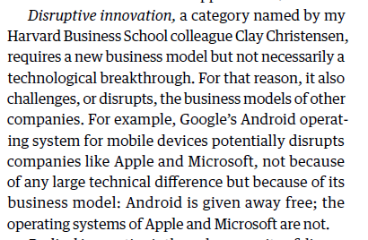

3. Business model

What is the money flow? Are you developing an internal system, a commercial product, a

bespoke system on contract for a customer, a component of a large system involving many

different parties? Is it free, libre, and open-source software (FLOSS)?

This business model provided unique advantages over traditional banking. The client did

not have fill out papers to open new account or to stand in line or.

To avoid the third scenario, and maximize the chances of the first, we see CIOs having to pay

particular attention to a number of *tasks.* First, the CIO needs to persuade all concerned that the

web-based era is more about fundamental business change than about technology. Technology is

now the easy bit, relatively speaking (especially if the CIO has built a competent IT management

team). The challenge is to think through new business models which address concerns about cost

structures, pricing, and channel conflict; to introduce new management processes that leverage

the intranet. Vision and holistic thinking rather than technology rollout are the key requirements.

The entire organisation is committed to a business model of driving costs out of supply chains to enable consumers to save money and live better.

In 2008 the company announced a two-year, US$120mn investment programme for the Sub-

Saharan region. The money will go to finance a programme to train graduates, as well as a

new Innovation Centre. The centre will showcase new technologies and business models and

will also incorporate a Banking Centre of Excellence. IBM already works with nearly 300

software companies in Sub-Saharan Africa, many of them South African.

Defining a unique but workable business model or architecture, within the context of the various identified competitive market forces;

Other drivers of turbulence in business today include digitisation, connectivity, trade liberalisation, global competition, and business model innovation (Reeves & Love, 2012).

Finally, a whole set of questions is just starting to emerge that will help us better understand IT

management in the web-based era. The questions will address issues such as management

responsibilities for IT, business models for firms in the web-based era, the role definition of the

CTOs and CKOs versus CIOs, and the development of core IT skills in organizations. Because

firms are just entering into the web-based era, these questions are not, we suggest, well-suited for

large-scale studies. Instead, a few leading-edge organizations can provide insights through case

studies into how firms might address the opportunities and challenges that IT continues to

present.

By using electronic licensing at the source code level, manufacturers are not only able

to help companies enforce their licence agreements, they are able to help build new

business models and pricing policies by adopting not just a single electronic licensing

policy but, rather, a whole raft of flexible policies that can be easily adapted to the different

requirements of varying customers, without the considerable expense of software rebuilds.

The economic context in which electronic contracting takes place has come to be dominated

by large-scale public networks of computers – networks that have become easy to use

and practically ubiquitous in many commercial environments, for example, the World Wide

Web. These developments fundamentally affect the way business is done, even where it is

already being done electronically. The greater power and reach of the new networks also

offer opportunities for achieving greater efficiency in performing transactions. To consider

how transactions work electronically, a look at basic business models is informative.

Re-design business models

The Boston Consulting Group (BCG) concurs. A recent BCG study concluded that organisations today must shift their business models—and their leadership skills—to become “adaptive firms.” Adaptive firms can adjust and learn better, faster, and more economically than their peers, giving them an “adaptive advantage.” Adaptive firms, the study notes, include Apple, Google, 3M, Target, and Amazon.

Once a company has developed a blue ocean strategy with a profitable business model, it must execute it. The challenge of execution exists, of course, for any strategy. Companies, like individuals, often have a tough time translating thought into action, whether in red or blue oceans.

Organisations of today are often virtual, more horizontal in nature and very different from traditional organisations of the last century. Technology of all kinds, aided by information systems, automated processes, and procedures control today’s work-flow, and have enabled companies to communicate more effectively, and efficiently than ever before. More can be accomplished with less people, virtually wiping out business models of the past. This requires people to be more technologically savvy, continually updating their skill-sets, which includes the soft-skills necessary for managers to be great leaders. Today’s new horizontal organisational structures make Jaques’ time-span theory of hierarchy more important than ever before.

Mary Kay, Inc., sells facial skin care products and cosmetics around the globe. The business

model is to provide one-on-one, highly personalized service.

These business

models are based on new ideas of coordination and integration made possible by the

Internet and information-based supply chains. In some cases, new services have

been designed by the partnership between supplier and customer, such as new

financial services offered when banks link up electronically with businesses to accept

online payments for goods and services purchased by the businesses’ customers

Thus, information technology was not only the key enabler of this business model but also was a

facilitator in creating a buzz and encouraging community development around the concept.

Nbnbbnb

It is clear that technology is moving fast and entire industries and business models are dissolving, making room for organisations that are giving customers exactly what they want, and when they want it for less money than ever before.

Effective strategic planning is underpinned by continuous strategic conversation in the organisation. The level of learning and knowledge transfer enable the organisation to design a business model and an architecture that would distinguish themselves and that would lead to higher levels of performance in the organisation. Moreover, these businesses could in fact constructively change the industry in which they operate!

With the emergence of social networks such as Facebook and Renren, social microblogs

such as Sina Weibo and Twitter, social media and the Web, businesses have had to

redesign their existing business models to account for the change in power now yielded

by customers and others in their communities.

Appropriately incorporating IS into the design of a business

model enables people to focus their time and resources on issues that bear directly on

customer satisfaction and other revenue- and profit-generating activities.

Likewise, Google played an important role in revolutionizing the way information is

located, changing the playing field for advertising and publishing business models.

Google began in 1999 as a basic search company but quickly learned that a unique

business model was a critical factor for future success. The company changed the way

people thought about Web content by making it available in a searchable format with an

incredibly fast response time and in a host of languages. Further, Google’s keywordtargeted

advertising program revolutionized the way companies advertise. By 2001,

Google announced its first quarter of profitability, solidifying the way the world finds

information, publishes, and advertises.3 More recently, Google expanded into a complete

suite of Web-based applications, such as calendaring, e-mail, collaboration,

shopping, and maps and then enhanced the applications by combining them with social



According to (Struck, et al., 2010), the complexity of business transactions and rate of changes in the business models have increased as a result of globalisation and international competition. In the context of the South African motor vehicle and asset finance industry, which is a segment of the South African banking industry, this sector is highly regulated with legislations such as FICA, AML, and POPI adding further complexity to the banks’ business processes and IT landscape. As a result, organizations in this industry, similar to organisations in other industries are increasingly looking to EA to manage their complex environments (Banaeianjahromi & Smolander, 2016).

**Business modelling**

This phase marks the beginning of defining the organisation’s ‘AS-IS’ state. In this phase, the description of “where we are and what we have today” is documented. Further, a high level understanding of the business and organisational structure is also derived in this phase.

Business Model Fit – at this point we know that customers receive the expected value but this must be maintained in order to continue delivering value

3. Business Model Fit

At this point you know that you are offering value that the customer segment wants, but you need to design a sustainable and scalable model to continue to deliver value. Value propositions are really focused on creating what the customer wants/needs, but to be sustainable they need to sit within a larger model that enables the organization (i.e. Library) to plan for and provide the necessary resources. Drawing up a business model is beyond the scope of this Toolkit, but it is a helpful exercise to clarify the costs associated with delivering customer value. For more information refer to the Business Model Canvas in *Business Model Generation*.

\\\\\\\\\\\\\\\\\\\\\\\\\\

**Electronic business models**

In most economic cultures the basic model for doing business is the market. In a market

model, those who *have* meet those who *need* – they bargain and agree, and they exchange.

The market is assumed to operate among an open, broad community, and in that respect it

differs from a chain. This constitutes an open business model.

In a chain, the number of buyers and sellers is restricted due to obligations of exclusivity.

If a chain has been imposed, a stranger can no longer simply go to the marketplace

and sell what he has or buy what he needs. Instead, a seller is committed to sell only to a

specified buyer or small group of buyers. Similarly, a buyer is also restricted to a defined set

of sellers. This constitutes a closed business model. The exclusivity is a matter of degree

and depends, among other things, on:

_ *Relative bargaining power of the parties.* The relative number and availability of alternatives

are amongst the factors determining bargaining power. Bargaining power has

often proven to be greater in the buying role, assuming that many potential suppliers

exist or can be induced to exist.

_ *Cost of building one-off relationships.* The stranger-to-stranger transactions of the

market model can be expensive, depending on how the transactions are carried out.

In the recent past, the cost of building relationships has increasingly led those parties with

superior bargaining power to promote the building of chains. Factors that contribute to that

cost are:

_ *Need for specialised goods.* In the automotive, aerospace and similar industries, the

captive supply chain manufactures goods that are not standard, fungible commodities

but rather are made to the buyer’s specifications. Over time the supplier may recover the

costs of tooling-up to produce goods that satisfy unique specifications, and may thus

become economically dependent on a powerful buyer. In addition to specialised goods,

distribution services are often established to support the chains and are dependent on the

chains for their subsequent survival.

_ *Technical set-up and integration.* Traditional electronic data interchange (EDI) is based

on the chain model because of the difficulty and complexity of setting up interconnected

databases and reliable means of transferring information between them. The legal

approach to EDI reinforced this dependence on chains – the legal basis for EDI was

established bilaterally between ‘trading partners’ through an agreement that was

intended to suffice for all transactions that the parties would carry out. EDI has thus

greatly promoted the development of trade chains in recent years at the expense of free

choice in the marketplace.

A more recent model is the web portal, whereby an intermediary establishes favourable

pricing for purchases made through their portal. Generally they establish a closed userconsumer/

retail group, and membership involves agreeing to certain rules. This model is

between a closed and open system, being less formally structured than EDI, and is businessto-

consumer focused rather than business-to-business focused as in EDI. The technical

connectivity is much simpler and the relationship is established contractually. Other forms

of ‘portal’ are appearing that are aimed at providing an open marketplace or exchange of goods and services. This marketplace or exchange is itself a service, and the growth of

intermediaries is an indication of the major change from more traditional business models.

Although chains have become common in recent years, the market (or ‘open’) model

retains a great advantage over the chain (or ‘closed’) model and a modest advantage over

the semi-closed portal model: it is more economically efficient. The exclusivity of a chain

causes the buyer to forego getting it cheaper elsewhere and the seller to forego finding a

better price elsewhere. A chain also burdens innovation by locking in a defined set of

suppliers and locking out entrepreneurs with innovative products but without access to the

locked-in sales channel. Further, a market is also highly responsive to changing circumstances,

whereas the complexity and production integration of a chain can make it slow to

realise that, for example, cars must now be more fuel-efficient. Fundamentally, the

economic attractiveness of the market model persists.

Early electronic commerce fostered the proliferation of chains into areas where either

they had not existed or they had never been firmed up into legal commitments. EDI was so

difficult and complex to set up that it required the co-operation of both buyer and seller.

Securing that co-operation often involved a strong party compelling a weaker one to join in

the interchange. However, the cost savings possible through EDI made the economic inefficiency

of the chain model compared to the market model tolerable. However, as electronic

commerce matures, it becomes simpler, easier and more standardised, as well as more

powerful. It has also become nearly ubiquitous, more than widely enough distributed to

support a market model of commerce. These subsequent developments create opportunities

for increased economic efficiency by re-evaluating where a chain is necessary and where a

return to a market model can yield advantage.

It is important to remember, however, that whatever model is in use, the protocols or

systems in use must be fit for purpose and the controls in place must be appropriate to the

value of the transaction.

**Developments affecting economic models**

The developments

\\\\\\\\\\\\\\\\\\\\\\\\\\\\

**5.3 The banking industry**

Market consolidation is one of the major challenges facing organizations in the banking industry (Mueller, et al., 2007). As a result many organizations that traditionally served distinct markets or market segments in the financial services sector are now integrating their offerings. Consequently, the concept of bancassurance as emerged which is “a type of company that offers comprehensive financial services and realises the concept of the one-stop shopping solution in the financial services market” (Amato-McCoy, 2005). These ‘bancassurance’ organization have significant advantage because they are able to push (promote and offer) their products to the market using effectively the same distribution channels (Mueller, et al., 2007). EA can play a vital role in facilitating this bancassurance business model and strategy.

Moreover, Van Greuning and Bratanovic (2009) noted that since the 1980s the face of banking has been significantly changed by the internationalization of financial flows as well as the rapid innovations in financial markets (Van Greuning & Brajovic-Bratanovic, 2009). Van Greuning and Bratanovic (2009) further observed that a combination of increased competition among banks and non-banks and deregulation as well as the technological progress has provided new opportunities to organizations in this industry. In addition, Van Greuning and Bratanovic (2009) noted that from the late 1980s, traditional banking began to offer decreased margins while there was an increase in capital adequacy requirements. In response to these challenges, the banks became highly imaginative and entered new business areas with increased focus on superior information and knowledge management capabilities.

According to Li (2012), banking is not just a business of money; instead it is a business of information. Li (2012) further noted the importance of managing knowledge in the banking industry just as it is the case in other industries. Capgemni (2008) summarised timelines of how banking systems have evolved since the 1970s as follows:

- **1970 – 1980**: Core banking systems provided basic functionality for core banking transactions

- **1980 – 1990**: Legacy core banking systems were primarily product centric and developed in silos. Bank of Scotland offered customers first internet banking services

- **1990 – 2000**: New core banking systems developed which were flexible and customer centric. Multi-channel processing/integration and adoption of SOA

**2000 – 2010**: Online banking goes mainstream and banks start to focus on customer centricity. Big data, analytics and cloud based platforms evolved, which led to look towards agile core banking solutions.

- **2010 – 2012**: Banks invest in core architecture due to tighter regulations. There was rapid growth in mobile banking. Banks focused on risk management.

- **2012 – Current**: Convergence of online banking, social networking, payments and mobile has increased banks’ focus to overhaul legacy systems for supporting fast-growing digital services and better integration of channels. New IT architecture adopted for core banking solutions which will be scalable, adaptable, agile and economical.

Combining KM and EA for the success of EA is under-researched in the context of this sector. This study will therefore contribute to the body of knowledge for both the EA and KM disciplines.

**5.4 The South African banking industry**

ATKearney (2012) noted five major trends that are reshaping the way banks operate: the technology tools, new competitors, branch networks, and today’s more empowered bank customers. In addition, according to Matoti (2012), the South African banking industry has attracted significant interest from abroad citing an increase in the number of foreign banks that have established a presence in South Africa while other foreign banks have acquired stakes in major banks, such as the merger of ABSA Bank and Barclays and the deal between Industrial and Commercial Bank of China’s and Standard Bank.

According to Matoti (2012), changes in the banks’ regulatory environment, product offerings, and growth in the number of participants have resulted in increased competition with smaller banks such as African Bank and Capitec Bank entering this industry targeting the low-income and the previously unbanked market (Matoti, 2012). Matoti (2012) further notes that the South African banking sector is regarded to be world class and it has sufficient capital resources, technology and infrastructure and a strong regulatory and supervisory environment. In addition, South Africa’s corporate sector is regarded as internationally competitive moreover it relies on sophisticated and advanced ICT and infrastructure (Marais, 2009).

According to PriceWaterhouseCoopers (2013), the South African banking sector continues to grow in an uncertain world. The PricewaterhouseCoopers’s (2013) survey findings reveal that South Africa’s banking sector is dynamic and evolving fast. Moreover, the findings revealed that changes in regulations and global economic pressures are some of the major forces challenging the banks to continually assess their capacity to enhance their competitiveness through successful use of their knowledge resources.

Additionally, South Africa’s open economy as well as its growing local economy have made it necessary for the corporate sector to be innovative and dynamic in adopting information and communication technologies. Many of the larger companies have been aggressive in their pursuit of formal and large-scale EA initiatives. Significantly, (Van Zijl & Van-Belle, 2014) found a strong empirical basis for many claimed EA benefits.

Strengths would define any internal

asset (expertise, motivation, technology,

finance, business model, etc.)

that will help to meet demands and to

Traditionally, new ideas have been classified as product innovation, process innovation or business model innovation. Two additional types of innovation are branding innovation and management innovation. Innovations can also be classified as radical or incremental.

Business model innovation – is the creation of new business models or the successful change in an element of a business model that substantially enhances a company’s ongoing performance in delivering benefits to customers and shareholders.

For South Africa, the incubator support programme aims to assists SMME entrepreneurs in the start-up phase with support and services that will enable their growth and development, offering incentives for investment and support initiatives, but business models and methods are changing rapidly, fuelled by e-commerce and disruptive technology innovations.

The business value derived from IT investments only emerges through business changes and innovations, whether they are product/service innovation, new business models, or process change.

Responding to community and staff expectations in a dynamic environment with constantly changing business models and rapid advancements in technology

The entire organisation is committed to a business model of driving costs out of supply chains to enable consumers to save money and live better.

A willingness to continually revisit the business model

The business value derived from IT investments only emerges through business

changes and innovations, whether they are product/service innovation, new business models, or process change. In

this paper a newly concept of IT Governance and its mechanisms are explained in further details

They are related to threats

and dangers that the intensive use of IS and IT

may cause undesired or unexpected damages,

misuses and losses in whole business model and

its environment. Since the efficiency,

effectiveness and in a great deal the

successfulness of all business activities depend

on the functioning of the IT and IS, a sound risk

management process should not only include

technical or operational issues but also executive

management’ frameworks such as IT

Governance and IS Audit.

2. Health Coverage Costs Business Model: Develop an application to track employee

healthcare expenses and company healthcare costs. Healthcare premiums continue to

increase, and the company has changed insurance carriers several times in the past

10 years. This application should allow business modeling of various scenarios as well as

tracking and analyzing current and past employee healthcare expenses and company

healthcare costs. This application must be secure and run on the current intranet so several

managers and analysts can access it and download selected data for further analysis.

The new application must also import data from the current systems that track employee

expenses submitted to the company and the company’s costs to the insurance provider.

You believe that having this data will help you revise policies concerning employee

contributions to healthcare premiums and help you negotiate for lower premiums with

insurance companies. You estimate that this application would save your company about

$20/employee/year for full-time employees over the next four years and cost about

$100,000 to develop.

Industry has also started to adopt OSIRIX

as a base for new business models where they provide the support

and integration services as well as training and customization

of the generic platforms.

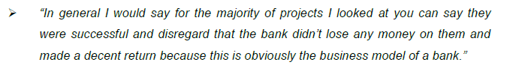

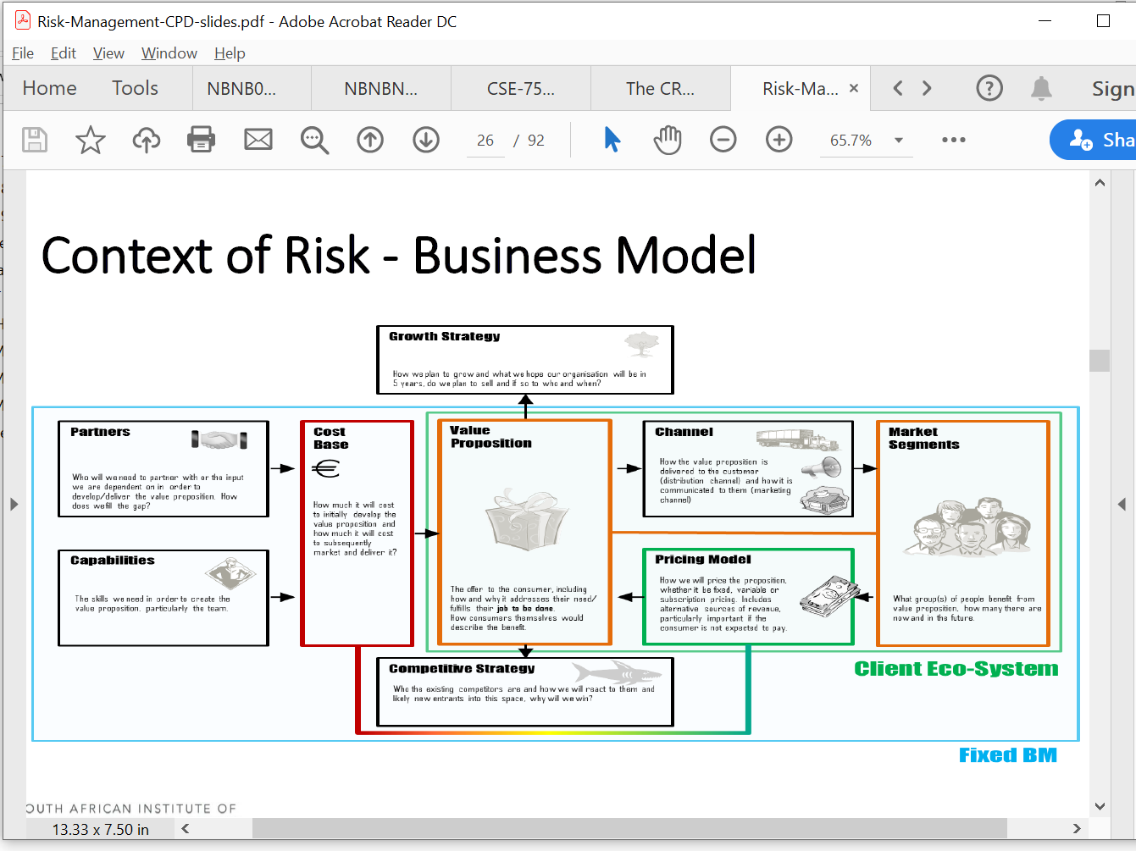

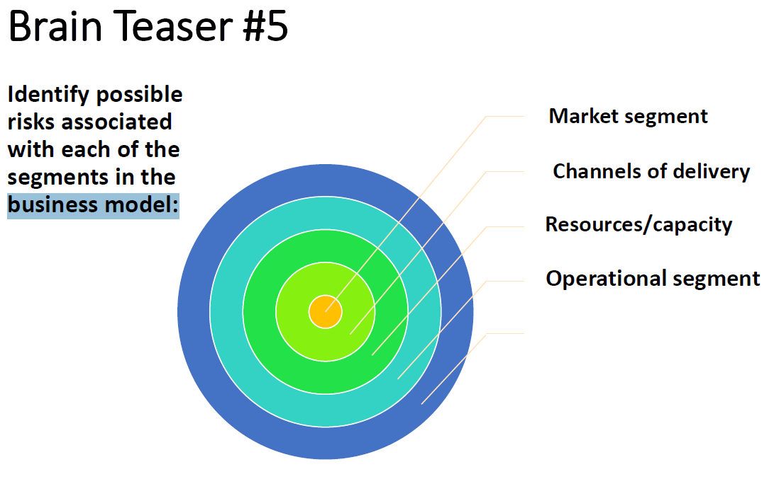

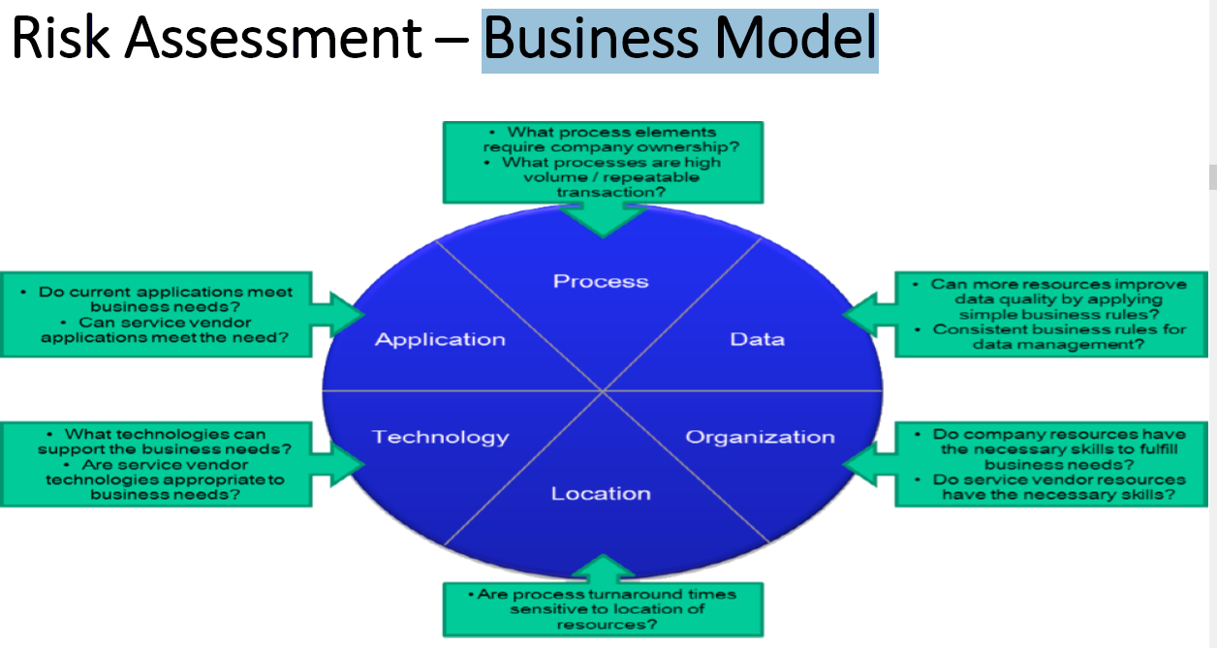

What Is a Business Model?

•A business model addresses ***“How do we make money in this business?”***

–Is the strategy capable of delivering good bottom-line results?

•Do the ***revenue-cost-profit economics*** of the strategy make good business sense?

–Look at ***revenue streams*** the strategy is expected to produce

–Look at associated ***cost structure*** and potential ***profit margins***

–Do resulting earnings streams and ROI indicate the strategy makes sense and the company has a viable business model for making money?

Relationship Between Strategy and Business Model

7.1 Business models indicating value propositions and revenue flow. (10)

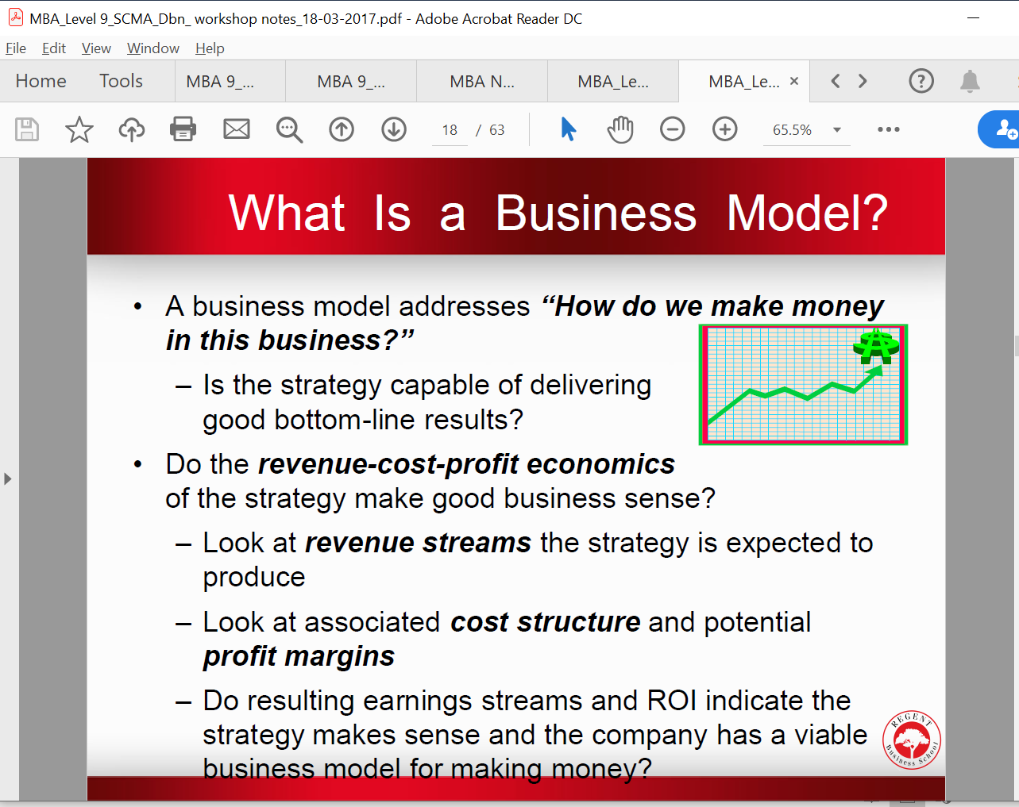

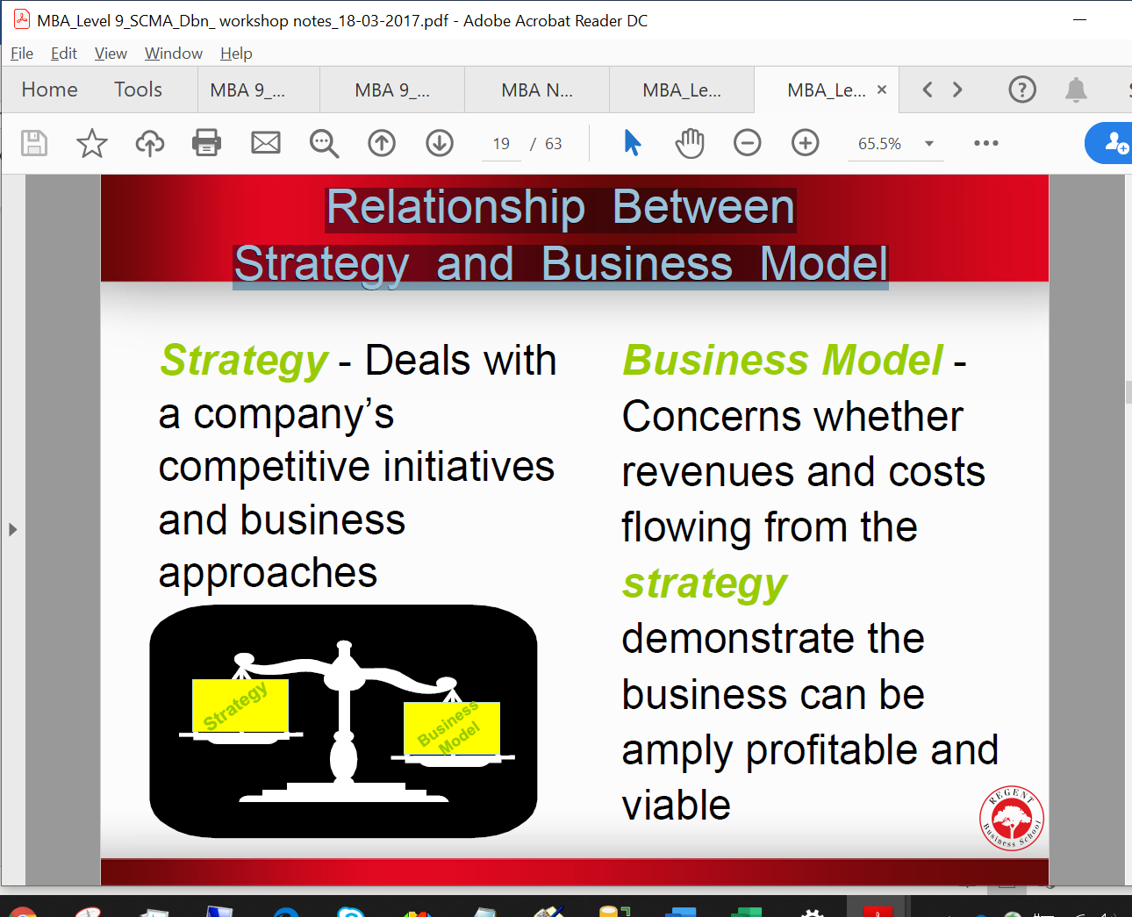

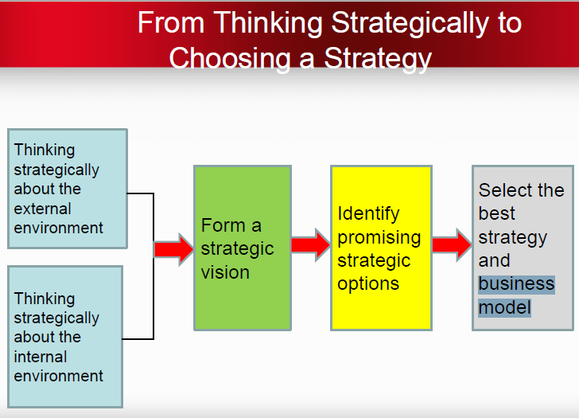

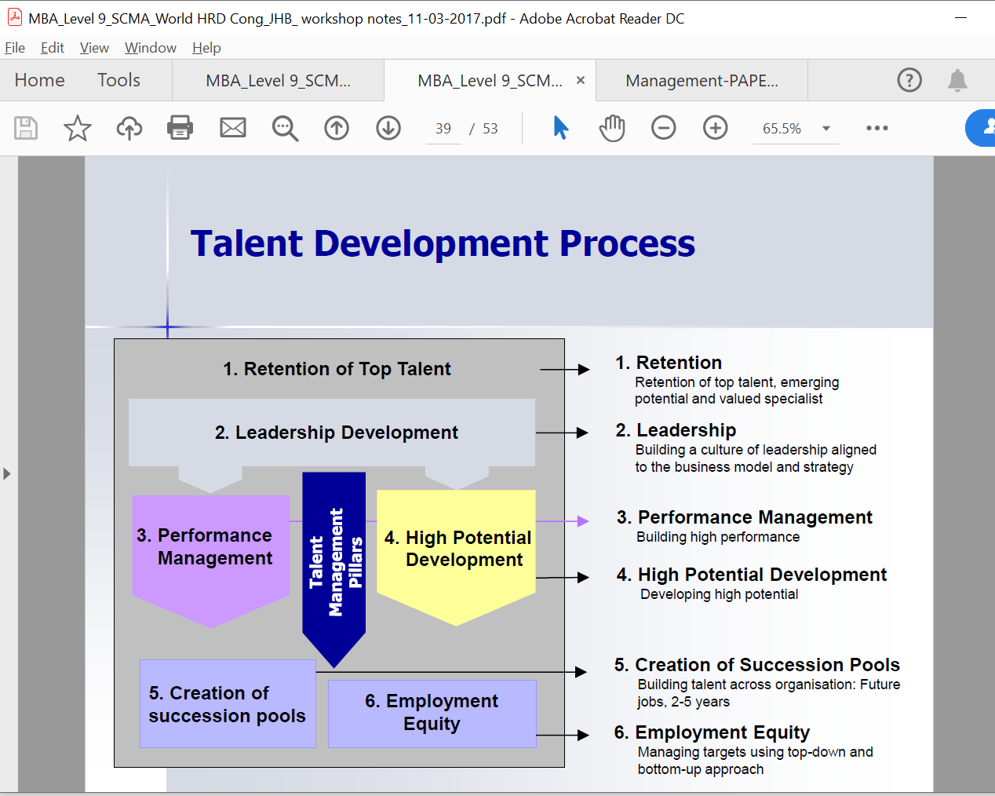

The understanding of entrepreneurship owes much to the work

of economist Joseph Schumpeter. In Schumpeter (1950), an

entrepreneur is a person who is willing and able to convert a new

idea or invention into a successful innovation. Entrepreneurship

forces "creative destruction" across markets and industries,

simultaneously creating new products and business models. In this

way, creative destruction is largely responsible for the dynamism of

industries and long-run economic growth. Despite Schumpeter's

early 20th-century contributions, the traditional microeconomic

theory of economics has had little room for entrepreneurs in its

theoretical frameworks (instead assuming that resources would find

each other through a price system.)

**(6) 20th Century:** In this century, entrepreneurship was

recongnised essentially a creative activity consisting in doing

innovative things—new products new technology or method of

production, new raw materials, and new business models using

computers, etc. Hence, it was associated with risks financial,

psychological, and social such risks are taken to get rewards.

According to **Joseph Schumpeter** (1952), “The function of the

entrepreneur is to reform or revolutionise the pattern of production

by exploiting an innovation or, more generally, an untried

technological method of producing a new commodity or producing

an old one is a new way, opening a new source of supply of raw

materials or a new outlet for products, by organising a new

industry.” Thus, the concept of innovation and newness is an

integral part of entrepreneurship.

**(7) 21th Century:** In this century the concept of entrepreneurship is

related to innovative endeavors. It is concerned with introducing

something new in the environment of tough competition. It is the

most difficult task of the entrepreneur in today’s complex

environment. It may be noted that the range of innovation starts

from creating a new product and may cover upto the development

of a new distribution system or upto the development of a new

organisation structure or upto developing a new business model

like computerised office equipments.

**Leadership**

Building a culture of leadership aligned

to the business model and strategy

We spend far too much time analyzing business models, markets and financial statements and we often overlook the most important investment quality, which is who is running the company and are they the right choice?

Show the product by the second slide of the presentation. You will be amazed how many people pitch business models without ever showing the product! By showing the product early in your presentation, your potential investors will have no problem paying attention or understanding your business model.

3: The quality of the business model is much more important than the quality of the management team.

True or False

**Differ your business model** – A lot of people change their

business model from the standard shopping cart type website to a

subscription model, bundle model, or some other model. Just be

sure whatever type of model you choose is suitable for YOUR

market before you invest too much time and money into it.

One of the ways we try to insure quality and that we grow as business and as entrepreneurs is to approach established construction companies. We don't ask them for BEE deals or handouts but we ask them to visit our sites and premises and to critique our construction processes and business model and suggest ways we can improve. The response has been phenomenal. Here's what some of them have had to say about us:

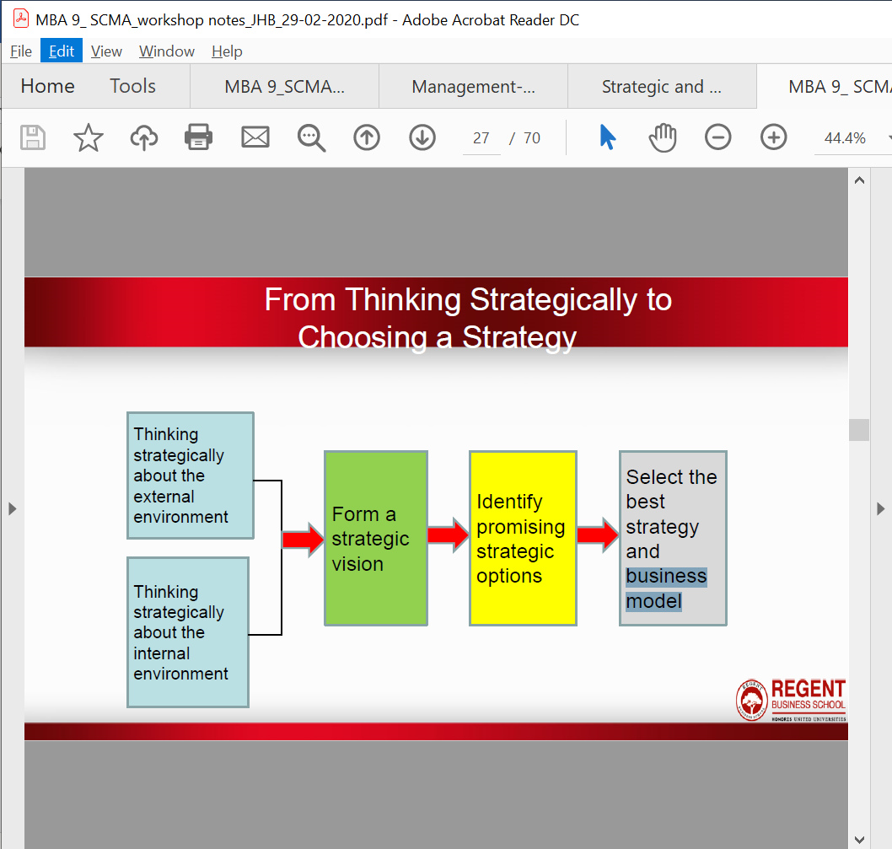

Their business model

shifts from simply process- ing payments to collecting data. The question then is what they do with it.

Business models are being upended as the value shifts to those who control the data. The European

carmaker that struck the intellectual property deal with its supplier had a strong in-house data-analysis

team but needed to work with an outside technology vendor to uncover insights from the data. The

tech firm was paid for its work, but the carmaker kept the bulk of the profits. Sniffing opportunity,

however, the tech company has tweaked its business model to share some of the risk and reward with

clients. It has experimented with working for a lower fee in return for sharing some of the wealth that

its analysis unleashes. (As for auto-parts suppliers, it is probably safe to say that in the future they all

will want to add measurement sensors to their products, or insist on access to performance data as a

standard part of the sales contract, in order to continually improve their components.)

Companies are also experimenting with different organizational forms in the business of big data.

Inrix didn’t stumble upon its business model as many startups do—its role as an intermediary was

established by design. Microsoft, which owned the essential patents to the technology, figured that a

small, independent firm—rather than a big company—might be perceived as more neutral, and could

bring together industry rivals and get the most from its intellectual property. Similarly, the MedStar

Washington Hospital Center that used Microsoft’s Amalga software to analyze patient readmissions

knew exactly what it was doing with its data: the Amalga system was originally the hospital’s own inhouse

emergency-room software, called Azyxxi, which it sold in 2006 to Microsoft so that it could be

better developed.

It enables, and may force, companies to change

their business models. It alters how organizations think about data and how they use it.

Information has always been essential for market transactions. Data enables price discovery, for instance, which is a signal for how much to produce.

Changes in business models

In order to assure the success of the new strategy, a company has to follow the principles and concept of blue ocean strategy one by one. This could very well result in a strong business model with exceedingly positive results.

According to Kim and Mauborgne (2005) companies have to focus on:

1. Utility for the buyer

2. Price

3. Costs

4. Share the new vision

5. Make sure that the vision is understood by all employees

This focus has to be sequential in order to provide the best results. Indeed, thanks to the right strategic sequence, the company will be allowed to implement its strategy and also decrease potential business model risks. I

IT risks are risks associated with intensive use of IT to support and improve business processes and business as a whole. They are related to threats and dangers that the intensive use of IT may cause undesired or unexpected damages, misuses and losses in whole business model and its environment

New business era inaugurate the information infrastructure as a business backbone and a platform for

conducting transactions and economic activities, what makes information technology (IT) a key prerequisite and the

very basis for any competitive business model.

(3) separating the notation for the business modeling (object-oriented analysis) that is independent

of technology from the one for solution modeling (object-oriented design) that is

dependent of underlying technology.

**Risk Assessment:** prior evaluation of the business model and the most relevant risks, including those related to liquidity, leverage and funding. Each bank’s risk profile was taken into account, their relationship with other banks and their vulnerability to external factors.

All of them showed that, largely thanks to its business model and geographic diversification

**Banking business model and fundamentals of the risk appetite**

The definition and establishment of the risk appetite in Grupo Santander is consistent with its risk culture and banking business model from the risk perspective. The main elements that define this business model and which are behind the risk appetite are:

• A general medium-low and predictable risk profile based on a diversified business model, focused on retail and commercial banking and with an internationally diversified presence and with important market shares, and a wholesale banking business model that gives priority to relations with clients in the Group’s main markets.

• A stable and recurring policy to generate earnings and remunerate shareholders, on a strong capital and liquidity base and a strategy of diversification by sources and maturities.

• An organisational structure based on subsidiaries that are autonomous and self-sufficient in capital and liquidity, minimising the use of instrumental companies, and ensuring that no subsidiary has a risk profile that jeopardises the Group’s solvency.

• An independent risk function with very active involvement of senior management that guarantees a strong risk culture focused on protecting and ensuring an adequate return on capital.

• A management model that ensures a global and inter-related view of all risks, through an environment of control and robust monitoring of risks, with global scope responsibilities: all risk, all businesses, all countries.

• Focus in the business model on those products that the Group knows sufficiently well and has the management capacity (systems, processes and resources).

• The development of its activity on the basis of a conduct model that oversees the interests of clients and shareholders.

• Adequate and sufficient availability of staff, systems and the tools that guarantee maintaining a risk profile compatible with the established risk appetite, both at the global and local levels.

• A remuneration policy that has the necessary incentives to ensure that the individual interests of employees and executives are aligned with the corporate framework of risk appetite and that these are consistent with the evolution of the Bank’s long-term results.

The Group has a corporate management model which sets the guidelines and general lines of action to be applied in the various countries, always taking into account the local particularities that the recovery activity requires (economic environment, business model or a mixture of both). The recovery areas are business areas that directly manage clients; the corporate model thus has a business focus, whose creation of value on a sustained basis is based on effective and efficient collection management, whether by regularisation of balances pending payment or by total recovery.

Banco Santander’s business model, based on geographic diversification and a customer-focused bank, strengthens the stability of results in the face of macroeconomic uncertainty, ensuring a medium-low profile.

This structure makes it possible for Santander to take advantage of its solid retail banking business model in order to maintain comfortable liquidity positions at Group level and in its main units, even during stress in the markets.

As a result, this reserve includes deposits in central banks and cash, unencumbered sovereign debt, the discounting capacity in central banks, as well as those assets eligible as collateral and undrawn credit lines in official institutions (Federal Home Loans Banks in US). All of this reinforces the solid liquidity position that Santander’s business model (diversified, retail banking focus, autonomous subsidiaries) confers on the Group and its subsidiaries.

Furthermore, if we take into account the Group’s business model, characterised by its high geographic diversification, recurrent results and resilience to adverse environments, as manifested in the recent European stress exercise, the Group’s capital standards are among the best in the sector.

The Group’s objective is

All of them, thanks mainly to the business model and geographic diversification in the Group, showed that Banco Santander will continue to generate profits for its shareholders and comply with the most demanding regulatory requirements.

Lastly, in the recent stress test carried out in 2014 by the European Central Bank, in conjunction with the European Banking Authority, as previously commented on, Grupo Santander was the bank with the smallest impact from the adverse scenario among its international peers (EUR 20,000 million capital surplus above the minimum requirement). These results show, once again, that Grupo Santander’s business model enables it to face with greater robustness the most severe international crises.

*Administration platform* – Investment administration forms

the foundation of the business model. The platform is flexible

to ensure investment decisions are implemented efficiently

with minimal disruptions and secure so as to detect errors and

prevent fraudulent activities.

2. Health Coverage Costs Business Model: Develop an application to track employee

healthcare expenses and company healthcare costs. Healthcare premiums continue to

increase, and the company has changed insurance carriers several times in the past

10 years. This application should allow business modeling of various scenarios as well as

tracking and analyzing current and past employee healthcare expenses and company

healthcare costs. This application must be secure and run on the current intranet so several

managers and analysts can access it and download selected data for further analysis.

The new application must also import data from the current systems that track employee

expenses submitted to the company and the company’s costs to the insurance provider.

You believe that having this data will help you revise policies concerning employee

contributions to healthcare premiums and help you negotiate for lower premiums with

insurance companies. You estimate that this application would save your company about

$20/employee/year for full-time employees over the next four years and cost about

$100,000 to develop.

Much of the focus in IaaS has been the scalability offered by the provid­ers, an issue that is important for e-business models that face highly scalable market demand. Many innovative models are inherently risky and it makes sense to rent limited resources to

ccccccccccccccccccccccccccccc

**The cloud is not only**

**a technology that**

**enables businesses**

**to embrace**

**opportunities for**

**innovation, it also**

**serves as a catalyst**

**for business-model**

**transformation.**

Firm 3 mainly serves customers in

its home country and a customer base

consisting mainly of large organizations

in various industries, especially

in the retail, pharmaceutical, and insurance

sectors. With selling propositions

in mind, Firm 3 decided against a

public cloud offering, as it saw a number

of constraints that would disrupt

its existing business model, beyond

even its in-depth, personal relationships

with all its customers. Shifting to

a public cloud offering would also imply cultural change within the company

that would be difficult to achieve.

Firm 3 opted instead for a private cloud

solution, as it would be largely compatible

with its existing personalized

services. This new offering might attract

new customers that do not want

to operate the application themselves

but do want their own private application.

The only constraint in this case

was the lack of a data center where the

application could be hosted. As running

such a data center is not its core

business, Firm 3 decided to outsource

the task to a well-known provider that

could ensure the scalability and, more

important, the security demanded by

its customers.

The cloud is not only

a technology that enables businesses

to embrace opportunities for innovation,

3 it also serves as a catalyst for

business-model transformation.

The figure here

outlines the seven building blocks

that largely determine whether a firm

should use cloud computing to innovate,

disrupt, or optimize its business

model. The first five are derived from

the two frameworks of digital business

strategy we discussed earlier, namely

those of digital strategic posture6 and

design-based logic of digital business

strategy.11 The remaining two—the

criticality of security optimization and

demand for software customization—

emerge from the cases and refer to

clients’ requirements with respect to

a cloud-based SaaS offering. These

two attributes of the software appear

to complement the broader categories

of a firm’s industry environments and

digital capital.

Managing information is a critical skill for success in today’s business environment.

All decisions made by companies involve, at some level, the management and use of IS.

Managers today need to know about their organization’s capabilities and uses of

information as much as they need to understand how to obtain and budget financial

resources. The ubiquity of personal devices such as smart phones, laptops and tablets,

and access to apps within corporations and externally over the Internet, highlights this

fact because today’s technologies form the backbone for virtually all business models.

**The most robust dot.coms with the good business models have and survived and will thrive**

|  |
| --- |
| **Turnaround**  (major impact on their business model in the future with new development changes) |

***Web-based Era-Applications Portfolio.*** The development of Internet, extranet, and intranet

applications has implications for the customer interface, for the supply chain, and for intraorganizational

communications. While the longer term expectations are that the Internet will

drive new organizational models (Venkatraman and Henderson, 1998), the early impacts are

dramatic for just a handful of organizations. New Internet firms-the darlings of investors-have

emerged that substitute electronic exchange for brick-and-mortar facilities. Meanwhile existing

firms have more often extended existing business models to incorporate an electronic customer

interface, but they are increasingly recognizing the opportunity to offer value-added services to

customers at low cost across the web.

2 Business Models, Commerce and Market Structure

One important way in which information technology is a_ecting work is by reducing the importance

of distance. In many industries, the geographic distribution of work is changing

signi_cantly. For instance, some software _rms have found that they can overcome the tight local

market for software engineers by sending projects to India or other nations where the wages

are much lower. Furthermore, such arrangements can take advantage of the time di_erences

so that critical projects can be worked on nearly around the clock. Firms can outsource their

manufacturing to other nations and rely on telecommunications to keep marketing, R&D, and

distribution teams in close contact with the manufacturing groups. Thus the technology can

enable a _ner division of labour among countries, which in turn a_ects the relative demand for

various skills in each nation. The technology enables various types of work and employment

to be decoupled from one another. Firms have greater freedom to locate their economic activities,

creating greater competition among regions in infrastructure, labour, capital, and other resource markets. It also opens the door for regulatory arbitrage : _rms can increasingly choose

which tax authority and other regulations apply.

Computers and communication technologies also promote more market-like forms of production

and distribution. An infrastructure of computing and communication technology, providing

24-hour access at low cost to almost any kind of price and product information desired by buyers,

will reduce the informational barriers to e_cient market operation. This infrastructure

might also provide the means for e_ecting real-time transactions and make intermediaries such

as sales clerks, stock brokers and travel agents, whose function is to provide an essential information

link between buyers and sellers, redundant. Removal of intermediaries would reduce

the costs in the production and distribution value chain. The information technologies have

facilitated the evolution of enhanced mail order retailing, in which goods can be ordered quickly

by using telephones or computer networks and then dispatched by suppliers through integrated

transport companies that rely extensively on computers and communication technologies to

control their operations. Nonphysical goods, such as software, can be shipped electronically,

eliminating the entire transport channel. Payments can be done in new ways. The result is disintermediation

throughout the distribution channel, with cost reduction, lower end-consumer

prices, and higher pro_t margins.

The impact of information technology on the _rms' cost structure can be best illustrated

on the electronic commerce example. The key areas of cost reduction when carrying out a sale

via electronic commerce rather than in a traditional store involve physical establishment, order

placement and execution, customer support, sta_ng, inventory carrying, and distribution. Although

setting up and maintaining an e-commerce web site might be expensive, it is certainly

less expensive to maintain such a storefront than a physical one because it is always open, can

be accessed by millions around the globe, and has few variable costs, so that it can scale up to

meet the demand. By maintaining one 'store' instead of several, duplicate inventory costs are

eliminated. In addition, e-commerce is very e_ective at reducing the costs of attracting new

customers, because advertising is typically cheaper than for other media and more targeted.

Moreover, the electronic interface allows e-commerce merchants to check that an order is internally

consistent and that the order, receipt, and invoice match. Through e-commerce, _rms are

able to move much of their customer support on line so that customers can access databases or

manuals directly. This signi_cantly cuts costs while generally improving the quality of service.

E-commerce shops require far fewer, but high-skilled, employees. E-commerce also permits

savings in inventory carrying costs. The faster the input can be ordered and delivered, the

less the need for a large inventory. The impact on costs associated with decreased inventories

is most pronounced in industries where the product has a limited shelf life (e.g. bananas), is

subject to fast technological obsolescence or price declines (e.g. computers), or where there is

a rapid ow of new products (e.g. books, music). Although shipping costs can increase the

cost of many products purchased via electronic commerce and add substantially to the _nal

price, distribution costs are signi_cantly reduced for digital products such as _nancial services,

software, and travel, which are important e-commerce segments.

Although electronic commerce causes the disintermediation of some intermediaries, it creates

greater dependency on others and also some entirely new intermediary functions. Among the

intermediary services that could add costs to e-commerce transactions are advertising, secure

online payment, and delivery. The relative ease of becoming an e-commerce merchant and

setting up stores results in such a huge number of o_erings that consumers can easily be

overwhelmed. This increases the importance of using advertising to establish a brand name

and thus generate consumer familiarity and trust. For new e-commerce start-ups, this process

can be expensive and represents a signi_cant transaction cost. The openness, global reach, and

lack of physical clues that are inherent characteristics of e-commerce also make it vulnerable to fraud and thus increase certain costs for e-commerce merchants as compared to traditional

stores. New techniques are being developed to protect the use of credit cards in e-commerce

transactions, but the need for greater security and user veri_cation leads to increased costs. A

key feature of e-commerce is the convenience of having purchases delivered directly. In the case

of tangibles, such as books, this incurs delivery costs, which cause prices to rise in most cases,

thereby negating many of the savings associated with e-commerce and substantially adding to

transaction costs.

With the Internet, e-commerce is rapidly expanding into a fast-moving, open global market

with an ever-increasing number of participants. The open and global nature of e-commerce is

likely to increase market size and change market structure, both in terms of the number and size

of players and the way in which players compete on international markets. Digitized products

can cross the border in real time, consumers can shop 24 hours a day, seven days a week, and

_rms are increasingly faced with international online competition. The Internet is helping to

enlarge existing markets by cutting through many of the distribution and marketing barriers

that can prevent _rms from gaining access to foreign markets. E-commerce lowers information

and transaction costs for operating on overseas markets and provides a cheap and e_cient way

to strengthen customer-supplier relations. It also encourages companies to develop innovative

ways of advertising, delivering and supporting their product and services. While e-commerce on

the Internet o_ers the potential for global markets, certain factors, such as language, transport

costs, local reputation, as well as di_erences in the cost and ease of access to networks, attenuate

this potential to a greater or lesser extent.

//////////////////////////

1.4 Critically discuss the ‘entry’ strategies of the challenger banks. (9)

Entry strategies of the challenger bank refers to the timeliness and likelihood of entry by potential competitors in this case challenger banks, and whether this entry can exert competitive pressures on the current enterprises which is the traditional banks or **‘big four’**  in the market shall be examined;

**New banking sector entrants challenge the status quo**

Traditional banks that will survive are those that will successfully integrate the new technologies with innovative servicing and lower fees

SA’s banking sector is dominated by its big five banks. Together they share almost 95% of the assets in this mature market, in which up to 80% of customers are already banked.

As a result, investment in digital service innovation and customer solutions has so far been slow and focused on targeted back-office processes, only recently ramping up more widely in response to low customer satisfaction with banks’ services and accessibility.

Incumbent banks have been concentrating on pricing and customer-value propositions as their initial growth drivers in recent years. Nevertheless, new entrants like Bank Zero, Discovery Bank and Tyme Bank are set up to challenge the status quo with lower-priced banking and innovative servicing .

Post the year twenty twenty ,new wave of challengers will come from platform plays, integrate multiple non-financial and financial a products and services into 1 simple accessible ecosystem. The next twelve to twenty four months are going to be critical for players of the market to position themselves at epicentre of such new platforms. If ever banks, big techs, telecom, or insurers,can lead on the platform build remains to be seen.??????? Interestingly, Capitec is the only bank that is actually increasing its branch footprint, even though 2.2-million clients have migrated to the app and 4-million to the USSD (SMS-based) transactional platform.

Narsai says most banks opt for off-the-shelf IT systems, where both the risk and capital requirements are significant. Bank IT managers naturally gravitate towards packages conforming to past norms, which tend to create a "me too" starting point.

"We have preferred to build our platform to clearly defined bank specifications. We are very comfortable doing this with our deep expertise. And we can design from the ground up for today’s issues such as regulation and cybercrime," he says.

To date FNB has been the leading bank for innovative features, such as registering as a customer using a selfie from your phone. But Hore says the Discovery platform will ensure that bank customers never need to visit a branch, even to open an account, and from day one cardless capabilities such as Samsung Pay, Garmin Pay and FitBit Pay will be available.

The Discovery Bank app went live this week, and the first stage is to migrate former clients of Discovery Card (which was backed by the FNB platform) into the bank. It will necessarily be a slow process to avoid anything going wrong. But by June, the first 10,000 clients are expected to be onboard.

South Africa is realizing its 1st wave of digital challengers that come into the market, with 3 new banks launching in 2019 which are Bank Zero, Discovery Bank and Tyme Bank. All of these banks bring a differentiated value proposition to clients.

Looking further ahead, Big Tech (Apple, Alibaba, Amazon, Whatsapp,Facebook) and mobile operators (MTN, Orange) are entering digital banking over Africa are more suitable to adopt ecosystem driver strategies given the diversity and breadth their client base.

This play is going to put additional pressure on incumbents over the continent and in South Africa as the new way of banking will start to involve broad range of non-financial services and products .

Some banks are adopting a wait-and-see approach as they create their digital capabilities. This approach is driven by 5 main reasons:

* The existing shortage of efficiency and agility in executing transformation/ change is remaining a constraint that making change more expensive than it should be and is slowing down the pace of innovation.
* Capabilities of data analytics remain far away from their full potential in the South African banking sector and are slowing responses from the banks to evolving client’s expectations and needs , meanwhile are having an impact on operational efficiency and higher-level commercial . Entering the digital era is not viable without analytical capabilities that feed off a central, accessible, strong data set.
* The banking talent pool is slowly beginning to be disconnected from existing and future requirements. New content and Technical capabilities (ecosystem banking, bots, machine learning, AI, data analytics) are not being received at the required scale now at the risk of creating a capabilities gap in the short to medium term.
* The economics of modular core banking solutions can provide an opportunity for run-cost avoidance and IT change yet are not completely understood by market players. The coming age of cloud-based pay-as-you-go core banking solutions is opening most responsive group of technology options. Such new “digital by design” operating models which promise to allow attractive less than 30% cost to income ratios merit deeper evaluation.
* The concentration on digital is still anchored in filling a short to medium-term capability gap ( analytics, customer journeys, automation/ process optimisation) vs developing a five to ten year view of the bank’s future. The existing concentration is translating into the majority of efforts and investments being spent on playing catch-up instead of holistically transforming the bank to thrive in the future.

Having a look back at digital disruption, people observe such financial institutions that embrace change materially and determine a clear future state vision outperform. People can expect that the winners will be those that assess their existing digital challenger playbook and establish a proactive response.

Recent experience and that of new digital players indicates that though launching a digital platform would have been extremely difficult just a few years ago, it is now possible in under 12 months and at a reasonable cost.

Meanwhile the long and short-term success of challenger banks and their disruptive impact on the South African economy won’t be known for at least twelve to eighteen months, it is safe to suggest that new banking models being launched can increase competitive pressures in the banking market.

For two decades, SA’s banking sector has remained largely the same. The advent of Capitec, in 2001, showed that customers were desperate for something different. Now, three new banks — all backed by powerful SA business personalities — are opening their digital doors, offering something entirely different. So what can they offer that’s new, and how much of a threat is this for the ‘big four’ banks?

Standard Bank CEO Sim Tshabalala called it "realigning the retail and business banking model to the changing needs of customers". And, of course, the convenience of digital banking makes so much more sense than travelling to a branch and queuing.

Only Investec has operated without branches — but to a narrow spectrum of high net worth clients. To see what sort of riches are up for grabs, consider Capitec’s trajectory. In its first year on the JSE in 2002, Capitec made revenue of R270m, with just a smattering of clients. By August 2018, it was clocking up R9.3bn in operating income with its 10.5-million customers. Its share price has reacted accordingly: R10 000 invested in the bank at the beginning would now be worth R7.2m. Fees were a big part of this success. Capitec has a nominal monthly fee of R5, with R1 charged for each digital transaction. Cash withdrawals are more expensive at R6 for the first R1 000 at a Capitec ATM, or a flat R1.60 at till points of retailers like Pick n Pay or Shoprite. As many of Capitec’s transactional clients earn interest of 5% on their deposits, they often get more money coming in than they pay in fees.

Van Zyl says the Reserve Bank does not want TymeBank to become a Sanlam group company as it wants to keep banks and insurers as separate as possible. TymeBank, he says, will ride the wave away from cash transactions to digital payments.

You might have expected Pick n Pay to have cold feet after the failure of its Go Banking venture with Nedbank in the mid-2000s. But Van Rensburg argues that Go Banking offered similar services to Nedbank, whereas TymeBank has developed products exclusively for digital clients. He says he would not try to set up a bank as a subsidiary of a retailer again, but an alliance between a retailer and a bank makes sense.

Mark Elliott, president of Mastercard Southern Africa, says he is working with Bank Zero to develop a new kind of card that can deliver better security, which is appropriate for today’s increasingly mobile and digital customers.

Meanwhile identical to successful European challengers, Tyme Bank’s monthly-fee account, together with attention-grabbing “up-to 10%” savings rate, can put pressure on incumbent margins. Nevertheless, it is Tyme Coach which signals the ambition of the bank to handle most of its clients financial lives.

Discovery Bank has mentioned that its intention to compete as a multiproduct behavioural bank, leveraging its insurance expertise in data-driven rewards and insights. The model contains competitive pricing and rewards depending on client’s behaviour meanwhile allowing all banking services to be carried out via mobile application. Mark Elliott, president of Mastercard Southern Africa, says he is working with Bank Zero to develop a new kind of card that can deliver better security, which is appropriate for today’s increasingly mobile and digital customers.

Bank Zero also keeps costs down by using the cloud, but the heart of the business will be its IBM LinuxOne enterprise server, which uses (free) open-source software. Perhaps Bank Zero’s most serious competitor, at least in the small to medium business sector, could be Mercantile, once it is revitalised under Capitec’s ownership.

Though price alone might not be enough to propel the new banks into profit, they are launching at a time of considerable unhappiness over bank fees. It is easier than ever, through apps, to compare fees. Until now, none of the large banks has been prepared to jeopardise their lucrative income stream from transactional fees with a price war. But now they will have no choice.

Discovery’s advantage is that unlike the other two new banks, it is already a household brand. It also has a good chance of capturing the majority of its credit card clients (bought back from FNB) and a sizeable slice of its medical aid and insurance clients. Already, the group’s Vitality programme has cult status among some, and if you believe their marketing, physically fit people are less likely to be financially irresponsible. And the ability to cross-sell was an important reason for setting up the bank in the first place.For those who are on the main Vitality Health programme (Discovery medical aid members or life policyholders), and who hold a Discovery bank account, there will be plenty of benefits. For example, those on the higher Vitality status can get free membership at Virgin Active or Planet Fitness gyms, while the discounts for flights on Kulula can be up to 75%. There are also cash-back rewards for healthy food at Woolworths and Pick n Pay.

This suggests it will take longer for Gore’s bank to make a profit than either of its more nimble competitors, Bank Zero and TymeBank, and the marketing spend will be higher. Discovery estimates it could take five years to turn profitable. Gore says the bank has been built from the ground up with the latest technology and features — including the most advanced fingerprint and facial recognition systems — as well as the ability to add accounts with a few clicks. But he is pinning much hope on the behavioural approach and rewards system, which he believes is the differentiator

Hore insists you don’t have to be a gym bunny to get a good deal from the bank — people with no other Discovery product still get a 25% discount on fuel and healthy food. But these are the frills. Discovery has not yet revealed how it plans to recoup the considerable start-up costs. It has spent close to R4.5bn between developing the bank systems (which, like those of Standard Bank, are based on SAP products) and buying back the Discovery credit card from FNB. Gore says Discovery could not opt for a simpler cloud-based solution, as Tyme Bank has done, because its system needs to accommodate the complex links between the bank and its Vitality programme and the company’s health, life, investment and insurance businesses .

Gore says banks operate on three legs: fees, interest and rewards. Some banks (like Capitec and the other newcomers) will offer competitive fees and attractive interest rates on accounts but no rewards programme; while the large banks pay little or no interest on current accounts but have decent rewards programmes.

Discovery Bank’s lower-income clients (those earning less than R300,000 a year) will pay between R149 and R186 a month in fees; middle-income customers will pay between R213 and R240; and higher-income clients will pay between R275 and R440. For a pure transactional account the fee will be R60 to R120, but as Discovery has no ATMs, cash withdrawal fees will be higher.

But if it won’t compete on fees, Discovery Bank will be second to none with its Vitality Money rewards programme, and the sophisticated way in which it encourages the right financial behaviour.

??????????

If Bank Zero’s model is simple, Discovery Bank’s is the opposite.

The launch included a 70-page "thought leadership" document with chapters on such warm and fuzzy notions as "shared value", "behaviour change" and "people-centric" design. Still, Discovery Bank’s CEO, Barry Hore, promises that the app will be simple to use, once clients get used to it. "It is multifunctional, a bank branch in the palm of the hand," he says.

Gore challenges the view, expressed by FirstRand CEO Alan Pullinger recently, that SA’s banks already use a behavioural approach to assess the quality of their clients when it comes to risk. "We don’t agree," says Gore. Most banks reward clients for taking out more products, which specifically increases their debt and credit levels, he says. This means there are now 8-million more credit-active consumers than employed people — a big risk to society.

"We don’t push products, but encourage [customers] to follow key behaviour to secure financial health. They get the tools to help them through the Vitality Money programme," he says. Still, it’s clear that Discovery Bank won’t be matching the costs of TymeBank and Bank Zero item-for-item, at least for the average client. Instead, its sales proposition is to help clients achieve financial health and then reward them. Hore says it will set personalised goals based on an individual’s circumstances, and will have a wider product range on day one than its rivals. Discovery will offer credit, transactional products and savings products.

For now though, Pick n Pay stores are more than happy to offer excess cash to TymeBank customers at no charge. The retailer’s deputy CEO, Richard van Rensburg, says Capitec also recommends its customers draw money at Pick n Pay tills because it is far cheaper than using an ATM. And a central feature of TymeBank is its access to the information gathered by Pick n Pay on the 11-million members of its Smart Shopper programme, which provides rewards points on all purchases, not just at Pick n Pay. And unlike Discovery, that benefit is not confined to healthy foods. In a much less judgmental way, all purchases qualify.

Bank Zero is intending to create a niche offering. Its mutual bank business model will seek to appeal to digital communities, tapping into groups of like-minded clients that want to take part in in the broader benefits of mutual ownership.

The more suitable impact of all 3 new banks that come into the market this year is 3-fold:

* Increased client’s expectations and scrutiny in terms of hassle-free client journeys
* Retention strategies and deposit acquisition to take centre stage
* Increased pressure on rates and fees over short-term asset and liabilities products

Only Investec has operated without branches — but to a narrow spectrum of high net worth clients. To see what sort of riches are up for grabs, consider Capitec’s trajectory. In its first year on the JSE in 2002, Capitec made revenue of R270m, with just a smattering of clients. By August 2018, it was clocking up R9.3bn in operating income with its 10.5-million customers. Its share price has reacted accordingly: R10 000 invested in the bank at the beginning would now be worth R7.2m. Fees were a big part of this success. Capitec has a nominal monthly fee of R5, with R1 charged for each digital transaction. Cash withdrawals are more expensive at R6 for the first R1 000 at a Capitec ATM, or a flat R1.60 at till points of retailers like Pick n Pay or Shoprite. As many of Capitec’s transactional clients earn interest of 5% on their deposits, they often get more money coming in than they pay in fees.

The three new banks are not just aiming for the tech-savvy. TymeBank’s former parent, CBA, has a larger market cap than the entire SA banking sector, though it took a softly-softly approach to the new bank. Even before Tyme was registered, it offered money transfer services from Pick n Pay.

Though Tyme doesn’t have any of its own branches, it will have 750 points of sale through Pick n Pay and Boxer stores. This gives it reach into the main urban areas, as well as the rural areas where few banking services are typically available. Boxer customers are more likely to be unbanked, so could prove the most fertile hunting ground for Tyme.

Most transactions are free if carried out at Pick n Pay or Boxer, and cost only R2 if done elsewhere, and the bank pays up to 10% interest on positive balances. TymeBank has such low costs because it is cloud-based and highly scalable, and has minimised the bells and whistles. Incredibly, there are just 125 staff keeping the bank running. Clients can join through the TymeBank website, but by far the most popular recruitment tool has been self-service kiosks, which provide a new card within five minutes.

CEO Sandile Shabalala says the bank will start offering loans next year. It plans to offer keener lending rates because, like Capitec, it will be able to cross-subsidise its transaction and deposit books from its loan income. The tipping point for Tyme, at which it becomes profitable, is 2-million customers and 700,000 loans.

There is 1 path forward for incumbents: adjust to and expect client expectations in terms of relevance, accessibility, convenience, price and speed . We know a big change to banking infrastructures is needed to obtain this goal in the short to medium term.

This means it will be the big four who will bear the brunt of the industry disruption. Already they’re scrambling, introducing innovations like joining up with just a selfie. But they may have left it too late to ride the tsunami of change

EEEEEEEEEEEEEEEEEEEEEEEEEEEEEEEEEEEEEE

• Degree of Entry: The likelihood and timeliness of entry by potential competitors, and whether such entry would exert competitive pressures on the existing enterprises in the market shall be examined;

RRRRRRRRRRRRRRRRRRRRRRRRRRRRRRRRRRRRRRR

2.2

Tough Mudder is experiencing strong competition from established rivals and the barriers to entry into this market are relatively low which means there is a potential threat from new entrants. In recent years endurance sports and military style fitness activities have increased in popularity (this is *an opportunity*) but the fitness industry, like many others, is subject to the vagaries of changing fads and fashion (this is *a challenge*). It seems reasonable to suggest that endurance sports might be income elastic; that is to say expenditure on this kind of activity is discretionary and something that individual and firms may choose to cut back on if they feel that “money is tight” (*a challenge*) or engage in when disposable incomes are rising (*an opportunity*). The obstacle courses are designed to present teams with physical and mental challenges but that is not without risk. Although the company has very well developed health and safety procedures, there is always a risk that a participant may injure themselves severely and that the company’s reputation could be damaged (*a challenge*). Social media is a double-13

edged sword – while the company has used it to great effect to develop its business, any shortcoming on its part would be disseminated very quickly.

The company strategy is to differentiate itself from its competitors not only in terms of the design of its obstacle courses, its events and its customer service but also in terms of its values and its connection with purpose and people. Having a distinctive ‘identity’ gives it a slight edge in an increasingly competitive market place and is one way of meeting the challenge of competition. Other suggestions might include: drawing on its brand image and distinctive capabilities to move into adjacent markets e.g. other types of team building, risk assessment for third parties, events management.

RRRRRRRRRRRRRRRRRRRRRRRRRRRRRRRRRRRRRRR

////////////////////////////////

As a final consideration in any antitrust assessment of financial mergers, one special aspect of finance

should be kept in mind: Entry is likely to be a less rapid and less powerful force for checking the exercise

of market power than might be the case in otherwise similar non-financial industries.70 The reason is

asymmetric information: Lenders are likely to be more wary of entering and of expanding rapidly in

unfamiliar markets, because of fears of adverse selection and moral hazard; and in financial industries

where prudential regulation is in place, financial regulators should be additionally wary of rapid growth by

their regulated firms, for the same reasons.

With the regulatory burden for safety now placed directly on the financial institution, there would be no

necessity to maintain the NRSRO category. Competition and entry in the market for bond information –

DAF/COMP(2010)9

309

including the possibilities of new ideas, new methodologies, new technologies, new business models74 --

would be opened up in a way that has not happened since at least 1975 – and, arguably, not since the 1930s.

***6.5 Beware of Proposals for Regulatory Simplification***

This final proposal does not directly affect competition in financial markets, but it is in the same spirit

Entry-level focused digital (e.g. African Bank)

**Q: What do you think are the key challenges in setting up a challenger bank?**

By far and by many, technology is considered to be the biggest barrier to entry in

the challenger banks sector. However, I think this isn’t completely true. Instead the

bigger barrier is getting the right talent to work at a startup and obtaining regulatory

licenses etc. The technology part is in-fact simpler in today’s day and age.

 The promotion of the entry of new businesses and the revision of legislation to

make it lateral and function-specific so that uniform rules can be applied to the

same function and risk in cases where related legislation is currently organized

by operational categories, so that individuals and businesses can engage in

transactional services under more convenient conditions.

**Institutional Support:** We see access to capital and expertise from stronger

players in more mature markets as another factor that could drive growth in mobile

money in relatively “emerging” mobile money markets. For example, much of the

early success of mobile money in countries like Myanmar and Pakistan was

spearheaded by Telenor of Norway’s entry into those markets.

Particular attention will need to be paid to how governments withdraw support from the banking sector and ensuring that new entry can be a credible threat to existing players28. Ideally, regulatory responses should not try to force a particular model.

While many transaction banking businesses enjoy high barriers to entry, this has not prevented fintechs from entering these businesses—consider London-based fintech firm Kantox growing in the foreign exchange market.66

**Implications for Fintechs**

The rise of cost‐sharing utilities and B2B

providers lowers the barriers to entry

for new entrants

Fintechs will face serious obstacles to

establishing themselves in multiple

jurisdictions, even as technology

theoretically lowers barriers to entry

**Implications for All Players**

Product distribution represents a

likely point of entry for large tech

firms, due to their expertise

Digital banking has greatly evolved in the last several years. This section examines

the key trends shaping the industry and the uncertain path forward

*The first half of this decade saw rapid change in the payments landscape, with the global entry of several innovative forces that raised*

*fundamental questions about the future of payments*

Very few technological barriers to entry affect the development of an online or mobile challenger bank

(the majority of the barriers concern regulation). Thus, if customer defections to challenger banks

accelerate, incumbents can quickly follow with visually appealing front‐end offerings or an online bank of

their own

**Implications for**

**Alternative Lenders**

Non‐financial firms expand into lending

as barriers to entry fall, potentially

leading to a return to the era of

personal credit issued by retailers

**SUPPORTING EVIDENCE**

**Low Barriers**

**to Entry**

Robo‐advisory offerings have proven to be relatively quick and economical to develop. The low cost of

entry has allowed incumbent wealth managers to fast follow new entrants and build their own offerings,

which they can then offer to their existing customer base to keep customer acquisition costs low

**Challenging**

**Per‐Customer**

**Economics** Monoline robo‐advisors have primarily attracted mass or mass‐affluent customers. Coupled with their low

fees, these clients generate relatively low per‐customer revenue. These economics have proven

challenging, as customer acquisition costs are high relative to each customer's value, making it difficult to

be profitable

**Value Added**

**Services** Traditional wealth management services are becoming commoditized as new entrants automate advice

and cash flow management services. However, this commoditization has underscored that clients value

highly intangible "human" capabilities and bespoke services, especially as they increase in net worth.

Incumbents’ ability to provide these services can foster customer stickiness

**Rise in**

**Entrepreneurship**

Shifting attitudes towards entrepreneurship and the availability of new technologies that lower barriers to

entry for start‐ups have resulted in an explosion in the number of tech‐based start‐ups, driving the need

for additional sources of funding

//////////////////////////////

**1.1.5 Islamic Commercial Banks in Kenya**

Islamic banks in Kenya constitutes of 1% of gross assets of the banking sector. The Gulf First Community Bank and A the African Bank are the main Islamic banks that currently operates in the Kenyan industry. The two banks have a combined loan portfolio that totals to Ksh4.9 billion, the customer deposits of Ksh7.5 billion and 27,270 deposit accounts. Introduction of the fully fledged Islamic Banking in the country has been anticipated by Muslim communities. In two years, there have been several launches on Islamic banks. Barclays Bank Limited and KCB Limited have Islamic windows that have former branding its services, "LARIBA Banking. Entry into the market of First Community Bank and Gulf African Bank will usher the hundred percent Shari'ah complaints in the financial institutions with various products for customers. Currently, there is high expectations among Kenyans for this was of banking which brings news partnership and the interest free banking. Kenyan ppublic have been suffering due to high interest rates and regular fluctuations on interest rates among conventional banks (Dusuki & Abdullah, 2007).

Kuisma et al., (2007) study stated that Islamic banks need to consider the market entry, protect and build its competitive edge. Guided by these facts, it was critical formulating a study on banking industry in Kenya, specifically in understanding the effects of the combined strategies on Islamic banks in Kenya. The past have emphasized on competitive strategies implementation adopted by various banks including Chege (2008) who studied strategies on competition that are adopted by Islamic banks in East African countries. Nupur (2010) studied strategies on competition employed by Islamic banks in many countries. Nyakang'o (2007) studied on the competitive strategies that are adopted by various auditing companies among firms in county of Nairobi.

Competitive edge can be attained through ensuring the organization ability to deal with substitute products, customers and suppliers. Power of bargaining of customers and suppliers, traditional positioning. Investments in complex Information and Communication Technology (ICT) increases firm‟s efficiency and creates barrier to entry in the market. Information and Communication Technology ICT is used in cost reduction by reducing cost of the business processes and

///////////

The closed version of the Japanese

economy mirrors traditional banking

in many ways. Most banks have

been vertically integrated, covering

all aspects of the value chain from

origination to servicing to risk and

balance sheet management. They have

also benefited from the protection of

regulatory barriers to entry that have

generally prevented cross-industry

threats from retailers, telecoms and

consumer tech giants, while allowing

competition between banks to flourish

///////////////

The timing and method of entry into a new opportunity are also crucial. To

some extent these considerations may be governed by economic factors or the

behaviour of competitors.

One of the problems facing financial services firms in the 1990s is which entry

strategy to adopt with regard to the European Union. In principle there are

three alternatives: opening new branches, acquisitions or joint ventures.9

Strategic alliances and/or joint ventures are the most likely entry strategies in

commercial banking in Europe. However, marketing research and assessment

of individual markets (countries) is still necessary because of the diversity in the

European financial services industry

////////////////////

**3. Competition and stability in the financial sector: a theoretically ambiguous nexus**

This section describes competition in the financial sector and explains the reasons and the channels through which greater competition could lead to greater instability. Competition in banking should produce the same effects as competition in other sectors, to improve efficiency and foster innovation, thus leading to a greater variety of products, lower prices, wider access to finance and better service. Several features of the financial sector depart from the textbook competition model. These include endogenous barriers to entry, asymmetric information in corporate relationships, switching costs, network effects and elements of non-price competition that can be used as strategic variables and sources

***3.3 Competition and risk taking: restrict competition, or improve regulation?***

If competition worsens stability by encouraging too much risky behaviour, then one way to correct that effect would be to restrict competition, by measures such as ceilings on interest rates or limits on entry. But another way to address the problem would be regulation to discourage and discipline risky actions. Risk-adjusted deposit insurance or appropriate capital requirements would help control risk taking, even in the presence of intense competition.27 Policies about mergers and entry could also dampen the incentive for risky conduct. If a solvent bank could gain market share by acquiring a failing institution, that would create an *ex ante* incentive for a bank to remain solvent. Furthermore, allowing new entry could limit the market power that the survivor might gain from the rescue acquisition and restore competition.28

The interrelation between regulation and competition is complex. On the one hand, regulation can help mitigate the potential negative effects of competition on banks‘ risk taking. On the other hand, however, badly designed regulation can distort banks‘ incentives even further. Theory predicts that higher charter values and thus less competition would give banks more incentive to contain risk. However, if higher charter values are a result of an inefficient regulatory policy such as the bailout of inefficient institutions, then banks would still have incentives to take risk.29 This suggests again that the design of financial regulation matters at least as much as the market structure for the stability of the banking sector.

*Key elements of the decision:* Following its Internal Guidelines of Investigative Proceedings, the FNE analysed every item included there**:** definition of relevant markets (different products, geographic) and of entry conditions to each of them**;** concentration and thresholds, types of entry barriers, sunk costs, opportunity and sufficiency of entry, and strategic behaviour. None of them involved a real threat to competition in this case, hence the investigation was filed

As demonstrated, the Bundeskartellamt considered the standard structural measures of competition (e.g., market shares, market entry barriers) applied to any other sector to be equally suitable to assess the degree of competition in the financial sector. This coherence in substantive analysis may also serve to emphasise the Bundeskartellamt‘s view that the financial crisis was not caused by ―too much‖ or ―excessive‖ competition. Rather, the Bundeskartellamt is convinced that the crisis and its adverse effects, at least in Germany, were caused by an insufficient regulation of the financial markets and that it can only

Entry barriers to new entrants, ceteris paribus, may eliminate the number of efficient new banks in the sector and decrease the possibility of new potential entrants in the future. The characteristics of entry conditions in Greek banking sector indicate that entrance may be easy but not efficient. That is, the new entrants are not capable to play a crucial role in the near future since, as we show above, only 5 commercial banks possess the market in terms of total assets and the remaining banks, as well as the new entrants play the role of followers.

**Present situation of the Irish banking sector**

The weakness exhibited by smaller banks including the retrenchment by foreign banks may have increased concentration in some banking areas and created a negative effect on competition. Given the fact that most banks, Irish and foreign, in Ireland are experiencing difficulties, increased competition in the banking sector is unlikely to come about except through new entry into the sector. Thus, changes to lower the barriers to entry such as facilitating Internet banking especially by foreign banks would be welcomed from a competition perspective.

***3.1 Case study: DSB Bank***

In October 2009, maverick player DSB Bank (DSB) got into financial trouble and went bankrupt.

Prior to DSB‘s difficult period, DSB‘s entry into the Dutch banking sector did, in fact, lead to an increase in competition. DSB was regarded to be a maverick player on its markets,10 as it heavily advertised cheap credits and high savings interest rates. Research into consumer credit11 showed that DSB‘s entry had caused a significant shift in market shares,12 which forced the main banks to introduce new products and stimulate innovation, such as the launch of new labels.

The problems at DSB are a typical example of individual instability, because the problems DSB faced were not caused by the financial crisis. It is commonly believed that DSB‘s own unsustainable business model13 was the main cause for its exit, which the financial crisis possibly had only accelerated. It is rather doubtful whether its individual instability was caused by the increased level of competition by the major banks.

DSB‘s case therefore does not give new material to empirically test whether a relationship between competition and individual stability can be established. This case cannot be seen as an example of one of the two aforementioned explanations (a) and (b).

NMa took into consideration were the SME‘s low level of countervailing buyer power and several high entry barriers (such as putting up an office network, legislation, knowledge of local markets, credit portfolio history, and a low customer mobility caused by, for example, the SME‘s long-term relationship with its bank).

The NMa agrees with Bikker (2008a) that in the highly concentrated banking industry, ―the large economies of scale in many financial industries, due to relatively large fixed costs, makes a hindrance for new entries‖, hence resulting in an even further decrease in competition. Bikker, too, mentions the risk of transparency and frequent interaction by competitors, especially in combination with a symmetric cost structure, in a tight oligopoly, making it easier to closely follow each other‘s behaviour.

Hence, in this examined market, the high concentration was one of the characteristics that led to a low level of competition.

Taking the effect of competition on stability into account, it is argued in literature that this may have a negative effect on (system or individual) stability in the financial sector, due to the excessive risk incentive and increased risk of bank runs and contagion. In the NMa‘s experience, many relevant markets seem to vary in degree of competition, and no clear relationship between a market‘s level of competition and its stability can be found. The DSB case illustrates the entry of a new player that has increased competition, which turned out to be (individually) unstable and eventually turned into bankruptcy. This instability is believed to be caused by the bank‘s business model rather than by its competitive nature, and it thus does not provide evidence for the relationship between competition and stability.

In merger analysis as well as in the assessment of anti-competitive conducts, the most important measure of competition is the market share of the companies under investigation as well as of their competitors. Related to the market shares is the Herfindahl-Hirschman-Index (HHI) as a measure of concentration and the delta-HHI as a measure of the change in concentration in a relevant market. However, so far the Swiss Competition Commission has not agreed to apply the HHI-thresholds from the EU-Guidelines for Switzerland. In relevant cases, there is only a reference to those values. Furthermore, an analysis of market entry (barriers) and potential competitors is conducted. Additionally, in concentrated markets the following factors are typically considered to assess the possibility of a collective dominance: high market concentration, similar market shares with little variance over time, similar cost structures, high entry barriers, high degree of homogeneity in the products, low price-elasticity of demand, saturation of demand, stagnation of demand and market transparency.

***1.3 How concentrated and how competitive was the banking system in your jurisdiction before the crisis? Can you refer to cases (e.g. mergers) where your agency had to review the degree of competition in the banking sector?***

The Swiss banking system is concentrated. If competition issues arise, it is often in the retail and commercial banking – due to the narrow market definition (e.g. regional or national markets). Most other relevant markets in the banking sector are broader (e.g. European or international markets). The two biggest Swiss banks (UBS, Credit Suisse) are ―global players‖ in most of their business areas.

The degree of competition in the banking sector was examined for example in the UBS / SBV Merger (published in RPW 1998/2, p.278ff.). This merger implied a concentration in the Swiss banking sector in 1998. Competition in the Swiss banking sector rather increased afterwards - above all in the retail and commercial banking - due to the market entry of Post-finance and foreign banks (in retail banking as well as in private banking) and the increased market shares of other Swiss banks.

***3.1 Measuring Stability and Competition***

*3.1.1 Measuring Stability*

In empirical studies several measures are used to approximate market structure and stability. Stability in banking system is generally measured as either by identifying the occurrence of systemic banking distress or measuring individual bank distress8. Systemic banking distress is measured by taking into account the episodes of banking system crisis. It is broadly defined as periods when the banking system is not capable of fulfilling its intermediation function effectively anymore. Individual banking distress, however, is approximated by using bank level accounting data. There are two commonly used measures of individual bank fragility; namely Z-Index and non-performing loan ratio (NPL). They both measure the probability of occurrence of a banking distress9.

Z-Index is a proxy for the probability of insolvency or entry into bankruptcy. It is an inverse measure of overall bank risk. Z-Index is defined as the sum of return on assets and capital to asset ratio divided by the standard deviation of return on assets. Z-Index combines in a single indicator the profitability, leverage or capitalisation level and return volatility. It indicates the number of standard deviations in return on assets that a bank is away from insolvency and likelihood of failure. Thus, a larger value of the Z-Index

SCP paradigm is criticised on the assumption that structure determines performance and it is argued that structure is not necessarily exogenous and market structure itself is affected by conduct and performance. Moreover, the measures of competition based on SCP approach are also criticised since the competitiveness of an industry cannot be measured by market structure indicators alone. They measure the actual market shares without allowing inferences on the competitive behaviour of banks. Hence they are indirect proxies14. Claessens and Laeven (2004) and Claessens (2009) argue that the degree of competition in the banking system should be measured with respect to the actual behaviour of banks. The actual behaviour is related not only to market structure but also to entry barriers, barriers on foreign ownership and activity restrictions which can limit the degree of competition.

***3.2 The Empirical Literature***

*3.2.1 Studies Based on One Country*

Keeley (1990) tests whether increase in competition after deregulation of the banking industry in the US in 1970s and 1980s leads to a decline in bank franchise values and increase in bank default risk. He provides evidence that increased competition erodes franchise values and capital cushions; in turn induces banks to increase their risk profiles resulting in higher bank fragility. Banks with more market power hold more capital relative to assets and they have a lower default risk as reflected in lower risk premiums on certificate of deposits17.

Jayaratne and Strahan (1998) contrast Keeley‘s result. They show that branching restrictions in US banking serve as entry barriers that prevent efficient banks from expanding and therefore reduce the efficiency and performance of the banking system. Once these restrictions are lifted and interstate banking is allowed, competition among banks increases and more efficient banks grow at the expense of their less efficient rivals. Hence the efficiency and performance of the banking system improve significantly. Thus increase in competition has the opposite effect of the franchise value paradigm by improving bank performance and stability. Dick (2006) for the period 1993–1999, examines the effect of the latter stage of

***4.1 Evolution of the Turkish Banking System18***

In 1980s, Turkish economy witnessed some important structural changes including financial liberalisation and banking system regulation. In this context, ceilings on interest rates were abolished, foreign exchange rates were freed, Interbank Money Market was set up in order to regulate liquidity in the banking system, Capital Markets Board and Istanbul Stock Exchange were established to enhance the efficiency and competition in the financial markets. After capital account liberalisation, transition to full convertibility of the Turkish Lira was achieved in 1989. In order to increase efficiency and competition in the banking system, new entry to the banking sector was eased and foreign banks were encouraged to come to Turkey. Furthermore, Turkish banks began to do business abroad through purchasing banks in foreign countries or opening branches and representative offices. The liberalisation of foreign exchange regulations increased foreign exchange transactions of banks.

Despite these favourable developments in 1980s, many structural problems started to arise in the Turkish banking system in 1990s. First of all, there was a significant weight of public banks in the system. The distortions resulting from the duty losses of these banks marked the 1990s. Furthermore, granting of new bank licenses and hence entry of new banks into the sector was mainly on the basis of political criteria which had a detrimental effect on the development and efficiency of banking sector19. Moreover, the

When assessing competition in financial services, concentration is a useful indicator but other indicators of the dynamics of the market, such as barriers to entry or expansion, may be more important. Barriers to exit are also very important when determining the competitive structure of the financial services market. This leads us to the question of how policy should address these issues.

There is no clear case that either competition or concentration impacts on stability in the long term. But actions taken to preserve financial stability can affect competition – in the short term preventing market exit and, more significantly, in the longer term if regulation is badly designed, leading to the development of entry barriers which give incumbents an advantage or facilitate regulatory capture.

For instance, both the Competition Commission9 and the OFT10 have considered such issues in relation to Personal Current Accounts (PCAs). The OFT‘s market study into PCAs found that competition was restricted as a result of barriers to entry and expansion, highlighting the following key factors:

• **Branch networks** – established competitors have strong branch networks that would give them a geographical presence which new entrants would not be able to replicate immediately, making it difficult for them to enter the market.

It is also important to consider barriers to exit in this market. The competitive process needs to facilitate exit from a market so that firms that are unable to compete effectively can be replaced by more efficient competitors. In 2008, the UK Government took control of Bradford and Bingley, a failing bank, and sold its retail deposit book to Santander. This example shows that government intervention can facilitate exit from the industry whilst stimulating competition at the same time. Ensuring that failing businesses can exit the financial services market without affecting stability can help to preserve dynamic efficiency.

Information asymmetries may also make it hard for new entrants to access information about the credit risk posed by certain customers, thus acting as a deterrent to entry.

211 ***1.6 What policies were implemented to facilitate/hinder the consolidation process, if any?***

As explained above, the enactment of certain statutes greatly expanded the geographic areas and the scope of activities within which financial sector companies could compete. Along with these came new restrictions, as the relaxation of geographic entry barriers was accompanied by a national deposit cap of 10 percent for any one bank and a default state deposit cap of 30 percent, with the option for any state to impose its own less restrictive deposit cap. Attendant upon these statutes was an overall approach of less regulation or self-regulation, as evidenced by the 1999 Gramm-Leach-Bliley Act13 repeal of the restrictions separating commercial banking and investment banking that had been codified in the Glass-Steagall Act of 1933.14

Prudential regulation should maintain stability, without relaxing competition policy. This coincides with the OFT‘s opinion on competition and regulation namely that the emerging market structures post-crisis will need to be assessed to ensure that they are pro-competitive and deliver the best outcomes for consumers. Particular attention will need to be paid to how governments withdraw support from the banking sector and ensuring that new entry can be a credible threat to existing players28. Ideally, regulatory responses should not try to force a particular model.

***1.6 What policies were implemented to facilitate/hinder the consolidation process, if any?***

As explained above, the enactment of certain statutes greatly expanded the geographic areas and the scope of activities within which financial sector companies could compete. Along with these came new restrictions, as the relaxation of geographic entry barriers was accompanied by a national deposit cap of 10 percent for any one bank and a default state deposit cap of 30 percent, with the option for any state to impose its own less restrictive deposit cap. Attendant upon these statutes was an overall approach of less regulation or self-regulation, as evidenced by the 1999 Gramm-Leach-Bliley Act13 repeal of the restrictions separating commercial banking and investment banking that had been codified in the Glass-Steagall Act of 1933.14

for some financial institutions, namely on those that could not be qualified as "fundamentally sound"6 and which have received large amount of aid. Restructuring aid must be based on a credible and coherent plan to restore a financial institution's long-term viability without further State support. The plan must be submitted to the Commission within six months from the rescue, otherwise the rescue aid needs to be paid back. These restructuring plans focus first and foremost on the long-term viability of the financial institution, but also on the private contribution by the owners to the coverage of the restructuring costs (state aid limited to the minimum necessary), as well as measures to limit the distortion of competition. The first requirement seeks to ensure that state intervention has a lasting positive effect on the aided financial institution and the sector in which it operates. This may comprise a business model reality check given the "new normal" market conditions, a stress test that needs to be applied without being able to rely on explicit state support, the withdrawal from loss-making activities, the diversification and rebalancing of the funding mix, and a de-risking of the balance sheet. The second requirement aims to ensure that the restructuring costs are borne by the owners, managers, and creditors of the entity receiving support, to the extent possible in a systemic crisis, in order to address moral hazard and to limit the state aid to the minimum necessary. Bans on the payment of dividends and coupons to shareholders and hybrid capital holders would be illustrations of measures that would fall under this heading. The third requirement is aimed at reducing the distortions towards competitors and at addressing moral hazard and may consist of measures such as divestments, capacity reductions, the lowering of entry barriers to allow the introduction of credible new competitors in concentrated home market, and behavioural restrictions.

In this context, the Commission‘s pragmatic objectives in designing and enforcing measures to limit competition distortions have been (i) to alleviate identified competition problems in selected markets, (ii) to protect the internal market, and (iii) to ensure consistency across cases. Notably, the Commission has focused on seeking structural and behavioural remedies depending on the relative state aid amount received (in particular, no mandatory restructuring plan for fundamentally sound financial institutions having received relatively limited amounts of state aid), the conditions in which they were granted (in particular, the expected remuneration to be paid by the bank in exchange for the public measures), the characteristics of the markets in which the recipient bank is active, and the market positioning of the bank. The Commission favoured structural divestment of stand-alone entities that allow for new entry of credible competitors in concentrated submarkets, whilst taking care that financial institutions would not unduly retrench from other EU markets. The Commission also sought some behavioural competition remedies and remedies on corporate governance, where appropriate.

Simple *market structure measures* such as concentration ratios and Herfindahl-Hirschman indices aim to measure banking sector competitiveness indirectly. They are criticised for relying on the structure-conduct-performance (SCP) hypothesis, by implicitly or explicitly making inferences from market structure to bank competitiveness (or lack thereof). In addition, the relation between concentration and competitive intensity is most probably non-linear. The SCP hypothesis has been challenged theoretically and empirically. First, the general contestability theory suggests that actual entry and exit are not necessarily the most important indicators of market contestability, rather it is the degree of entry and exit barriers that matters (Baumol, Panzar, and Willig 1982). Second, the SCP hypothesis relies on the market structure being exogenous, whereas the alternative "efficiency hypothesis" would argue that efficiency may drive *both* the structure of the market and its pricing efficiency, rendering market structure endogenous. Third, to the extent that the banking sector is characterised by innovation2and creative destruction, higher levels of (temporary) concentration and market power would be a prerequisite for continuing innovation (and increases in social welfare). Fourth, next to entry and exit barriers, market failures such as information asymmetries, network externalities, prudential regulation, and other factors can matter as well for determining the effective degree of competition (Claessens 2009). Finally, delineating a relevant market in banking, a precondition for measuring concentration and market structure, may be more challenging than in some other industries, due to the intrinsically complex nature and characteristics of the banking sector alluded to above.

The third set of measures aims to give an indication about the contestability of the banking sector, by observing the presence or absence of entry requirements, formal and informal barriers to entry or exit for domestic and foreign banks, activity restrictions, switching costs, etc. Institutions like the IMF and OECD then map these indicators into a single *overall contestability indicator* that can be compared across countries.

All in all, it is obvious from the theoretical and empirical literature that measuring competition in the banking sector is particularly challenging and complicated, possibly even compared to most other markets in the economy, due to the paucity and volatility of data in the banking area, the difficulty of applying sophisticated analysis to the banking sector (unclear production function), and bank-specific complexities such as the presence of network externalities and the frequent sale of bundled services.

In the analysis of the barriers for entry to the market no significant obstacles were found. The presence of increasing competition, forcing the banks to adopt flexible and dynamic policies, is considered by the Commission on Protection of Competition to be positive factor, influencing the supply side of the market of banking services.

As none of the concentrations assessed by the CPC actually created a dominant position within the relevant market in Bulgaria, it was presumed it stimulates competition, provides more products and better services.

• Definition of entry barriers on this market;

A 2004 study4 identified various anti-competitive outcomes such as high prices and financial exclusion, poor quality service, and low rates of innovation (especially in payments). The study attributed these partly to the basic characteristics or structure of the market—very high concentration and profitability in retail banking and payments—and partly to the conclusion that retail banking in South African is not contestable, and competition amongst incumbents is ineffective. Entry barriers in retail banking are very high and the threat of entry is weak; while significant information problems hamper rational consumer choice.

The Enquiry attributed this mainly to cost structures (high fixed and common costs) that encourage or indeed require banks to achieve large scale economies; and barriers to entry, which have virtually eliminated the threat of entry. The Enquiry argued further that banks have built on these advantages by ensuring that product differentiation and pricing complexity are both high; large information gaps and asymmetries prevail; and customer switching is very low.

**Conclusion**

Given all of this the Commission is committed to working with regulators and industry to find ways to improve competition in retail banking. The major policy reform challenges concern entry barriers, both to deposit-taking and to the payments system. The Commission believes that one of the major lessons of the crisis, more specifically of governments‘ responses to it, is that the more concentrated a banking sector is prior to a crisis, the more difficult it is for a government to refuse financial assistance to a failing bank. In other words, the Commission regards highly the notion that no bank should ever be allowed or encouraged to become ‗too big to fail‘.

The past decades have also seen a rapid consolidation of banks around the world, which is intensifying concerns among policymakers about bank concentration, as reflected in major reports by the Bank for International Settlements (2001), International Monetary Fund (2001), and the Group of Ten (2001). This consolidation has happened not only within countries, but also across countries. The past decades have seen a wave of foreign bank entry in many developing countries, and, more recently, there have also been cross-border mergers in many developed financial systems, most notably within Europe. Consolidation has happened both within business lines but also across business lines, resulting in financial conglomerates that offer commercial and investment banking, insurance and pension fund services. While consolidation has often been justified by efficiency and scale economy arguments, the process of consolidation and the resulting financial conglomerates have given rise to stability concerns. Specifically, the size and complexity of these institutions might undermine proper regulation and supervision by both markets and authorities; their size and critical role across different segments of financial systems might make it difficult for authorities to intervene and potentially close such as institutions, a phenomenon known as ―too-big‖ or ―too-important-to-fail.‖

It is important to define what this paper does not cover. First, the paper is focused on domestic bank competition; the increased financial integration in the EU – while of increasing importance for policy makers and regulators – will not be specifically touched upon in this paper. Second, an important dimension of competition, as pointed out by Claessens and Laeven (2004), is foreign bank entry. While we do not cover this literature in this paper, our policy discussion will make reference to the findings of this

Individual bank distress can be measured in terms of proximity to bankruptcy or entry into bankruptcy. Specifically, researchers often use the z-score, which is the sum of capital-asset ratio and return on assets, weighted by the standard deviation of return on assets (Boyd, de Nicoló and Jalal, 2006). The resulting ratio indicates the number of standard deviations in return on assets that a bank is away from insolvency and thus the likelihood of failure. Alternatively, researchers have used the non-performing loan ratio as fragility indicator. Unlike the z-score, this measure focuses on credit risk and cannot be related directly to the likelihood of failure. Neither of the two measures considers actual failure of banks.

Third, indicators of the regulatory framework can provide indications of the contestability of the banking system. Such measures include entry requirements, formal and informal barriers to entry for domestic and foreign banks, activity restrictions and other regulatory requirements, which might prevent new entrants from challenging incumbents. However, one can include even the wider institutional framework among these indicators, such as the contractual and informational framework, a topic to which we will return to in section 5.

***3.1 Competition-fragility Hypotheses***

Some models predict that more concentrated and less competitive banking systems are more stable, as profits provide a buffer against fragility and provide incentives against excessive risk taking. This ―charter value‖ view of banking, as theoretically modelled by Marcus (1984), Chan, Greenbaum and Thakor (1986), and Keeley (1990), sees banks as choosing the risk of their asset portfolio. Bank owners, however, have incentives to shift risks to depositors, as in a world of limited liability they only participate in the up-side part of this risk taking. In more competitive environment with more pressures on profits, banks have higher incentives to take more excessive risks, resulting in higher fragility. In systems with restricted entry and therefore limited competition, on the other hand, banks have better profit opportunities, capital cushions and therefore fewer incentives to take aggressive risks, with positive repercussions for financial stability. In addition, in more competitive environment, banks earn fewer informational rents from their relationship with borrowers, reducing their incentives to properly screen borrowers, again increasing the risk of fragility (Boot and Greenbaum, 1993; Allen and Gale, (2000, 2004). These models thus predict that deregulation resulting in more entry and competition, such as in the U.S. in the 1970s and 1980s and in many emerging markets, would lead to more fragility.

What regulatory policies can enhance banks‘ charter value and thus prudent risk taking? Deposit insurance can reduce fragility by preventing bank runs (Diamond and Dybvig, 1983), but also introduces moral hazard and risk shifting into the banking system by providing increased incentives to banks to take excessive risk and reduced incentives for market participants to monitor. A reduction in charter value and more generous deposit insurance can thus act in a multiplicative way to undermine bank stability. Matutes and Vives (1996) show that deposit insurance schemes can prevent a systemic confidence crisis and overcome the coordination failure problem in their model of multiple equilibriums. At the same time, however, deposit insurance schemes can increase unhealthy competition between banks, reduce diversification benefits and ultimately increase failure probability. Cordella and Yeyati (2002) show that with fixed-rate deposit insurance schemes, higher competition increases deposit interest rates and risk, while lowering profits. With risk-adjusted deposit insurance premiums, on the other hand, banks can credibly commit to lower asset risk, thus lowering cost of funding even in competitive environments. Perrotti and Suarez (2003) show that bank failure policies that aim for mergers of failing banks with healthy banks increase the incentives of banks to take prudent risk, as the ―last bank standing‖ increases its charter value. At the same time, an active entry policy can reduce negative effects of increasing concentration in the banking market. The model by Perotti and Suarez also underlines the importance of taking into account dynamic incentive effects for banks.

Finally, there is cross-country evidence that regulatory policies that restrict entry and banks‘ activities are negatively associated with bank stability. Specifically, Barth, Caprio and Levine (2004) and Beck et al. (2006 a,b) find that banking systems with more restrictions on banks‘ activities and barriers to bank entry are more likely to suffer systemic banking distress, while capital regulations are not significantly associated with the likelihood of suffering a crisis. Limiting contestability of the banking sector thus seems to undermine rather than to strengthen bank stability, a result contradicting the charter value hypothesis.

Overall, the cross-country evidence points mostly to a positive relationship between bank competition and stability, but yields mixed results on the relationship between concentration and stability. This also underlines that market structure measures, such as concentration ratios are inadequate measures of bank competition. Higher concentration might result in more stability through channels other than lack of competitiveness, such as improved risk diversification. The rather clear picture arising from the cross-country studies is somewhat in contrast to the ambiguous findings emerging from country-specific bank-level studies, which can be explained by the fact that the latter do not control for the regulatory framework.

and financial innovation such as securitisation that allowed easier risk shifting (Dell‘Ariccia, Igan, and Laeven, 2008). While proper regulatory safeguards (entry requirements, capital regulations, liquidity requirements etc.) and effective bank supervision are important, an incentive compatible financial safety net that forces banks to assume the consequences of their risk decisions seems especially important.

Another important area that interacts with competition is bank failure resolution, as shown by Perrotti and Suarez (2003). A combination of an active merger and acquisition policy for banks and a liberal entry policy can give banks incentives to take prudent risks, while at the same time maintaining contestability of the banking system. An important issue in the context of increasing consolidation has been the issue of ―too-big‖ or ―too-important-to-fail‖ banks. A clear policy of governments is necessary on how to address large failing banks that are systemically important. While intervention and government support for such institutions might be unavoidable in times of distress, a clear and transparent framework on who takes the decision and assumes the cost is necessary.

information can substantially improve the precision of credit decisions even for a large bank. This has important positive repercussions for bank stability. Effective systems of credit information sharing have thus positive ramification for competition, lowering barriers to entry, and stability.

Another important issue for policy makers, though not covered in the previous sections, is foreign bank entry.10 Claessens and Laeven (2004) show that foreign bank participation is an important dimension of competition in the banking system. Numerous studies have shown that foreign bank participation has contributed to rather than weakened financial sector stability, as often feared by policy makers in developing countries (see Cull and Martinez Peria, 2007, for a literature overview). Specifically, Cull and Martinez Peria (2007) show, using data on the share of banking sector assets held by foreign banks in over 100 developing countries during 1995-2002, that countries that experienced a banking crisis tended to have higher levels of foreign bank participation than those that did not. Importantly, however, foreign participation increased as a result of crises rather than prior to them.

While foreign bank entry is mostly positively related to banking system stability, government ownership has mostly a negative impact on both competitiveness of the banking system and its stability (Barth, Caprio, and Levine, 2004; Caprio and Martinez Peria, 2002).

**6. Conclusions**

Theory makes ambiguous predictions about the effect of competition on banking stability. Empirical research has been made difficult by finding proper measures of bank competition. Cross-country research has found that more concentrated banking systems are less likely to suffer from systemic banking distress. On the other hand, more competitive banking systems are also less likely to suffer from systemic banking distress. Bank-level analyses give less clear indications, however, and are often confounded with regulatory changes in the country being analysed.

The tentative conclusion of this paper is that competition per se is not detrimental for banking system stability in a market-based financial system with the necessary supporting institutional frameworks. Policies associated with more competitive financial systems – fewer activity restrictions, lower entry barriers, openness to foreign bank entry – have also been found to be associated with higher stability. However, it is important to note the necessary institutional frameworks for countries to reap maximum benefits from competition. While unchecked competition can lead to fragility in weak institutional environment, it is important to focus in improving these frameworks, rather than limiting competition, at least in the long term. Restrictions put in place at times of financial liberalisation to allow upgrading of regulatory and supervisory frameworks and capacities should be temporary and have clear sunset clauses.

Stability is one important concern of policy makers in the financial sector, but should not be the only one. Deep and efficient financial systems are important for economic growth and poverty alleviation (Beck, Levine, and Loayza, 2000; Beck, Demirguc-Kunt and Levine, 2007). Even if there were a trade-off between competition and stability, it is ex-ante not clear whether stability should have a higher priority than efficiency, which has clearly been shown to be linked to higher degrees of competition. It is more,

While the theoretical literature typically assumes a one-to-one mapping between market structure and competition, the empirical literature has struggled with properly defining competition. First, market structure indices, such as concentration ratios or Herfindahl indices do not take account of contestability and face the difficulty that the market has to be properly defined. Second, price-cost indices such as the H Statistics or Lerner index gauge the competitive behaviour of banks but their calculation requires certain assumption about cost function and equilibrium conditions. Finally, regulatory indicators of entry barriers are an important component, but often refer to the laws and rules on the books or previous supervisory behaviour. A final limitation of all indicators is that the competitive nature of banking might vary across different services (credit, deposit and payment) or even within segments of, e.g., the credit market.

create even larger national champions and stronger bail-out expectations. Combining effective resolution

with contestability, i.e. allow new entry – both domestic and foreign – is important in this context (Perotti

and Suarez, 2003).

***2.3 Types of Financial Regulation***

At first glance, government regulation may appear to be a jumble of intervention, with no discernible

pattern. There are, however, major categories of regulation that can help organize our thinking about

regulation.

First, there is ―economic‖ regulation: the direct control over prices, profits, entry, and/or exit. This

form of regulation is often used to address monopoly problems (such as the public utility regulation

mentioned above), but it may be used to address other problems and is often employed in income

redistribution efforts. In financial services, ―usury‖ limits on interest rates are (arguably) an effort to deal

with the market power of lenders. Merchants' periodic campaigns to try to limit the ―interchange‖ fees

levied by the credit card networks can also be interpreted through this market-power lens. Consumers‘

efforts to limit credit card fees, on the other hand, are not so much about the abuses of monopoly (after all,

there are hundreds of credit card issuers, who are the entities that determine these fees) as the problems of

asymmetric information.

Second, there is health

A major component of the general economic reforms that were enacted in the 1930s involved changes

in bank regulation. The Congress was convinced that excessive competition among banks had caused them

to pay excessively high rates on deposits and to make excessively risky loans, which had led to those

thousands of bank failures. Consequently, in addition to mandating tighter prudential regulatory standards

and creating the Federal Deposit Insurance Corporation (FDIC), the Banking Acts of 1933 and 1935

insisted that entry by new banks be allowed only if the ―convenience and needs of the community‖ weren‘t

already being served by the existing banks.34 In the same spirit, the Congress banned the payment of

interest on checking accounts and instructed the Federal Reserve to set ceilings on the interest that could be

paid on other types of deposits. (The Fed‘s rules subsequently came to be called ―Regulation Q‖.) In

separate legislation the Congress created a national charter and regulatory system for mortgage-oriented

savings institutions (savings and loan associations, or S&Ls), and a separate deposit insurance system for

them, but with similar entry restrictions as were placed on commercial banks. However, Regulation Q was

not applied to savings institutions at the time (but eventually did apply, starting in 1966).

These restrictions on entry were in addition to the restrictions that would sensibly accompany prudential

regulation: that an entrant have adequate capital, competent management, and a sensible business plan.

As of the early 1970s, then, there were substantial features of bank regulation that were clearly anticompetitive:

Bank regulators restricted entry; all states restricted interstate branching, and many states

restricted intra-state branching. Regulation Q inhibited price competition with respect to deposits offered

by banks and (as of 1966) thrifts. The Glass-Steagall Act prohibited banks and their holding companies

from entering investment banking (and equally prevented investment banks from entering commercial

banking); the BHCA prevented bank holding companies from engaging in activities that were not closely

related to banking (and equally prevented commercial or industrial companies, and even insurance

companies, from owning a bank.

*4.1.3 Procompetitive policies since the early 1970s*

Consistent with the general trend in the U.S. toward deregulation and a greater emphasis on

competition in markets that began in the 1970s, bank regulation also moved in the direction of fewer

restrictions on entry and competition. First, in the 1970s bank and thrift regulators eased their nonprudential

restrictions on de novo entry; in essence, they interpreted a potential entrant‘s willingness to

enter as an indication that the ―convenience and needs of the community‖ weren‘t being satisfied by the

incumbents. Second, in the mid 1970s, some states began allowing wider ranges of intrastate branching;

and in the late 1970s, several states began signing compacts among themselves that permitted interstate

branching. These compacts progressively grew in number and scope during the 1980s. Eventually, in 1994

the Riegel-Neal Act effectively permitted unlimited interstate branching, although the Act set a ceiling of

10% of the total of national deposits as the limit on the deposit size of a merging bank. Third, restrictions

on the ability of S&Ls to expand their investments beyond residential mortgages and to be able to make

adjustable-rate mortgages were loosened in the late 1970s and early 1980s.

As a practical matter, the SEC had created a substantial barrier to entry into the rating business (since

only the NRSROs‘ ratings mattered for the bond investment decisions of regulated financial institutions). It

shouldn't be a surprise that the protected rating industry incumbents -- whose importance for bond markets

was greatly magnified by all of those safety delegations by financial regulators -- might grow sluggish and

careless. Also, although the issuer-pays business model had not created major problems when the agencies

were primarily rating corporate and municipal bonds from thousands of issuers, the model proved more

problematic when there were only a handful of investment banks that were bringing most of the mortgagerelated

securities to the agencies for ratings.

Although the SEC has designated seven additional NRSROs since 2000,43 and legislation passed in

2006 required that the SEC cease being a barrier to entry and gave it limited regulatory powers over the

But the story of how the Big Three rating agencies came to be at the centre of the market for bond

information, which was recounted at the Section IV, is worth remembering: Starting in the 1930s, financial

regulators have forced their regulated institutions (banks, insurance companies, pension funds, brokerdealers,

money market mutual funds) to heed the judgments of the major rating agencies, thus endowing

these judgments with the force of law -- and the problem was compounded by the SEC‘s erection of the

―nationally recognized statistical rating organization‖ (NRSRO) category and its maintenance as a barrier

to entry for over 30 years.

**2. Background – Competition, Concentration and Stability**

There is a longstanding debate both in academic literature and in the policy arena on the relationship

between competition, concentration and stability in the banking sector.

On the one hand, there are academics and policy makers who believe that more competition in

banking results in greater instability and more market failures, other things being equal.2 This theory

suggests that banks operating in a concentrated market (or in a market that restricts entry) will earn profits

that can serve as a buffer against fragility, and as an incentive against excessive risk taking. More

competition, which puts more pressure on profits, is thought to create higher incentives for banks to take

greater (potentially excessive) risks, resulting in greater instability. This theory predicts that deregulation,

resulting in more entry and competition, would ultimately lead to more fragility. It also holds that a more

concentrated banking system might reduce the supervisory burden of regulators, thus enhancing overall

stability. 3

With respect to merger policy and failed banks, he stated that a key issue is whether prudent banks

should be rewarded for their good behaviour, allowing them to gain some extra market power thanks to

these acquisitions. In his opinion, also supported by some theoretical papers, that policy could be fine as

long as it is only temporary. Indeed, these measures are good as long as the entry of future competitors is

The Chair then noted that the Netherlands has a quite opposite view about the relationship between

concentration and stability. Moreover, the Netherlands' contribution did not seem to share Prof. Vives‘

view about the importance of not having high barriers to entry as a factor promoting stability: The DSB

bank case showed that the entry of a new competitor actually increased instability. The Chair asked the

Netherlands to present the DSB case and to discuss why concentration did not increase the resilience of

their banking system.

A delegate from Korea first described the pre-crisis situation. Before the Asian financial crisis in

1997, there had been a relaxation of entry regulation in Korea's banking sector. Moreover, the government

implemented some policies that had the effect of minimizing the possibility of bank mergers and exit of the

inefficient banks from the market. The overall effect of these policies was an increase in the number of

active banks. This induced banks to focus on expanding their size, relying on the government's too big to

fail policy. Furthemore, the government regulation schemes were actually ineffective. All these factors

together contributed to make the financial system more prone to financial distress.

Furthermore, the adoption of piecemeal and uncoordinated regulatory reforms in different countries in

response to the crisis may increase barriers to entry and thereby reduce effective competition across sectors

in jurisdictions.

///////////////

Although antitrust authorities use measures of market concentration, such as market shares and HHI, to make an initial assessment of competition, these structural measures are only a first step in analyzing whether concentration will create or enhance the exercise of market power. Market contestability, for example, is also important for evaluating competition in financial markets. The existence of entry barriers, as well as activity restrictions and other rigidities, must be taken into account in evaluating financial firms‘ behaviour, both in a static and in a dynamic sense. Furthermore, factors such as switching costs, geographic constraints on customers or supplies, competition from nonfinancial firms, and the size of competitors and customers need to be considered.

///////////////

CCCCCCCCCCCCCCCCCCCCCCCCCCCCCCCCCCCCCCCCCCC

**Cloud technology is increasingly mainstream**

Financial businesses are increasingly likely to be hosted online by third-party providers. This is known as public cloud technology and ranges from pure infrastructure services through to data applications and analytics.

Cloud services are increasingly important for the digital economy. They have potential to reduce technology infrastructure costs by 30%–50% according to McKinsey & Company.1 In finance, a quarter of major banks’ core banking activities are cloud hosted,2 and 14% of banking workloads use public cloud or software as a service.3 Synergy Group Research estimate the public cloud infrastructure market at $70bn for 2018 globally, up 48% year on year.4

Cloud computing can spur innovation.5 It provides flexible and agile infrastructure and reduces barriers to entry for smaller players who might not be able to invest in their own solutions.6 Combined with digital business services, it offers ready-made platforms for early-stage companies, including fintechs to cut their time (and cost) to market.

McKinsey & Company estimate that 40%–90% of banks’ workloads globally could be hosted on public cloud or use software as a service in a decade (**Figure 7**). Finastra has found that 30% of financial institutions surveyed in the UK and 33% in the US have moved towards payments or collaboration in the cloud, behind Singapore with 42%.7

Banks primarily use the cloud for customer relationship management, human resources and financial accounting.8 But a growing number could expand to consumer payments, credit scoring and asset management.9 And increasingly, financial firms’ technology vendors are dependent on the cloud, creating reliance in the supply chain.

What is certain is that the banking landscape will look very different in SA by 2025. The question is who will be the winners and what will be the new norm in banking

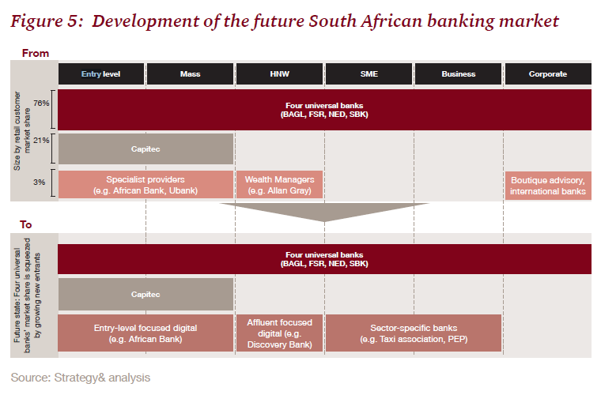

Summary_of_entry_and_expansion_in_retail_banking.pdf

strategyand-digital-disruption-in-sa-banking-sector.pdf

Regulatory initiatives and technological developments may cause

unprecedented change to business models

BBBBBBBBBBBBBBBBBBBBBBBBBBBBBBBBBBBBBBBBBBBBB

///////////

**Scenario 1 — Low rates/economic growth and low disruption**

It is possible that competition and the entry of new actors in finance proceeds at a gradual pace. Opportunities to contest markets which are easier to enter, such as payments and SME lending may have largely been exploited. Other activities, such as custody and settlement could prove sticky with fewer chances to disrupt. It is possible some fintechs could adopt a partnership model, offering their services primarily through incumbent banks.

The degree of value chain unbundling and market disruption in such a scenario might be moderate with continued vertical integration of non‑disrupted activities.

Return on equity could exceed the industry’s cost of capital. In this scenario, banks might use technology to enhance their products, services and operations, allowing them to retain their customer relationships and core services. Risks to financial stability might be more modest in this situation as the pace of change would be lower, yet the benefits of competition and innovation may also reduce.

**Scenario 2 — Low rates/economic growth and “high degree of disruption”:**

New firms might consolidate their market position and aggressively contest markets, with value chains unbundling faster as a result. Greater access to data and growth in peer‑to‑peer systems allow fintechs to form new types of connections and dependencies. The core banking model may be increasingly focused on a narrower set of activities in which the funding advantages of banks are powerful, or where there are very high barriers to entry. In the most extreme form, the deposit‑taking and credit provision services traditionally bundled in banks would be increasingly separated. Funding and lending might be undertaken in new market places.

Continued low rates mean the system may struggle to make their cost of capital. The majority of incumbents might become low‑margin back‑end utilities with nimble new entrants focused on customer acquisition. Smaller banks may be forced to merge to find scale. The industry could become more modularised with services provided primarily through market place platforms and outsourced activities.

In this scenario, the Bank would need to consider its perimeter or regulation to account for new market structures and the distribution of critical economic functions.

**IMPLICATIONS FOR THE BANK**

//////////////

NBNBNBNB

**Digital transformation in financial services**

Although financial services have been computerized for decades, with products such as retail brokerage using digital channels for some 20 years, a more radical transformation of the industry was delayed due to market advantages of traditional financial services providers. These included the established trust of customers, regulatory barriers to entry in banking and insurance, and supervisory approaches that created a bias to internalizing all or most of the value chain.

The 2008 financial crisis reduced trust in financial institutions, and the regulatory response to the crisis, including increased capital requirements and compliance costs, and made it more difficult and expensive for banks to lend.2 Paradoxically, this created an opportunity for less regulated, technology enabled non-banks to thrive. They could offer financial services more cheaply and efficiently than incumbents burdened with legacy infrastructure and regulation.

In addition, digital transformations of other industries made customers more trusting of and comfortable with tech-based financial solutions. It also increased their demand for immediacy and customized products and services. Some of the most prominent FinTech companies are meeting these consumer demands with low cost, convenient ways to transfer money, borrow, and invest.

The impact of FinTech on financial services, however, goes beyond retail and customer-facing applications and services to include all elements of the financial services production process. The transformations in other industries demonstrated how increased availability of data and speed of information transmission could address key issues in contracting and monitoring that had determined the structures of firms and the degree of internalization of activities. For example, the ability to send designs across the world and monitor the quality of production has enabled the separation of design and marketing from manufacturing and logistics in companies such as Apple and Nike.

Yet commercial banks are still internalizing almost all aspects of channels, product design, and operations as well as a fair amount of private infrastructure (with call centers being an occasional exception, though many such operations were offshored rather than outsourced).

New FinTech entrants can optimize a single link of the financial services value chain to provide a bank-beating solution that can connect to the rest of the financial ecosystem. That might mean delivering services directly to users’ mobile devices instead of using bank branches, dispensing with proprietary communication lines by using encrypted Internet transmissions, or avoiding the cost of data centers by utilizing cloud computing.

There are FinTechs offering point solutions in product areas such as payments, remittances, savings and investments, personal financial management, trade and invoice finance, small and medium-sized enterprises (SMEs), lending, and insurance.

Innovations are also directed at processes such as Anti-Money Laundering-Know Your Customer (AML-KYC) compliance, credit scoring, underwriting and risk management, customer service, collections and recovery, capital markets activities, asset securitization, middle- and back-office reporting, trade processing, and connectivity between banking systems.

While this note largely takes a functional or product oriented approach, the potential also exists for innovative technologies to change the scope of what is possible in financial services and disrupt traditional intermediation roles. Technologies with radically transformative potential include digital identities and currencies, distributed ledgers, big data, artificial intelligence, and machine learning. These are already being incorporated into specific products and solutions in familiar institutions, but may in time fundamentally transform financial intermediation

**Impact on financial services value chains**

Some FinTechs aim to operate separately from—and compete directly with—banks. Others offer solutions to banks. Virtually all of them need to connect to other financial services and to existing infrastructure (for funds transfers, for example). And banks, whether they want to or not, will be dragged into this age of reconfiguration by market forces and, in some cases, by government interoperability mandates.

Where unitary proprietary bank systems once precluded connection to external solutions, interoperability that will help FinTechs to carve off profitable slices of banks’ businesses is now mandated in some jurisdictions, notably the European Union.3 The digital transformation of financial services is likely to result in more competition, with significant portions of banks’ products and profitability at risk. Barriers to entry may have risen in terms of core bank compliance costs, but regulators’ willingness to countenance non-bank competitors in product areas traditionally dominated by banks has increased, and the economics of banking have shifted. Cloud infrastructure and mobile channels mean that the provision of financial services no longer requires high fixed-cost mainframe data centers and branch networks, so costs are more variable.

While there may be consolidation in certain lines of business that have very large scale or network economies, at the same time it is increasingly easy for niche providers to offer tailored solutions to a particular market and be profitable with a much smaller asset base. Fintechs have taken market share in high margin slices of banking such as remittances and asset management, and technology-enabled challenger banks have emerged as serious contenders in a number of markets.

The reconfiguration of value chains is also crossing industry boundaries. SoFi, an online personal finance company offers career coaching, while Holvi, a Finnish-based financial startup, provides bookkeeping services and cash flow tracking.4 Similarly, data analytics company Atsora, a Polish provider of SME financial management tools, offers its products to SMEs through banks and in turn leverages the data to create cash flow based scoring the banks can use to lend.5

As the financial services industry becomes increasingly contestable, decomposable, and reconfigurable, the capacity to innovate will be a key success factor. Banks that learn to adopt new technologies, adapt their products and processes, and become more adept at delivering tailored solutions to their customers will succeed. Given banks’ preoccupation with the global financial crisis and regulatory requirements, non-bank innovators have been leading, or have acted as catalysts for, the digital transformation of financial services.

Yet incumbents are increasingly catching on. Just as brick-and-mortar giants Wal-Mart and Target responded to the online threat from Amazon with strengthened online presences of their own as well as modified physical channels such as pick-up locations, almost every financial services provider, from banks to credit unions, now has Internet and mobile channels, and many are adopting new technologies across products and processes as well. FinTech innovations can help banks deliver enhanced risk assessment, reduce transaction costs, make operational back offices more efficient, lower fixed asset investment requirements, and enter new markets. At the same time, banks can help FinTech innovators address their target markets. Adoption of new technologies by incumbents has been aided by the use of standardized Application Program Interfaces (APIs) and the availability of plug-and-play third-

**Quadrant I (Upper Left): “Bank Dominance”**

This quadrant includes economies in which the traditional banking sector is already well established and will likely continue to dominate the market. In-sector competition may create a positive dynamic of service innovation among banks. Examples include Alior, Idea, and mBank in Poland.7

With only nascent local tech ecosystems, innovation may come from foreign FinTechs. Regulators may seek to create an open environment for non-bank entry in order to foster competition and product and service innovation, but entrenched local banks enjoy a “home field” advantage.

This has resulted in a follow-on financial innovation as the solar hardware companies have become de facto leasing companies. Once a device is paid off it can become collateral for further general purpose lending. More recently, the entry of FinTechs using mobile phone data for credit scoring to extend micro-loans (Tala and Branch, for example) may shift the innovation lead back to the technology side.

In another play for the market, Safaricom has recently eliminated fees on low value transactions and reduced the minimum transfer amount from ten to one Kenya shilling with M-Pesa Kadogo. This essentially makes mobile money a costless cash replacement, and potentially positions Safaricom at the center of the merchant payment ecosystem.

It is still not clear who will dominate the provision of financial services in Kenya. For now, consumers are benefiting from reduced prices and increased availability of services, and a recent study has demonstrated the contribution of mobile

///////////////////

The emergence of fintech is only the latest wave of innovation to affect the banking industry. While banks have undergone various technology-enabled innovation phases before, fintech has the potential to lower barriers of entry to the financial services market and elevate the role of data as a key commodity, and drive the emergence of new business models. As a result, the scope and nature of banks’ risks and activities are rapidly changing and rules governing them may need to evolve as well. These developments may indeed prove to be more disruptive than previous changes in the banking industry, although as with any forecast, this is in no way certain

**Potential positive impact on financial stability due to increased competition:** The entry of new players competing with incumbent banks could eventually fragment the banking services market and reduce the systemic risk associated with players of systemic size, as also analysed by the FSB.17.

A transparent view of end-to-end operations and the management of banks’ ability to manage new risks will be essential to effective supervision. The entry of new non-bank players, both as the main providers of banking services and as third-party service providers, could result in significant financial services activities that are integral to banks but not subject to prudential supervision under current supervisory frameworks. Each jurisdiction may monitor trends and consider whether their regulatory framework and supervisory approaches continue to be appropriate based on changes in the banking industry and how financial services are delivered. Virtually all jurisdictions conduct prudential supervisory and enforcement activities at the legal entity level, not by types of activity. Nonetheless, within most of these frameworks, opportunities exist for supervisors to focus on activity, rather than legal entity type.

Regulators have taken steps to revise the process by which new financial services providers, including banks, are authorised to remove any undesirable barriers to new entrants. The UK Financial Conduct Authority (FCA) and the Bank of England have jointly set up a New Bank Start-up Unit, which, among other things, seeks to ensure that there are no disproportionate barriers to entry for new entrants, whether fintech or traditional banks.

*Key strengths*

As specialists, these banks have a deep understanding of

the segments they serve. The areas these banks focus on

tend to require depth of expertise, which creates a barrier

to entry for potential competitors. They are able to price

risk on an individual basis in a way that is more difficult for

larger, more automated providers. Many have experienced

management teams, who have operated across the full

spectrum of UK banking. Their relatively small size also

means they are better able to manage certain types of risk.

These factors mean they are able to provide differentiated

services and competitive offers to their customers.

//////

In September 2018, we held a conference with key industry stakeholders to discuss

how retail banking business models could evolve in response to these changes. We

focused on three scenarios, including the prospect of increased disintermediation

(‘Banks as Utilities’); increased switching (‘the Big Switch’); and the entry of big

technology firms (‘Platform Providers').

Technological change is also changing the way the industry works, reducing entry

costs as new digital-only banks establish themselves without the need for a branch

network. These banks plan to operate with low operating cost models involving fewer

service channels (typically app based only) and with flexible, scalable, cloud-based IT

systems that could allow them to provide customer friendly service for a fraction of

the cost of established banks.

Platform Providers

4.40 We asked participants at our September 2018 conference about the prospects for

large-scale entry into payments or core deposit taking and lending services in the UK

by an established technology platform. The consensus was that platform providers were most likely to focus on engaging

with new business models in financial services to the extent that they supported or

developed the functionality of their core platform offering, rather than extending

into an entirely new industry. As such, the entry of a large platform provider into core

lending and deposit taking was viewed as unlikely, although not impossible.

////////////

In this context, there has been a growing pressure for retail banking activities to be made

separate from investment banking activities by the so-called ‘ring fencing’ of the two activities

from each other. In a speech in February 2013, the Chancellor of the Exchequer in the United

Kingdom gave a speech on the future of banking in which he suggested that the proposed ‘ring

fence’ should be ‘electrified’ with draconian sanctions if retail banking was not protected from

riskier investment banking operations. The Chancellor said ‘My message to the banks is clear: if a

bank flouts the rules, the regulator and the Treasury will have the power to break it up altogether –

full separation, not just a ring fence’ (Financial Times 2013 ). He underlined his determination to

open up the United Kingdom’s retail banking sector beyond its current domination by the large,

well-established banks by facilitating the entry of ‘challenger banks’ to create a more competitive

retail banking system, that would be more focussed on customers.

The OFT review concluded that in the UK market, further significant changes were still

required to tackle longstanding competition concerns and a lack of focus on customers’ needs.

The OFT found that since it last looked at PCAs in 2008, the major banks had increased their

share of the market, that entry by new competitors remained infrequent and that consumers

still only rarely switched their PCA to an alternative provider. The conclusion was that overall a

combination of a lack of competition, low levels of innovation, ongoing customer apathy/inertia

in the face of unclear costs and a lack of diversity in the choices of PCAs available meant that

this market was not working well for consumers or indeed the wider economy.

The OFT in January 2013 made new recommendations to make PCA costs more transparent,

the switching process more reliable and to improve the way in which managed overdrafts are

provided. It called upon all providers to make rapid progress in implementing these recommendations,

as well as being more proactive in ensuring that their products and services are better

aligned with the needs of their customers. The OFT Chief Executive commented:

Personal current accounts are critical to the efficient functioning of the UK economy.

Despite some improvements, this market is still not serving consumers as well as it should.

Customers still find it difficult to assess which account offers the best deal and lack confidence

that they can switch accounts easily. This prevents them from driving effective competition

between providers. Major changes are taking place in the personal current account

market. For these changes to improve the effectiveness of competition in this market, banks

and building societies need to act to improve the quality and value for money they provide

their customers. The retail banking sector needs to become more competitive and customerfocussed

to ensure that further action by the competition authorities is not required.

In many markets, retailers have been perceived as the biggest threat. Their strong brands, marketing

know-how, existing retail networks and store and loyalty cards offered a potential entry

platform. In the UK, leading retailers took up the challenge and have been offering financial services

for many years. For example, Marks & Spencer (M&S), a leading clothing, food and household

goods retailer, entered the market as far back as the late 1980s and Tesco and Sainsbury’s,

then the two largest UK supermarket chains, launched banking services in the mid-1990s. In the

US, Walmart has shown interest in entering the financial services market and made a bid in 2007 to acquire a banking licence; a bid that was subsequently abandoned under fierce opposition

from some American lawmakers and community banks that were wary of Walmart’s power as a

retailer. This has not stopped Walmart from entering the market for financial services and it now

has MoneyCenters in-store and offers both credit cards and a checking and debit card service

called Bluebird, in partnership with American Express. Bluebird is directly aimed at Walmart

customers (140 million visit Walmart every week) who are disillusioned with or excluded from

traditional banking services. In China banking regulators are also inviting retailers to apply for

banking licenses and their desire to enter this market is understandable as there are large margins

to be made in Chinese banking.

Disruptive value brands, such as Virgin, that operate across structurally diverse consumer sectors

(air travel, music retailing and mobile telephony) have also identified opportunities in financial

services. Virgin Money launched in 1995 with an index tracking unit trust (mutual fund) and has

since considerably expanded its range of services. However, prior to the crisis, the ‘non-banks’ concentrated

on a select range of financial services and often operated through partnerships with existing

banks. For example, the UK retailers concentrated principally on credit cards and other forms

of consumer credit, simple savings accounts and insurance policies that could be sold directly. Tesco

and Sainsbury’s operated through joint ventures with Royal Bank of Scotland (RBS) and Halifax

Bank of Scotland (HBOS) respectively, while M&S, after initially operating on its own, moved

into a partnership agreement with the Hong Kong and Shanghai Banking Corporation (HSBC).

The crisis may have extended the opportunities for ‘non-banks’. Tesco and Virgin Money in

particular aspire to move from being niche players in financial services to full-service providers

of retail banking. Both have sought to expand their offerings and the introduction of current

accounts (PCAs) and mortgages are planned or in progress. Tesco bought out RBS’s stake in its

financial services joint venture in 2008 and re-branded Tesco Personal Finance as Tesco Bank.

Virgin Money purchased a small regional UK bank (Church House Trust) in 2010 to expedite

its acquisition of a banking licence and provide a platform for launching a retail banking business.

In early 2012 Virgin bought, from the UK Government, the viable assets of the ailing Northern

Rock bank, taking over the healthy loan and depositor base of Northern Rock and converted

its existing 75 bank branches into Virgin Money outlets. Since taking over in 2012, Virgin has

added 1.7 million new saving and mortgage accounts to its business and it is preparing to enter

the PCA market, following Tesco and M&S.

Furthermore, these ‘challenger banks’ are ambitious in their visions for retail banking. Virgin

Money talks of an ambition ‘to offer a new kind of bank in the UK – one where everyone benefits’.

Tesco says it will focus on ‘being simple, straightforward and rewarding loyalty’. Moreover,

Tesco and Virgin are not alone. In 2010 it was announced that another new entrant, Metro Bank

had received a banking licence from the Financial Services Authority. The activities of each of

these three new entrants are now analysed below.

Looking forward, changes to the ‘macro’ environment of retail banking outlined may help to

restore trust in the banks, but they will combine with existing structural forces to make it even

more difficult for new entrants to make an impact in the market. Switching providers continues

to be fraught with suspicion by customers, capital requirements make new entry expensive,

credit is being rationed making lending less profitable and the housing market remains flat,

perhaps because of fears of another financial crisis. New entrants, from whatever origins they

emerge, will need both patience and luck if they are initially to survive and then prosper!

***Barriers to Entry***

Threats to entry into industries take many forms:

Economies of scale

Capital requirement of entry

Access to distribution channels

Expected retaliation

Legislation or political action

Differentiation

These elements require significant management attention.

/////////////////////

3.3.1 Concept of Direct Banking

Banking has typically been a conservative industry which used to benefit from comparably high entry barriers foremost due to regulations and excess of identical products. However, cloud, mobile, online and big data technologies have severely reduced the entry barriers. In certain jurisdictions, central banks diminished regulations to support innovations in the banking sector. Accordingly, both entrepreneurs and existing banks noticed a room for innovation in retail banking and create digital-only banks.

The following figure summarizes all the key points from the previous sections and illustrates the emerging business models. The figure includes recent megatrends of the industry and challenges that are relevant to traditional banks nowadays.

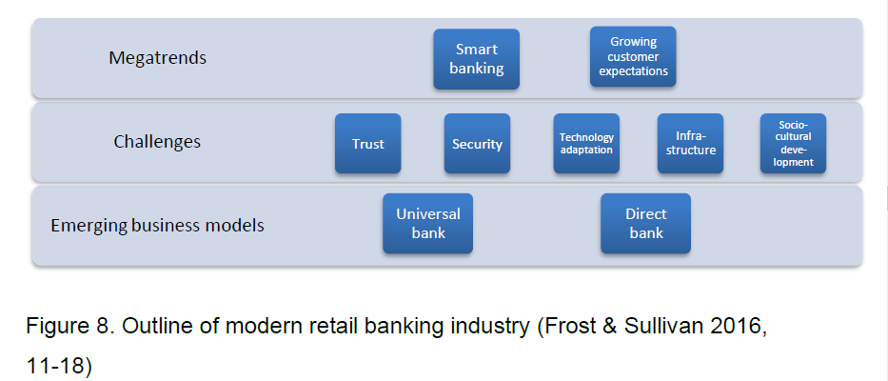

Smart banking includes all the digital disruption factors which have reshaped the retail banking industry. Smart banking solutions consist of using online and mobile applications, cloud technologies, analysis of big data and social integrations. Implementation of digital solutions gives banks a better risk management, improvement of customer experience, lower operational costs, increase of efficiency. However, in order to enjoy the benefits, banks have to create a transitional strategy and invest in digital technologies. (Frost & Sullivan 2016, 12-14.)

Another megatrend is described in digital disruption section of the thesis - growing customer expectations. Customers in all industries have more access to information, and due to this progress customers have increased their expectations towards products and services. Retail banking industry recognized this issue and actively invested in new technologies (see figure 6). Besides megatrends, consumer banks have faced five challenges during digital transformation. Banks are required to accept the challenges and find appropriate internal solutions to stay competitive and profitable. One of the major challenges for the industry is trust. Banks have to ensure customers that the new technologies are safe and that smart banking improves trust in relationships with customers. The second challenge is security because usage of digital technologies might cause frauds and cyber crimes. Next, adoption of new technologies is the key activity of digital transformation. Banking operations should be digitalized reliably and efficiently. The fourth challenge is infrastructure, which is a cornerstone factor for a successful implementation of smart banking. Finally, sociocultural changes play a significant role in the modern retail banking industry. People’s attitude towards digital technologies is changing; they rapidly accept new digital solutions in everyday activities. However, some customer groups might resist from digitalization in banking. Therefore, banks should conduct campaigns and training to smoothen the transition with an aim to inform customers about positive outcomes. (Frost & Sullivan 2016, 15.)

The retail banking industry proposed two business models which meet the requirements of the reshaped industry. One of them, updated universal banking, offers more flexible and tailored products to the targeted customers. The main idea of the renewed business model is to achieve a high level of economy of scale and to maximize efficiency. It is possible through implementation of digital technologies, correct targeting and a balance between online and offline channels. (Kobler, Bucherer & Schlotmann 2016.) On the other hand, the second business model, direct banking, suggests that the significance of offline channels has fallen.

Drivers

Channels (web, mobile) can be accessed everywhere via Internat

Mobility, flexibilityand time saving

24/7/365 availability

Aggressive customer acquisition strategies

Improvementof customer confidence through security upgrade

Consumer conservatism towards financial sector

Strict regulations

Limited internet access in some regions

Greater risk of consumer loss in caseof security breaches

Consumers tend to see the financial sector as an industry with no room for dramatic changes. Strict regulations do not allow smaller player enter retail banking industry. As a solution, FinTech companies can cooperate with bigger banks to operate under their license. Nonetheless, this entry barrier is significant from the business point of view. Limited internet access in some regions (e.g. Africa, Asia, Southern America) makes this business model less attractive. Also, technical interruptions and security breaches may significantly undermine customers’ confidence in the idea of fully digital banks. (Frost & Sullivan 2016, 20.)

///////////

Clearly, major lenders are too big to fall and too big

for smaller banks to compete against. Early in 2000, the

publication of the Cruikshank Report emphasised the

ineffective competition environment in the UK banking

industry regarding three areas: money transmission,

services to personal consumers and services to SMEs.27

It pointed out that

“regulatory barriers to entry are high, producers are

represented on the board of the industry’s regulator,

their exposure to competition law is diluted, and in

many areas banks are allowed to write their own

rules”.28

//////////////////////////

The use of **multi-sided online platforms** to provide FinTech services implies that the definition of the **relevant market** cannot be undertaken following traditional models built on the premises of *pipeline* businesses where value is generated by the supplier of a product or a service. In the case of platforms, the value or a large part of it, is generated by the users on the other side. The second competition challenge resulting from the combination of platform dynamics and users’ perception and behaviour is the generation of **network effects**. FinTech platforms are not as regulated as financial trading platforms, and therefore the challenges arising from network effects need to be assessed as a competition challenge. These challenges include the risk that multi-sided network effects enable a large platform to be **insulated** from competition from smaller platforms with fewer participants and can create **barriers of entry**. Other factors may be at play that modulate the intensity and features of the network effects, and their influence on the potential competition issues. It is particularly relevant whether users tend to choose only one provider (‘*single homing’*) or several providers (‘*multi-homing’*). Network effects increase with the **intensity of use** and the **single-homing** nature of the platforms.

**Standardisation** also plays a relevant role in the field of competition between FinTech providers. If standardisation lowers entry costs, and prices, and/or allows firms to compete on more *core* parts of the service, then it has a positive effect. However, standardisation may also result in an oligopoly where providers may take the opportunity to agree on features of the service to split the market between them.

**Specific competition issues of each FinTech category**

**Banking**

The main obstacle for the development of a competitive market is not due to existing anticompetitive behaviours in the market, but a **lack of clear regulatory standards**. Banking platform markets are primarily multi-home and do not have a high intensity of use, so potential anticompetitive factors might not have a real impact on competition at this stage.

**Payments, transfers and Forex**

Payments are the FinTech services that competition authorities are paying the most attention to. Relevant concerns that could lead to diminishing competition in the provision of payment services include **access to critical assets** such as data and mobile near field communication (NFC) chips, and the **use of an incumbency position gained offline** to engage in exclusionary conduct towards competitors.

**Digital currencies**

The market for digital currencies is characterised by **competition between currencies** (inter-cryptocurrency market) and **competition between exchanges** (intra-cryptocurrency market). While each sub-market, namely mining, exchanges, wallets and payments, is subject to diverse dynamics which may result in different competition issues, there are also common factors among them. One of the most relevant is the presence of **network effects**. Another potential anticompetitive factor is the **standardisation of distributed ledger technology (DLT)** and other technical protocols. Private or public consortia agreements in relation to technical standards may affect the market entry or have an impact on current costs.

**Denial of access** to the gateways of traditional banking activities, such as payment systems for bank account transfers or card processor schemes, is also a potential anticompetitive behaviour.

The arrival of permissioned cryptocurrencies promoted by banks, even by central banks, will reshape the current competition level in the cryptocurrency market, broadening the number of competitors. However, the **market power of banks in traditional banking services might be used to limit competition in the cryptocurrency market** through pre-emptive acquisitions or predatory pricing schemes.

**Wealth and Asset management**

The potential competition challenges in this area involve the **fee policies** of different service providers, the **blurring of boundaries** between different types of services (information, advisory, management) and the implications of the **use of algorithms**. The last one is an issue that looks more promising from a competition policy perspective. The effects of the use of algorithms in the provision of FinTech wealth management services is mixed. On the one hand, there are pro-competitive effects, such as increased transparency on both price and quality variables as well as a more efficient development of products and services. On the other hand, there are also risks for competition, such as the **potential role of algorithms** to be facilitating factors for co-ordination and **collusion** (algorithmic collusion).

**Personal Finance management**

Competition issues regarding digital Personal Finance management (PFM) services arise mainly in the field of **customer data access**.

**Insurance**

**Access to customers’ data and the impact of algorithms on pricing strategies** are the main factors that can lead to anticompetitive practices. The standardisation of private blockchains might also create barriers of entry if the standardisation process lacks the required transparency.

**Enabling technologies and infrastructures**

**There are no specific competition concerns in technologies** such as DLTs, Artificial Intelligence (AI) and Data Analytics, apart from the common ones (standardisation, network effects, access data).

There are some specific niches of cybersecurity technologies where market concentration and potential competition concerns might occur.

The advanced cloud services market is dominated by a small number of big tech companies and, furthermore, the barriers for new actors to access this market are huge.

**Conclusions**

The current state of the markets for FinTech services is generally **too fluid** to reach firm **conclusions on the existence of competition challenges that need the deployment of competition tools on a large-scale basis**. The special role of regulation in the field of financial services sends a message of caution about the appropriateness of competition policy tools as the preferred means to address every challenge.

FinTech services, as part of the digital economy, share potential competition challenges with other digital businesses, mainly those derived from the provision of services through digital platforms and the access to customer data. Thus, the remarks regarding competition in the digital environment remain valid in the FinTech ecosystem.

///////////////

1.1.1. FinTech disruptive and innovative services

FinTech adoption provides major impacts on the financial industry: **lowering barriers to entry** by eliminating physical branches and large organisational structures; **disintermediating** the current value chains; introducing **new business models** based on **platforms** and **sharing economies**; and providing a more efficient provision of services.

For decades, the financial industry has massively used information and communications technologies (ICT) in all its internal processes (back-end). More recently, with the emergence of the internet, ICT have enabled banks to offer online services to their customers, both from fixed and mobile devices. By January 2018, 51 % of European adults used internet banking5, doubling since 2007 when it was only 25 %, with substantial differences6 across age, country and education level.

FinTech has come to revolutionise the way in which traditional financial services providers work and interact with their customers. It is **changing the dominant paradigms** with which traditional financial services are provided, resulting in a real disruption in terms of applicable business models and, potentially, in a growing market share.

This is the case, for example, of loans, where assets (loans) are traditionally financed in the bank's balance sheet through their own capital and liabilities (deposits and wholesale financing). The new scenario consists of the disintermediation of these activities by means of peer-to-peer (P2P) lending platforms, in which the assets and liabilities disappear from the balance sheets of the new FinTech companies and their work becomes the **intermediation between lenders** investing in every individual loan borrowed. They use very novel credit scoring techniques based on AI, big data or social crowd-scoring. The appearance of this new type of intermediation has been accompanied in some countries7 by the **regulation of alternative financing**8, allowing the emergence of new FinTech P2P lending companies.

More recently, with the entry into force of the new Payment Services Directive (PSD2)9, FinTech services providers will be able to start developing new, hitherto unknown models based on the online platform business models. FinTech providers enable the

////////////

2.1.3. A preliminary list of common competition challenges based on the matrix’ explanatory categories

Starting at the upper-left corner of the matrix, by looking at platform technologies (supply-side) from the perspective of access and operations (demand-side) one can identify the issue of **interoperability** as a challenge to competition. This problem arises when the lack of interoperability between two technologies is used by incumbents as an (artificial) barrier of entry for newcomers. The same combination helps to explain the opposite problem, i.e. when the **standardisation** required to facilitate interoperability becomes a source of non-competitive behaviour, because firms lack the incentive to innovate and differentiate.

Moving to the upper-right corner of the matrix, looking at platform technologies using the perspective of user perception and behaviour helps in identifying challenges such as the definition of the **relevant market**, as well as the role of **network effects**, as a source of market power. The problem of the relevant market, i.e. whether certain services must be considered as substitutes, is partly determined by the presence of platform technologies, but differs from case to case depending on how users perceive, and use, the platform. This,

The matrix allows for a second type of distinction between the challenges that can be addressed with competition law instruments and those that are **excluded from its scope** (in the grey boxes outside the matrix). For example, access to technology can be conditioned by barriers of entry arising not from an action by incumbents, but from **regulatory requirements**, e.g. licensing and prudential rules, if they are too stringent or not harmonised. Conduct consisting in exclusion or unfair treatment of users may be an issue for **consumer protection**.

Big banks

2.2.2. Competition issues in the business processes: regulatory disparities and market power of big tech companies

Marketplace lending faces several challenges that could hinder the creation of a competitive market where users, both lenders and borrowers, could benefit from the innovative business models described in section 2.2.1 in terms of efficiency (reduced timing, lower fees, etc.) from the lender side and financial inclusion from the borrower side. The most relevant one is the **diverse regulatory approaches** that lending platforms must comply with to operate in different jurisdictions. As the Bank for International Settlements states, ‘*There are no internationally agreed financial regulatory standards or policies for FinTech credit lending*’59. Some countries have decided to apply the existing regulatory framework regarding licensing and prudential rules while others have enacted specific regulation for marketplace lending. The **disparity of the national regulatory approaches** may hamper the creation of transnational marketplace lending platforms60. In a recent study, the Bank for International Settlements recognised that ‘*existing FinTech companies are developing mainly within individual jurisdictions*’61; however, ‘*if some services were provided across borders (by relegated, disintermediated or new banks), this could increase the need for coordination and cooperation, both between jurisdictions as well as across sectors*’62. **Regulatory disparities** between national jurisdictions could also affect competition in the FinTech lending market, as they may become a **barrier of entry** for new players. These new players would need to divert investments from innovation in order to adapt their solutions to the concrete requirements of each national jurisdiction. This regulatory barrier to competition has been addressed by the European Commission in its recent FinTech action plan63.

59 Bank

Regulation on marketplace lending platforms aims at **controlling financial risks** and **protecting consumers** (both lenders and borrowers) from inappropriate behaviours. Regulatory burdens, however, can somehow blur the main benefits of this model, which are: (1) efficiency, which allows access to funding with lower costs provided in a timelier manner than traditional financial instruments, and (2) the digital inclusion of those collectives that face difficulties when it comes to accessing credit (low-income individuals, SMEs, etc.). Therefore, it is necessary to find the **right balance** between regulation and

**Inter-cryptocurrency market: potential market problems**

Some data can help set the stage for the analysis of inter-cryptocurrency market competition issues. According to a recent study109, **competition** between cryptocurrencies is still **limited**, although it is growing. While Bitcoin accounted for 86 % of the total cryptocurrency market capitalisation in March 2015, it decreased to 72 % in March 2017. Ethereum accounted for 16 % of the market capitalisation in March 2017, which is the only data we have since this cryptocurrency did not exist in 2015110. Nevertheless, these two cryptocurrencies accounted for 88 % of the total cryptocurrency market capitalisation in March 2017, a relevant indicator of the current **market concentration**.

Competition problems of the inter-cryptocurrency market are quite sophisticated, given the complex activities that are part of the value chain. One of the most significant is the **presence of network effects**In the future, network effects may lead to potential **collusive agreements** between members of hypothetical cartels. 111 related to the network and platform nature of cryptocurrencies. This prevents a currency from being substituted by another competing one and resulting in ‘*a substantial barrier to entry and, at the same time, give incumbents large market power*’112. An increasingly higher number of users of a cryptocurrency and its use as a payment instrument create barriers of entry to new cryptocurrencies due to the lack of adhesion to its use in merchants, wallets, or exchanges.

The question of the implementation of **vertical integration strategies**, either in intra-cryptocurrency and inter-cryptocurrency markets, comes to mind when considering additional concerns. Exchange, wallet and payment providers may design behaviour **practices to exclude** each other from the market, e.g. by receiving incentives from miners favouring a specific cryptocurrency, or from certain dominant players trying to exclude competitors in other activities.

The arrival of **permissioned cryptocurrencies promoted by banks**, even by central banks, will reshape the current competition level in the inter-cryptocurrency market, broadening the number of competitors113. A potential inadequacy of traditional competition policy to address competition issues in the cryptocurrency markets can be found114, suggesting direct public participation through a central-bank digital currency as a remedy.

The **international nature** of cryptocurrency markets115 is also a challenge to competition policy at the European level. Many of the players operate from global locations outside the jurisdiction of European competition authorities, which makes investigation or prosecution on anticompetitive behaviours more difficult. Europe leads, at international level116, the supply of wallet and exchange services, with 42 % and 37 % in terms of number of players. It is also the principal actor in payments (33 %). Nevertheless, the main weakness of Europe is the concentration of the mining activity on non-European countries (Europe only capture just 13 % of the current mining market). Mining is the most strategic, sophisticated

**Intra-cryptocurrency market: potential competitive misconducts**

**Market power** of incumbent banks might be used to **limit competition** in the intra-cryptocurrency market through **pre-emptive acquisitions** or **predatory pricing** schemes. Incumbent banks may also engage in anticompetitive practices by denying access to their gateways for exchange or wallet services, such as bank payment and transfer systems or card processor schemes. This **denial of access** may be conducted by means of low service quality, delays in negotiation, proprietary technical standards or excessive pricing. These practices may deter consumers from using the permission-less cryptocurrencies in favour of the permissioned ones promoted by banks.

Another potential anticompetitive factor is the **standardisation of DLT** and other technical protocols. Private or public consortia agreements in relation to technical standards may affect the market entry or impact current costs. In fact, 70 % of the large miners rate their influence on protocol development as high or very high117

2.6.2. Competition issues in the business processes: customer’s data access and security

Competition issues regarding digital PFM services arise mainly in the field of **customers’ data access**. Historically, many traditional financial services providers, such as banks, imposed restrictions on FinTech providers trying to access customers’ account information. Security reasons were usually used to limit this access, creating **technical entry barriers** for some service providers. Such limitations have been addressed by the PSD2 Directive, which defines the ‘*Account Information Services Provider*’ (AISP)136 as a type of payment service provider and obliges the ‘*Account Servicing Payment Service Provider*’ (ASPSP), usually banking institutions, to open the access to customer accounts’ data to AISPs.

The competition issues in the provision of InsurTech services have similarities to those experienced in the field of FinTech. **Access to customers’ data** and the impact of **algorithms** on pricing strategies are the main factors that can lead to anticompetitive practices. The distribution ledger technologies, mainly blockchain, are also going to have a prominent role in several processes of the InsurTech value chain, particularly on record keeping, transfer value, peer-to-peer insurance and supporting smart contracts149. Given its relevance, the standardisation of private blockchains150 might create entry barriers if the standardisation process lacks the required transparency.

**2.8. Enabling technologies and infrastructures**

The enabling technologies described in section 1.2.7. are not specific to FinTech services. Even if DLT was born within the FinTech world, it is increasingly used in other sectors. Each technology/infrastructure identified is positioned in the market with specific characteristics.

2.8.1. Business models: from consulting services to Software as a Service

Four different technologies and infrastructures can be considered as enablers of FinTech services.

**Distributed Ledger Technologies / blockchain**

These technologies have emerged from financial applications (i.e. accounting, payments, and transactions) but they are also valuable for other applications such as:

• Commercialisation of assets that require strict control: legal trade of drugs for medical purposes, diamonds, etc. DLT can bring the required guarantees that transactions are clean, registered and all parties are identified.

• E-voting: DLT are used to ensure transparency.

It is possible to implement DLT/blockchain using available IT technologies and most IT consulting firms can offer the service. From the business/competition perspective, this technology falls into the larger category of specialised software implementation and services.

**Software as a Service**

This model is complementary to the previous one. It can be considered a particular case of OEM, where the service is incorporated into the FinTech application in order to provide the service to the customer.

The business model is a **direct payment** from the FinTech company to the service providers, which may be in the form of monthly or yearly subscription periods. The FinTech company must then evaluate the impact of incorporating the service into its application and the cost involved in integrating the service in order to consider if a change of provider is required in the future. No company has a dominant position in this market, but the *de facto* oligopoly of the big tech companies already mentioned might create barriers of entry for new players.

2.8.2. Competition issues in the business processes: oligopoly in the advanced cloud services market

Most of the enabling technologies and infrastructures of FinTech services, particularly DLTs, AI and Data Analytics, are still in their infancy, with many providers competing in fragmented markets. Although they are also subject to several factors that might result in anticompetitive behaviours —standardisation processes, network effects, mergers and acquisitions—, **none of them has materialised** so far.

In the field of cybersecurity, the provision of services in Europe also remains very fragmented155. Under the umbrella of ‘*cybersecurity services*’, however, there are some specific technology niches where **market concentration** and potential competition concerns might occur.

NBNBNBNBNBNB

**AN ASSESSMENT OF COMPETITION CHALLENGES AND THE USE OF COMPETITION INSTRUMENTS**

**KEY FINDINGS**

• Multi-sided markets, such as FinTech platforms, imply that the definition of the **relevant market** cannot be undertaken following traditional models built on the premises of ‘*pipeline*’ businesses where value is generated by the supplier of a product or a service.

• FinTech platforms are not as regulated as financial trading platforms, and therefore the challenges arising from **network effects** need to be assessed as a competition challenge. Network effects enable a large platform to be insulated from competition from smaller platforms with fewer participants and can create barriers of entry. Yet, network effects are not indicative *per se* of the existence of competition problems that need to be addressed.

• An active pursuit of **non-interoperability** in the provision of FinTech services can act as a deterrent with anticompetitive effects if access to the market is difficult or costly, or can even cause foreclose effects when barriers are insurmountable.

• The **role of data** to establish a competitive advantage, which can give rise to exclusionary conducts such as refusal of access or exclusive contracts, needs to be borne in mind as one of the elements when assessing the position of a company resulting from a merger.

• Some of the competition challenges described in this section **fall outside the scope of competition tools**, and they should be addressed by specific regulations of the financial sector (investor protection rules, licensing scheme, prudential rules), data protection and privacy laws or consumer protection laws.

**NBNBNNBNBN**

**Financial regulation** is one of the primary **entry barriers** for these services, but it is also the primary source of **legal certainty**. All market operators, regardless of whether they demand more or less regulation, tend to ask for **a more stable legal framework** for FinTech services, which they see as one of the major competitive challenges. While being a competition issue, it cannot be addressed by means of competition tools.

The conclusion that the initial response to these challenges may lie in regulatory measures, rather than competition measures, is shared for a number of different services, such as banking/lending, wealth and asset management and insurance. Others, such as services related to digital currencies, or PFM, are still in an even earlier stage where the need for regulation is being assessed.

In some cases, the conclusions may be mixed. This is the case for the use of algorithms in wealth and asset management. The use of algorithms can give rise to genuine competition challenges, such as collusive behaviour (primarily) and abuse of dominant position (potentially). In cases where trading and investment is a regulated activity, as it is in financial markets, even competition concerns tend to be captured by financial regulation, through the rules on market abuse, for example.

**4.3. The role of competition policy**

If some services offer examples of pure regulatory problems, or problems that despite their characterisation as competition problems, can be addressed through regulatory, or non-competition measures, other cases show that the opposite may be also true, i.e. that a **regulatory problem**, addressed by regulatory provisions, **may** nonetheless **be aided through** the use of **competition policy tools**. This is the case of payment services, which is also the field where the actions of market incumbents are subject to more scrutiny.

The lowering of barriers of entry by facilitating access to data has been a policy decision implemented through regulation, such as **PSD2**, which is better suited than competition tools to stipulate the means by and conditions on which such access may be granted. The recent activity of competition authorities against large financial institutions for behaviours suggesting a denial of access to such data, however, suggests that competition tools may be deployed as a deterrent for firms that use customer consent, or the interoperability of technologies, to block competitors’ access.

///////////

The most important advantage of differentiation is that it can bring about loyalty in

buyers. Other **advantages** of a differentiation strategy are:

▪ It creates entry barriers in the form of buyers’ loyalty.

▪ It increases the transfer costs for the buyer since competitors’ products are now

less attractive.

▪ It provides protection against substitute products.

Differentiation **works best** in markets where:

▪ Various ways exist to differentiate the product, and buyers attach value to this

differentiation.

▪ The product can be applied for a variety of uses.

▪ There are few competitors that differentiate on the same basis.

It appears as though a differentiation strategy that is based on one or more of the

following **areas** are more successful:

▪ Technological leadership

▪ Product quality

▪ Service quality

The major **risks and impediments** associated with a differentiation strategy are, among

others:

▪ To base the differentiation on something that is not really valuable to the buyer.

▪ To apply a differentiation that is too expensive. This causes the additional costs, which

do not necessarily justify the additional characteristics.

▪ Differentiation that is marketed badly. This means that the difference that is brought

about as a result of the differentiation is not effectively communicated to the buyer.

▪ Buyers lacking knowledge.

▪ **The cost-of-entry test.** Here the cost of diversification is looked at in order to

determine whether it is viable.

**4.1 Strategies for competing in turbulent, high-velocity markets**

Here organisations find themselves in industry situations that are characterised by rapid

technological change and short product life cycles because of the pace at which nextgeneration

products are being introduced and the entry of new rivals into the market.

The industry is established, with rapid change being the prevailing condition. Personal

computer hardware and software, video games, wireless telecommunications,

prescription drugs and the whole arena of cyberspace is typical examples of this industry

situation.

Change is a fundamental characteristic of this type of market environment and thus poses

a challenge for strategy making. An organisation in this industry has three strategic

options for dealing with the change:

▪ **It will react to change.** To react to change means that the organisation defends itself.

The organisation can, for example, respond to a competitor’s new product with a

better one. This is a defensive strategy and unlikely to create a fresh opportunity.

▪ **It will anticipate change.** Anticipating change is still fundamentally a defensive

strategy because forces outside the organisation are controlling what is going to

happen in it. Anticipation means that the organisation is looking ahead to analyse

what is going to happen and then prepare and position itself for that future.

▪ **It will lead change.** To lead change is inherently an offensive strategy because it

means being first in the market with

////////

**Product and Self Introspection**

The second stage in product selection is consolidation through

introspection. After proposing a product, attempts should be made

to improve it through innovation. The same or a close substitute

might already be available in the market. The new entrepreneur will

find entry into the market difficult. It can be made easier by slightly

differentiating the product whereever possible. A change in product

design based on user preferences could be a good idea. In

consolidating the product for being selected, its potentialities in

terms of present and future demand be kept in mind.

The product introspection leads to self introspection wherein the

entrepreneur considers his aptitude and weakness. It is essential to objectively assess the financial technical and marketing capabilities

of the entrepreneur. Though not essential, it is desirable and

generally advantageous to select a product over which the

entrepreneur has some command. At the threshold of the final

product selection, such an objective assessment in highly essential.

Characteristics of products may differ from one another. For

instance certain products are “marketing” based demanding certain

marketing traits in the entrepreneur. The entrepreneur should be a

gogetter with an inclination towards marketing and personal

relations.

Some products may be capital intensive. The entrepreneur should

be endowed with or have access to adequate financial resources.

Similarly, some products require technical and innovative skills in

designing and manufacturing. The entrepreneur should have an

instinct for application of technical expertise to product design and

development.

These entreprencurial attributes will help consolidate the product

concept in addition to developing a wider base of knowledge to

analyse and assess the product-market relationship.

Threat could take the shape of

unexpected entry of competitors, including well established units

with brand names, introduction of cheaper or better substitutes,

change in the tastepreferences, rates of obsolescence of

technology restrictions by government, to mention a few. The

entrepreneur should organise his resources to improve strength,

reduce weakness, scize opportunities and anticipate threats.

TTTTTTTTTTTTTTTTTTTTTTTTTTT

Threat could take the shape of

unexpected entry of competitors, including well established units

with brand names, introduction of cheaper or better substitutes,

change in the tastepreferences, rates of obsolescence of

technology restrictions by government, to mention a few. The

entrepreneur should organise his resources to improve strength,

reduce weakness, scize opportunities and anticipate threats.

**Decision on the Mode of Entry into Overseas Markets :** Once a

firm has decided to go international it has six alternative methods to

choose, amongst, for getting the entry into the foreign market. The

choice depends very much on the resources of the firm and the

market potentials for its product in the importing country. The

methods of entering foreign markets are :

3. To identify and remove entry barriers for potential

entrepreneurs (first generation and new entrepreneurs).

////////////

Famous Harvard strategy professor Michael Porter once said that strategic superiority ultimately comes from

innovation. Innovations allows companies to race ahead of competitors and thus build costly competitive entry

barriers that discourage competitors (Gubman, 1998). Creating an atmosphere of innovation is a direct result of

an environment that encourages entrepreneurial thinking at the local level. A forward-thinking customer

relationship leader fosters an atmosphere of innovation and encourages employees to remove barriers that

inhibit effective CRM.

/////

How does Bó impact on group profitability?

Bó is forecast to generate attractive standalone

returns. The core challenge is maintaining customer

engagement in a world where the big tech firms are

building powerful customer relationships, there are

lots of competitors emerging, the barriers to entry

are falling, and technology is ever more flexible and

powerful.

Corporate

Banking

CUSTOMER

Corporates looking to optimize

their treasury processes and

working capital

• High all-in cost of cross-border

activity

• Emerging needs from changes

to corporates’ own business

models

COMPETITION

Aggregators providing access

to multiple providers, e.g. in FX

• Potential for commerce

platforms to integrate

banking services

• Market entry of traditional

broker dealers

• Banks’ integration into clients’

systems a major barrier to entry

COST

• Relationship management

remains a major cost, but

also a requirement to win

broad mandates

• Sprawling systems and

processes supporting

highly complex large

corporate activity

TECHNOLOGY

Scope to plug in fintech

o_erings – products, analytics

• Core payment/transaction

banking systems highly

customized

/////////////////////////////

Despite regulation and other potential

barriers to entry, we see tremendous demand

for FinTech-related services in areas such as

consumer banking and wealth management.

This will open up new opportunities for both

incumbents and disruptors. For example,

consider the rise of ‘robo-investing platforms’

offered by both online-only and traditional

wealth management companies. New players

are using the online-only model to reach

millennials and increasingly other segments

too. Meanwhile, traditional players are

employing this approach to significantly

CCCCCCCCCCCCCCCCCCCCCCCCCCCCCCCCCCCCCCC

*Using the cloud to scale*

What is behind this shift? Data storage

costs have plummeted, facilitated by

cloud-based infrastructure. This has made

it easier to manage ‘big data’ and apply

sophisticated analytics, and it has also

reduced the barriers to entry for new FinTech

disruptors. According to the International

Data Corporation (IDC), public cloud

investments are growing quickly, spending

on private cloud is increasing, and traditional

infrastructure spending has plateaued. IDC

estimates that public cloud investments

increased by 32% in 2015 to US$21.7 billion

and private cloud investments grew in 2015

by 17%, reaching US$11.7 billion. Overall,

total cloud IT infrastructure spending grew

26% in 2015, reaching US$33.4 billion. To

put that in perspective, this is approximately

one-third of all IT spending.22

Curiously, the sharing economy also plays

a role here. After all, some companies that

have a demonstrated competence in an area

are choosing to sell it to others who need it.

For example, the payments infrastructure

of many industrial, healthcare and smaller

FinTech institutions are being provided by

conventional banks. These banks are selling

their infrastructure as a service to others,

and leveraging the cloud to do it. In our view,

this provides an important source of revenue

to these institutions.

NBBNBNBNBBNBN

After proposing a product, attempts should be made

to improve it through innovation. The same or a close substitute

might already be available in the market. The new entrepreneur will

find entry into the market difficult. It can be made easier by slightly

differentiating the product whereever possible. A change in product

design based on user preferences could be a good idea. In

consolidating the product for being selected, its potentialities in

terms of present and future demand be kept in mind.

Threat could take the shape of

unexpected entry of competitors, including well established units

with brand names, introduction of cheaper or better substitutes,

change in the tastepreferences, rates of obsolescence of

technology restrictions by government, to mention a few. The

entrepreneur should organise his resources to improve strength,

reduce weakness, scize opportunities and anticipate threats.

To identify and remove entry barriers for potential

entrepreneurs (first generation and new entrepreneurs).

NBNBBNBBN

**5.2 Global pricing Strategies**

Specific pricing strategies must be developed for each individual situation. Frequently, however, one of two situations prevail when one is pursuing project acquisitions competitively. First, the new business opportunity may be a one-of-a-kind program with little or no follow-on potential, a situation classified as type I acquisition. Second, the new business opportunity may be an entry point to a larger follow-on or repeat business, or may represent a planned penetration into a new market. This acquisition is classified as type II. Clearly, in each case, we have specific but different business objectives.

Atmosphere of innovation

Famous Harvard strategy professor Michael Porter once said that strategic superiority ultimately comes from

innovation. Innovations allows companies to race ahead of competitors and thus build costly competitive entry

barriers that discourage competitors (Gubman, 1998). Creating an atmosphere of innovation is a direct result of

an environment that encourages entrepreneurial thinking at the local level. A forward-thinking customer

relationship leader fosters an atmosphere of innovation and encourages employees to remove barriers that

inhibit effective CRM.

STST

12Open-source can be interpreted as a rational response by economic interests to monopolistic tendencies in the software

market. New or marginalised software companies can overcome barriers of entry into a saturated software market by becoming

open source. They can change their profit-making strategy from the sale of licensed software to other aspects of their business,

such as charging users for technical services and customisation. This argument is sometimes favoured in the open-source

community.

13Realpolitik in international relations may come into play in government decisions to opt for non-proprietary software.

For example, in China, Brazil, India and elsewhere, there is the view that being dependent on America for such an important

resource as software would be against the national interest (see [12]).

14In the UK, where government departments have over 100 ICT projects in progress with a total value of ê10 billion, a

number of projects have been classed as ‘unsuccessful’. A survey in 2003 showed that only 13‘successful’; viz., on time, to

specification and to cost [49, p. 1].

Weapply the logic-based approach to the development of

a rule base for new product entry, i.e. the decision to

introduce a new product into an existing market. In the

following sections, we review current approaches in rule

induction, introduce our logic-based approach to rule

induction, and apply it to develop rules for new product

entry. We compare our approach of rule induction with

other approaches.We discuss howthe logic-based approach

of rule induction can be used to create a decision support

system and the methodology to create such a system. We

conclude with a discussion of future research areas. 4. Application to new product entry

We apply the logic-based approach to rule induction to the

new product entry problem (Crawford, 1994). This is one

of the most important strategic concerns for a company. If

a company launches a product prematurely, it might result

in a loss of profit. If the company does not enter the market,

however, or enters the market too late, it might forgo

valuable opportunities. The rules on market entry problems,

as derived through the logic-based approach, will

thus be a significant decision support for the manager.

An experiment was conducted to elicit expertise from

marketing experts on new product entry. The subjects used

were 36 senior MBA students in the Kellogg Graduate

School of Management at Northwestern University in

Evanston, Illinois, USA. They had an average of four

years’ experience and were trained in strategic planning.

They were asked to evaluate decision factors x1, x2,y, x7

and the entry strategy y.

The scenario decision variables and their values are the

position of the firm (x1: 1 for dominant and 0 for not

dominant), financial strength (x2: 1 for strong and 0 for

weak), demand growth rate (x3: 1 for high and 0 for low),

product life cycle (x4: 1 for long and 0 for short), diffusion

across competitors (x5: 1 for high and 0 for low),

cannibalization (x6: 1 for high and 0 for low) and cost of

market development (x7: 1 for high and 0 for low). The

decision is to launch the product (GO, y¼1) or not to

launch the product (NOGO, y¼0). These decision

variables were identified through a protocol analysis and

literature review. The details of the knowledge elicitation

process are described in Mak and Bui (1996) and Mak et al.

(1996). Inconsistent data were removed from the data set

before the logic-based approach could be applied to induce

rules from the data set. A total of 105 usable cases with

different values of x1, x2,y, x7 were obtained.

Table 1 displays the decision rules derived from the data

using the logic-based rule induction approach. The first

column of the table displays the decision rules relating to

equivalent relationships. A one-variable equivalent rule for

theGOdecision (e.g./xi_GO, c0S) with c0 greater than or

equal to 80% includes /x3_GO, 80%S, which means

that the GO strategy would be launched if and only if the

demand growth rate is high, with a level of certainty of

80%. However, a one-variable implication rule for the GO

decision (e.g. /xi-GO, c0S) with c0 greater than or equal

to 80% includes /x3-GO, 93%S, which means that the

GO strategy would be launched if the demand growth rate

is high, with a level of certainty of 93%.

When properly marketed, businesses can dissemi-nate information about their products and services, and grow through viral exposure. In addition, accord-ing to the co-founders of Groupon, due to its low barriers for entry, social commerce enables new busi-nesses to go online quickly and easily (*Crain's Chicago Business* 2012). Such low set-up and implementa-tion costs and simple subscription plans are partly enabled by software-as-a-service (SaaS) capabilities. Thus, social commerce has the potential to significantly enhance the competitive advantage of a firm by having a dramatic impact on its operational effectiveness and efficiency, customer relationships, product and service offerings, and revenue growth.

Easy entry into social commerce may also lead to fierce competition in this emerging platform. The growth of social commerce market is further hampered by a number of transaction-related issues such as the failure of purchased items to be properly delivered and the delivery of wrong items (Kim and Park 2013), and inappropriate recommendations and uninformed reviews (Briggs 2011).

It may take time to reap the benefits of social networks because a consumer who becomes interested in a product online through a referral from his/her social networks may only buy the product in the future or use the recommendation for future reference. Even Groupon, the largest online coupon site that offers discount deals on various products and services in the international market, has seen the market casting doubt on the sustainability of its business model, which has caused its stock price plummet and fluctuate in the last year (Bhattacharjee and Oreskovic 2012). As a result, many businesses are hesitant to transition into social commerce due to concerns over return on investment on marketing and obtaining customers.

Key issues are the low barriers to entry and brand recognition, as well as sharp increases in marketing and advertising expenditures. To avoid the tragedy of the commons and to encourage the industry to develop sustainable business models for the future, social commerce firms need to be aware of these issues and take preventive actions to overcome the shortcomings of the current business models. The author offers recommendations for reducing the marketing costs of social commerce firms in their early stage by establishing business policies (e.g., advertising code compliance and quality assurance), and seeking technological innovations (e.g., location-based, personalized services with mobile support). This study suggests that social commerce firms should emphasize the social aspects of their business models, where the marketing activities focus more on word-of-mouth diffusion through social networks than through aggressive multimedia advertising campaigns.

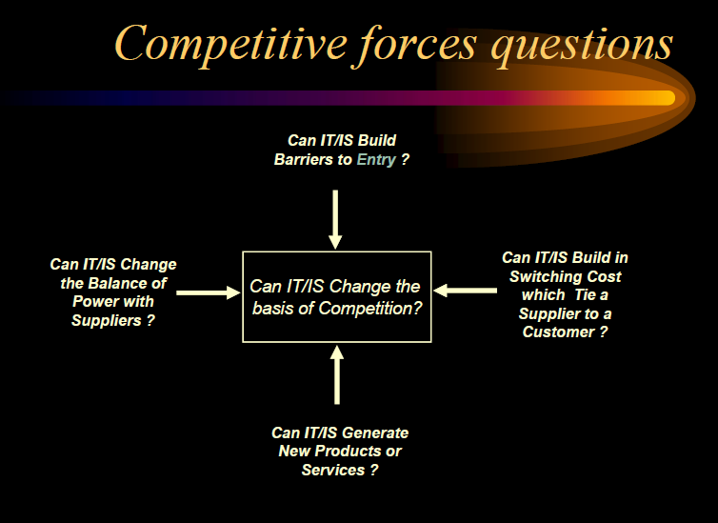

*Porter’s competitive forces*

◆ **Bargaining Power of Buyer:** Where there are only a few customers, they can

exert a strong influence over their suppliers, causing them to undercut each

other.

◆ **Bargaining Power of Supplier:** Similar to that of buyer but from the opposite

perspective. If suppliers are in a strong position they can increase the firms

costs by extracting a higher price.

◆ **Threat of New Entrants:** New competitors bring capacity, often with substantial

resources to compete with. Unless market is expanding faster than new entrants

arrive, they will be competing away profits and profitability will decline. (Entry

barriers include brand names and loyalty).

◆ **Substitute Products:** The propensity of buyers to switch to alternative products

is affected by both price and performance of substitute products. Can offer

substitution to others.

◆ **Rivalry Between Competitors:** Employ competitive strategy to improve their

position and competitive edge, by offering buyers something their competitors

can not duplicate easily or cheaply.

**1 Threat of new e-commerce entrants**

For traditional ‘bricks and mortar’ companies (*Chapter 2*, *p. 88*) this has been a common

threat for retailers selling products such as books and financial services. For example, in

Europe, traditional banks have been threatened by the entry of completely new start-up competitors such as Zopa **(**www.zopa.com, which did not prove to be a viable business) or

traditional companies from a different geographic market that use the Internet to facilitate

their entry into an overseas market. Citibank **(**www.citibank.com), which successfully operates

in the UK, has used this approach. ING, another existing financial services group,

formed in 1991 and based in the Netherlands, has also used the Internet to facilitate market

development. In May 2003, ING **(**www.ing.com**)** launched the online bank ING Direct in the

UK **(**www.ingdirect.co.uk**)**. Since its launch in 1997 ING Direct has gained over 10 million

customers worldwide through its online banking operations in the USA, France, Italy, Germany,

Spain, Australia and Canada. More recently, the Icelandic bank Landsbanki

(www.landsbanki.is) is another example of a new entrant. These new entrants have been

able to succeed in a short time since they do not have the cost of developing and maintaining

a distribution network to sell their products and these products do not require a

manufacturing base. In other words, the *barriers to entry* are low. However, to succeed, new

entrants need to be market leaders in executing marketing and customer service. The costs

of achieving these will be high. These could perhaps be described as *barriers to success* rather

than barriers to entry. This competitive threat is less common in vertical business-tobusiness

markets involving manufacture and process industries such as the chemical or oil

industry since the investment barriers to entry are much higher.

**Barriers to entry**

Barriers to entry are reduced through lower fixed costs

enabling new competitors, particularly for retailers or service organizations that have traditionally required a high-street presence or mobile sales force

New entrants must be carefully monitored to avoid erosion of market share.

Internet services are easier to imitate than traditional services, making it easy for ‘fast followers’.

The cost of establishing a recognized, trusted brand is a major barrier or cost of

entry and new entrants have to encourage customers to overcome switching costs.

These new entrants have been

able to succeed in a short time since they do not have the cost of developing and maintaining

a distribution network to sell their products and these products do not require a

manufacturing base. In other words, the *barriers to entry* are low. However, to succeed, new

entrants need to be market leaders in executing marketing and customer service. The costs

of achieving these will be high. These could perhaps be described as *barriers to success* rather

than barriers to entry. This competitive threat is less common in vertical business-tobusiness

markets involving manufacture and process industries such as the chemical or oil

industry since the investment barriers to entry are much higher.

**3** Treat the local distributors as long-term partners, not temporary market entry vehicles.

**4** Support market entry by committing money, managers and proven marketing ideas.

An alternative

view of the spiral model can be considered by examining the *project entry point*

*axis,* also shown in Figure 2.8. Each cube placed along the axis can be used to represent

the starting point for different types of projects. A “concept development project” starts at the core of the spiral and will continue (multiple iterations occur

along the spiral path that bounds the central shaded region) until concept development

is complete. If the concept is to be developed into an actual product, the process

proceeds through the next cube (new product development project entry point) and

a “new development project” is initiated. The new product will evolve through a number

of iterations around the spiral, following the path that bounds the region that has

somewhat lighter shading than the core. In essence, the spiral, when characterized

in this way, remains operative until the software is retired. There are times when the

process is dormant, but whenever a change is initiated, the process starts at the appropriate

entry point (e.g., product enhancement).

CCCCCCCCCCCCCCCCCCCCCCCCCCLOUD

their personal data security (Kshetri 2010, 47) whilst the redundancy provided by

cloud computing significantly reduces the risk of data loss (Rajan and Jairath 2011,

665) whilst offering greater reliability (Chunye et al. 2010, 275). Cloud computing

may be considered an environmentally-friendly computing paradigm due to cloud

providers placing focus on energy efficiency (Jing et al. 2013, 445). Since cloud

computing removes barriers-to-entry for smaller organisations, consumers may

benefit from rapid development of new and innovative services and products across

industries (Heng and Neitzel 2012).

Whilst cloud computing offers many benefits, there are also challenges (Rajan

and Jairath 2011, 665). In the context of a developing country, such as South Africa,

these challenges stem from the reality that a seamless cloud computing experience

requires a stable broadband connection (Leuschner 2011; Miller 2008). Poor coverage

or network congestion may restrict ubiquitous cloud access to an environment such

as a wireless hotspot (Coughlin 2012, 406). This challenge is compounded by high

broadband costs (Muwanga 2008) and costs associated with acquiring and learning to

use cloud capable devices (Chien and Chien 2011, 250; Chung and Hermans 2010).

As a result, despite on-demand cloud availability, ubiquitous access is not always a

reality. Other significant challenges include reliability, performance (Leavitt 2009,

15) and a lack of expertise in supporting cloud-based platforms (Chien and Chien

2011, 250). Despite cloud computing being considered reliable and secure, issues

may exist among users around security and privacy (Chabrow 2009). Examples of

recent personal cloud privacy breaches may instil uncertainty and mistrust among

personal cloud users (Ward 2014). Furthermore, in the event that a cloud provider’s

business were to fail, data loss might occur (Miller 2008).

In terms of adoption, cloud computing adoption in education is happening in

major developing economies such as China and India (Kshetri 2010, 47). However,

adoption in South Africa is arguably slower (Cisco 2013; Kshetri 2010, 47). Whilst

cloud computing has the ability to balance IT infrastructure variances between

developing in developed countries (Greenguard 2010, 18), issues such as user

confusion, lack of regulatory clarity, and security and privacy challenges have been

found to be inhibitors of adoption, particularly in South Africa (Tobin and Bidoli

2006, 31).

Despite challenges prevalent in some developing contexts, cloud computing can

provide efficiencies in higher education (Sultan 2010, 109). For example, researchers

may benefit from the distributed processing features of dedicated and independentlyowned

cloud computing infrastructure, especially when implementing data analysis

for research purposes (Kshetri 2010, 47). Furthermore, universities are deploying

cloud solutions to reduce costs (Sultan 2010, 109). Cloud computing also enhances the

area of distance and mobile learning allowing students to access various educational

resources remotely (Kshetri 2010, 47; Masud, Huang and Yong 2011, 735). It is also

necessary that university students are exposed to cloud services in preparation for entry into an increasingly cloud-dominated workplace that demands cloud literacy

(Razak 2009, 101). However, gaps exist within the literature, particularly with regard

to students and their adoption and utilisation of personal cloud technologies.

In order to comprehensively investigate the adoption of personal cloud

technologies by students, a theoretical model is crucial. A number of technology

adoption models aim to understand factors influencing technology adoption. These

include: the Technology Adoption Model (TAM) (Davis, Bagozzi and Warshaw

1989, 982); a second revision – TAM2 (Venkatesh and Davis 2000, 186); a third

revision – TAM3 (Venkatesh and Bala 2008, 273); and the Unified Theory and

Acceptance and Use of Technology (UTAUT) model (Venkatesh et al. 2003, 425).

Whilst each of these models may be applied to a technology adoption study, UTAUT

offers moderating variables which consider the user-environment which is crucial

when investigating a diverse context (Im, Hong and Kang 2011, 1).

UTAUT has been applied across studies investigating the adoption of various

technologies. Examples include the application of UTAUT to investigate the adoption

of Internet banking in Jordan (Al-Qeisi 2009, 383); the adoption of Internet-based

telephony services in Korea (Park, Chung and Hur 2011, 1); and to determine user

acceptance of SaaS (Wang 2011, 11). UTAUT has been empirically proven to be a

robust model to apply in technology adoption and utilisation studies (Sundaravej

2010, 5). Furthermore, UTAUT was found to be viable and suitable in a study into

Internet banking adoption in Jordan (Al Qeisi and Al-Abdallah 2013, 84).

The UTAUT2 model is an extension of the UTAUT model with a specific focus

on consumer adoption of technologies (Venkatesh, Thong and Xu 2012, 157). This

model considers Hedonic Motivation, Price Value and User-Habit whilst the focus

on voluntariness of use is not considered (Venkatesh et al. 2012, 157). UTAUT2 has

been successfully applied to a cloud adoption study at a tertiary level (Dhulla and

Mathur 2014).

In order to effectively explore the adoption and utilisation of the personal cloud

within our context, it became necessary to adapt the UTAUT2 model. Our adaptation

comprised the exclusion of two independent variables (Habit and Hedonic Motivation)

and the introduction of two independent variables (Cloud Accessibility and Cloud

Trust) based on the literature review. Since cost is a factor influencing access to

the personal cloud, Price Value was integrated into Cloud Accessibility. Habit

was excluded since the personal cloud is an emerging technology, whilst Hedonic

Motivation was excluded on the basis that our study did not aim to understand

enjoyment derived from personal cloud use. We included the Voluntariness of Use

variable from UTAUT since certain cloud applications may be pioneered by modern

curricula (Smith and Caruso 2010, 37). The resultant theoretical model as illustrated

in Figure 2, the Personal Cloud Adoption Model (PCAM), focuses specifically on

personal cloud adoption.

Nbnbnbnb

The business strategy specifies the positioning of

the organization or subunit with respect to its customers and competitors. Starting point for

the analysis of the organizational situation can be Porter’s five forces model. Porter

distinguishes between three generic business strategies – differentiation, cost leadership,

and focus – in order to counter the five forces of competition within an industry – supplier

power, buyer power, threat of substitutes, industry competitors, and barriers to entry (Porter,

1980). The objective of differentiation is to generate something unique in the market place

such as special design, unique brand, advanced technologies, or customer services.

sales force with the same competitive advantage. Therefore, the system at Mass

Mutual may be a barrier to entry for new companies.

Answers to these questions vary widely from industry to industry. Strategic

time frames depend on industrywide factors such as level of commitment to fixed

resources, maturity of the industry, cyclicality, and barriers to entry. As discussed

in Chapter 1, hypercompetition has increased the pace of change to the point that

requires any strategic decision be viewed as temporary.

Recent trends in computer hardware

prices have greatly lowered the barriers to entry on this account. Second and more

important, the user must gain access to information itself. In this sense, the issue of

access is closely linked to that of property. Although major corporations have

benefited greatly from the drop in computer prices, the same benefit only now is

beginning to filter through the rest of society. Looking forward, the major issue

facing managers is how to create and maintain access to information for society

at large. As our society moves toward a service- or knowledge-based economy,

managers whose organizations control vast quantities of information will have to

weigh the benefits of information control against societal needs to upgrade the

knowledge bases of individuals or knowledge workers.

Potential Threat of New Entrants

Existing firms within an industry often try to reduce the threat of new entrants to the

marketplace by erecting barriers to entry. Barriers to entry help the firm create a

stronghold by offering products or services that are difficult to displace in the eyes of

customers based on apparently unique features. Such barriers include controlled access

to limited distribution channels, public image of a firm, and government regulations of

an industry. Information resources also can be used to build barriers that discourage

competitors from entering the industry. For example, Google’s search algorithm is a

source of competitive advantage for the search company, and it’s a barrier of entry for

new entrants, who would have to create something better to compete against Google.

Walmart, another example, effectively blocked competition with their inventory control

system, which helped them drive down expenses and ultimately offer low costs to

customers. Any company entering Walmart’s marketplace would have to spend millions

of dollars to build the inventory control system and IS required to provide its operations

with the same competitive advantage. Therefore, the system at Walmart may be a barrier

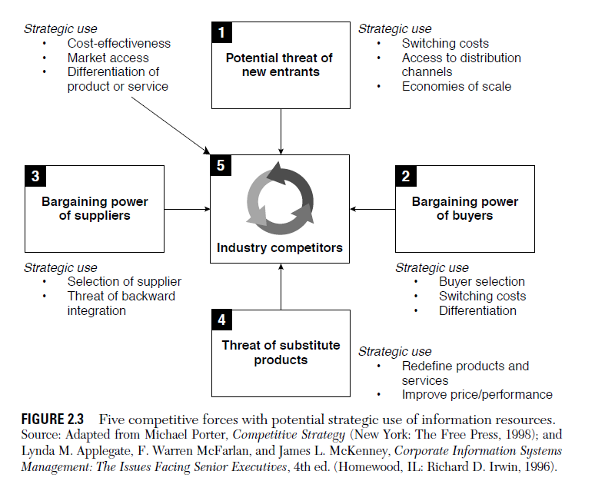

How to enter a banking market

It’s an industry with an image problem and one that has seen little change in hundreds of years. It’s heavily regulated, requiring investment in robust system and processes, making it expensive and time-consuming.

So, with all of that in mind, why would you launch a new bank? Well, despite the many hurdles, the last decade has seen some significant trends emerge that have made the sector more attractive.

Firstly, we have a regulatory environment that is actively attempting to stimulate both competition and innovation. From Europe with [PSD2](https://www.fintechfutures.com/2018/06/psd2-customer-loyalty-and-bespoke-behavioural-open-banking/), [HKMA issuing virtual banking licences](https://www.fintechfutures.com/2019/05/hong-kong-grants-four-more-virtual-bank-licenses/), through to Australia and the US, via the OCC, [taking applications from fintechs](https://www.fintechfutures.com/2019/02/fintech-charms-us-state-regulator-into-modelling/) for national banking charters.

The popularity of these initiatives indicates the appetite of firms to enter the market, despite the significant hurdles to success they face. It also shows the key role regulators play in creating a viable environment for new market entrants.

Secondly, consumer attitudes are evolving. Driven by digital experiences in retail, entertainment and transportation, digitally-native services have fundamentally shifted consumer’s perception of what it possible.

And finally, the widespread availability of new technologies to power these services. It is now possible to stand up an entirely new bank, from core systems to customer interaction channels, at a vastly lower cost than historical solutions involving on-prem software and in-house, proprietary data centres. This reduces the capital required to start a business in the banking industry and opens it up to far more potential new entrants.

Technology is also behind the distribution to a much broader audience, at a much lower cost, than has been historically possible.

**Spotting the difference**

So, we have consumers who experience and increasinglywant digital, always-on, personalised options and intelligent services. But incumbent financial institutions have struggled to deliver and the new guard having spotted that gap in the market, are stepping into the breach.

The most obvious difference between most of the new market entrants and incumbents is they serve customers via apps, websites and in some cases over the phone, but they lack a physical presence on high streets or in shopping centres.

The areas of banking these new entrants are entering varies, but the current account, in particular, has been reimagined in many different ways. Some providers are targeting underserved demographics such as migrant workers, others are going after specific niches like frequent overseas travellers and a few are taking on the full banking product stack.

They are doing this through the use of new technology-powered features and services that far outstrip those offered by the incumbent institutions in a wide range of areas, from onboarding through to personalisation and customer service.

While the current account has been the obvious and most widely used entry point, not all digital challengers have been created equal.

First things first, you need an understanding of the market you are entering. If there are already a number of successful neobanks in a relatively small market, then the operating model you decide on will be different from a region where there is little to no competition, or a market with a huge potential customer base.

**Not all banks are created equal**

Despite the UK having one of the most well-established processes for new bank entrants to acquire a license, it’s still a long process which, back when [Starling](https://www.fintechfutures.com/2019/06/starling-partners-with-paytechs-tribe-and-pelicanpay/) and [Monzo](https://www.fintechfutures.com/2019/04/new-funding-set-to-make-monzo-second-largest-uk-fintech-startup/) applied, took around 24 months to complete. It also comes with significant capital requirements and keeping the licence once you have it adds significant overheads to the business.

For some, the benefits of being a fully licensed bank – the ability to earn net interest margin, the customer trust and the ability to hold and lend deposits – outweigh the costs. Monzo, for example, launched a prepaid card product to customers while awaiting a full licence; a period which allowed them to build and iterate on Monzo’s app, and to create the intelligent services the firm provides.

[Monese](https://www.fintechfutures.com/2018/10/monese-ventures-into-business-banking/), which just passed a million customers took a different path. While Monzo is squarely a mass-market proposition, Monese focused on a particular group of people. CEO Norris Koppel’s struggle to get a bank account after moving to the UK from Estonia inspired him to create an account that could be opened in a quick and easy manner by others in similar situations. And by doing so, he and his team would be solving a serious pain point for a large number of potential customers.

Crucially, it didn’t apply for a UK banking licence as that would only have allowed Monese to operate in that region and obtaining further banking licenses in Europe would have required resources the firm was unlikely to have access to for the foreseeable future.

**Incumbent approaches**

Goldman Sachs took another, highly novel, approach, particularly for incumbent banks looking to expand. Its IT structure gave it some big advantages and its brand, even if not used widely by the general public is still known. Second, it had no retail offerings so it had no legacy technology constraints that meant it could start from a truly greenfield position.

It entered the market with a personal loan product in 2016 for the US, followed swiftly by a high-interest savings account, both under the [Marcus](https://www.fintechfutures.com/2018/08/goldman-sachs-lending-platform-marcus-coming-to-uk/) brand. The products are only available via the website, no app yet exists but the strategy of launching two complementary but very simple products, with market leading rates, has been hugely effective. By September 2018, the Marcus brand had accumulated $20 million in deposits and issued $3 million in loans.

Phase two of the product development came in 2018, when Goldman acquired personal financial management (PFM) app [Clarity Money](https://www.fintechfutures.com/2018/04/goldman-sachs-acquires-personal-finance-app-clarity-money/). The aim is to eventually offer a platform that consumers can use to manage their entire financial lives in one place.

**Alternative entry points**

There are other methods that are worth discussing. As an incumbent, BBVA, for example, has taken a multi-pronged approach, buying challenger banks – [Holvi](https://www.fintechfutures.com/2019/05/holvi-expansion-targets-micro-businesses-in-five-new-european-markets/) in Finland and [Simple](https://www.fintechfutures.com/2018/11/simple-appoints-former-amazon-exec-as-ceo/) in the US – as well as holding a 40% stake in UK challenger [Atom](https://www.fintechfutures.com/2019/05/atom-picks-trunarrative-to-provide-aml-solution/) which offers savings, business loans and mortgages.

Then there are the infrastructure players which offer a fascinating glimpse into a model that is facilitating other new market entrants. These include Germany’s [solarisBank](https://www.fintechfutures.com/2018/12/solarisbank-shines-for-boerse-stuttgarts-crypto-trading-launch/) and its Banking-as-a-Service (BaaS) product which allows third parties to build financial services using its modular platform and under its banking license. It supports the unbundling of banking and payments products, allowing users to focus on one core product or service and ensuring that is done well. Not only is it arguably a new entrant to the German banking industry given it holds a banking license, it is also facilitating the entry of other startups to the same market.

Starling, which began initially as a retail account offering, has moved into other banking silos with the launch of its business account, its Payment Services and a BaaS product. This suite of products means the bank is entering new markets both vertically and horizontally – it’s offering customer-facing products and the infrastructure that supports these products at the same time.

Finally, there’s [ClearBank](https://www.fintechfutures.com/2019/05/settlego-signs-for-clearbanks-payment-access-services/) which provides clearing and settlement services as well as core banking software to regulated financial firms including banks and fintechs. Unlike the UK’s other clearing banks, it doesn’t offer any retail or business banking services directly, choosing to focus on being an infrastructure player instead.

ClearBank’s strategy is one of the more unusual ways of entering a new banking market and required significant upfront outlay in terms of time and money.

**Lessons to be learned**

In talking to a number of founders of challengers, there are a number of different strategies that have already been used to enter new banking markets and there are valuable takeaways from each of them.

However, firms thinking of joining their ranks should also bear in mind that the global financial services market has an ever-growing number of new entrants and they should not look to create a carbon copy of any existing product, service or model if they wish to succeed.

* ***Find your beachhead***

Decide which product or service will lead your go to market strategy. In some cases, that product or service might be highly complex and take significant time and resources to bring to market, such as in ClearBank’s case, in others it might take as little time as weeks to launch an MVP. The most important thing is to ensure it focuses on one key area and you can find out what actually works in that market before you attempt to broaden your offering.

* ***Create a community***

Some of the most successful new market entrants, most notably Monzo, have built communities months ahead of launching. That’s translated to free marketing and an almost guaranteed group of early adopters, many of whom are willing to use a product that is still being iterated upon while providing valuable feedback. Later entrants have followed suit; however, this strategy is no guaranteed means of success and requires intensive planning to get off the ground effectively.

* ***Build a brand***

This is linked to both previous points but should not be overlooked. Brand identity is still important, particularly if you are entering a crowded market. As a result, any firms attempting to enter new markets should have a full strategy in place that outlines what values they want to embody and how they want to be perceived by their chosen market.

* ***Rethink your processes***

Key for any existing firm seeking to break into a new area is to ensure your organisation is prepared to learn about and adopt new ways of working and even more importantly, to explore new business models. Trying to build an innovative product or service is hard when you are held back by years and years of historical processes and linear development patterns. One of the very first steps organisations should take is to explore how they are going to build something new, in turn that should help ensure the maximum chance of success for what they develop.

////////////////

Consumers around the world are quickly adopting digital banking. Incumbents only have a short period to adjust to this new reality or risk becoming obsolete

f the last epoch in retail banking was defined by a boom-to-bust expansion of consumer credit, the current one will be defined by digital. This will include rapid innovation in payments and the broader transformation in systems enabled by digital technologies. The urgency of acting is acute. Banks have three to five years at most to become digitally proficient. If they fail to take action, they risk entering a spiral of decline similar to laggards in other industries.

Revenues and profits will migrate at scale toward banks that successfully use digital technologies to automate processes, create new products, improve regulatory compliance, transform the experiences of their customers, and disrupt key components of the value chain. Institutions that resist digital innovation will be punished by customers, financial markets, and—sometimes—regulators. Indeed, our analysis suggests that digital laggards could see up to 35 percent of net profit eroded, while winners may realize a profit upside of 40 percent or more (exhibit).

Digital innovation in banking offers potential rewards and losses.

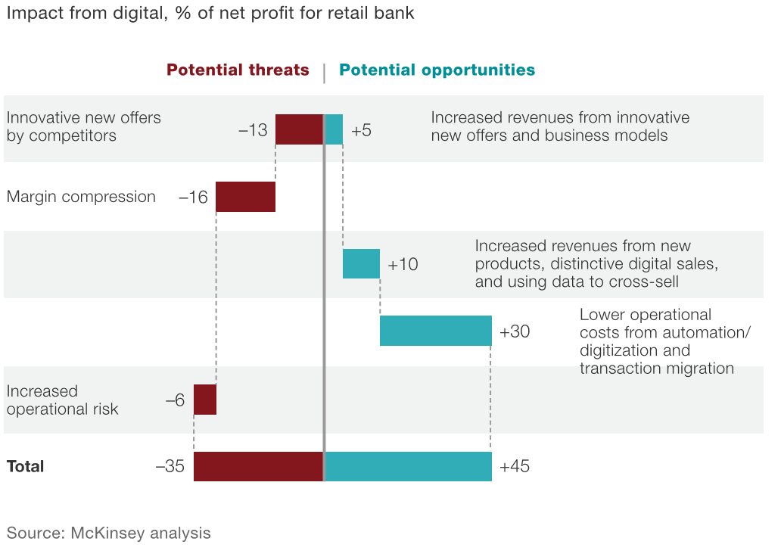

Where banks stand

Globally, more innovative incumbent banks and financial institutions are moving rapidly to embrace digital. Most have invested heavily in transaction migration. They have also significantly upgraded web and mobile technologies and created innovation and testing centers. In addition, banks increasingly realize that to succeed with digital, they must adopt the habits and culture of digitally native companies: for example, opening up the banks’ application programming interfaces, pursuing agile development, or hosting hackathons to foster intensive digital collaboration.

We expect no letup in the pace of change. Within the next five years, digital sales have the potential to account for 40 percent or more of new inflow revenue in the most progressive geographies and customer segments. By 2018, banks in Scandinavia, the United Kingdom, and Western Europe are forecast to have half or more of new inflow revenue in most products coming from digital sales. Those in the United States are expected to trail them but are still forecast to see significant new inflow revenue come from digital. Among bank products, savings and term deposits, as well as bank services to small and midsize enterprises, are expected to see more than half of new inflow revenue coming from digital by 2018 (see sidebar “Digitally disrupted revenue”).

Although these forecasts may take longer to materialize than expected, we believe the digital transformation is at an inflection point. Banks have just a few years to adapt. Appreciating the magnitude of the opportunity—and the gravity of the threat—is vital, but it is just the first step in formulating a winning digital strategy. Digital will touch every aspect of bank operations, from product development to risk management and human-capital management. Successful strategies need to be based on a clear understanding of how digital creates value, granular perspectives on consumer behavior and market dynamics, and careful prioritization by top management among hundreds of potential digital investments.

Meanwhile, new entrants are moving into the broader financial-services sector in many markets. In China, Alibaba has captured some $100 billion in assets in the second year since its launch of a wealth-management platform, while online giant Tencent is building a financial ecosystem around a large-scale online platform. The realm of payments, already digitized, is seeing more innovation from Apple Pay’s contactless-payment technology.1 1. Olivier Denecker, Sameer Gulati, and Marc Niederkorn, “[The digital battle that banks must win](https://www.mckinsey.com/industries/financial-services/our-insights/the-digital-battle-that-banks-must-win),” August 2014. In response, banks must also use digital to innovate and prosper.

### Capturing the value of digital

There are four fundamental ways in which digital capabilities can be used by banks to create value. First, digital technologies increase a bank’s connectivity—not just with customers but also with employees and suppliers. This extends from online interactivity and payment solutions to mobile functionality and opportunities to boost bank brands in social media. Second, digital draws on big data and advanced analytics to extend and refine decision making. Such analytics are being deployed by the most innovative banks in many areas, including sales, product design, pricing and underwriting, and the design of truly amazing customer experiences.

A third way that digital creates value is by enabling straight-through processing—that is, automating and digitizing a number of repetitive, low-value, and low-risk processes. Process apps, for example, boost productivity and facilitate regulatory compliance, while imaging and straight-through processing lead to paperless, more efficient work flows. Finally, digitization is a means of fostering innovation across products and business models. Examples of this include social marketing and crowdsourced support, as well as “digitally centered” business models.

For CEOs, the good news is that each of these ways of creating value through digital can be applied to every bank function. However, developing a digital agenda and driving a digitally centered transformation is a complex task. It requires an unusually high level of coordination of cross-bank initiatives spanning prioritization, resource allocation, and collaboration in execution. Moreover, most banks are only in the early stages of developing the capabilities and culture of digitally native organizations, which include several elements:

* User-centered customer-journey design. Customer journeys should be compelling and highly differentiated, combining personalization, speed, and ease of use for all processes, including applying and getting approved for a loan, opening and understanding how to make full use of an account, and reconciling payments. To make this leap in the delivery of customer journeys, banks need to act quickly to acquire deep capabilities in user experience and user interfaces.
* Personalization, leveraging data, and advanced analytics. Most data still go unused. Yet there is significant value in applying advanced analytics to create targeted offerings for cross-selling and up-selling. This is achieved by making data usable in real time, such as at the point of sale, and combining the data with analytical tools to generate insights provided by “next product to buy” models or risk assessments, for example.
* Rapid experimentation and agile development. Banks need to learn to rapidly acquire or imitate high-value initiatives, while showing tolerance of failures in trials. Banks often struggle with this trialing and testing culture. In addition, they need to move to “agile delivery,” with weekly sprints, from a “waterfall” approach in which there are months between releases. They must achieve this agile model at scale but still recognize that agile isn’t the right answer for every development effort.

While developing these capabilities is crucial, an equally critical part of the digital transformation is the need to develop a different culture (see sidebar “Habits for an effective digital transformation”). That requires adopting a mind-set similar to that found in successful digital enterprises when it comes to everything from establishing a challenging and coherent digital vision to acquiring new data capabilities and adopting a test-and-learn approach with rapid iterations.

Across the value chain—from operations and IT to marketing and sales to product development and finance—the data and technology required to realize this vision in the bank often already exists. What’s missing is the organizational orientation and mind-set to have small, cross-functional teams working together through rapid testing and improvement programs. Indeed, we have noted that many of the new capabilities required cannot be found in banks but instead need to be imported from other industries.

Becoming aware of the need for change is the first challenge that bank CEOs face. The next challenge is to take leadership in the development and execution of a holistic change program that simultaneously addresses the culture, systems, and capabilities required. Invariably, a number of issues will arise to test CEOs (see sidebar “Confronting digital dilemmas”).

The scope of these changes demonstrates that digitization is a tough, complicated journey. Capturing the opportunities it provides will require investment, painstaking planning, and coordinated decision making spanning the whole bank. Digitization is rewriting the rules of how banks compete. Incumbents that fail to grasp this risk damaging franchises built over generations. But if CEOs manage to address the multiple strategic challenges posed by digital advances, they can position their institutions to compete effectively and capture an emerging, long-term growth

//////////////////////////////

The big four banks have long operated as if they were an informal cartel. Even the one entrant in the past 20 years to grow to large-bank status, Capitec, has adopted a traditional branch-based distribution model.

a) India has a rich experience in the outsourcing industry while the

new entrants are yet to gather knowledge of the industry.

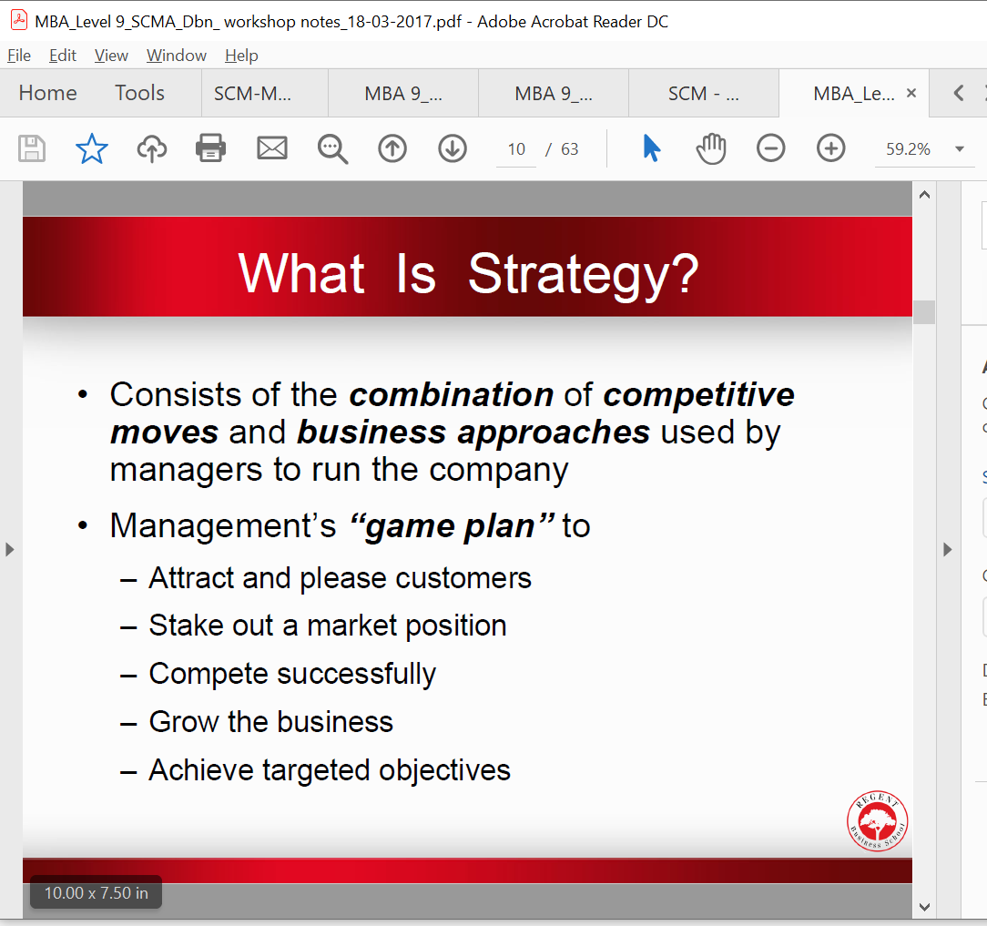

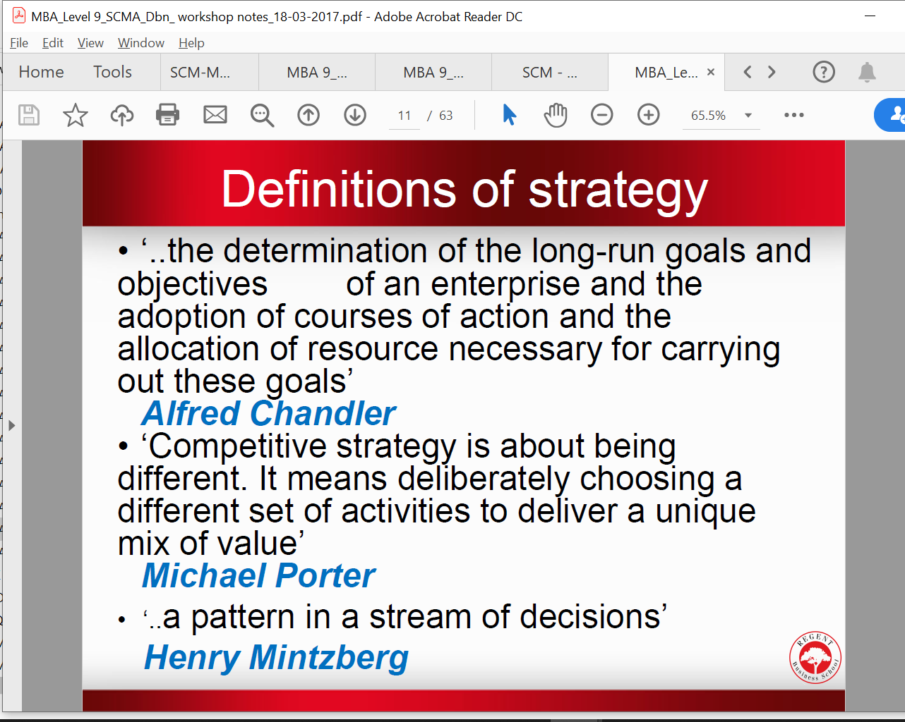

n\NBNBBNBNBNBNB

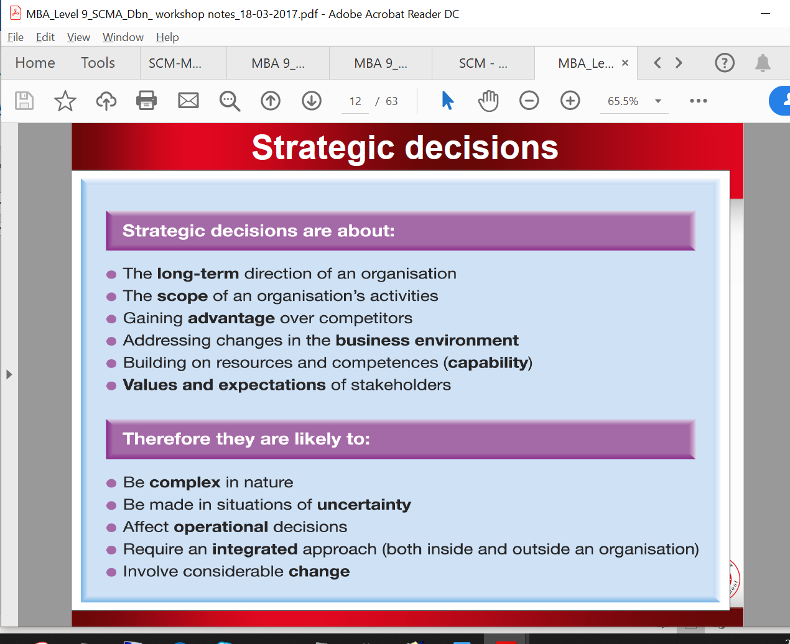

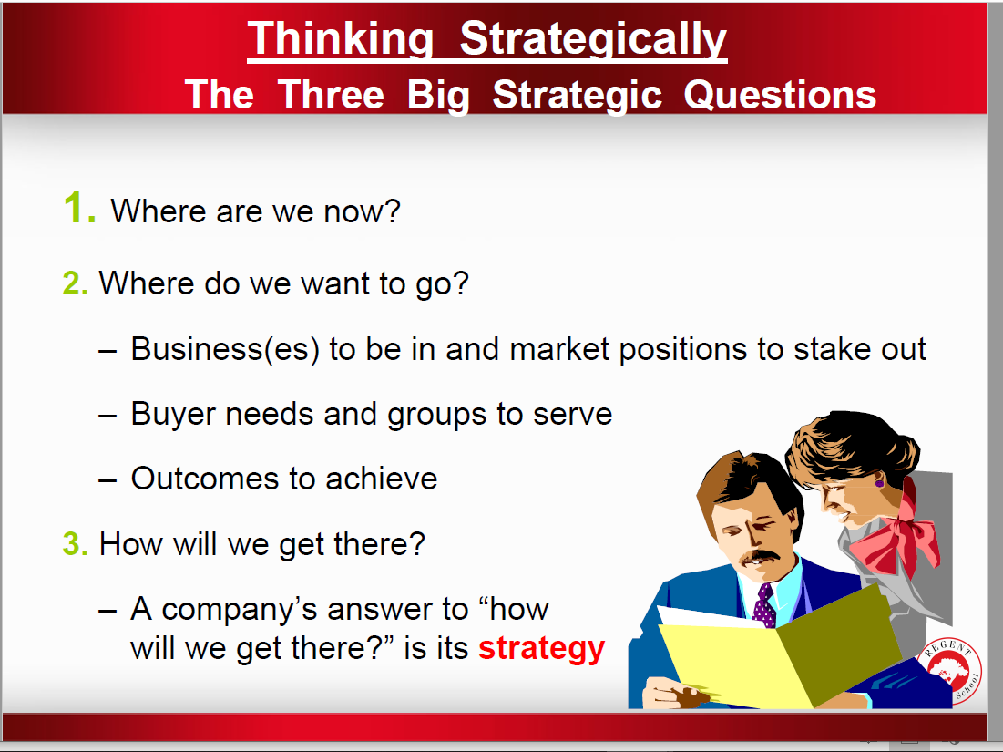

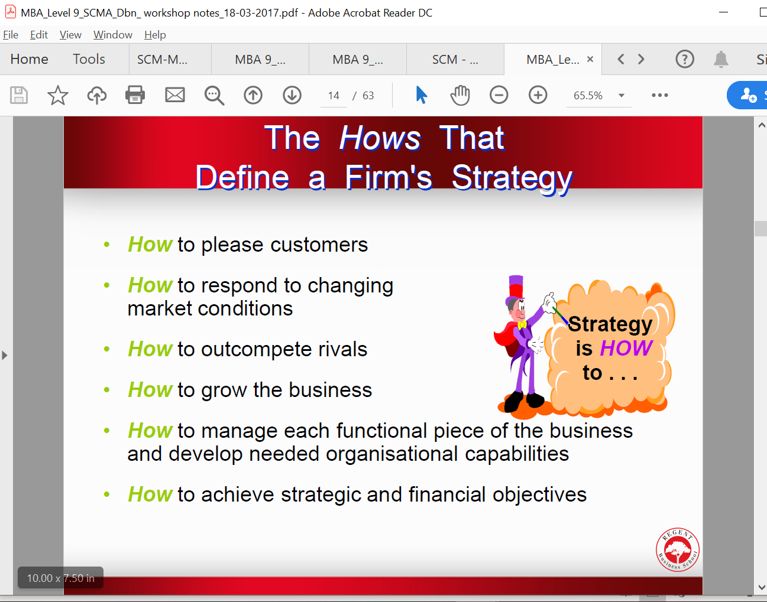

SWOT -1.3

1.5 “it will be the big four who will bear the brunt of the industry disruption”.

About this view:

1.5.1 Discuss, with reasons, the strategies the ‘big four’ banks should adopt. (8) 1.1

63FE43C8-D536-47FD-B52F-6BA82BCF7D67.pdf q3 4.1 4.2-P5 p11 1.4

Marked Assignment_Strategic Management.pdf question 3 and 4 1.1-1.3

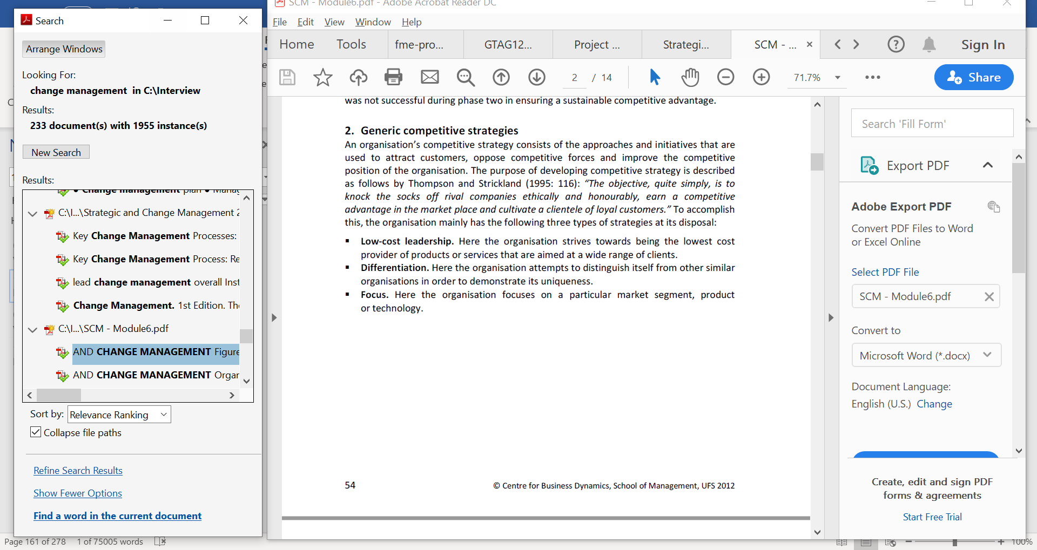

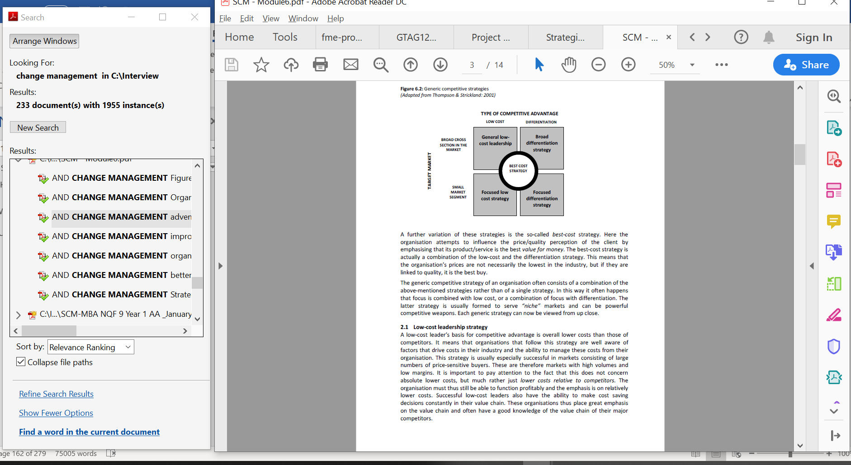





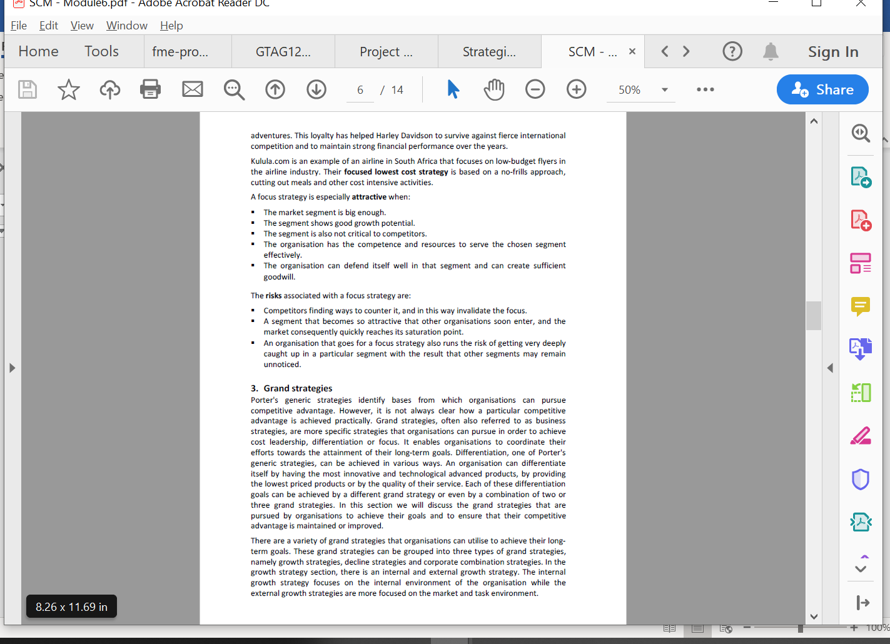

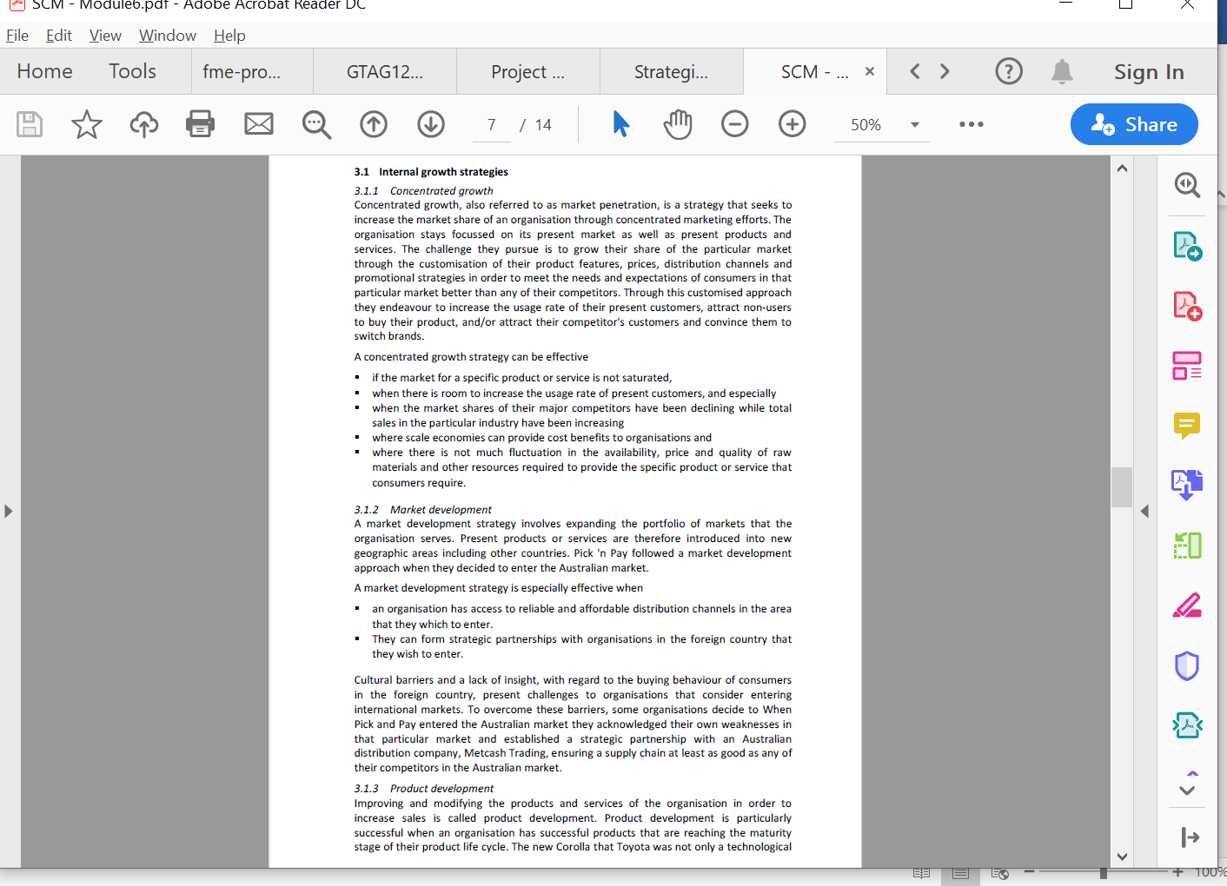



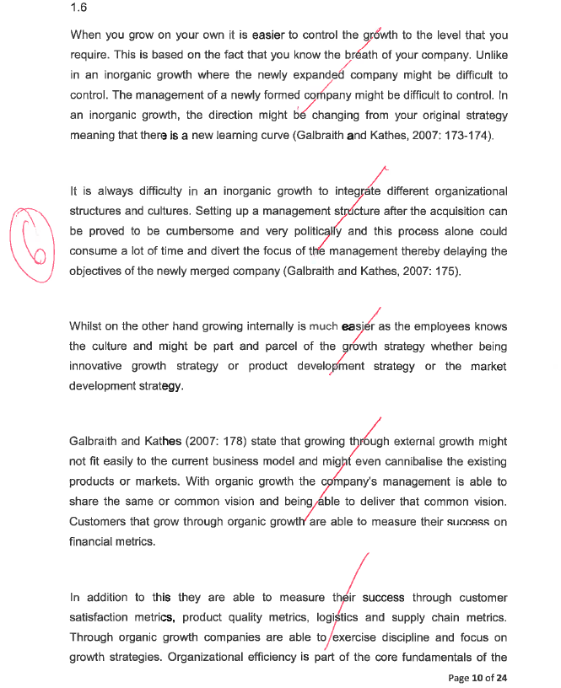

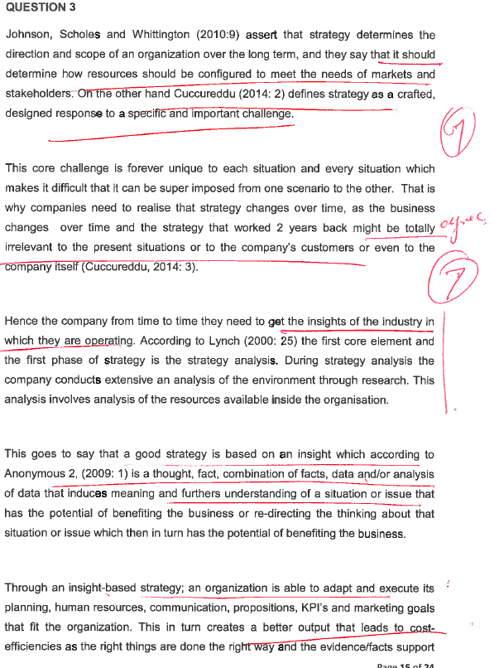

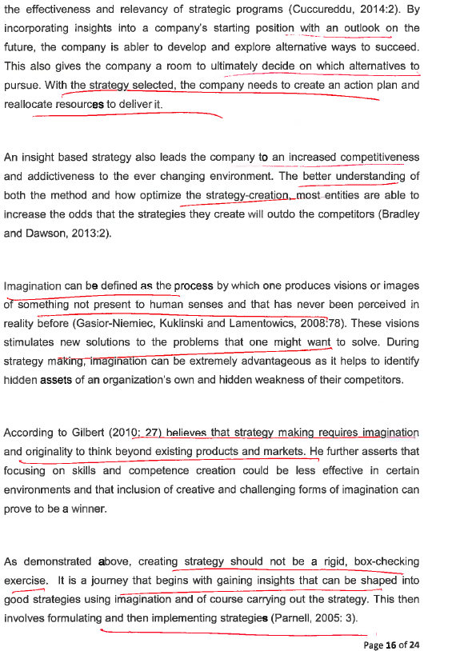

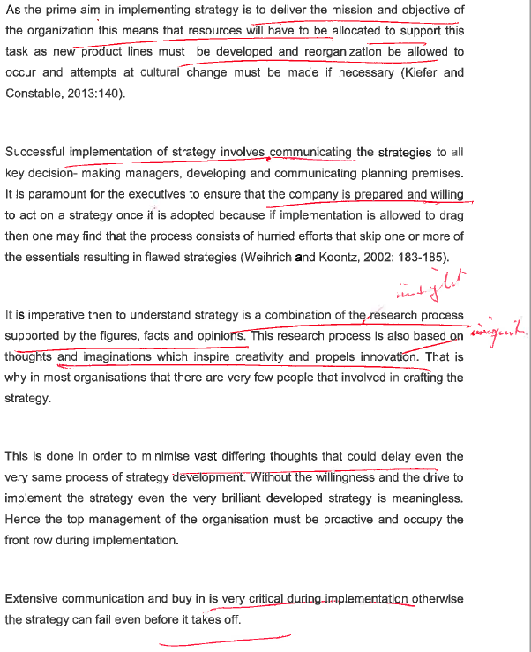

1.3

Recommendation

A strategy is a course of action to which valuable resources (including one’s own energies) will be committed (. Based on the SWOT analysis done the following were identified as Strength, Weaknesses, Opportunities and Threats and recommendations are made for each factor identified:

Recommendation

A best-cost provider strategy: which implies giving customers more value for the money by combining an emphasis on low-cost with an emphasis on upscale differentiation will be the best option to address the weakness identified. The target is to have the lowest costs and prices relative to producers of products with comparable quality and features like Chobani and big brands entering the yogurt market. Fage will also need to encourage innovation amongst its employees to ensure that new ideas are brought in into the company in the form of marketing its product. A clear vision of the company will need to be communicated with its employees to ensure good marketing of Fage products. It’s through innovation that a company is able to have good brand awareness and market its products

/////////

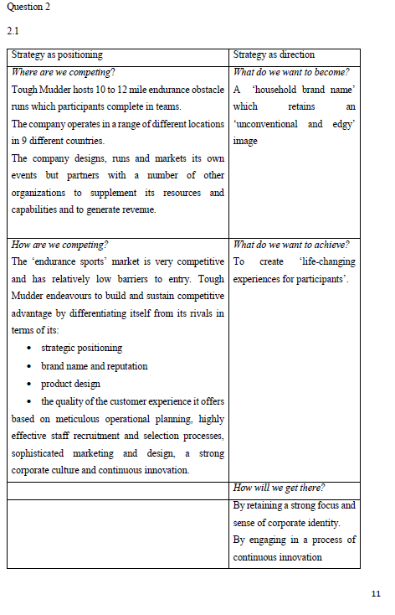



Why has the strategy been successful?

Tough Mudder’s rapid growth both in terms of number of participants and number of events as a good indication that their strategy is a success. The company is one of the market leaders and has built a loyal customer base. The company has consistent long term goals outlined in the case study. The case study emphasises the founders’ focus and their recognition of the need for a clear mission and brand. The company’s core values guide the action and behaviour of the management team. The leaders of the company have a profound understanding of the competitive environment they are in. The management team clearly recognises the threat that competition poses and pays close attention to customer feedback in order to improve the customer experience and strives to continuous update and improve the design of its obstacle courses. Objective appraisal of resources- while the company seeks to build its resources and capabilities internally through the recruitment of knowledgeable, committed and enthusiastic individuals, it also recognises the advantages of partnering with other organizations.

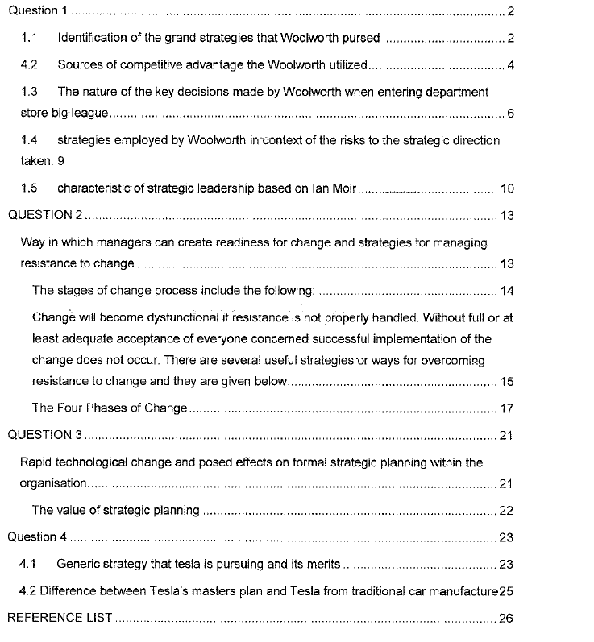

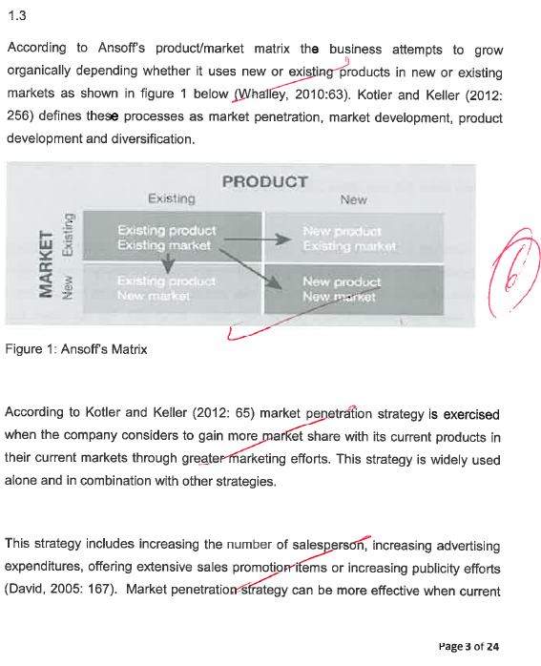

Product/market matrix

According to Ansoff’s product/market strategy matrix is when the business is attemting to grow organically based on whether it is utilizing existing or new products in existing or new markets as displayed on figure 1 below(Whalley, 2010: 63). Kotter and Keller (2012:256) describe such processes as diversification , product development , market development and market penetration.

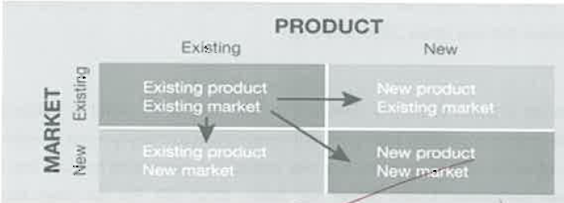

Ansoffs product/market

The strategies the ‘big four’ banks should adopt include market penetration strategy, according to Kotler and Keller(2012:65) market penetration is done when the organization is considering to obtain more market share with the existing products in the existing market via greater marketing efforts. Such strategy is broadly utilized alone and in combination with some strategies.

Such strategy involves increasing publicity efforts, providing extensive promotion of sales ,

increasing the advertising expenditure or increasing number of salesperson(David, 2005:167). Market penetration may be more effective if the existing markets are not saturated with a specific service or products. Secondly if the usage rate to present to clients may be increased significantly.

Thirdly it may be implemented if the market shares of major competitors such as Tymebank, Discovery bank and Bank zero have been declining while the total industry sales are increasing(David, 2005:167). In addition this is applicable when increased economies of scale offers major competitive advantage. Finaly this is applicable if correlation among marketing expenditure and rand sales historically has been high.

In markets that are mature organization are engaging in market penetration are using advertising so that they can increase their reputation and influence client’s brand choice(David,2005: 167). In this manner advertising assists the organization to attract many clients as a result of that it takes the client away from the competitor that means increasing their market share(Hill and Jones: 2009: 209-210).

For e.g. when Sasol chemicals considers to sell most of its petrol to Gauteng motorists that it is currently selling. Market development strategy is if organization is deciding to sell is existing products in a new market i.e. geographic markets that it has never participated on before(Kotler and Keller, 2012: 65). When Tymebank decided to lauch is South Africa that presented a market development as they were expanding in developing markets.

ZCC

Such strategy is depending on how the organization utilizing its strong brand name it has developed in the existing market to compete in the new market. When TymeBank decided to come to and launch in South African bank market this was a market development strategy as it took part outside its traditional market.??????????

According to David(2005:168) market development strategy can be effective if there are inexpensive, reliable , available and good quality distribution channels that are new. If an organization is very successful and strong at what it is doing. Thirdly if there are available unsaturated and untapped market. This is often applicable if the developed company from developed economies is seeking to expand in less growth and developed economies such as South America and Africa.

Additionally market development is applicable if entity’s basic industry becomes expenditiously global in scope(David, 2005: 168). Many entities which are having excess production capacity in their home countries are normally following such strategy. Finally if the entity is having the available human resource and capital to manage expanded operations.

Kotler and Keller(2012: 65) suggest that product development strategy is when an organization is developing new products of potential interests to its current markets like the challenger banks did. The new product can replace the existing products which the strategies that the ‘big four’ banks should adopt by replacing their existing products. Product development is essential when it comes to building market share and maintaining product differentiation. Many organizations are utilizing such strategy to improve and fine tune their business model such as Tymebank, discovery bank and bank zero’s model(Hill et al, 2009:210).

David(2005: 1680) suggest that product development strategy includes refining amd improving the products vua research and development. According to hill et al(2009:210) this type of strategy may be as brutal as a price war because it is costly and is contributing dramatically to increased cost structure. For e.g. when RBS(Regent Business School) develops a DBA(Doctor of Business Admistration) it targets existing Masters of Business Administration learners and the ones which finished their Masters of Business Administration degrees this can be called initiative of product development .

According to David(2005: 168-169) the list below is beneficial when implementing the product development strategy.

When a company is having successful products which are in maturity stage of the product life cycle.

Secondly when a company is competing in industry which is characterized by rapid technological developments.

When major competitors provide better quality products at **cheaper price.**

When a company is having especially strong research and development strategies.

When a company is competing in a high growth industry such as banking industry.

DIVERSIFICATION???????????? P8

Finally diversification strategy is when a company is developing new products for new

////////////////////////

Nbnbnnb

1.2 Strategic Options available to Fage

Option 1:

There are 5 Generic Competitive Strategies Thompson et al. (2006:134) is identifying 5 generic competitive strategies:

1. A strategy of low-cost leadership: this appeals to a wide spectrum of clients depending on being the entire low-cost provider of a service or product.

2. A broad differentiation strategy: seeking to differentiate the company’s product offering from rivals’ in ways that will appeal to a broad spectrum of buyers.

3. A best-cost provider strategy: giving customers more value for the money by combining an emphasis on low-cost with an emphasis on upscale differentiation; the target is to have the best (lowest) costs and prices relative to producers of products with comparable quality and features.

4. A focused or market niche strategy based on lower cost: concentrating on a narrower buyer segment and out-competing rivals by serving niche members at a lower cost than rivals.

5. A focused or market niche strategy based on differentiation: concentrating on a narrow buyer segment and out-competing rivals by offering niche members a customised product or service that meets their tastes and requirements better than rivals’ offerings.

Option 2:

Red oceans Strategy option:

Red oceans are existing market spaces, with known products, strategies and competitors. Low-price and quality are some of the factors that the competition is based-on. The market is overcrowded and the goal is to acquire more market shares every year. All actors’ positions are well-known and it is almost impossible for new entrants to settle and compete. Profit and growth are limited due to the strong competition.

Option 3:

Blue Ocean Strategy option:

To create a blue ocean is a necessity for companies who want to ‘move on’. Several factors as globalisation, technology, innovation, prices, and market shares are factors leading companies to choose their best solution: a blue ocean strategy. The strategy is to create a new demand and head in another direction from competition.

All these steps will help for formulating the blue ocean strategy by reconstructing the market boundaries.

The first step indicates that value innovation can be done between alternative industries. Indeed, opportunities will be created due to products and services, different forms but serving a shared goal.

The second step suggests that the creation of a blue ocean is possible by proposing a common key factor from all strategic groups. The third step points out that a blue ocean can be created by challenging established thoughts about who are the buyers and users.

The fourth step underlines the fact that companies need to find a complete solution for their products or services. For example, a restaurant can open a crèche for customer’s kids. The fifth step suggests adding emotion to products or services. The sixth step recommends identifying issues, trying to find solutions and forecast them

In order to develop a company’s strategic canvas, leaders will have to: a) Share their vision and make it understandable for all employees. Employees need to know the situation of the company, and its position in the marketplace. They need to share the vision in order to feel as a part of a bigger plan. b) Know their customers. A company must know their customers habits. This results in competitive advantage, since leaders will know the pros and cons of every product. c) Ask employee’s for their inputs into strategic decisions. This will assist in attaining ‘the buy-in’ of the strategy by employees, since they have a say in the direction it may pursue. d) Communicate with all services. A leader must keep his teams informed. A company operating a blue ocean should have two main goals about users: to keep their customers, but more importantly, to reach their non-customers. e) To reach beyond existing demand is one of the key components of achieving value innovation. To succeed, companies have to focus on existing customers and non-customers in order to maximise the size of the blue ocean.

According to Kim and Mauborgne (2005), “non-customers can be classified into three different tiers”:

The first tier, “Soon-to-be,” represents ‘future customers’ who are in search of improved or better products. Some factors may make these individuals reluctant to buy the initial product, but with some minor modifications to the product, customers will buy the revised product. This category also includes non-regular customers who choose your product since there is nothing better on the market. Companies should try to find out what customers want, so that their needs will be satisfied by newly adapted products, which in turn, may also attract new customers. A blue ocean will be created from this intervention. Additionally, non-customers provide better product feedback than existing customers.

The second tier, “Refusing,” represents non-customers who are of the opinion that the products companies offer is unaffordable or not adapted to their demands. The goal here is to address these concerns in order to expand the market.

The third tier, “Unexplored,” represents non-customers who have never used or explored your product or service. Indeed, their needs are fulfilled by other markets.

Best option for Fage

Based on the three options proposed above, the Blue Ocean Strategy will be the best option for the Fage company. By implementing the strategies proposed, Fage will be able to increase their market base, they will be able to retain and get new customers. Being able to get continual feedback will assist Fage to improve their product in order to satisfy their customers.

1.3

/////////

**3.1 Internal growth strategies**

*3.1.1 Concentrated growth*

Concentrated growth, also referred to as market penetration, is a strategy that seeks to

increase the market share of an organisation through concentrated marketing efforts. The

organisation stays focussed on its present market as well as present products and

services. The challenge they pursue is to grow their share of the particular market

through the customisation of their product features, prices, distribution channels and

promotional strategies in order to meet the needs and expectations of consumers in that

particular market better than any of their competitors. Through this customised approach

they endeavour to increase the usage rate of their present customers, attract non-users

to buy their product, and/or attract their competitor's customers and convince them to

switch brands.

A concentrated growth strategy can be effective

▪ if the market for a specific product or service is not saturated,

▪ when there is room to increase the usage rate of present customers, and especially

▪ when the market shares of their major competitors have been declining while total

sales in the particular industry have been increasing

▪ where scale economies can provide cost benefits to organisations and

▪ where there is not much fluctuation in the availability, price and quality of raw

materials and other resources required to provide the specific product or service that

consumers require.

*3.1.2 Market development*

A market development strategy involves expanding the portfolio of markets that the

organisation serves. Present products or services are therefore introduced into new

geographic areas including other countries. Pick 'n Pay followed a market development

approach when they decided to enter the Australian market.

A market development strategy is especially effective when

▪ an organisation has access to reliable and affordable distribution channels in the area

that they which to enter.

▪ They can form strategic partnerships with organisations in the foreign country that

they wish to enter.

Cultural barriers and a lack of insight, with regard to the buying behaviour of consumers

in the foreign country, present challenges to organisations that consider entering

international markets. To overcome these barriers, some organisations decide to When

Pick and Pay entered the Australian market they acknowledged their own weaknesses in

that particular market and established a strategic partnership with an Australian

distribution company, Metcash Trading, ensuring a supply chain at least as good as any of

their competitors in the Australian market.

*3.1.3 Product development*

Improving and modifying the products and services of the organisation in order to

increase sales is called product development. Product development is particularly

successful when an organisation has successful products that are reaching the maturity

stage of their product life cycle. The new Corolla that Toyota was not only a technological

improvement on the previous model, but it also boasted a new sporty look that appealed

to a wider audience. With this strategy Toyota did not only increase sales, but also

expanded their market to include the younger generation.

Product development is essential for organisations that compete in industries that are

characterised by rapid technological developments, especially when their major

competitors offer better quality products at comparable prices. However, this strategy

demands huge capital investment with regard to research and development, as

technology and the attainment of appropriate human resources.

*3.1.4 Innovation*

Organisations that have distinct technological competencies and capital reserves to invest

in research and development find it profitable to make innovation their grand strategy.

Instead of concentrating on extending the life cycle of their products or services through

differentiation and product development, these organisations create new product life

cycles that will make similar existing products or services obsolete. While most growthoriented

organisations innovate from time to time, organisations that make innovation

their grand strategy use innovation as the fundamental way of relating to their markets.

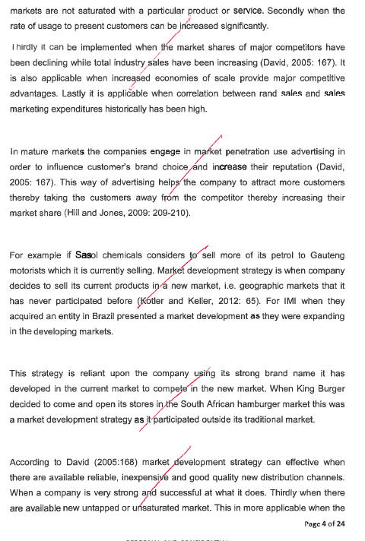

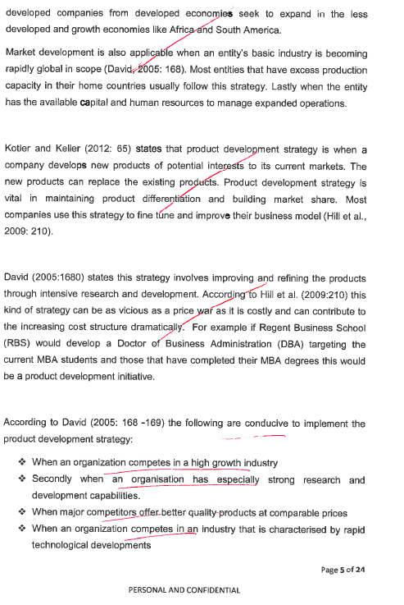

Xxxxxxxxxxx

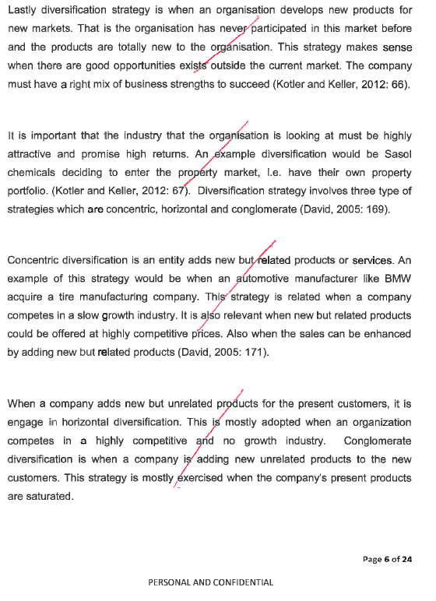

Ttttttttttttttttttttyme

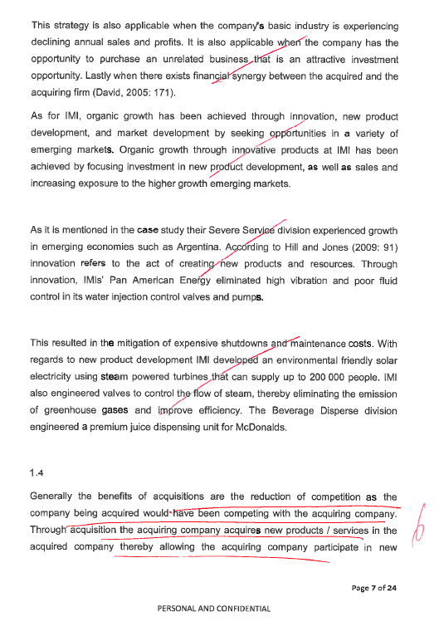

1.4 AcqusitionXxxxxxxxxxxxxxx EEEEEEEEEEEEEEEEEENTRY

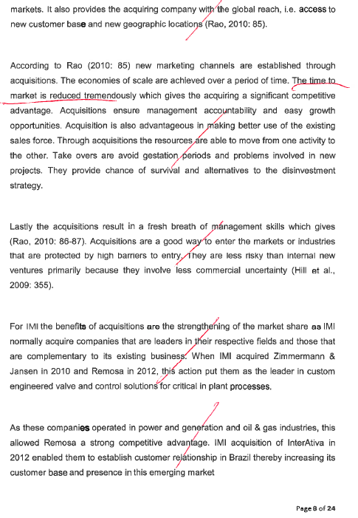

GROWTH STRATEY

1.5 TYME 120 000

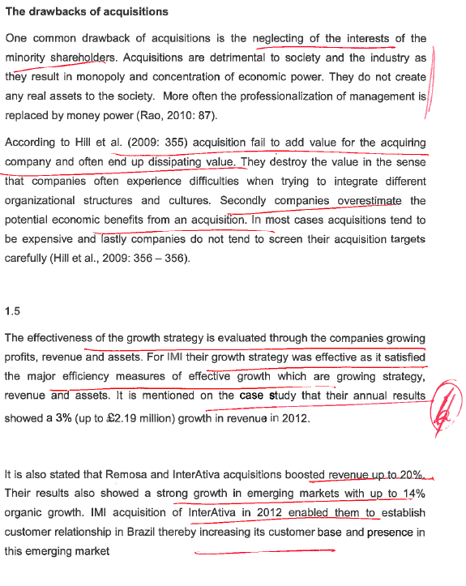

INORGANIC

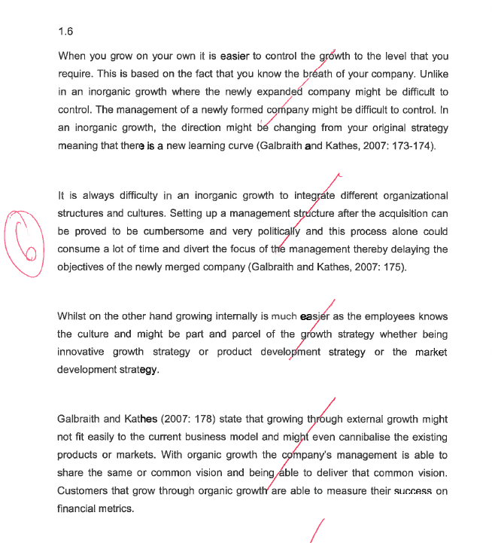

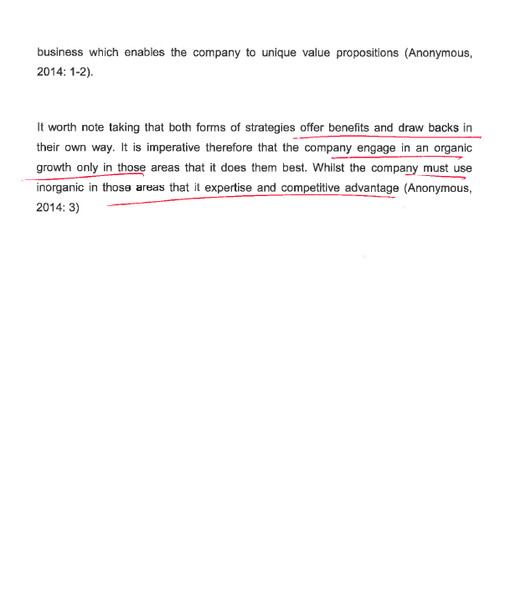

Bureaucratic process?????????????

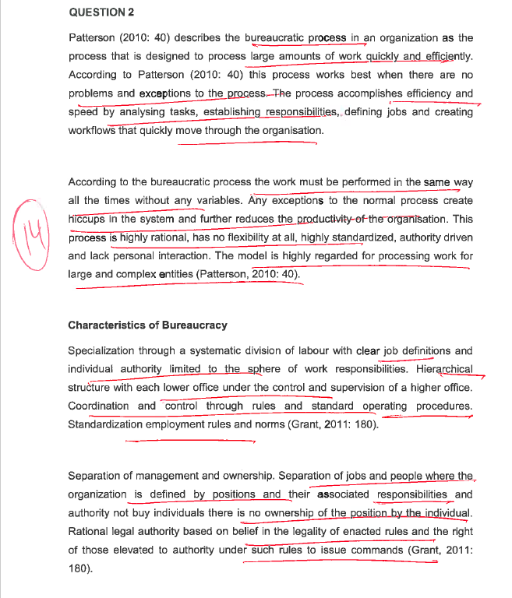

Strategy implementation / organizational structure

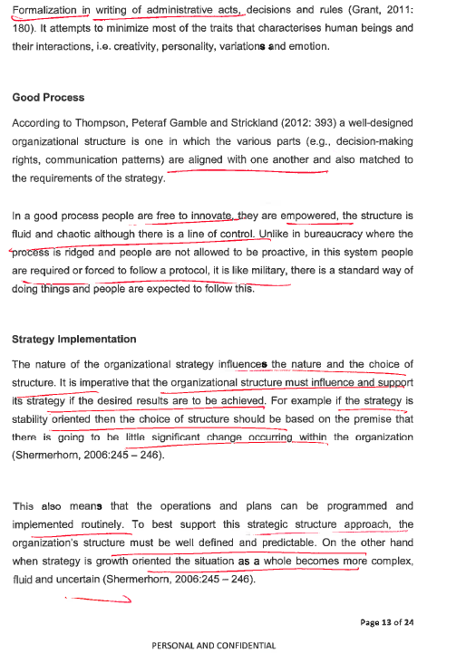

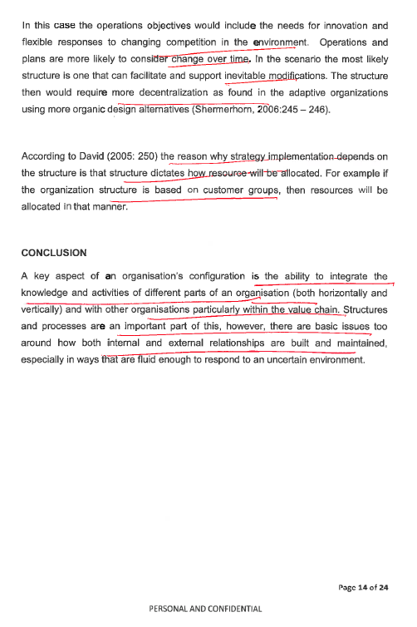

Strategy nbnbnbnb Strategy analysis

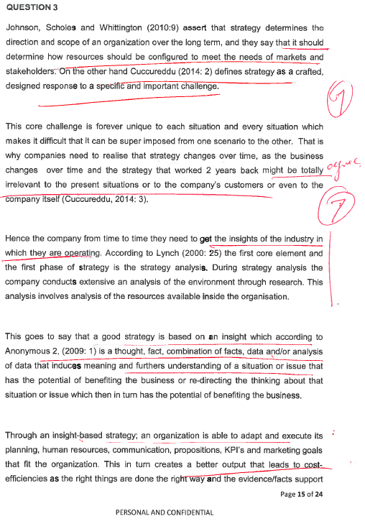

Insight based strategy and implement strategy

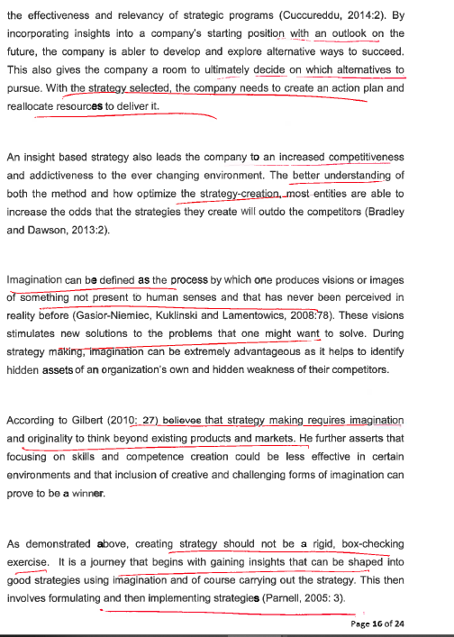

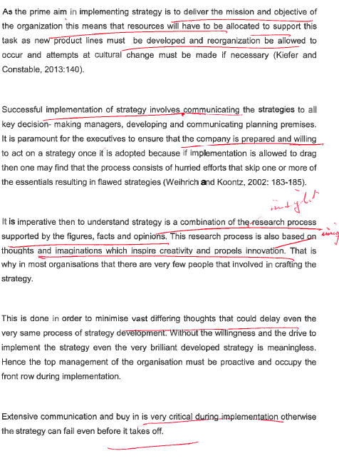



QUESTION 4???????????????????? DIAGOSIS

Digital banking

Cloud

**Discussion questions**

Discuss the circumstances where low costs and differentiation strategies will work

best.

Develop a competitive strategy for your organisation.

Anything that an organisation does especially well compared to its rivals

What Is Strategy?

Consists of the ***combination*** of ***competitive moves*** and ***business approaches*** used by managers to run the company

•Management’s ***“game plan”*** to

–Attract and please customers

–Stake out a market position

–Compete successfully

–Grow the business

–Achieve targeted objectives

• ‘..the determination of the long-run goals and objectives of an enterprise and the adoption of courses of action and the allocation of resource necessary for carrying out these goals’

***Alfred Chandler***

• ‘Competitive strategy is about being different. It means deliberately choosing a different set of activities to deliver a unique mix of value’

***Michael Porter***

• ‘..a pattern in a stream of decisions’

***Henry Mintzberg***

A

Strategic Approaches to Building Competitive Advantage

Strive to be the industry’s low-cost provider

•Outcompete rivals on a key differentiating feature

•Focus on a narrow market niche, doing a better job than rivals of serving the unique needs of niche buyers

•Develop expertise, resource strengths, and capabilities not easily imitated by rivals

NBNBNBNB

**Strategic Management is Gaining and Maintaining Competitive Advantage**

Anything that an organisation does especially well compared to its rivals

**Achieving Sustained Competitive Advantage**

1. Continually adapting to changes in external trends and events and internal capabilities, competencies, and resources **Achieving Sustained Competitive Advantage**

2. Effectively formulating, implementing, and evaluating strategies that capitalize on those factors

**Benefits of Strategic Management**

Nonfinancial Benefits

–Enhanced awareness of threats

–Improved understanding of competitors’ strategies

–Increased employee productivity

–Reduced resistance to change

–Clearer understanding of performance-reward relationship

–Enhanced problem-prevention capabilities

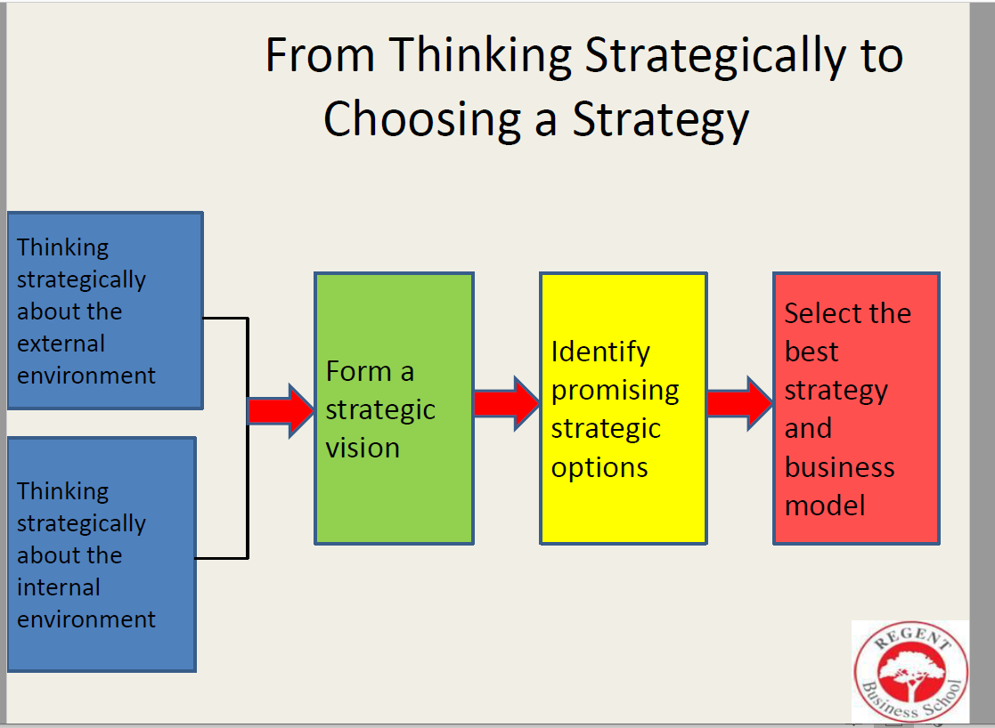

Strategic Capability

The capabilities of an organisation that contribute to its long-term survival or competitive advantage

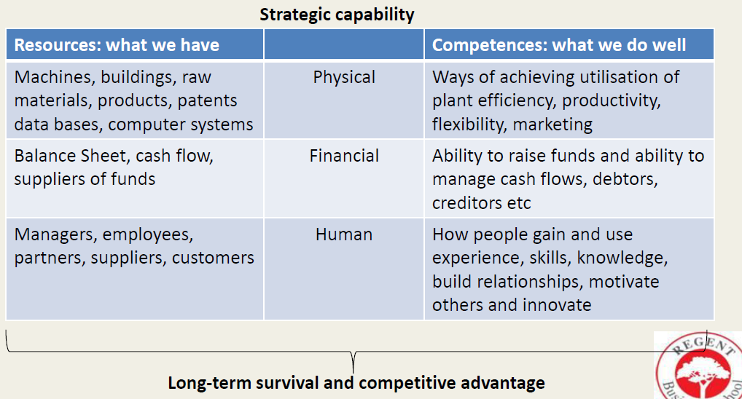

Strategic

**A *strategic vision* concerns a firm’s *future* business path - *“where we are going”***

– **Markets to be pursued Future technology-product-customer focus**

– **Kind of company management is trying to create**

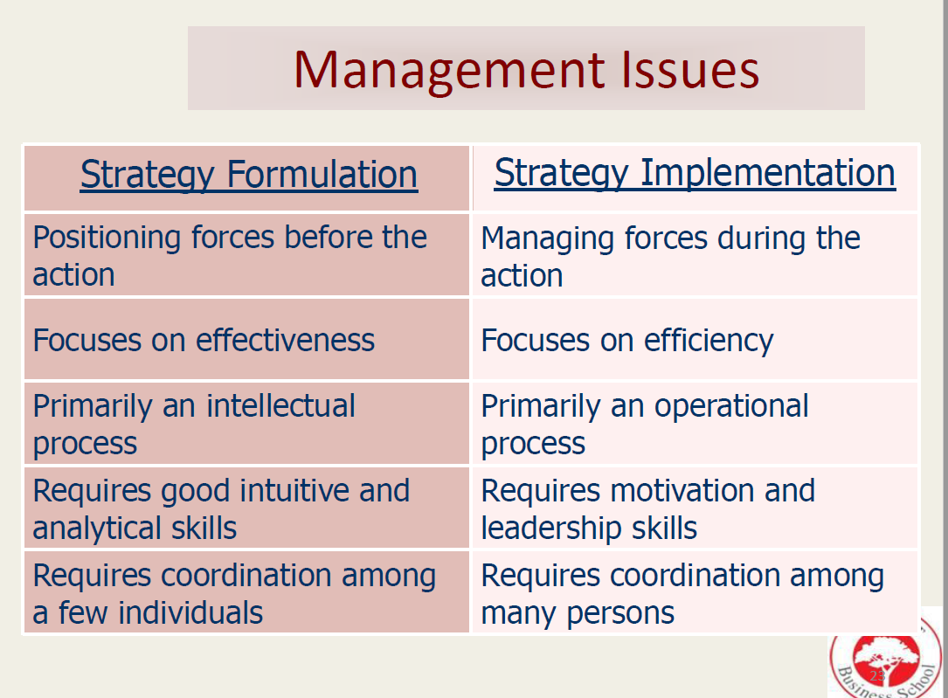

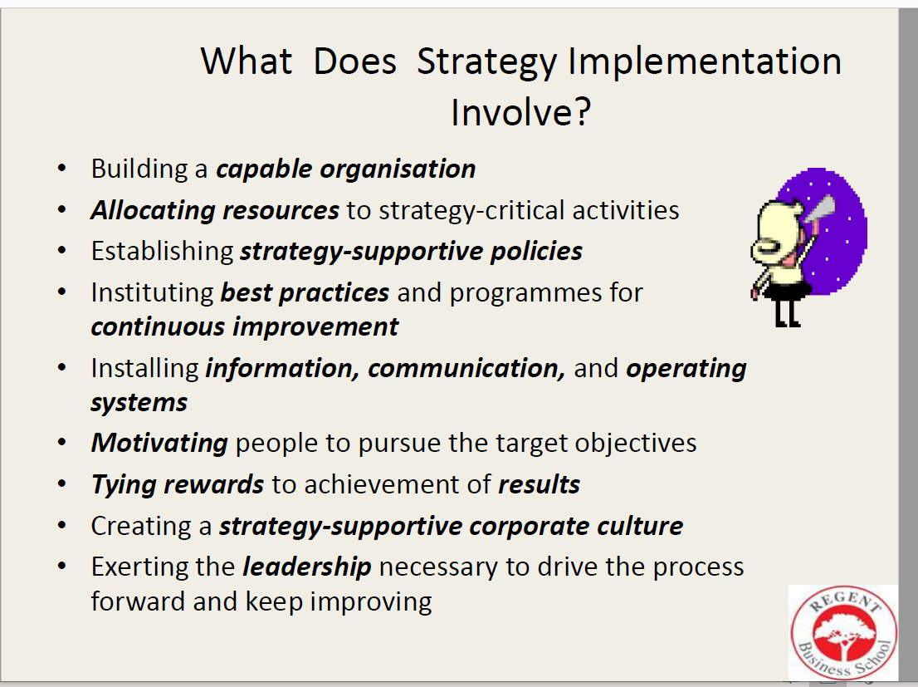

NBNBNBNBNBNBNBNBNBNB

Characteristics of Good Strategy Execution

Involves ***creating strong “fits” between strategy*** and

–Organizational capabilities

–Reward structure

–Internal operating systems

–Organisation’s work climate and culture

•The ***stronger the “fits***” the

–Better the execution

–Higher a company’s odds of achieving its performance targets

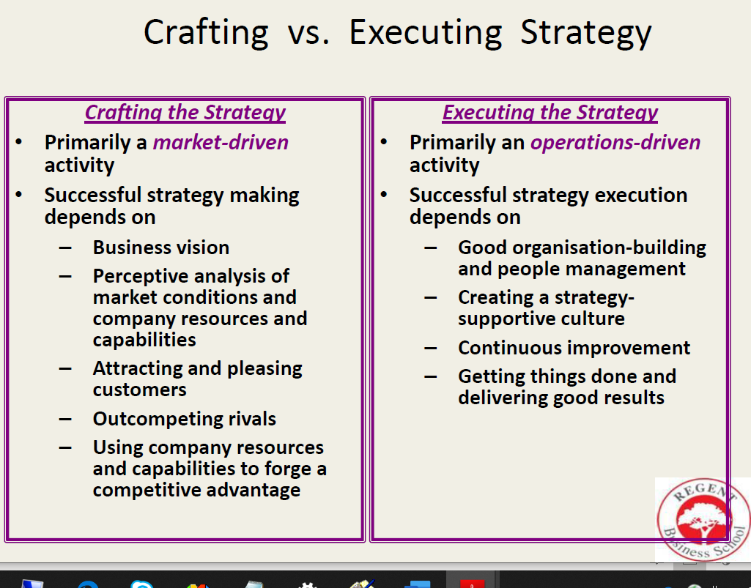

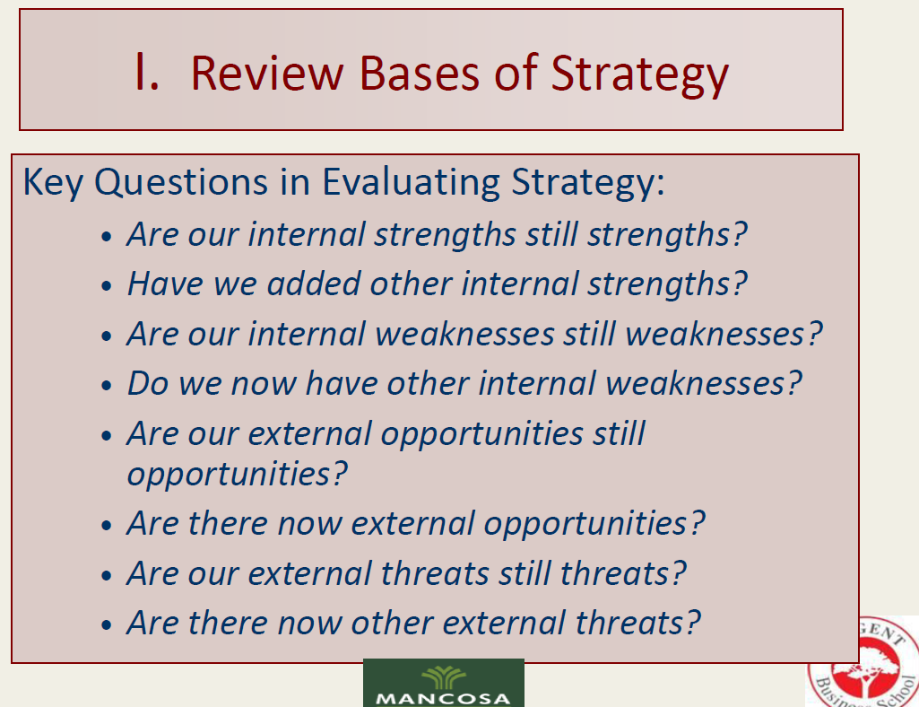

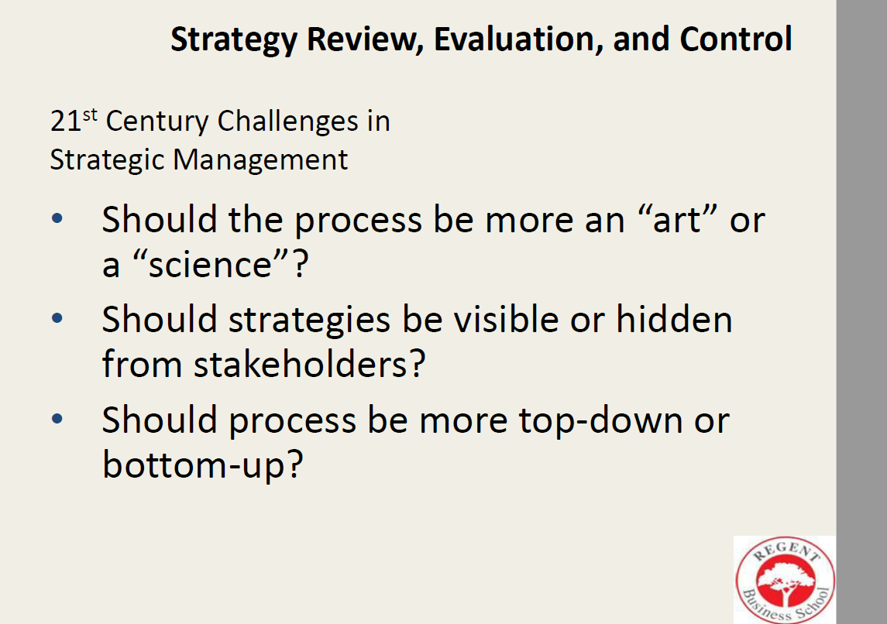

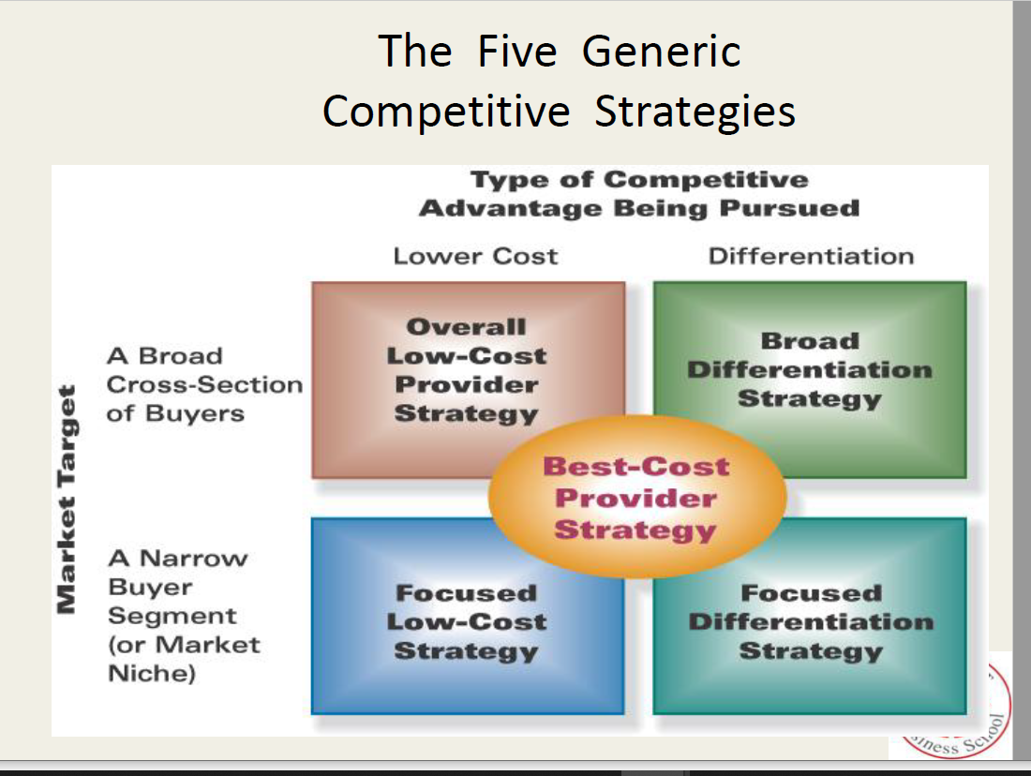

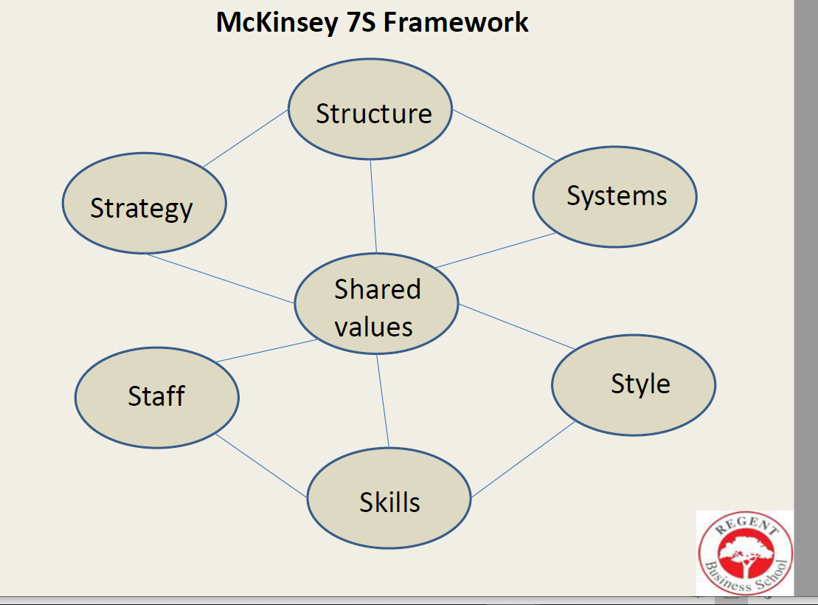

McKinsey 7S Framework

Starting point is the strategy

•Strategy drives organisational structure and must fit the culture of the organisation

•Culture is based on the shared values and is especially influenced by the style of leadership.

•The systems will be determined through, and influenced by, the organisation’s structure.

•Structure and systems will define what staff and skills are required.

Seven components

•**Strategy** – the plan devised to maintain and build competitive advantage

•**Structure** – indicates the way the organisation is structured and who reports to whom

•**Systems** – involves the daily activities and procedures (e.g. the IT systems) that staff members engage in to get the job done.

•**Shared values** – or “super-ordinate goals”, the core values of the organisation that are evidenced in the corporate culture and organisational ethics

•**Style** – the style of leadership applied in the organisation

•**Staff** – the employees and their general capabilities

•**Skills** – the actual skills and competencies of the employees needed to do the work in the organisation

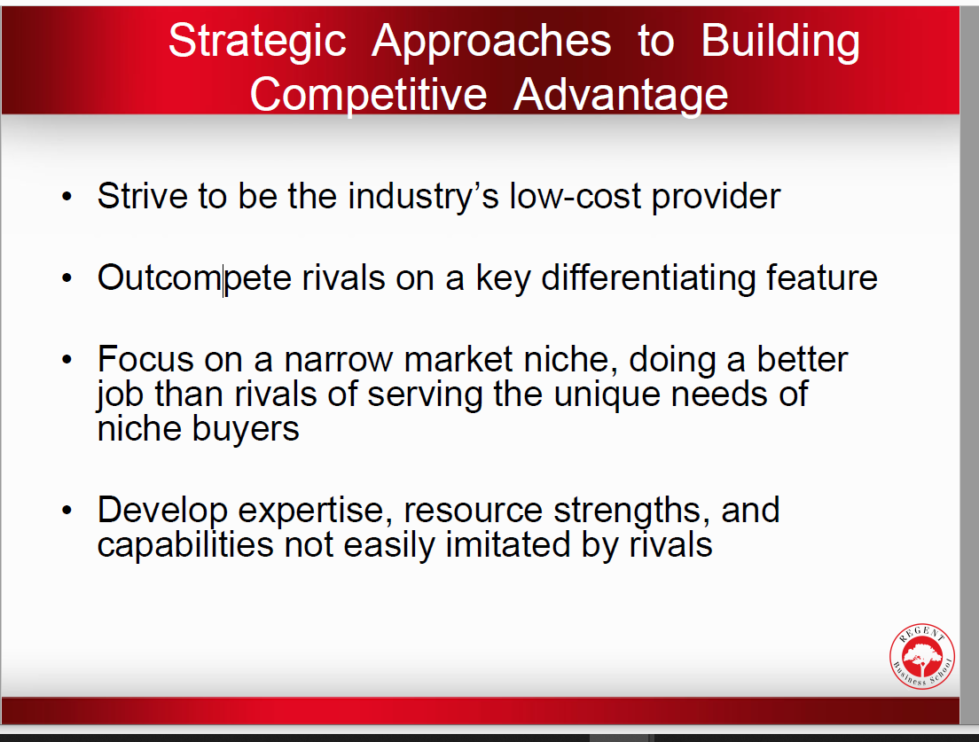

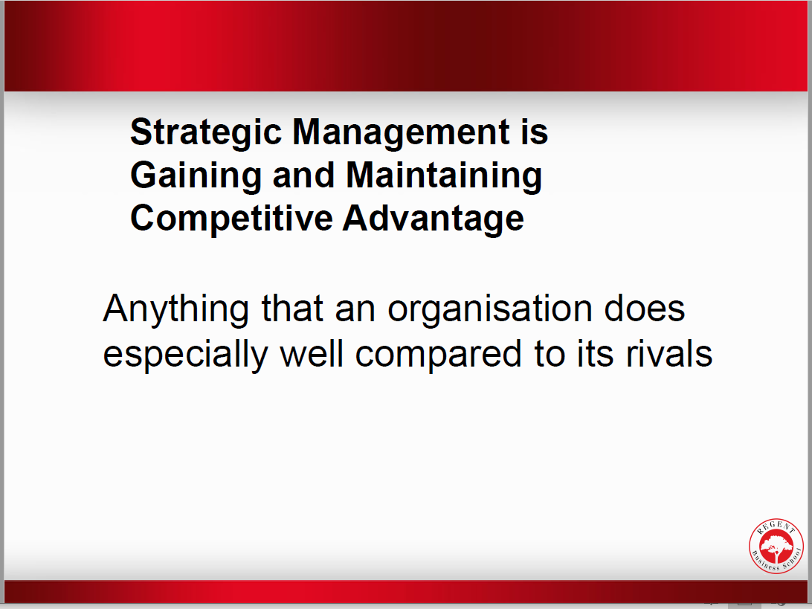

**1. Strategic and competitive advantage**

The primary goal of strategic management is to enable organisations to adapt to changes

in the environment in such a way that the success and long-term survival of the

organisation is ensured. Since 1994 South Africa has gradually entered the global business

arena and local companies today have to compete with international companies for the

disposable income of consumers, both locally and internationally. In an organisation

arena where competition is constantly increasing, success and survival is dependent on

the attainment of a competitive advantage. This means that the organisation has to

distinguish itself from competitors through distinctive competencies (special capabilities,

technologies or resources) that these competitors will not be able to copy readily.

Activities like innovative product design, low-cost-manufacturing, superior quality and

efficient after-sale service are examples of competitive advantages that are created from

distinct competencies like superior technology, committed and qualified human

resources (intellectual capital), a visionary leadership style and pro-active management.

Competitive strategies must be based on some source of competitive advantage to be

successful. One of the competitive advantages that distinguish Woolworths from its

competitors is their ability to ensure the freshness and quality of their products through

excellent supply chain management (distinctive competency). It is clear that winning

strategies are anchored in a sustainable competitive advantage. The organisation’s

strategy must attempt to influence the size and length of the organisation’s competitive

advantage. Figure 6.1 illustrates this relationship.

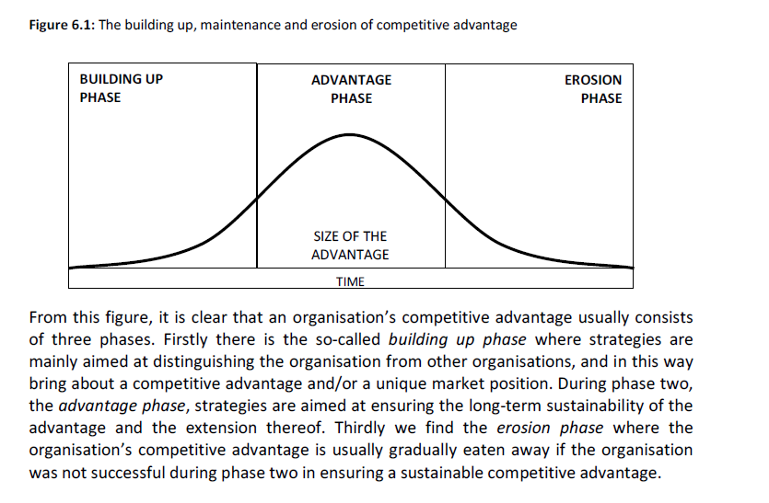

**2. Generic competitive strategies**

An organisation’s competitive strategy consists of the approaches and initiatives that are

used to attract customers, oppose competitive forces and improve the competitive

position of the organisation. The purpose of developing competitive strategy is described

as follows by Thompson and Strickland (1995: 116): *“The objective, quite simply, is to*

*knock the socks off rival companies ethically and honourably, earn a competitive*

*advantage in the market place and cultivate a clientele of loyal customers.”* To accomplish

this, the organisation mainly has the following three types of strategies at its disposal:

▪ **Low-cost leadership.** Here the organisation strives towards being the lowest cost

provider of products or services that are aimed at a wide range of clients.

▪ **Differentiation.** Here the organisation attempts to distinguish itself from other similar

organisations in order to demonstrate its uniqueness.

▪ **Focus.** Here the organisation focuses on a particular market segment, product

or technology.

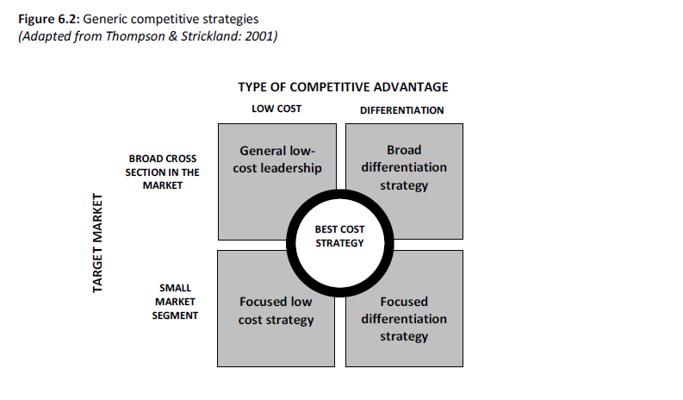

A further variation of these strategies is the so-called *best-cost* strategy. Here the

organisation attempts to influence the price/quality perception of the client by

emphasising that its product/service is the best *value for money*. The best-cost strategy is

actually a combination of the low-cost and the differentiation strategy. This means that

the organisation’s prices are not necessarily the lowest in the industry, but if they are

linked to quality, it is the best buy.

The generic competitive strategy of an organisation often consists of a combination of the

above-mentioned strategies rather than of a single strategy. In this way it often happens

that focus is combined with low cost, or a combination of focus with differentiation. The

latter strategy is usually formed to serve *“niche”* markets and can be powerful

competitive weapons. Each generic strategy can now be viewed from up close.

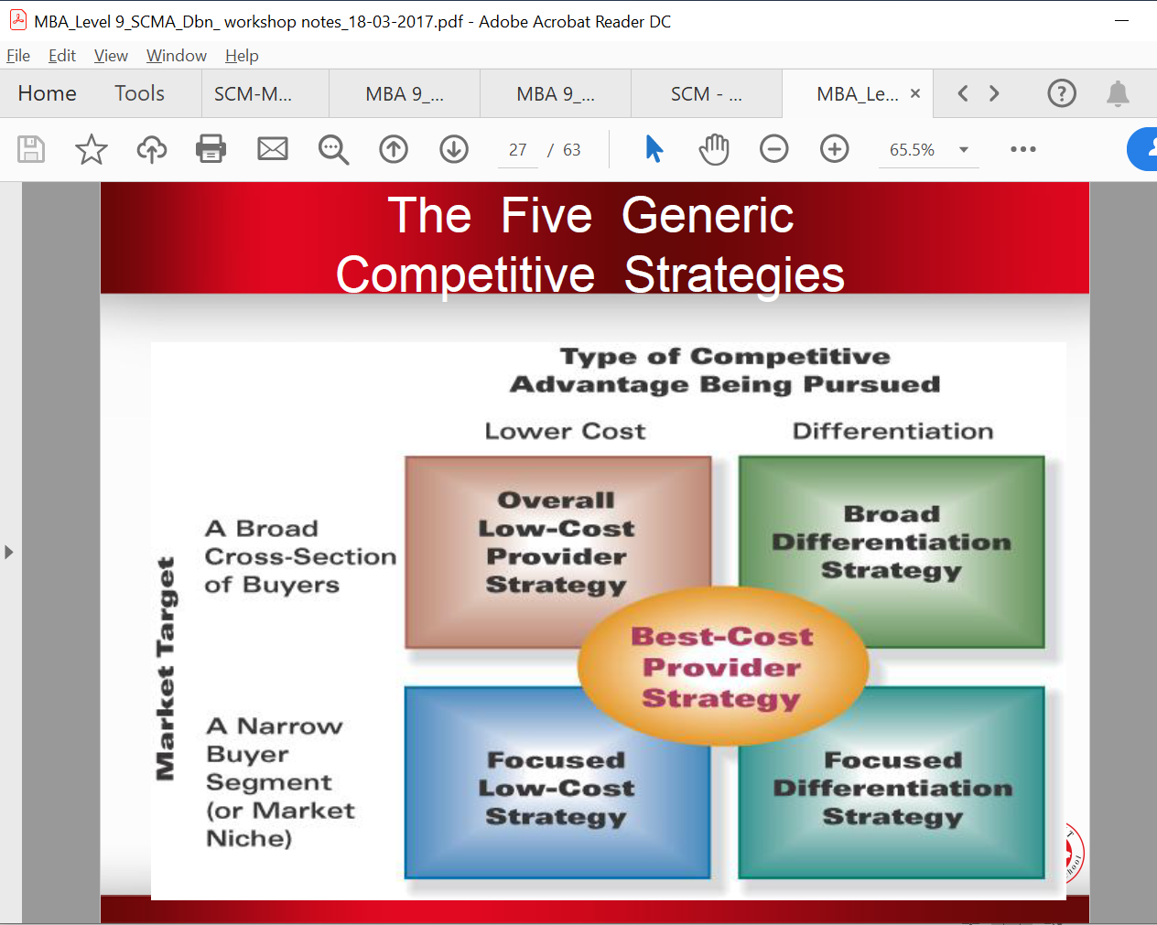

**2.1 Low-cost leadership strategy**

A low-cost leader’s basis for competitive advantage is overall lower costs than those of

competitors. It means that organisations that follow this strategy are well aware of

factors that drive costs in their industry and the ability to manage these costs from their

organisation. This strategy is usually especially successful in markets consisting of large

numbers of price-sensitive buyers. These are therefore markets with high volumes and

low margins. It is important to pay attention to the fact that this does not concern

absolute lower costs, but much rather just *lower costs relative to competitors*. The

organisation must thus still be able to function profitably and the emphasis is on relatively

lower costs. Successful low-cost leaders also have the ability to make cost saving

decisions constantly in their value chain. These organisations thus place great emphasis

on the value chain and often have a good knowledge of the value chain of their major

competitors.

Organisations pursue cost leadership for one of the following two reasons:

▪ To provide the lowest prices to consumers in order to gain market share in a

particular industry. This strategy is particularly successful in industries where the

market is price sensitive. In South Africa, a market that is very price-sensitive is the

disposable diaper market. These products are used by the parents of infants on a

constant basis over a period of at least two years and the money spent on diapers on

a monthly basis contribute significantly to the household budget.

▪ To provide the organisation with a bigger profit margin. Organisations that pursue this

strategy do not pursue price leadership, but focus on maximising their profits. Vast

capital resources are an extremely valuable competitive advantage as this provides

organisations with a variety of strategic alternatives when it comes to defending or

expanding the market share of the organisation. Should their competitors for instance

decide to embark on a price war, these organisations will be able to lower their prices

substantially (even below cost price) for a prolonged period in order to defend their

market share position. This could even lead to higher sales and therefore

bigger profits.

A low-cost leadership strategy operates **best** in the following circumstances:

▪ When tough price competition exists.

▪ The products in the industry are reasonably standardised and buyers cannot really be

lured on the basis of product characteristics.

▪ If there are not many ways on the basis of which product differentiation can be

brought about.

▪ Most buyers apply the product in the same way.

▪ When the changeover costs are very low for buyers.

▪ When there are big buyers that dominate the market and have a substantial influence

on prices.

A low-cost leadership strategy is **risky** when:

▪ Technological breakthroughs occur often in the industry.

▪ Cost advantages can easily be imitated by competitors.

▪ The organisation focuses so much on lower costs that other market tendencies and

movements pass unnoticed.

**2.2 Differentiation strategy**

The essence of a differentiation strategy is to be unique in a way that is valuable to the

buyer, and is also sustainable. Organisations can distinguish themselves and their

products/services in various ways from other organisations. Areas where differentiation

can be applied include, among others, the following: Purchases, Research and

Development, Production processes, Logistics management, Marketing, Sales, Service,

etc. The basis for competitive advantage via differentiation is products/services where

the characteristics differ significantly from those of competitors, and where buyers are

willing to pay for these differences. This implies that organisations that apply a

differentiation strategy are often in a position to demand a price premium for it. This

premium must, however, be within limits otherwise the organisation could price itself out

of the market.

The most important advantage of differentiation is that it can bring about loyalty in

buyers. Other **advantages** of a differentiation strategy are:

▪ It creates entry barriers in the form of buyers’ loyalty.

▪ It increases the transfer costs for the buyer since competitors’ products are now

less attractive.

▪ It provides protection against substitute products.

Differentiation **works best** in markets where:

▪ Various ways exist to differentiate the product, and buyers attach value to this

differentiation.

▪ The product can be applied for a variety of uses.

▪ There are few competitors that differentiate on the same basis.

It appears as though a differentiation strategy that is based on one or more of the

following **areas** are more successful:

▪ Technological leadership

▪ Product quality

▪ Service quality

The major **risks and impediments** associated with a differentiation strategy are, among

others:

▪ To base the differentiation on something that is not really valuable to the buyer.

▪ To apply a differentiation that is too expensive. This causes the additional costs, which

do not necessarily justify the additional characteristics.

▪ Differentiation that is marketed badly. This means that the difference that is brought

about as a result of the differentiation is not effectively communicated to the buyer.

▪ Buyers lacking knowledge.

**2.3 Focus strategy**

A focus strategy entails that the organisation concentrates on a particular element or

elements. These elements can be various things, such as a particular market segment, a

particular product/service, or a certain technology.

**A focus strategy based on differentiation** implies that the products and services provided

to this niche market come at a high price premium. Because a niche market is relatively

small, sales figures are relatively low compared to that of mass producers. Furthermore

extensive differentiation is usually accompanied by high costs.

Harley Davidson has pursued this type of strategy very effectively for a very long time.

Their market consists of motor cycle enthusiasts, in the high-middle to high income

group, usually in their forties and with a relatively high education, who have a passion for

the open road and especially for Harley Davidson. They are fiercely loyal to Harley

Davidson and a large percentage of them demonstrate this loyalty with the distinctive

Harley-Davidson tattoo on their bodies. Harley-Davidson is engraved in their lifestyle

(demonstrated through their clothing, helmets and other paraphernalia) and most of

them belong to a Harley club that organises regular breakfast runs and other outdoor

adventures. This loyalty has helped Harley Davidson to survive against fierce international

competition and to maintain strong financial performance over the years.

Kulula.com is an example of an airline in South Africa that focuses on low-budget flyers in

the airline industry. Their **focused lowest cost strategy** is based on a no-frills approach,

cutting out meals and other cost intensive activities.

A focus strategy is especially **attractive** when:

▪ The market segment is big enough.

▪ The segment shows good growth potential.

▪ The segment is also not critical to competitors.

▪ The organisation has the competence and resources to serve the chosen segment

effectively.

▪ The organisation can defend itself well in that segment and can create sufficient

goodwill.

The **risks** associated with a focus strategy are:

▪ Competitors finding ways to counter it, and in this way invalidate the focus.

▪ A segment that becomes so attractive that other organisations soon enter, and the

market consequently quickly reaches its saturation point.

▪ An organisation that goes for a focus strategy also runs the risk of getting very deeply

caught up in a particular segment with the result that other segments may remain

unnoticed.

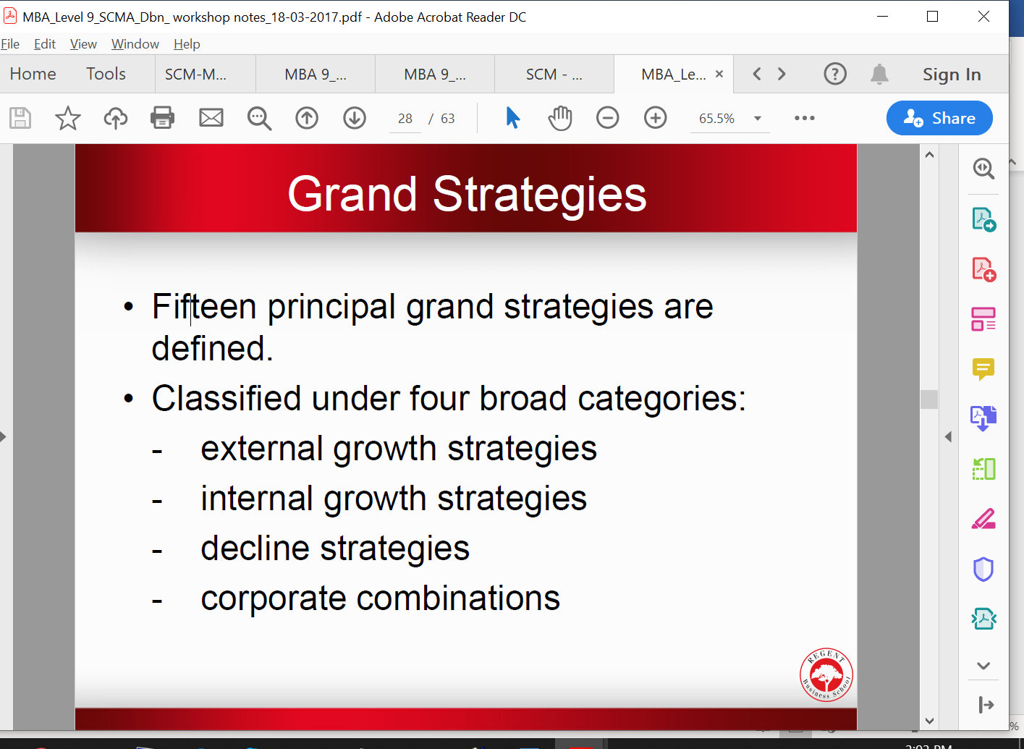

**3. Grand strategies**

Porter's generic strategies identify bases from which organisations can pursue

competitive advantage. However, it is not always clear how a particular competitive

advantage is achieved practically. Grand strategies, often also referred to as business

strategies, are more specific strategies that organisations can pursue in order to achieve

cost leadership, differentiation or focus. It enables organisations to coordinate their

efforts towards the attainment of their long-term goals. Differentiation, one of Porter's

generic strategies, can be achieved in various ways. An organisation can differentiate

itself by having the most innovative and technological advanced products, by providing

the lowest priced products or by the quality of their service. Each of these differentiation

goals can be achieved by a different grand strategy or even by a combination of two or

three grand strategies. In this section we will discuss the grand strategies that are

pursued by organisations to achieve their goals and to ensure that their competitive

advantage is maintained or improved.

There are a variety of grand strategies that organisations can utilise to achieve their longterm

goals. These grand strategies can be grouped into three types of grand strategies,

namely growth strategies, decline strategies and corporate combination strategies. In the

growth strategy section, there is an internal and external growth strategy. The internal

growth strategy focuses on the internal environment of the organisation while the

external growth strategies are more focused on the market and task environment.

**3.1 Internal growth strategies**

*3.1.1 Concentrated growth*

Concentrated growth, also referred to as market penetration, is a strategy that seeks to

increase the market share of an organisation through concentrated marketing efforts. The

organisation stays focussed on its present market as well as present products and

services. The challenge they pursue is to grow their share of the particular market

through the customisation of their product features, prices, distribution channels and

promotional strategies in order to meet the needs and expectations of consumers in that

particular market better than any of their competitors. Through this customised approach

they endeavour to increase the usage rate of their present customers, attract non-users

to buy their product, and/or attract their competitor's customers and convince them to

switch brands.

A concentrated growth strategy can be effective

▪ if the market for a specific product or service is not saturated,

▪ when there is room to increase the usage rate of present customers, and especially

▪ when the market shares of their major competitors have been declining while total

sales in the particular industry have been increasing

▪ where scale economies can provide cost benefits to organisations and

▪ where there is not much fluctuation in the availability, price and quality of raw

materials and other resources required to provide the specific product or service that

consumers require.

*3.1.2 Market development*

A market development strategy involves expanding the portfolio of markets that the

organisation serves. Present products or services are therefore introduced into new

geographic areas including other countries. Pick 'n Pay followed a market development

approach when they decided to enter the Australian market.

A market development strategy is especially effective when

▪ an organisation has access to reliable and affordable distribution channels in the area

that they which to enter.

▪ They can form strategic partnerships with organisations in the foreign country that

they wish to enter.

Cultural barriers and a lack of insight, with regard to the buying behaviour of consumers

in the foreign country, present challenges to organisations that consider entering

international markets. To overcome these barriers, some organisations decide to When

Pick and Pay entered the Australian market they acknowledged their own weaknesses in

that particular market and established a strategic partnership with an Australian

distribution company, Metcash Trading, ensuring a supply chain at least as good as any of

their competitors in the Australian market.

*3.1.3 Product development*

Improving and modifying the products and services of the organisation in order to

increase sales is called product development. Product development is particularly

successful when an organisation has successful products that are reaching the maturity

stage of their product life cycle. The new Corolla that Toyota was not only a technological

improvement on the previous model, but it also boasted a new sporty look that appealed

to a wider audience. With this strategy Toyota did not only increase sales, but also

expanded their market to include the younger generation.

Product development is essential for organisations that compete in industries that are

characterised by rapid technological developments, especially when their major

competitors offer better quality products at comparable prices. However, this strategy

demands huge capital investment with regard to research and development, as

technology and the attainment of appropriate human resources.

*3.1.4 Innovation*

Organisations that have distinct technological competencies and capital reserves to invest

in research and development find it profitable to make innovation their grand strategy.

Instead of concentrating on extending the life cycle of their products or services through

differentiation and product development, these organisations create new product life

cycles that will make similar existing products or services obsolete. While most growthoriented

organisations innovate from time to time, organisations that make innovation

their grand strategy use innovation as the fundamental way of relating to their markets.

**3.2 External growth strategies**

*3.2.1 Diversification*

This entails the organisation acquiring other organisations to, in this way, spread its risk.

In other words, an organisation that applies diversification argues that it is not a good

thing “to have all your eggs in one basket”, and therefore other organisations are

acquired so that the organisation can fall back on them if the existing organisation does

not perform well in certain areas. Here we also find two basic forms that the strategy can

assume:

**Related or concentric diversification** entails that the corporation takes up organisations

in its portfolio that are in the same industry as it is. Related diversification strategies have

potential in industries that experience slow growth or no growth. The goal is to increase

sales in this particular market by increasing the number of products consumed by each

individual consumer. Needless to say, the organisation should be able to offer the

additional products at highly competitive prices and should ensure that brand loyalty is

obtained before the additional products are introduced to the market. Concentric

diversification is also an attractive strategy for organisations whose current products or

services are in the decline stage of the product life cycle.

**Unrelated or conglomerate diversification** entails that the corporation acquires

organisations that are not necessarily in the same industry. The overarching goal of any

diversification strategy is to add value for shareholders and bring about a synergistic

effect (2 + 2 = 5). This is an attractive strategy when the basic industry of the organisation

is experiencing declining sales and profits, when existing markets for the products and

services of the organisation is saturated and when the organisation has the capital and

managerial talent needed to compete successfully in a new industry.

The diversification decision can be evaluated according to three tests:

▪ **The attractiveness test.** This means that the organisation that is acquired must be

attractive in terms of profitability and its return on investment.

▪ **The cost-of-entry test.** Here the cost of diversification is looked at in order to

determine whether it is viable.

▪ **The better-off test.** Here it is about the total portfolio of the corporation. This means

that the diversification must strengthen the corporation’s total portfolio and bring

about synergy. There must also be a particular fit between the corporation and the

organisations that are taken up in its portfolio. The most important areas where these

fits must occur are: the market, operational, management, strategic advantages and

the cultural fit.

Some of the **methods** through which an organisation can pursue unrelated diversification

include:

▪ Buying a high-performing organisation in an attractive industry;

▪ Buying a cash-strapped organisation that can be turned around quickly through

additional capital investment;

▪ Buying an organisation whose seasonal and cyclical sales patterns would provide

stability to the cash flow and profitability of the organisation;

▪ Buying a largely debt-free organisation to improve the borrowing power of the

acquiring organisation.

In conclusion, diversification is directly concerned with extending the organisation

beyond its original boundaries (industry and market). The **major benefits** that

diversification can provide to an organisation include:

▪ more attractive scope that can provide opportunities for faster growth, higher

profitability and greater stability

▪ access to key resources like capital, technology and expertise

▪ sharing of value chain activities to provide greater economies of scale and thus lower

total cost.

The **risks** associated with diversification include the following:

▪ Ignorance about newly entered markets could result in inefficiency as a result of

inadequate knowledge about customer needs, technological developments and

environmental shifts.

▪ Organisations that pursue unrelated diversification run the risk of reducing their

management effectiveness. Unrelated diversification places significant demands on

senior executives due to increased complexity and technological differences across

industries. It might be very difficult for managers to understand each of the core

technologies and appreciate the special requirements of each of the individual

business units in an unrelated diversified organisation.

▪ Sharing value chain activities with another organisation often entail substantial costs

with regards to communication, compromise and accountability.

*3.2.2 Integration*

Integration strategies involve gaining control over suppliers, distributors or competitors in

a particular industry to enhance the effectiveness and efficiency of the organisation.

**Integration** strategies extend the scope and operations of an organisation to other

activities within the same industry. This strategy is characterised by the expansion of the

organisation into other parts of the industry value chain directly related to the design,

production, distribution or marketing of its existing products and services. Integration

strategies can be divided into **vertical and horizontal** integration strategies. The primary

objective of vertical integration is to strengthen the hold of the organisation on resources

they deem critical to their competitive advantage. The purpose of **vertical integration** is

usually to gain better control over the distribution channel, provided that it strengthens

the competitive position of the organisation. The most important disadvantage of vertical

integration is that it traps the organisation further in a certain industry, and in this way it

can limit the mobility of the organisation. Vertical integration can be achieved in two

directions, namely forward and backward.

**Backward vertical integration** means that organisations are taken over in the direction of

the suppliers (upstream). This type of strategy is particularly common in industries where

low cost and certainty of supply are vital to maintaining the competitive advantage of the

organisation in its market. Toyota South Africa pursued this strategy when they gained

ownership of Raylite batteries and of Armstrong, manufacturers of shock absorbers.

Backward vertical integration is appropriate when the current suppliers of an organisation

are unreliable, too costly, or incapable of meeting the needs of the organisation with

regards to parts, components or materials. Needless to say, adequate capital and human

resources are prerequisites for pursuing this strategy.

**Forward vertical integration** means that organisations are taken over in the direction of

clients (downstream) - gaining ownership over distributors or retailers. Establishing web

sites to sell products directly to consumers is also a form of forward integration as the

organisation cuts out retailers and distributes its products directly to consumers. Forward

integration is attractive when existing distributors/retailers are unreliable, have high

profit margins (which inflates the price that the consumer has to pay for the product) or

are incapable of servicing the consumers of the organisation' products effectively.

There are **benefits** and **risks** associated with vertical integration. The cumulative potential

benefit of vertical integration strategies is that they tend to reduce the economic

uncertainties and transactions costs facing an organisation in a particular industry.

However, vertical integration can sometimes lead an organisation to over commit scarce

resources to a given technology, production process or other activity that could become

obsolete in a certain industry. This strategy is also capital intensive, resulting in high fixed

costs that may leave the organisation vulnerable in an industry downturn. Lastly, vertical

integration can pose problems with regard to integrating different sets of capabilities,

skills, management styles and values.

**Horizontal integration** takes place when an organisation seeks ownership or increased

control over certain value chain activities of its competitors. This takes place through

mergers, acquisitions and take-overs. This type of strategy is attractive when an

organisation competes in a growing industry, where the achievement of economies of

scale could provide cost benefits or other forms of competitive advantage and where an

organisation has both the capital and human talent needed to successfully manage an

expanded organisation. The merger between Volkskas, United, Trust Bank and Allied that

resulted in ABSA Bank is a good example of horizontal integration. Horizontal integration

can pose problems with regard to integrating the differences in organisational culture,

capabilities, skills, management styles and values of the organisations involved in the

merger or acquisition.

**3.3 Decline strategies**

Decline strategies are also often referred to as defensive strategies. These strategies are

pursued when an organisation finds itself in a vulnerable position as a result of poor

management, inefficiency and ineffectiveness. There are three types of defensive

strategies, namely:

*3.3.1 Retrenchment or turnaround*

Some organisations find themselves in a situation where their profits are declining.

Declining profits can result from a variety of reasons, including a decline in sales, adverse

economic conditions, increased competition, products becoming outdated or obsolete

(competitors launch innovative products), ineffective production and distribution

processes and poor management.

A turnaround strategy focuses on strengthening the distinctive competencies of the

organisation in order to break the downward spiral with regards to sales and profits.

Activities focus on ways to reduce costs and assets in order to stabilise the financial

condition of the organisation and to put the organisation on a path of recovery. Emphasis

is often on re-engineering of processes and the introduction of Total Quality Management

programmes to increase the cost-effectiveness of the organisation. Activities often

include the selling of land and buildings, the outsourcing of activities that are not the core

competencies of the organisation, reduction of personnel and curtailment of managerial

perks. Organisations that pursue turnaround strategies often appoint new managers with

new perspectives and specialised skills to facilitate dramatic changes like restructuring

and re-engineering.

Turnaround strategies are appropriate for organisations that have distinctive

competencies, but have been managed poorly or have grown too quickly and therefore

need major reorganisation in order to survive. These organisations are usually plagued by

inefficiency, low productivity, poor profitability, low employee morale and pressure from

their shareholders to increase performance.

*3.3.2 Divestiture*

Divestiture involves selling a division or part of the organisation to raise capital for further

acquisitions or investments. It can also be part of an overall retrenchment strategy to get

rid of divisions that are unprofitable or do no longer fit in with the strategic direction that

the organisation is embarking on. In diversified organisations divestiture will entail selling

one or two organisations that have become liabilities in the portfolio of the organisation

due to poor profitability, which often results from a lack of expertise, or increased

competition in a particular industry.

*3.3.3 Liquidation*

This strategy entails selling all the assets of an organisation in an attempt to avoid

bankruptcy. Liquidation is usually pursued when efforts to turn an organisation around

through retrenchment and divestiture have been unsuccessful and ceasing operations are

the only alternative to bankruptcy. Liquidation is therefore a planned and orderly way of

converting the assets of the organisation into cash in an attempt to minimise losses for

the shareholders of the organisation.

The decision to embark on liquidation is usually a very emotional one, because it basically

means admitting defeat and embarking on activities that result in hardship for the

employees and other stakeholders of the organisation. However, pursuing liquidation is a

better option than bankruptcy as management has the opportunity to plan the activities

in such a way that the loss to all the stakeholders of the organisation is minimised.

**4. Situation specific strategies**

Apart from the abovementioned strategies, the organisation must also constantly ensure

that its strategy adapts to the specific situation. Consequently we thus look briefly at

strategies for specific situations. It is, however, of cardinal importance that these

strategies are not handled as recipes, but rather as suggestions that can possibly

be considered.

**4.1 Strategies for competing in turbulent, high-velocity markets**

Here organisations find themselves in industry situations that are characterised by rapid

technological change and short product life cycles because of the pace at which nextgeneration

products are being introduced and the entry of new rivals into the market.

The industry is established, with rapid change being the prevailing condition. Personal

computer hardware and software, video games, wireless telecommunications,

prescription drugs and the whole arena of cyberspace is typical examples of this industry

situation.

Change is a fundamental characteristic of this type of market environment and thus poses

a challenge for strategy making. An organisation in this industry has three strategic

options for dealing with the change:

▪ **It will react to change.** To react to change means that the organisation defends itself.

The organisation can, for example, respond to a competitor’s new product with a

better one. This is a defensive strategy and unlikely to create a fresh opportunity.

▪ **It will anticipate change.** Anticipating change is still fundamentally a defensive

strategy because forces outside the organisation are controlling what is going to

happen in it. Anticipation means that the organisation is looking ahead to analyse

what is going to happen and then prepare and position itself for that future.

▪ **It will lead change.** To lead change is inherently an offensive strategy because it

means being first in the market with a new product or service. Organisations in this

situation are industry leaders.

What will determine competitive success in these fast-changing markets? The

organisation’s abilities to improvise, experiment, adapt, reinvent and regenerate as

market and competitive conditions shift rapidly and sometimes unpredictably are key

factors for success.

The following strategic moves may help the organisation to gain a competitive advantage:

▪ In order to stay at the leading edge of technological know-how, it is important for

organisations to invest aggressively in R&D.

▪ Specific organisational capabilities are required for an organisation to respond quickly

to the moves of competitors and surprising new developments.

▪ Organisations do not always have all the resources and competencies to pursue so

many new technological paths and product categories. ▪ It is important to keep the company’s products and services sufficiently fresh and

exciting to stand out in the midst of all the change that is taking place.

**4.2 Strategies for mature industries**

In these industries we see that competition is very tough, the demand for products

stabilises, buyers are more sophisticated, costs and service are very important, product

innovations are scarce, international competition increases, profitability stabilises and

may even decrease, take-overs and mergers occur. Strategic options in industries such as

these can be the following:

▪ Cut product lines – concentrate on your core business.

▪ Place more emphasis on process innovation. Redesign processes that hold long-term

cost advantages and other advantages for clients.

▪ Place more emphasis on lowering costs.

▪ Increase sales to existing clients, and try to make client retention the core of the

marketing strategy.

▪ Take over competitors, provided that this can be done at a bargain. As a result of the

tough competition and pressure on margins, it can happen that bargains such as these

begin to emerge.

▪ Consider international expansion.

**4.3 Strategies for declining industries**

The most important characteristic of these industries is that the demand for the product

stagnates and starts to decline. Organisations in industries such as these must seriously

reflect on their future, and leave the industry too early rather than too late. Strategic

options here can be:

▪ Focus on those segments that do still show a little bit of growth.

▪ Differentiate on the basis of quality.

▪ Do everything to limit costs.

**5. General guidelines for strategy formulation**

The general goal with designing strategies is to, in a creative manner:

▪ Improve the competitive position of the organisation.

▪ Remember that a clear and well-formulated strategy alone cannot improve the

organisation’s position, but also helps to build the organisation’s reputation.

▪ Ensure that the chosen strategy has enough flexibility to absorb changes in the market

and in the broad external environment by affixing the necessary adjustments.

▪ Invest in the creation of a sustainable competitive advantage.

▪ Be aggressive in building competitive advantage and also defend it aggressively.

▪ Guard against merely going for strategies that can only succeed in the best scenario.

▪ Do not underestimate competitors.

▪ Be careful to attack strong competitors before a distinctive competitive advantage is

built up.

▪ To attack competitors’ weaknesses is often cheaper than to attack their strengths.

▪ Beware of a low-cost strategy without it having real cost advantages. with companies making tie-in

products.

/////////

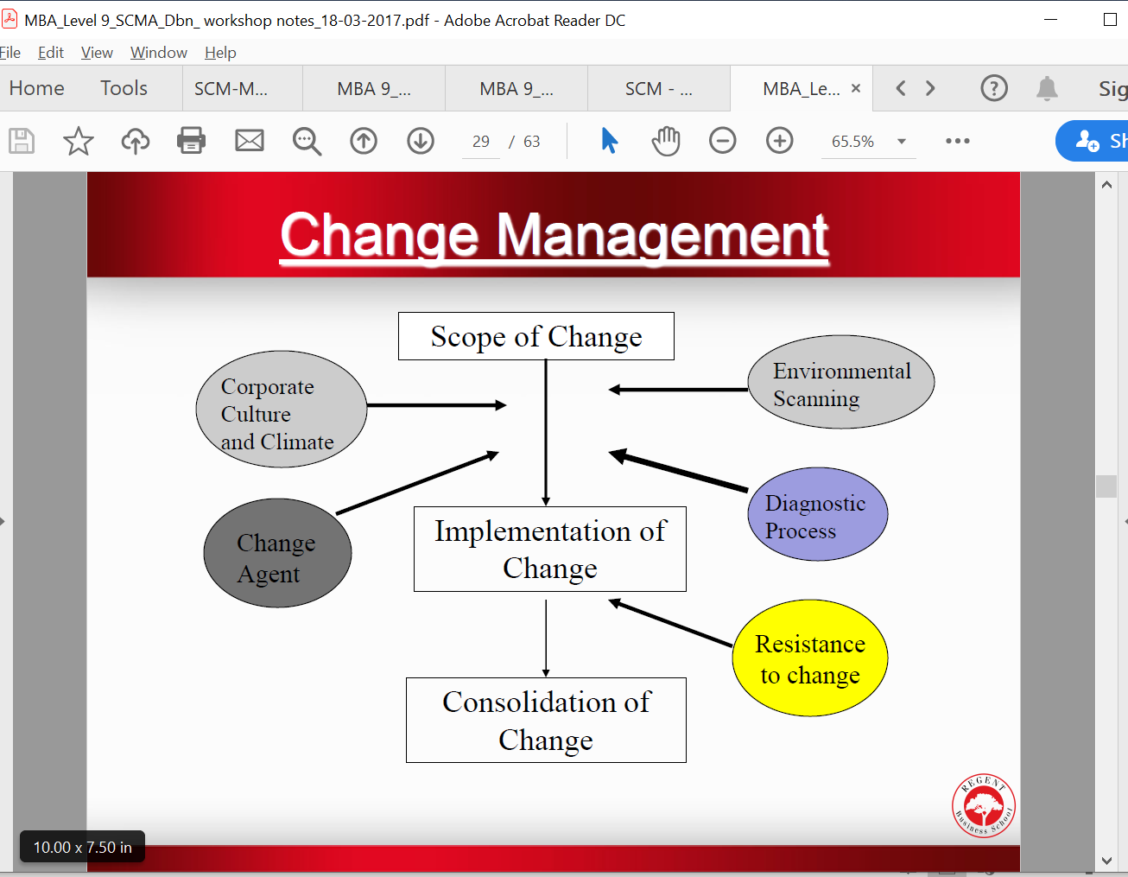

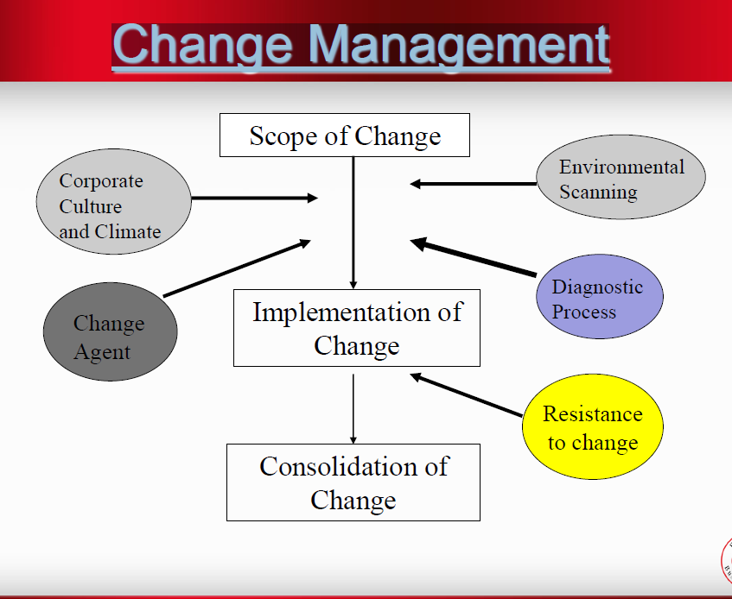

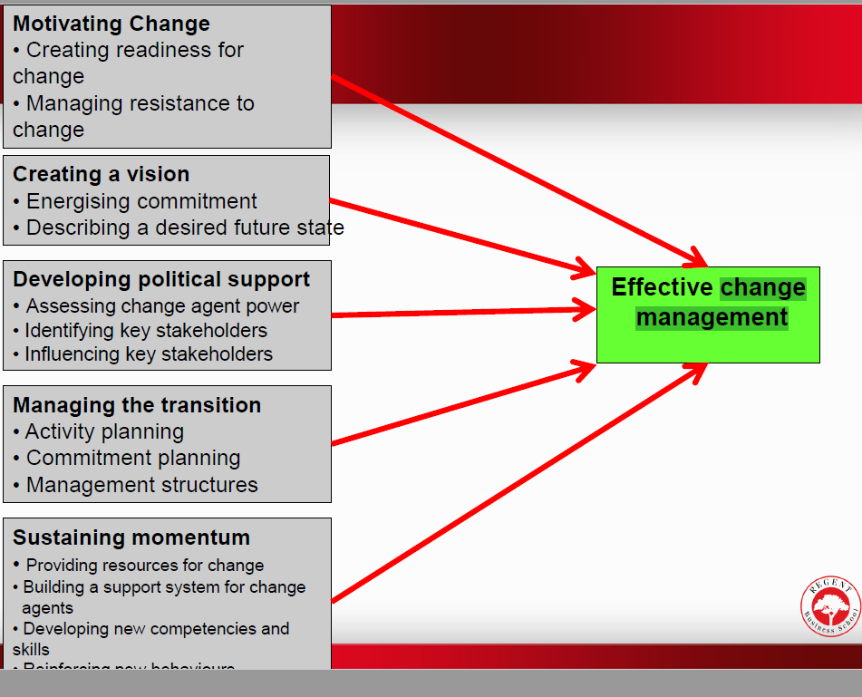

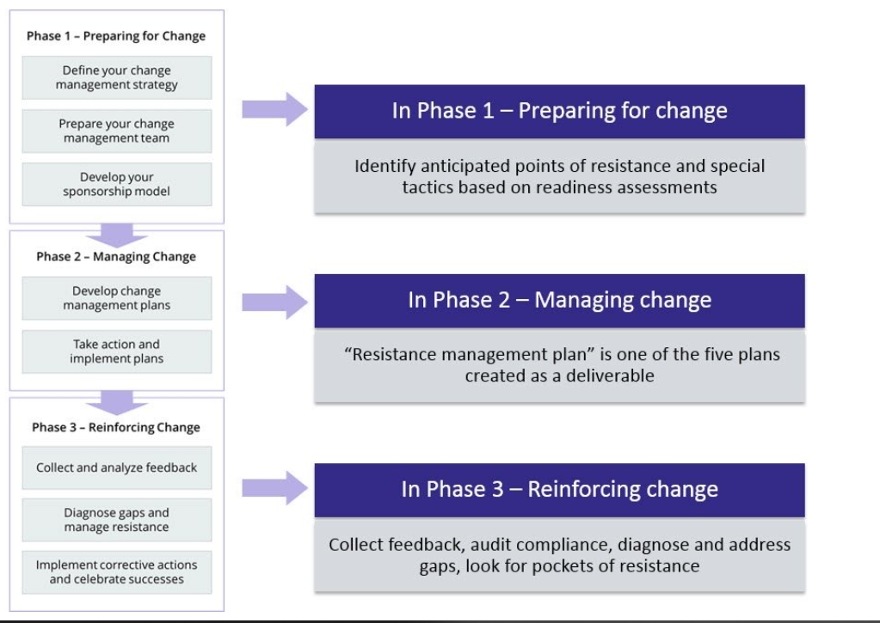

1.5.2 Discuss the elements of change management that the ‘big four’ banks should undertake to counter the threat of the challenger banks. (9)

Models of Organisational Change Kanter et al (1992) identified the following themes as the basic assumptions of most change models and/or frameworks:

Awakening the organisation to a new reality and disengaging it from the past. Recognising that the old way of doing things is no longer acceptable. The need to create and embrace a new vision of the future by the organisation. The need to unite behind the steps necessary to achieve the stated vision. The need to solidify’ or ‘refreeze’ the new attitudes, practices and policies. There are as many models of change as the attempts that have been undertaken to change organisations over the years.

3.1

The four criteria used:

Criteria 1

Exploration Phase The key activities here concern the organisation exploring and deciding whether it wants to make specific changes in its operations thereby committing the requisite resources. Key Change Management Processes: Creating an awareness of the need for change. Searching for outside assistance (consultants/facilitators) to assist with planning and implementation of the change programme. Establishing and defining terms of reference with the consultants/ facilitators.

*Exploration-a clear perception of need:*

Nokia was in difficulty at the end of 2010. It was losing market share at both ends of the mobile telephone market. At the top end, the share loss was to Apple’s iPhone and to smartphones using Google’s android open software system. At the bottom end, low-cost mobile telephones from China were much cheaper than similar Nokia telephones. All this was in spite of the company increasing its research and development (R & D) expenditure and its total number of employees. Nokia’s strategy was in deep trouble, through review done by Stephen Elop.

Criteria 2

Planning Phase: This involves the efforts to understand and tackle the organisation’s problem(s). Some of the discussions will revolve around understanding competitive trends and reactions of the respective organisational units. This may also involve systematic information gathering through research, networking and perusing related industry publications and other literature.

*Planning - a way forward:*

Stephen Elop after joining the company in 2010, spent the first few months reviewing the company’s position, talking to managers and employees. He concluded that there was a lack of accountability in many parts of the organisation. There needed to be simplified decision making with less reference back to headquarters before decisions were taken. The culture needed to be performance-based and less time serving. From a strategy perspective, Elop decided that radical strategic change was required as the strategy was in deep trouble. The 17

difficulty was that any admission of problems would potentially harm Nokia‟s business and reduce morale within the company

Criteria 3

Action Phase: this stage involves the implementation of the changes flowing from the Planning phase. The changes may involve alterations in the way things are done. This could result in the installation of computerised operational processes as well as changes in the organisational structure, among others.

Action -the capability to change

Elop and his senior colleagues developed future strategies. Nokia first made two strategic decisions and then followed this up with the implications in terms of a strategic change programme. The first strategic decision was to go ahead with Microsoft mobile software and get out of the Symbian software that had been the backbone of Nokia for many years. The second related strategic decision was that around 4 000 Nokia employees would be made redundant and another transferred to an outside company that would look after Symbian while it was still being used by customers.

Criteria 4

Integration Phase: this process follows the successful implementation of the intended changes. It focuses on consolidating and stabilising the adopted changes. Key Change Management Process: Reinforcing new behaviours through positive feedback and reward systems. Reduction of reliance on consultants. Diffusion of the successful aspects of the change process throughout the organisation. Training managers and employees to constantly monitor the change and to improve upon it.

*Integration- commitment.*

Elop showed commitment for change by sending out the “doomsday memo‟ as a first step. This was to be followed by an announcement of the new link with Microsoft several days later. On 7 February 2011, the well-constructed memorandum was sent as an email to senior managers. Elop made a joint presentation with Steve Bulmer, chief executive of Microsoft on part of the Nokia way forward. It had chosen Microsoft’s Windows & mobile platform. A few weeks later, a full deal was signed with Microsoft and, shortly afterwards, the announcement was made about the job losses. Nokia also announced a new senior management structure. It 18

included a change taskforce that would be disbanded once the goals had been achieved. The taskforce covered the following areas:

Work with Microsoft to produce the new smartphones to regain market leadership. Work on the low-end telephone market by expanding web access and applications that would deliver new uses for such telephones. Build new software systems that will deliver a complete smartphone experience to Nokia users. Develop closer co-operation between the various parts of Nokia to ensure that sales, production and marketing were fully aligned. Redevelop the Nokia management and governance structures to improve the effectiveness and speed of company practices and processes Develop a new and effective on-site R&D strategy. Set up a programme office to lead change management overall Instigate a culture change programme to embed the right values, mind-sets and behaviours

 Change management  is collective term for all approaches to help, support, and prepare organizations , teams and individuals to make company’s. The most usual change drivers involve: consumer habit changes, crisis, process reviews and technological evolution; pressure from organizational restructuring, mergers, acquisitions and new business entrants,

and It involves techniques which redefine or redirect the budget allocations, business process,

use of resources, or some modes of operation which drastically change an organization or company. Organizational change management takes into  consideration the entire organization and what must change, meanwhile change management can be utilized simply to refer to how teams and people are impacted by this organizational transition. It is dealing with number of different disciplines, from social sciences and behavioral to business solutions and information technology.

The elements of change management that the ‘big four’ banks should undertake to counter the threat of the challenger banks are:

* Critical success factors
* Communications issues
* Change dynamics — resistance to accept change
* Variables related to the management of the implementation process
* Evaluation stages of the change process.

These 5 elements to be managed if a change process is to be successful.

**The Success Factors:**  must be put in place prior to success being guaranteed. They involve:

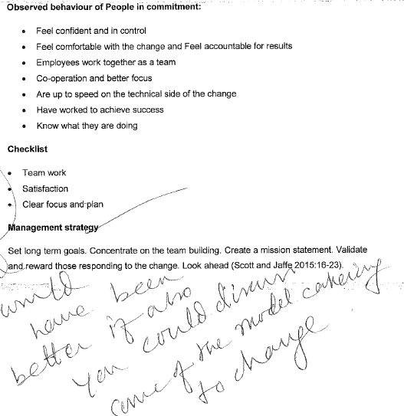

Commitment of all levels including the staff and managers , when changes are done which may have an impact on performance of the organization, resource commitments is essential as resources might not be available. **Commitment to the organization, m**anagers and employees must dedicate their expertise, skills, time to build and establish the organization. They prove their commitment by trying to put in long hours to assure organizational success. Normally, the focus is put on variables like the degree of shared commitment among management and employees, decision making structures and decentralized teams , job security, group rewards and individual systems.

Level of motivation : supervisors and managers are playing an important role in managing change. Eventually, the manager is having more influence over employee’s motivation to change than every other person.. It is important l for the executive sponsorsand change management team to obtain the support of supervisors and managers . Activities of individual change management must be utilized to assist such managers via change process.

**Use of professional judgment throughout the process** , professional judgment is obtained via experience, and via building a repertoire of actions, understandings and examples from which to draw on.

* Level of understanding for the need for change demonstrated by staff Identifiable communication skills . Recognition of the need for a high quality outcome to change

**Communication Process**

YYYYYYYYYYYYYYYYYYYYYYYYYYYYYY

Insufficient communication: miscommunication can be a cultural inhibitor in that people like to gain influence regarding their surroundings and have control. Restructing plans for an example in an organisation if not communicated properly can cause chaos.

Bad style: it’s a behaviour that is practised in an organisation where employees are not involved, they are just tod about the changes.

Unprofessional stakeholder management: stakeholders have different interests and numerous persons are affected by the changes.

Workload and speed: involves adoption to change. Normally with changes there is increased workload and time to catch-up to competitors may not be favourable to meet new targets.

Lack of control: if a change process is initiated, one should pay attention to the sustainability of the targeted changes.

Cultural change facilitators: Communication the need for change is important. This can be done by developing a business case outlining the reasons for change. Evaluate the readiness for change in the organisation. Ensuring that people support the change, understand the change and are involved in the plans for change. Better communication between the different stakeholders affected by the change. This can be done face to face or in groups to ensure everyone understands. Review the change by putting control measure to check the progress on changes made, areas of improvement.

Key variables involve : Consultation ,Education , Participation during the process , Needs of staff and clients are recognised , Negotiation with the decision makers , An understanding of the change dynamics that exist and democratic decision making in order to reduce resist.

Effective communication which is informing different stakeholders about the reasons for change, the advantages of successful implementation and also as the change details.

Most managers are assuming that when they communicate clearly with their workers , their work is done. Nevertheless , there are number of reasons why workers may not understand or hear what their managers are saying the 1st time around. In fact, one may have heard that messages need to be repeated 5 to 7 to seven times before they are understood into the minds of employees.

3 Components of Effective Communication

Effective communicators carefully consider three components:

1. The audience

2. What is communicated

3. When it is communicated

For example, the first step in managing change is building awareness around the need for change and creating a desire among employees. Therefore, initial communications are typically designed to create awareness around the business reasons for change and the risk of not changing. Likewise, at each step in the process, communications should be designed to share the right messages at the right time.

Communication planning, therefore, begins with a careful analysis of the audiences, key messages and the timing for those messages. The change management team or project leaders must design a communication plan that addresses the needs of frontline employees, supervisors and executives. Each audience has particular needs for information based on their role in the implementation of the change.

Insufficient communication: miscommunication can be a cultural inhibitor in that people like to gain influence regarding their surroundings and have control

Communication the need for change is important. This can be done by developing a business case outlining the reasons for change. Evaluate the readiness for change in the organisation. Ensuring that people support the change, understand the change and are involved in the plans for change. Better communication between the different stakeholders affected by the change. This can be done face to face or in groups to ensure everyone understands. Review the change by putting control measure to check the progress on changes made, areas of improvement.

**Acceptance and Management of Resistance to Change**

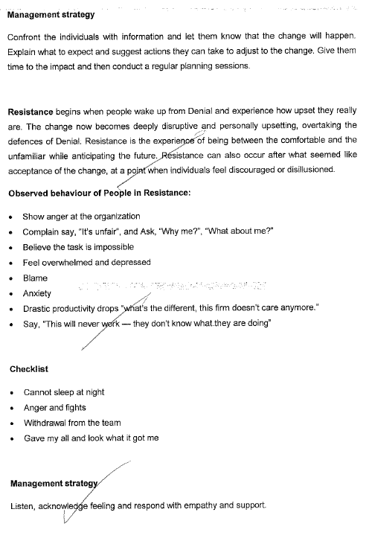

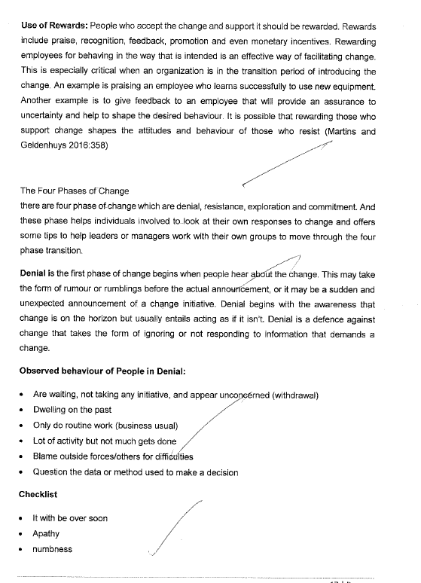

Key variables to **acceptance and management of resistance to change involve** : Level of acceptance of the change , Involvement and understanding of the need for change ,Likely impact of the proposed change on the social and cultural lives of the individuals concerned and a clear understanding of the need for a project team . This means that resistance to change must be managed.Resistance from managers and employees is normal and must be addressed. Persistent resistance, nevertheless, can threaten a project. The change management team must understand , identify and assist leaders to manage resistance throughout the company. Resistance management is the tools and processes utilized by executives and managers with support of the change team to manage employee resistance.

Resistance to change must be reduced at all the time,counter resistance from organization’s employees and aligning them to overall strategic direction of the organization. Resistance is a fact of human nature. Robbins and Finley (1998:102) defines it as an ancient pattern which widely models the following steps:

A good idea creating an aura of hope.

Hope inspires other people but causing anxiety to others.

Anxiety prompts resistance.

Resistance can destroy a good idea.

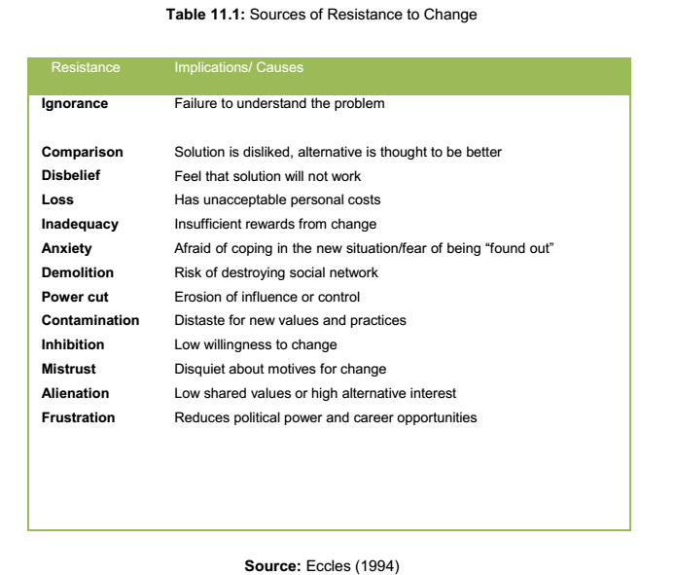

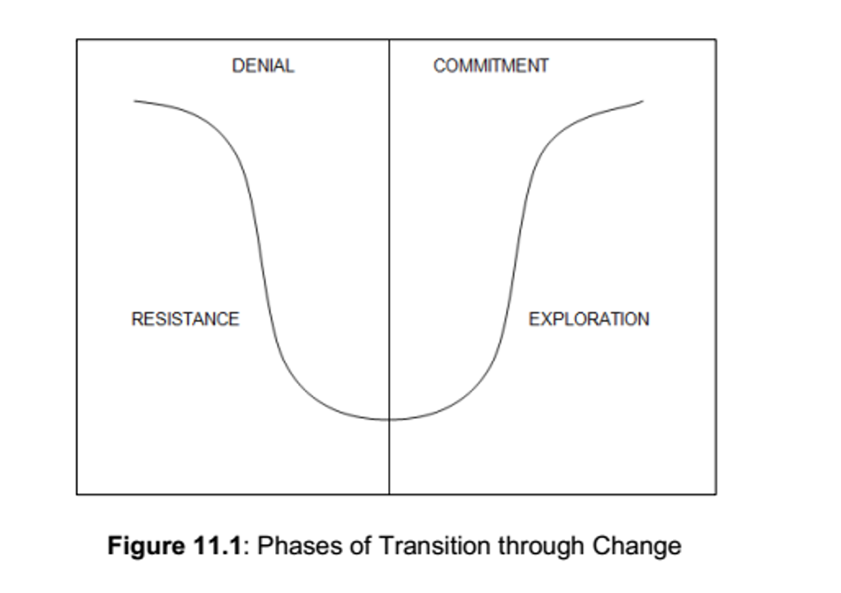

**Strategies for Recognising and Managing Resistance**

**Denial**

*Observed behaviour:* Withdrawal, “business as usual”, dwelling on the past, lots of activity but not much gets done.

*Checklist:* it will be over real soon - apathy - numbness

*Management Strategy:*

* Confront individuals with information and let them know that the change will happen.
* Explain what to expect and suggest actions they can take to adjust to the change.

Give them time to let the impact sink in and then conduct regular planning sessions to involve all levels.

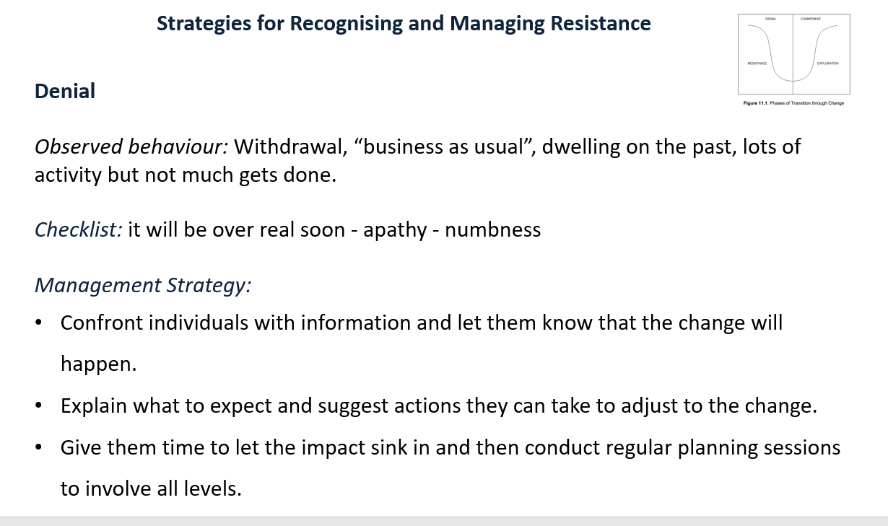

**Resistance**

*Observed behaviour:* Anger, blame, anxiety, depression, and drastic productivity drop “what’s the difference, this company doesn’t care anymore.”

*Checklist:* cannot sleep at night - anger and fights - withdrawal from the team - gave my all and look what it got me

*Management Strategy:*

* Listen, acknowledge feelings, and respond with empathy and support.
* Don’t try to talk people out of their feelings, or tell them to pull themselves together.

Accept their response and they will continue to tell you how they are feeling, which will help you address their concerns

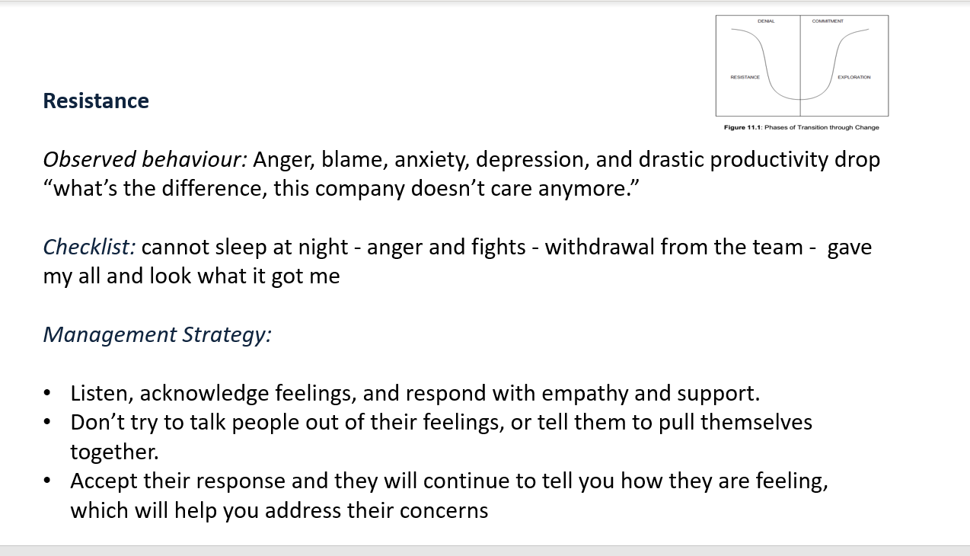

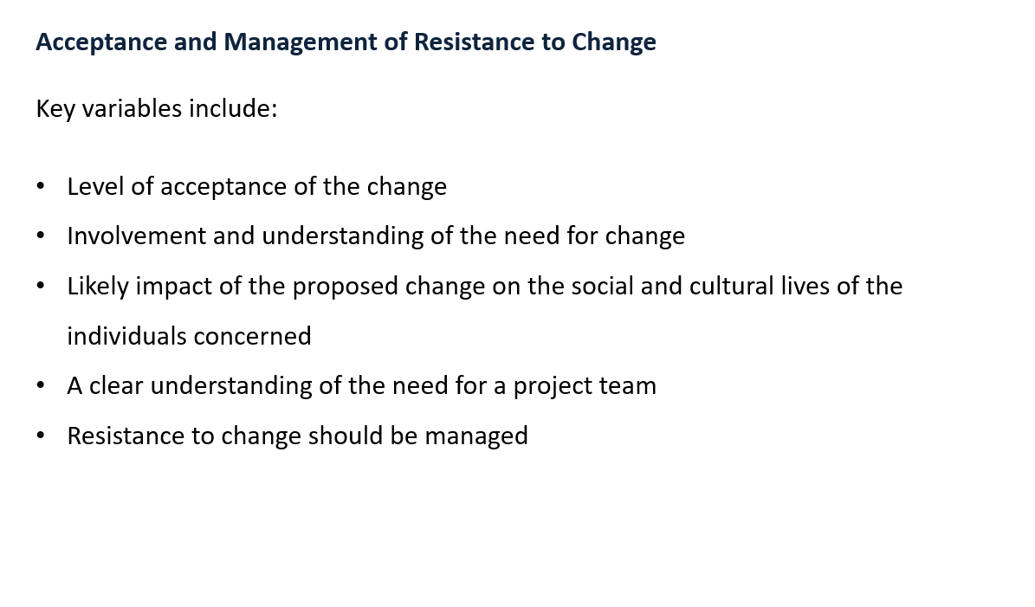

**Change Implementation Process**

Key variables include:

* Need for prior research Project team interacting and working well together
* Use of process tools. e.g. strategic development and planning with clear inputs and outputs identified
* Recognition and management of the transition state (with provision of the required education programme for staff to facilitate successful implementation)



**Critical Success Factors for Change – (Carney 2001)**

* Critical success factors
* Communications issues
* Change dynamics — resistance to accept change
* Variables related to the management of the implementation process
* Evaluation stages of the change process.

These five factors need to be managed if a change process is to be successful.

555555555555555

**Evaluation Process**

Key variables include:

* Recognition of the need to evaluate the process at various stages
* Taking necessary action
* Provision for feedback Recognition and acknowledgement of the contribution of staff

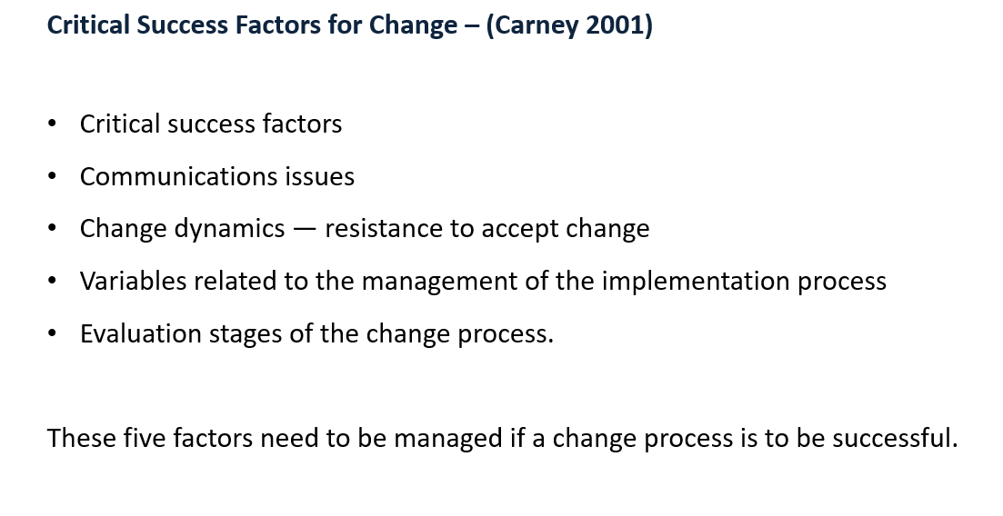

Sssssssssssssstttttttttttttt

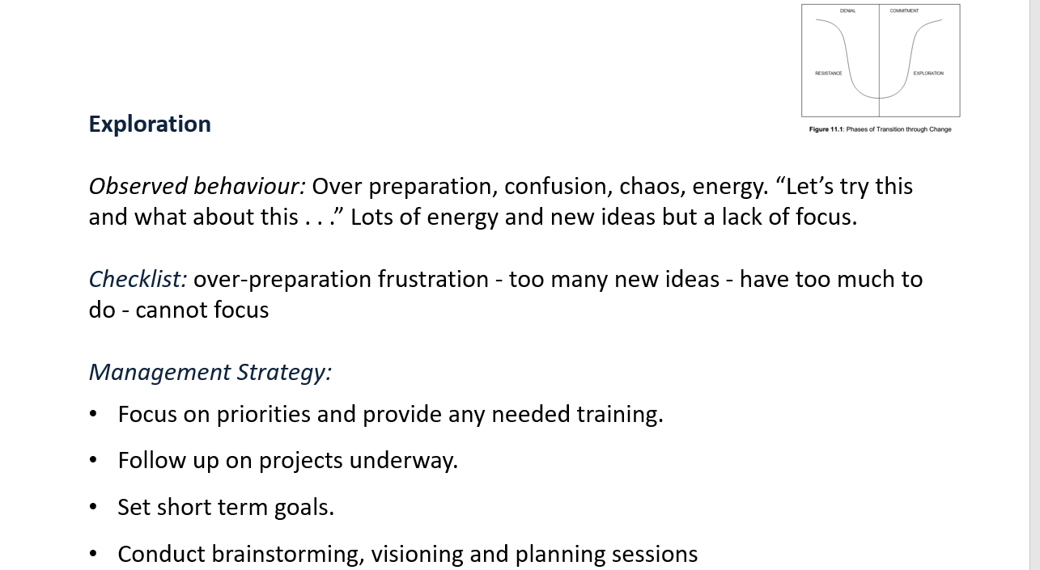



**From:** PHILLIP MANDLA MTOMBENI <55160735@mylifeunisaac.onmicrosoft.com>  
**Sent:** Tuesday, March 31, 2020 7:41 AM  
**To:** Mtombeni, Mandla <Mandla.Mtombeni@wesbank.co.za>; PHILLIP MANDLA MTOMBENI <55160735@mylifeunisaac.onmicrosoft.com>  
**Subject:**

 Change management  is a collective term for all approaches to prepare, support, and help individuals, teams, and organizations in making organizational change. The most common change drivers include: technological evolution, process reviews, crisis, and consumer habit changes; pressure from new business entrants, acquisitions, mergers, and organizational restructuring. It includes methods that redirect or redefine the use of resources, business process, budget allocations, or other modes of operation that significantly change a company or organization. Organizational change management  considers the full organization and what needs to change, while change management may be used solely to refer to how people and teams are affected by such organizational transition. It deals with many different disciplines, from behavioral and social sciences to information technology and business solutions.

In a project-management context, the term "change management" may be used as an alternative to change control processes wherein changes to the scope of a project are formally introduced and approved.

History

1960s

Many change management models and processes are based with their roots in grief studies. As consultants saw a correlation between grieving from health-related issues and grieving among employees in an organization due to loss of jobs and departments, many early change models captured the full range of human emotions as employees mourned job-related transitions.

In his work on diffusion of innovations, Everett Rogers posited that change must be understood in the context of time, communication channels, and its impact on all affected participants. Placing people at the core of change thinking was a fundamental contribution to developing the concept of change management. He proposed the descriptive Adopter groups of how people respond to change: Innovators, Early Adopters, Early Majority, Late Majority and Laggards.

1980s

McKinsey & Company consultant Julien Phillips published a change management model in 1982 in the journal Human Resource Management.

Robert Marshak has since credited the big six accounting and consulting firms with adopting the work of early organizational change pioneers, such as Daryl Conner and Don Harrison, thereby contributing to the legitimization of a whole change management industry when they branded their re-engineering services as change management in the 1980s.

1990s

In his 1993 book, Managing at the Speed of Change, Daryl Conner coined the term 'burning platform' based on the 1988 North Sea Piper Alpha oil rig fire. He went on to found Conner Partners in 1994, focusing on the human performance and adoption techniques that would help ensure technology innovations were absorbed and adopted as best as possible. The first State of the Change Management Industry report was published in the Consultants News in February 1995.

2000s

Linda Ackerman Anderson states in Beyond Change Management that in the late 1980s and early 1990s, top leaders, growing dissatisfied with the failures of creating and implementing changes in a top-down fashion, created the role of the change leader to take responsibility for the human side of change.

2010s

In Australia, change management is now recognised as a formal vocation through the work of Christina Dean with the Australian government in establishing national competency standards and academic programmes from diploma to masters level.

In response to continuing reports of the failure of large-scale top-down plan-driven change programmes, innovative change practitioners have been reporting success with applying Lean and Agile principles to the field of change management.

The Association of Change Management Professionals  announced a new certification to enhance the profession: Certified Change Management Professional  in 2016.

Approach

Organizational change management employs a structured approach to ensure that changes are implemented smoothly and successfully to achieve lasting benefits.

Reasons for change

Globalization and constant innovation of technology result in a constantly evolving business environment. Phenomena such as social media and mobile adaptability have revolutionized business and the effect of this is an ever-increasing need for change, and therefore change management. The growth in technology also has a secondary effect of increasing the availability and therefore accountability of knowledge. Easily accessible information has resulted in unprecedented scrutiny from stockholders and the media and pressure on management. With the business environment experiencing so much change, organizations must then learn to become comfortable with change as well. Therefore, the ability to manage and adapt to organizational change is an essential ability required in the workplace today. However, major and rapid organizational change is profoundly difficult because the structure, culture, and routines of organizations often reflect a persistent and difficult-to-remove "imprint" of past periods, which are resistant to radical change even as the current environment of the organization changes rapidly.

Due to the growth of technology, modern organizational change is largely motivated by exterior innovations rather than internal factors. When these developments occur, the organizations that adapt quickest create a competitive advantage for themselves, while the companies that refuse to change get left behind. This can result in drastic profit and/or market share losses. Organizational change directly affects all departments and employees. The entire company must learn how to handle changes to the organization. The effectiveness of change management can have a strong positive or negative impact on employee morale.

Change models

There are several models of change management:

John Kotter's 8-Step Process for Leading Change

Dr. John P. Kotter, the Konosuke Matsushita Professor of Leadership, Emeritus, at the Harvard Business School, invented the 8-Step Process for Leading Change. It consists of eight stages:

Create a Sense of Urgency

Build a Guiding Coalition

Form a Strategic Vision and Initiatives

Enlist a Volunteer Army

Enable Action by Removing Barriers

Generate Short-Term Wins

Sustain Acceleration

Institute Change

Change Management Foundation and Model

The Change Management Foundation is shaped like a pyramid with project management managing technical aspects and people implementing change at the base and leadership setting the direction at the top. The Change Management Model consists of four stages:

Determine Need for Change

Prepare & Plan for Change

Implement the Change

Sustain the Change

The Plan-Do-Check-Act Cycle, and choosing which changes to implement

The Plan-Do-Check-Act Cycle, created by W. Edwards Deming, is a management method to improve business method for control and continuous improvement of choosing which changes to implement. When determining which of the latest techniques or innovations to adopt, there are four major factors to be considered:

Levels, goals, and strategies

Measurement system

Sequence of steps

Implementation and organizational changes

Managing the change process

Although there are many types of organizational changes, the critical aspect is a company's ability to win the buy-in of their organization's employees on the change. Effectively managing organizational change is a four-step process:

Recognizing the changes in the broader business environment

Developing the necessary adjustments for their company's needs

Training their employees on the appropriate changes

Winning the support of the employees with the persuasiveness of the appropriate adjustments

As a multi-disciplinary practice that has evolved as a result of scholarly research, organizational change management should begin with a systematic diagnosis of the current situation in order to determine both the need for change and the capability to change. The objectives, content, and process of change should all be specified as part of a change management plan. Change management processes should include creative marketing to enable communication between changing audiences, as well as deep social understanding about leadership styles and group dynamics. As a visible track on transformation projects, organizational change management aligns groups' expectations, integrates teams, and manages employee training. It makes use of performance metrics, such as financial results, operational efficiency, leadership commitment, communication effectiveness, and the perceived need for change in order to design appropriate strategies, resolve troubled change projects, and avoid change failures.

Factors of successful change management

Successful change management is more likely to occur if the following are included:

Define measurable stakeholder aims and create a business case for their achievement

Monitor assumptions, risks, dependencies, costs, return on investment, dis-benefits and cultural issues

Effective communication that informs various stakeholders of the reasons for the change, the benefits of successful implementation  as well as the details of the change

Devise an effective education, training and/or skills upgrading scheme for the organization

Counter resistance from the employees of companies and align them to overall strategic direction of the organization

Provide personal counselling  to alleviate any change-related fears

Monitoring implementation and fine-tuning as and when required

Reasons for failure

Research across many different lists of reasons has resulted in the following - organizations:

Don’t get the sponsor right

Start on a solution before the underlying problem  is fully understood

Don’t spend time on systematically analysing the people and styles that are involved

Jump to a solution to the problem

Don’t validate the proposed solutions

Don’t plan for certainty

Don’t communicate what is happening and why

Don’t define measurable outcomes and way-points

Don’t put strong governance in place, particularly around dependencies

Don’t deal properly with Risk and Contingency

Challenges

Change management is faced with the fundamental difficulties of integration and navigation, and human factors. Change management must also take into account the human aspect where emotions and how they are handled play a significant role in implementing change successfully.

Integration

Traditionally, organizational development  departments overlooked the role of infrastructure and the possibility of carrying out change through technology. Now, managers almost exclusively focus on the structural and technical components of change. Alignment and integration between strategic, social, and technical components requires collaboration between people with different skill-sets.

Navigation

Managing change over time, referred to as navigation, requires continuous adaptation. It requires managing projects over time against a changing context, from interorganizational factors to marketplace volatility. It also requires a balance in bureaucratic organizations between top-down and bottom-up management, ensuring employee empowerment and flexibility. Furthermore, in cases where a company has seen declining fortunes, for a manager or executive to view themselves as a key part of the problem can be very humbling. This issue can be exacerbated in countries where "saving face" plays a large role in inter-personal relations.

To assist with this, a number of models have been developed which help identify their readiness for change and then to recommend the steps through which they could move. A common example is ADKAR, an acronym which stands for Awareness, Desire, Knowledge, Ability and Reinforcement. This model was developed by researcher and entrepreneur Jeff Hiatt in 1996 and first published in a white paper entitled The Perfect Change in 1999. Hiatt explained that the process of becoming ready for change is sequential, starting from the current level of each individual, and none of the five steps could be avoided: "they cannot be skipped or reordered".

As an academic discipline

As change management becomes more necessary in the business cycle of organizations, it is beginning to be taught as its own academic discipline at universities. There are a growing number of universities with research units dedicated to the study of organizational change.

See also

Business process reengineering

Business transformation

Change management

Employee engagement

Human resource management

Leadership development

Organization studies

Organizational culture

Organizational structure

Performance management

Stakeholder management

Talent management

Training and development

Transtheoretical model

References

Bibliography:

Wikipedia

@baygross

///////////////

3 Elements of Successful Change Management

We are sitting in a meeting with the CMO and a new Marketing Operations director from a large, well-established company. They had called and asked for a meeting to help kick their Marketing metrics and dashboard up a notch.

In the last year, this Marketing organization has added various capabilities and technologies, including customer relationship management, marketing automation, and marketing resource management systems. The Marketing Operations director has a staff, which includes the marketing automation and marketing resource management teams.

Recently, they’ve had some measurement adoption issues, so they decided to appoint a dozen of the marketers from their 200-person global Marketing organization with marketing performance and operations responsibilities, with dotted line reporting to the Marketing Operations director. Some adoption issues are related to experience and training, but some are more subtle and the result of people who aren’t receptive to change. As we listened, I realized that this team didn’t take change management into account at the beginning of their journey.

**No Magic Pill for an Instant Change**

The size or industry of a company doesn’t matter. Every aspect of Marketing Performance Management (MPM) often requires cultural, process, and skill changes.

Many times these organizations underestimate the effort required—they want something fast and easy. It reminds me a little of people who want to lose weight, but they don’t want to make any activity changes or diet. They want to take a pill to lose weight, preferably while they sleep, and watch the pounds quickly melt off.

Unfortunately, such a magic pill doesn’t exist. Even the diet pill companies clearly state, “*X pill was designed to be used in conjunction with a healthy diet and exercise. Some users may lose weight without changing their diets or exercising, but exercise and healthy eating are recommended for optimal results*.” And there you have it, most of us who want to lose weight are going to have change—change our diet and/or change our exercise routine.

## **Change Is Part of a Company’s Improvement**

Change is pervasive in our society and a fact of life in organizations. Change involves making alterations to the organization’s purpose, culture, structure, and processes in response to seen or anticipated changes in the environment. It can also facilitate prosperity and growth, even in volatile, uncertain, complex, and ambiguous environments.

Effective strategic Marketing leaders realize that change is part of the continuous improvement process, and CMOs

## **Three Elements of Change Management**

[Author Dallas Willard](https://www.audible.com/author/Dallas-Willard/B00P8EMQUA) tells us that successful change takes three elements: vision, method, and will.

### Vision

Successful change hinges on a picture of a desirable future.

Vision can provide both a corporate sense of being and a sense of enduring purpose. In 1995, John Kotter, a professor at Harvard Business School and world-renowned change expert, introduced his eight-step change process in his book

Leading Change. Kotter posits that without a sensible vision, change efforts can dissolve into a list of confusing projects that take the organization in the wrong direction. Kotter strongly emphasizes that the vision must be easy to communicate. That is true for marketing teams adopting performance management. The CMO must create the sense of urgency, craft and communicate the vision, remove obstacles, produce short-term wins, anchor the change in the culture, and build on the change.

One of the easiest, least expensive ways to create a quick win is to change the approach to the marketing plan, which is an existing process and output for many organizations.

### Method

Once you have a vision, the next thing you need is a method.

Using the losing weight example, let’s imagine that there is an upcoming event in a few months where being slimmer is important, a class reunion for example. You can envision all the benefits dropping 20 pounds offers both in the short term, for this event and, in the long term, for your overall health. The next step is to decide how to lose the weight… Will you hire a trainer and nutritionist? Join a gym? Join a weight loss group?

When you work with a firm that specializes in Marketing Operations, Marketing Performance Measurement, Marketing accountability, and so on, they should have a well-defined method you will use and can then adopt. [This is one of the most common reasons people bring us in  – for our processes](https://visionedgemarketing.com/customers/).

### Will

The last item is intention or will. This is probably the most critical for any successful change. If you don’t really want change and/or you can’t get your team onboard, the probability of success is slim. An initiative is only successful when individuals change their daily behaviors and workflows. Being able to mobilize the individual change necessary for an initiative to be successful and deliver value to the organization is the essence of change management.

Here are five important steps to support will:

1. **Be aware of the need for change.** If you don’t think you need to lose weight, you won’t.
2. **Desire the change.** Even if you may know that your life or quality of life depends on making a change (stop smoking for example), you have to want to change. Performance management takes hard work, so the payoff and value needs to be very clear.
3. **Know how to make the change**. The team members need to know how the change is going to take place and their roles in the change. They need to understand the timing and rhythm.
4. **Develop the skills needed to implement the change.** Most likely, team members will need skill development, and hands on training is key to adult learning. Include this investment in your performance management budget.
5. **Reinforce the change.** For the change to be sustained, constant vigilance and reinforcement is vital.

In a world where the rate of change is speeding up, the best defense is a good offense. So, master change management by planning for these three key elements: vision, method, and will.  Anyone trying to make a change and improve – whether a professional athlete or someone ready to make a shift in lifestyle recognizes the value of coaches.  [Hope to hear from you!](https://visionedgemarketing.com/contact/)

///////////////////

**Here are the nine elements of a successful change management process:**

* Readiness Assessments. ...
* Communication and Communication Planning. ...
* Sponsor Activities and Sponsor Roadmaps. ...
* Change Management Training for Managers. ...
* Training Development and Delivery. ...
* Resistance Management. ...
* Employee Feedback and Corrective Action.

## Change Management Process

The change management process is the sequence of steps or activities that a change management team or project leader follow to apply change management to a change in order to drive individual transitions and ensure the project meets its intended outcomes. The below elements have been identified from research as key elements of a successful change management process.

These elements are incorporated into Prosci’s 3-Phase Process. [Learn more](https://www.prosci.com/resources/articles/change-management-methodology) about Prosci’s methodology and how to apply it to achieve better outcomes.



## 1. Readiness Assessments

Assessments are tools used by a change management team or project leader to assess the organization's readiness to change. Readiness assessments can include organizational assessments, culture and history assessments, employee assessments, sponsor assessments and change assessments. Each tool provides the project team with insights into the challenges and opportunities they may face during the change process. What to assess:

### Assess the Scope of the Change:

* How big is this change?
* How many people are affected?
* Is it a gradual or radical change?

### Assess the Readiness of the Organization Impacted by the Change:

* What is the value-system and background of the impacted groups?
* How much change is already going on?
* What type of resistance can be expected?

You will also need to assess the strengths of your change management team and change sponsors, then take the first steps to enable them to effectively lead the change process.

## 2. Communication and Communication Planning

Many managers assume that if they communicate clearly with their employees, their job is done. However, there are many reasons why employees may not hear or understand what their managers are saying the first time around. In fact, you may have heard that messages need to be repeated five to seven times before they are cemented into the minds of employees.

### Three Components of Effective Communication

Effective communicators carefully consider three components:

1. The audience
2. What is communicated
3. When it is communicated

For example, the first step in managing change is [building awareness](https://www.prosci.com/resources/articles/adkar-model-awareness) around the need for change and [creating a desire](https://www.prosci.com/resources/articles/adkar-model-desire) among employees. Therefore, initial communications are typically designed to create awareness around the business reasons for change and the risk of not changing. Likewise, at each step in the process, communications should be designed to share the right messages at the right time.

Communication planning, therefore, begins with a careful analysis of the audiences, key messages and the timing for those messages. The change management team or project leaders must design a communication plan that addresses the needs of frontline employees, supervisors and executives. Each audience has particular needs for information based on their role in the implementation of the change.

## 3. Sponsor Activities and Sponsor Roadmaps

Business leaders and executives play a critical sponsor role in times of change. The change management team must develop a plan for sponsor activities and help key business leaders carry out these plans. Research shows that sponsorship is the most important success factor.

### Avoid Confusing the Notion of Sponsorship with Support

The CEO of the company may support your project, but that is not the same as sponsoring your initiative. Sponsorship involves active and visible participation by senior business leaders throughout the process, building a coalition of support among other leaders and communicating directly with employees. Unfortunately, many executives do not know what this sponsorship looks like. A change manager or project leader's role includes helping senior executives do the right things to sponsor the project.

## 4. Change Management Training for Managers

Managers and supervisors play a key role in managing change. Ultimately, the manager has more influence over an employee’s motivation to change than any other person. Unfortunately, managers can be the most difficult group to convince of the need for change and can be a source of resistance. It is vital for the change management team and executive sponsors to gain the support of managers and supervisors. Individual change management activities should be used to help these managers through the change process.

Once managers and supervisors are on board, the change management team must prepare a strategy to equip managers to successfully coach their employees through the change. They will need to provide training and guidance for managers, including how to use individual change management tools with their employees.

## 5. Training Development and Delivery

Training is the cornerstone for building knowledge about the change and the required skills to succeed in the future state. Ensuring impacted people receive the training they need at the right time is a primary role of change management. This means training should only be delivered after steps have been taken to ensure impacted employees have the awareness of the need for change and desire to support the change. Change management and project team members will develop training requirements based on the skills, knowledge and behaviors necessary to implement the change. These training requirements will be the starting point for the training group or the project team to develop and deliver training programs.

## 6. Resistance Management

Resistance from employees and managers is normal and can be proactively addressed. Persistent resistance, however, can threaten a project. The change management team needs to identify, understand and help leaders manage resistance throughout the organization. Resistance management is the processes and tools used by managers and executives with the support of the change team to manage employee resistance.

## 7. Employee Feedback and Corrective Action

Managing change is not a one way street; employee involvement is a necessary and integral part of managing change. Feedback from employees as a change is being implemented is a key element of the change management process. Change managers can analyze feedback and implement corrective action based on this feedback to ensure full adoption of the changes.

## 8. Recognizing Success and Reinforcing Change

Early adoption, successes and long-term wins must be recognized and celebrated. Individual and group recognition is a necessary component of change management in order to cement and reinforce the change in the organization. Continued adoption needs to be monitored to ensure employees do not slip back into their old ways of working.

## 9. After-Project Review

The final step in the change management process is the after-action review. It is at this point that you can stand back from the entire program, evaluate successes and failures, and identify process changes for the next project. This is part of the ongoing, continuous improvement of change management for your organization and ultimately leads to change competency.

These elements comprise the areas or components of a change management program. Along with the change management process, they create a system for managing change. Good project managers apply these components effectively to ensure project success, avoid the loss of valued employees and minimize the negative impact of the change on productivity and a company's customers.

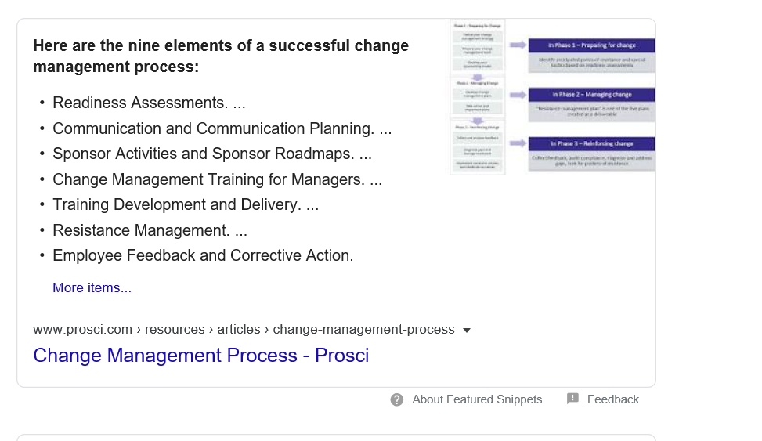

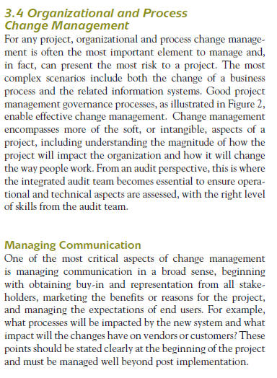

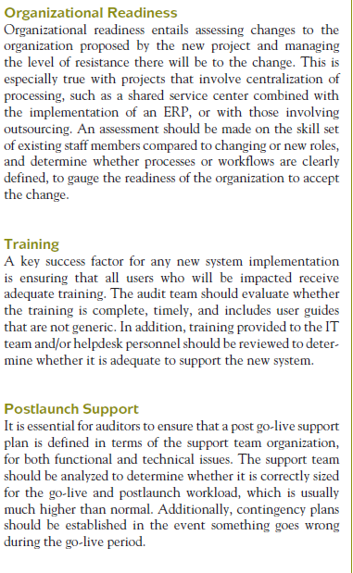

4.4.13 **Develop the Change Management Plan.**

The Project Manager with input from the Procurement Officer creates the Change Management Plan, which documents how project changes will be monitored and controlled from project inception through completion. The Change Management Plan should address:

• Process for approving/rejecting project change requests

• Process for monitoring and managing the rate of implemented change requests

• Process for maintaining baseline integrity by releasing only approved changes for incorporation into project products

• Process for configuration identification – how configuration items will be selected and identified, how products and documents are labeled, changes are managed, and accountability is maintained

• Process for configuration status accounting – how information is recorded and reported regarding configuration item data, including a listing of approved configuration identification, status of proposed changes to the configuration, and the implementation status of approved changes

• Process for configuration verification and audit – how configuration items will be verified and audited to ensure that they are correct and that corresponding changes are registered, assessed, approved, tracked, and correctly implemented

• Documentation of the complete impact of requested changes

Change Management

– Managing requirements change

– Reasons for requirements changes

– Definition of requirements change management

– Benefits of requirements change management process

– Requirements change management process

– Change request form

– Impact analysis

– Tools for impact analysis (N-square diagrams, traceability

lists, cost-benefit analysis, risk analysis)

– Unstable requirements

– Change control board actions

– Requirements change implementation

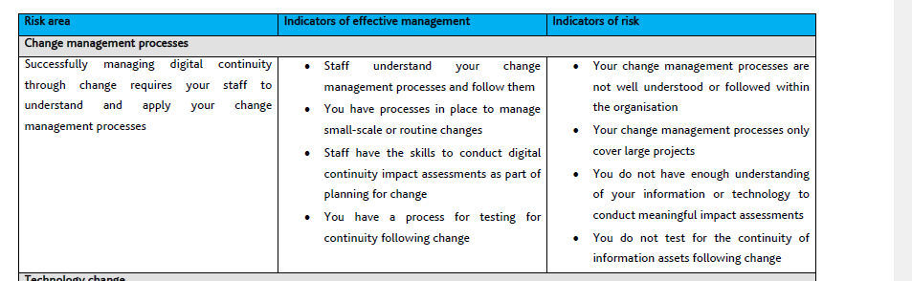

***"Change management:*** Change management is the process by which changes to the project scope,

deliverables, timescales or resources are formally requested, evaluated and approved prior to

implementation. A core aspect of the project manager's role is to manage change within the project. This

is achieved by understanding the business and system drivers requiring the change, identifying the costs

and benefits of adopting the change, and formulating a structured plan for implementing the change. To

formally request a change to the project, a change form is completed. The status of all active change

forms should he recorded within a change register.

Ritson(2013: 74) describes change management as a systematic approach that includes the application of tools, resources and knowledge to manage with the change. Change management is a coordinated structured period of changing from 1 scenario to the other scenario that should last for for a company. Change management is applied based on how much risk it can be linked with by not doing so.

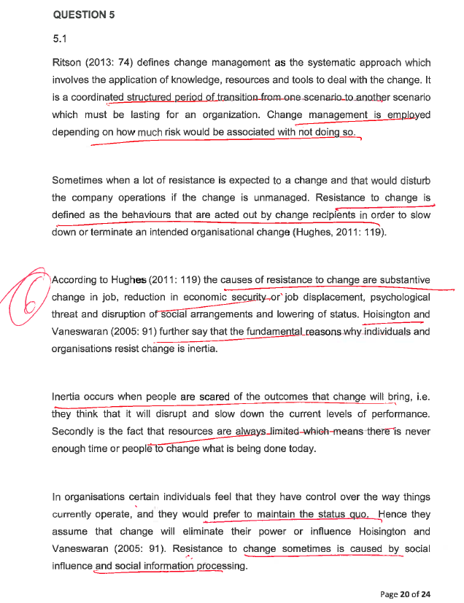

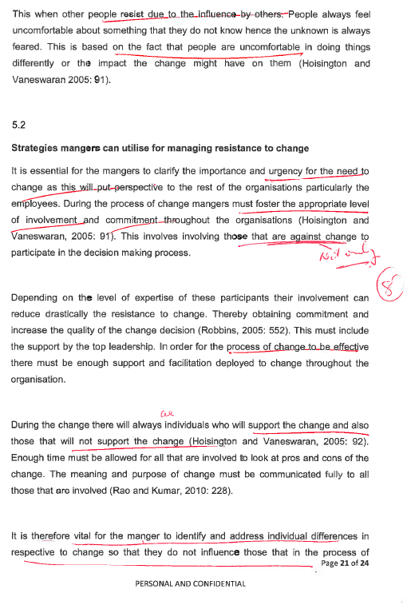

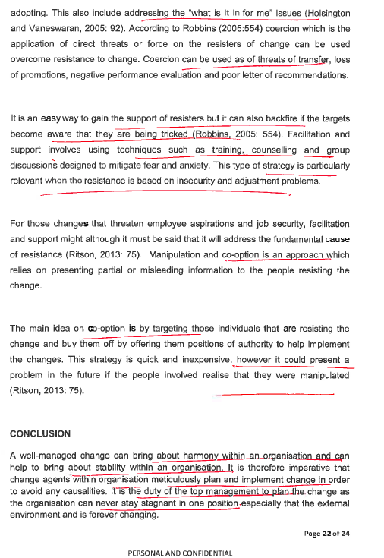

Question 3

3.1

The four criteria used:

Criteria 1

Exploration Phase The key activities here concern the organisation exploring and deciding whether it wants to make specific changes in its operations thereby committing the requisite resources. Key Change Management Processes: Creating an awareness of the need for change. Searching for outside assistance (consultants/facilitators) to assist with planning and implementation of the change programme. Establishing and defining terms of reference with the consultants/ facilitators.

*Exploration-a clear perception of need:*

Nokia was in difficulty at the end of 2010. It was losing market share at both ends of the mobile telephone market. At the top end, the share loss was to Apple’s iPhone and to smartphones using Google’s android open software system. At the bottom end, low-cost mobile telephones from China were much cheaper than similar Nokia telephones. All this was in spite of the company increasing its research and development (R & D) expenditure and its total number of employees. Nokia’s strategy was in deep trouble, through review done by Stephen Elop.

Criteria 2

Planning Phase: This involves the efforts to understand and tackle the organisation’s problem(s). Some of the discussions will revolve around understanding competitive trends and reactions of the respective organisational units. This may also involve systematic information gathering through research, networking and perusing related industry publications and other literature.

*Planning - a way forward:*

Stephen Elop after joining the company in 2010, spent the first few months reviewing the company’s position, talking to managers and employees. He concluded that there was a lack of accountability in many parts of the organisation. There needed to be simplified decision making with less reference back to headquarters before decisions were taken. The culture needed to be performance-based and less time serving. From a strategy perspective, Elop decided that radical strategic change was required as the strategy was in deep trouble. The 17

difficulty was that any admission of problems would potentially harm Nokia‟s business and reduce morale within the company

Criteria 3

Action Phase: this stage involves the implementation of the changes flowing from the Planning phase. The changes may involve alterations in the way things are done. This could result in the installation of computerised operational processes as well as changes in the organisational structure, among others.

Action -the capability to change

Elop and his senior colleagues developed future strategies. Nokia first made two strategic decisions and then followed this up with the implications in terms of a strategic change programme. The first strategic decision was to go ahead with Microsoft mobile software and get out of the Symbian software that had been the backbone of Nokia for many years. The second related strategic decision was that around 4 000 Nokia employees would be made redundant and another transferred to an outside company that would look after Symbian while it was still being used by customers.

Criteria 4

Integration Phase: this process follows the successful implementation of the intended changes. It focuses on consolidating and stabilising the adopted changes. Key Change Management Process: Reinforcing new behaviours through positive feedback and reward systems. Reduction of reliance on consultants. Diffusion of the successful aspects of the change process throughout the organisation. Training managers and employees to constantly monitor the change and to improve upon it.

*Integration- commitment.*

Elop showed commitment for change by sending out the “doomsday memo‟ as a first step. This was to be followed by an announcement of the new link with Microsoft several days later. On 7 February 2011, the well-constructed memorandum was sent as an email to senior managers. Elop made a joint presentation with Steve Bulmer, chief executive of Microsoft on part of the Nokia way forward. It had chosen Microsoft’s Windows & mobile platform. A few weeks later, a full deal was signed with Microsoft and, shortly afterwards, the announcement was made about the job losses. Nokia also announced a new senior management structure. It 18

included a change taskforce that would be disbanded once the goals had been achieved. The taskforce covered the following areas:

Work with Microsoft to produce the new smartphones to regain market leadership. Work on the low-end telephone market by expanding web access and applications that would deliver new uses for such telephones. Build new software systems that will deliver a complete smartphone experience to Nokia users. Develop closer co-operation between the various parts of Nokia to ensure that sales, production and marketing were fully aligned. Redevelop the Nokia management and governance structures to improve the effectiveness and speed of company practices and processes Develop a new and effective on-site R&D strategy. Set up a programme office to lead change management overall Instigate a culture change programme to embed the right values, mind-sets and behaviours

3.2

In my view, there is nothing wrong with the memorandum sent and the new strategies in the memorandum. Elop should have allowed an internal announcement by senior managers to the employees before sending it out as this leaked and was not well received by the employees especially knowing that they were going to lose their jobs. The employees should have been briefed by each line manager. Each senior manager should have allowed the employees to suggest ideas and also coming up with a strategy as they are people on the ground, they deal with Nokia customers and are also exposed to the latest technologies and would know what will work best. Getting feedback from employees would have given them a clear picture of customer needs. Nokia as a brand has managed to retain its customer base, they shouldn’t have completely changed their brand and adopt Microsoft completely and loose the brand. They should have continued with the Nokia brand but operating with a different software.

3.3

Schein (1990:111) provides one of the most widely quoted definitions of organisation culture as “(a) a pattern of basic assumptions, (b) invented, discovered, or developed by a given group, (c) as it learns to cope with its problems of external adaptation and internal integration, (d) that has worked well enough to be considered valid and, therefore (e) is to be taught to new members as the (f) correct way to perceive, think, and feel in relation to those problems.”

Bhattacharyya (2011: 268 - 269) emphasizes the following organisational culture change process: ƒ Identify the core values and beliefs ƒ Consider the subcultures within the 19

organisation ƒ List out the incongruence ƒ Establish new behavioural norms ƒ Repeat these steps over a long period of time.

Models of Organisational Change Kanter et al (1992) identified the following themes as the basic assumptions of most change models and/or frameworks:

Awakening the organisation to a new reality and disengaging it from the past. Recognising that the old way of doing things is no longer acceptable. The need to create and embrace a new vision of the future by the organisation. The need to unite behind the steps necessary to achieve the stated vision. The need to solidify’ or ‘refreeze’ the new attitudes, practices and policies. There are as many models of change as the attempts that have been undertaken to change organisations over the years.

Manifestations of Culture Schein 1990) identified three fundamental levels at which the culture manifests itself:

1. the observable artefacts: including the physical layout, dress code, manner of address, the smell and feel of the place, its emotional intensity, company records, products, statements of philosophy, and annual reports;

2. the values: including norms, ideologies, charters, philosophies, why certain observed phenomena happen the way they do;

3. the unconscious assumptions: the taken-for-granted, underlying, and usually unconscious assumptions that determine perceptions, thought processes, feelings, and behaviour.

Culture refers to beliefs, values and attitude held by management and their employees (Passenheim, 2010). Any business like Nokia may have inherent attitudes which do not support change. A change of strategy, structure and technology make it necessary for people (employees) to change their knowledge, behaviour and attitudes. If this is not implemented correctly this can inhibit cultural change in an organisation. Through better training on strategic changes to be implemented in an organisation and allowing employees to accept and adopt to the changes can help facilitate change in an organisation. There are steps to be followed when it comes to approaching cultural changes to avoid obstacles (Passenheim, 2010):

• Analyze the cultural situation

• Accept the cultural barrier, do not ignore it

• Work against it with a communication mechanism or integration methods.

20

Cultural change facilitators: Communication the need for change is important. This can be done by developing a business case outlining the reasons for change. Evaluate the readiness for change in the organisation. Ensuring that people support the change, understand the change and are involved in the plans for change. Better communication between the different stakeholders affected by the change. This can be done face to face or in groups to ensure everyone understands. Review the change by putting control measure to check the progress on changes made, areas of improvement.

Cultural change inhibitors

Insufficient problem awareness: this is the reasoning behind any change in an organisation. There are triggers for change processes which are extensively discussed with the management. Awareness arises of existing problems and the necessity to make changes. Workers/employees must have transparent view of the situation of the company, must be informed of the problems and planned changes

Insufficient communication: miscommunication can be a cultural inhibitor in that people like to gain influence regarding their surroundings and have control. Restructing plans for an example in an organisation if not communicated properly can cause chaos.

Bad style: it’s a behaviour that is practised in an organisation where employees are not involved, they are just tod about the changes.

Unprofessional stakeholder management: stakeholders have different interests and numerous persons are affected by the changes.

Workload and speed: involves adoption to change. Normally with changes there is increased workload and time to catch-up to competitors may not be favourable to meet new targets.

Lack of control: if a change process is initiated, one should pay attention to the sustainability of the targeted changes. 21

References

Ehlers, T and Lazenby, K (Editors) (2007) Strategic Management Southern African concepts and cases Second edition Van Schaik

Kim and Mauborgne, 2005, Blue ocean strategy book, How to Create Uncontested Market Space and Make the Competition Irrelevant

Thompson, Arthur A. Jr., Strickland, A.J. III, Peteraf, M.A and Gamble JE. (2014). Crafting and Executing Strategy – Concepts and Cases. 19th Edition. Boston: Irwin McGraw – Hill.

Schein, E. H. (1990) Organisation Culture. American Psychologist. February 1990

Passenheim, O (2010) Change Management. 1st Edition. The ebook company



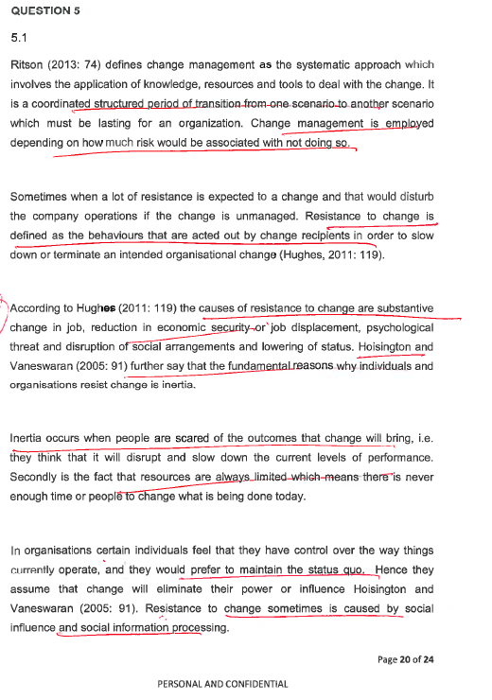

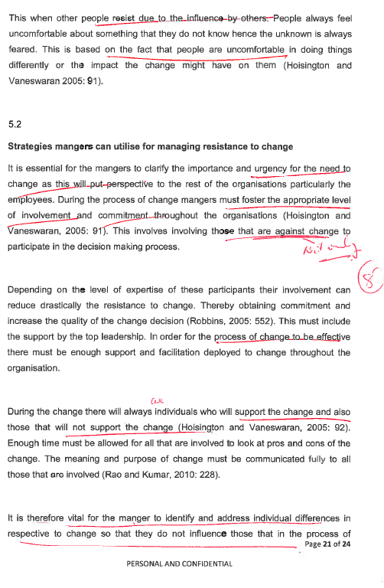

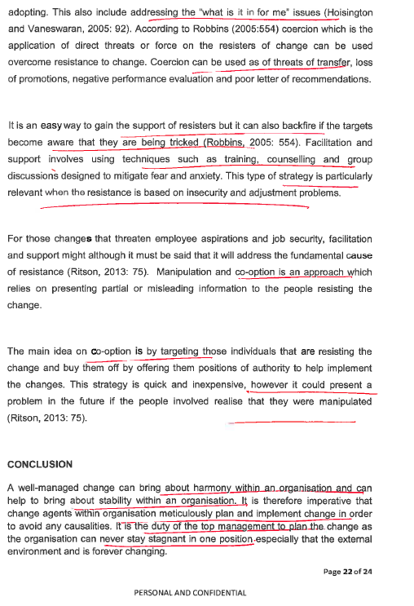

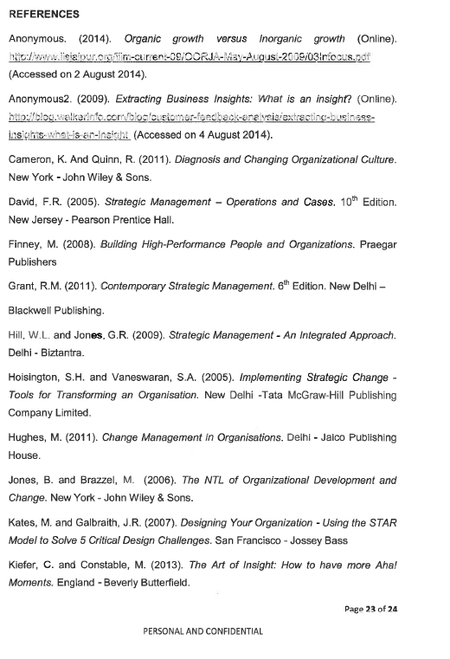

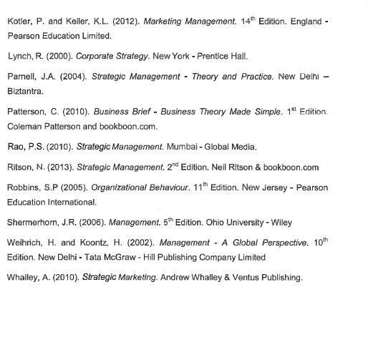

Marked Assignment_Strategic Management.pdf. 5.1 5.2

63FE43C8-D536-47FD-B52F-6BA82BCF7D67.pdf p18 p16 Question 2

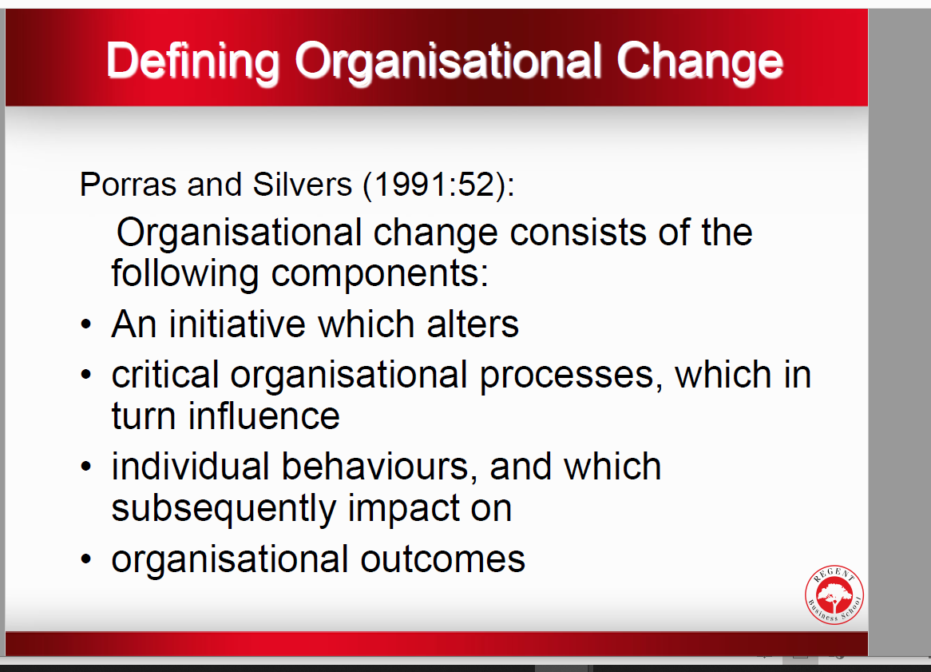

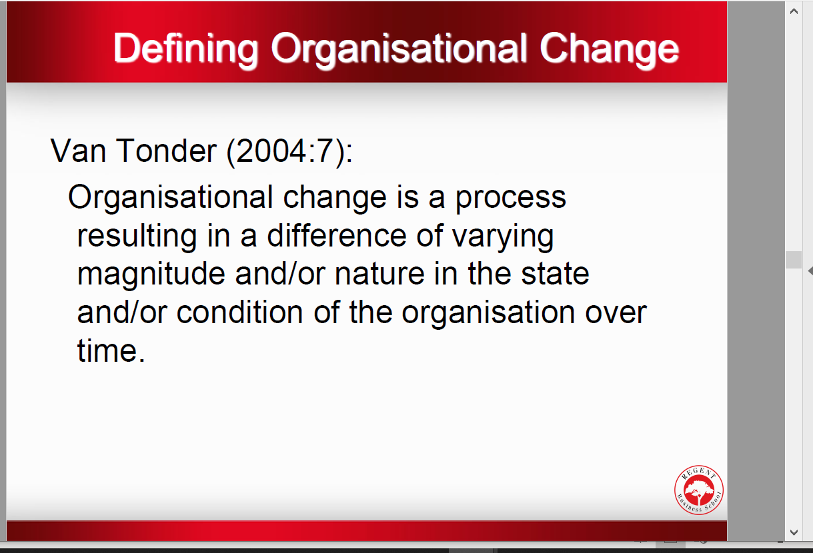

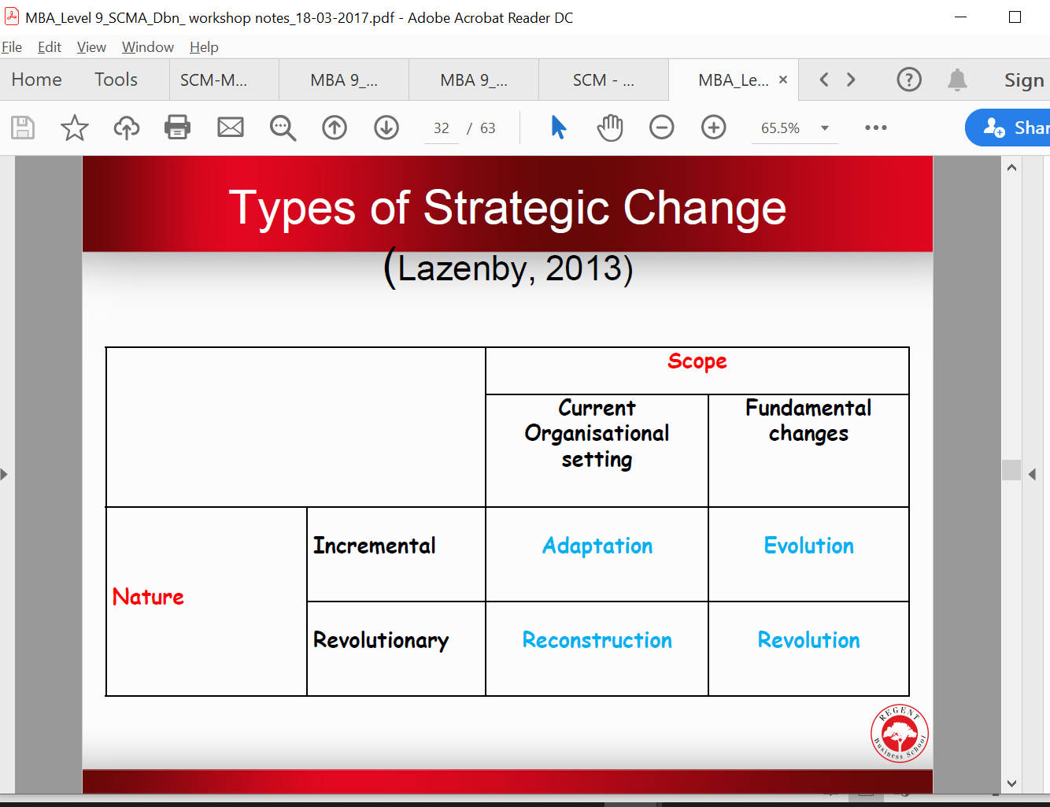

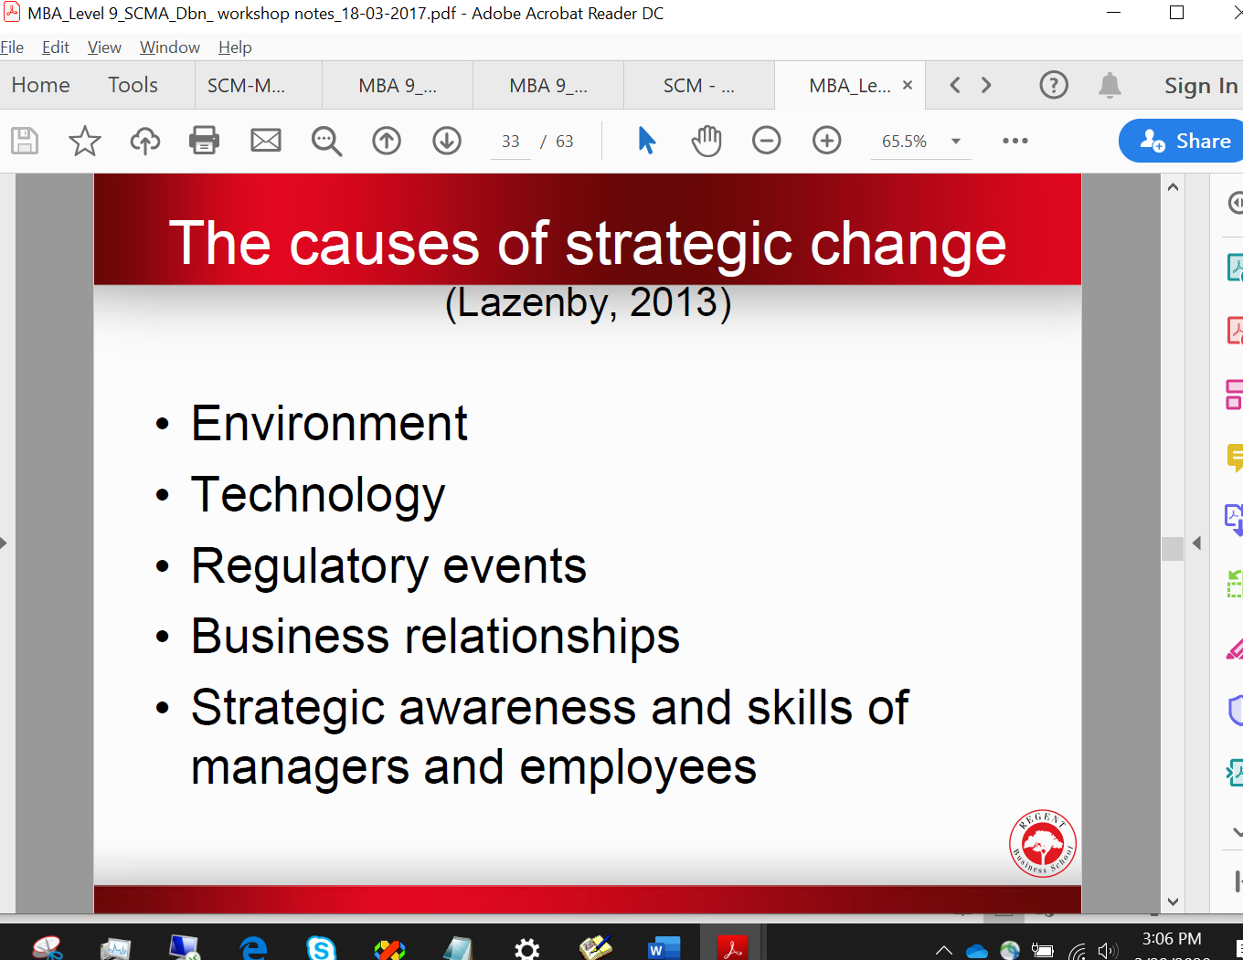

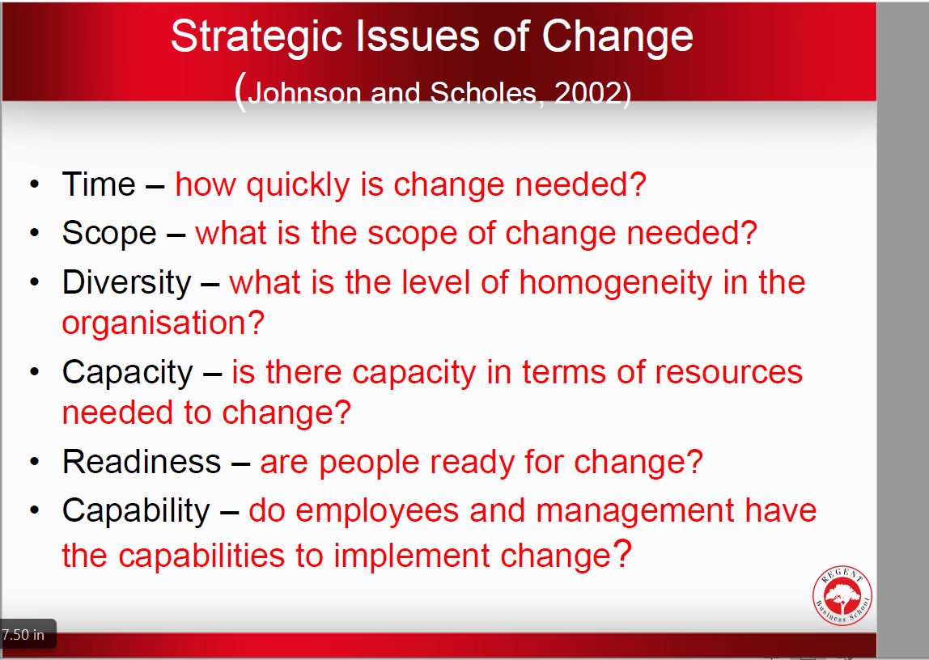

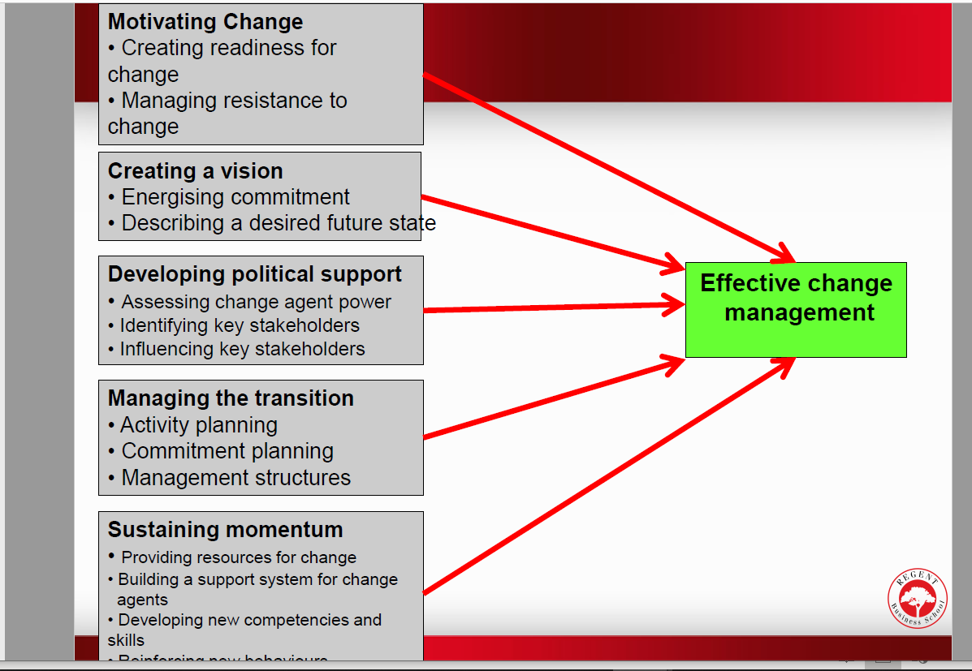

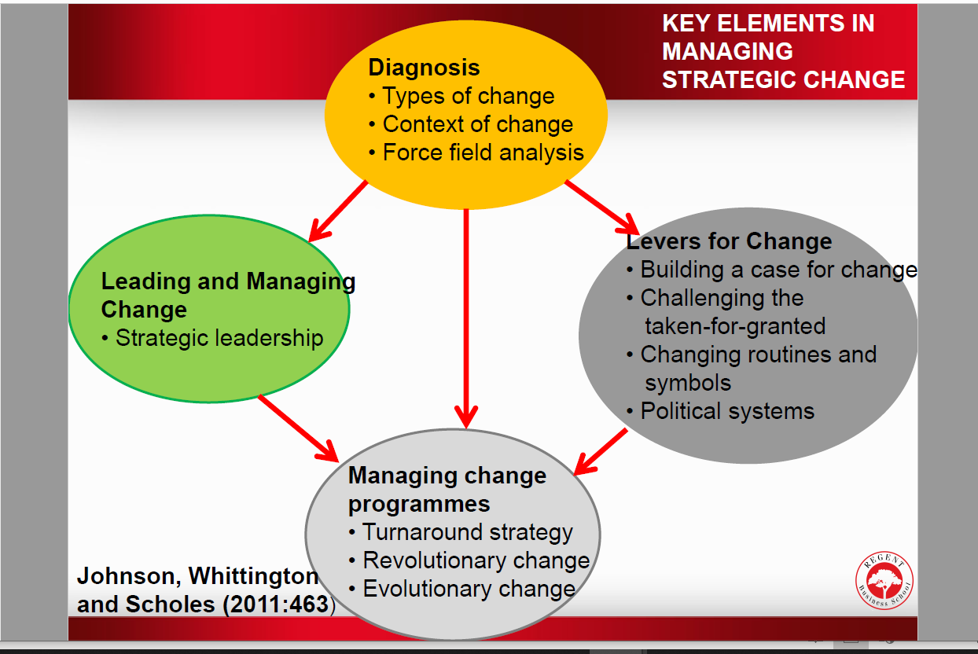

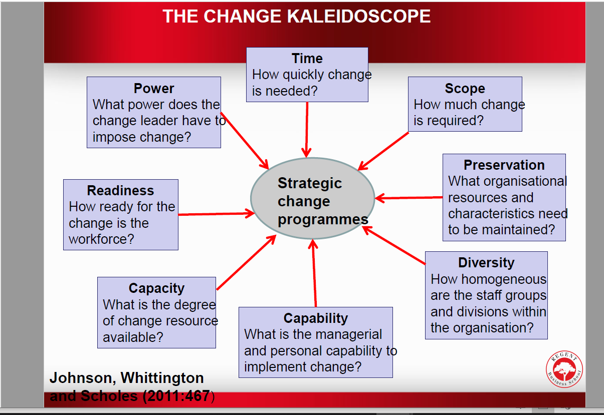

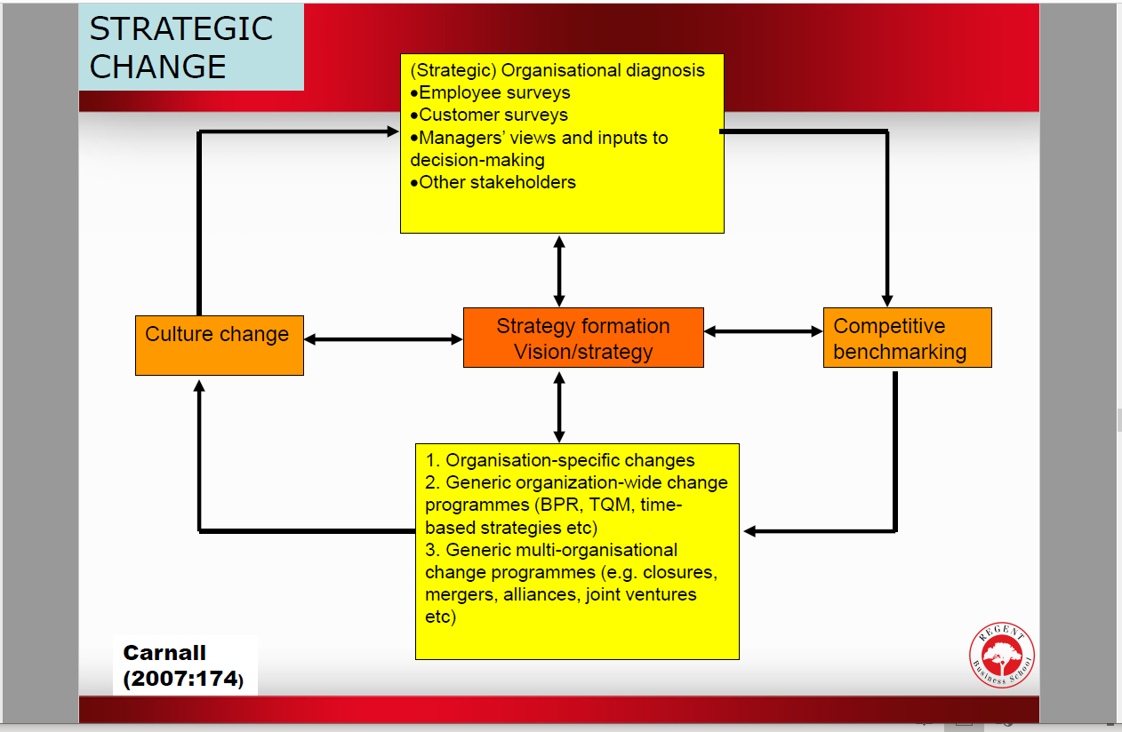

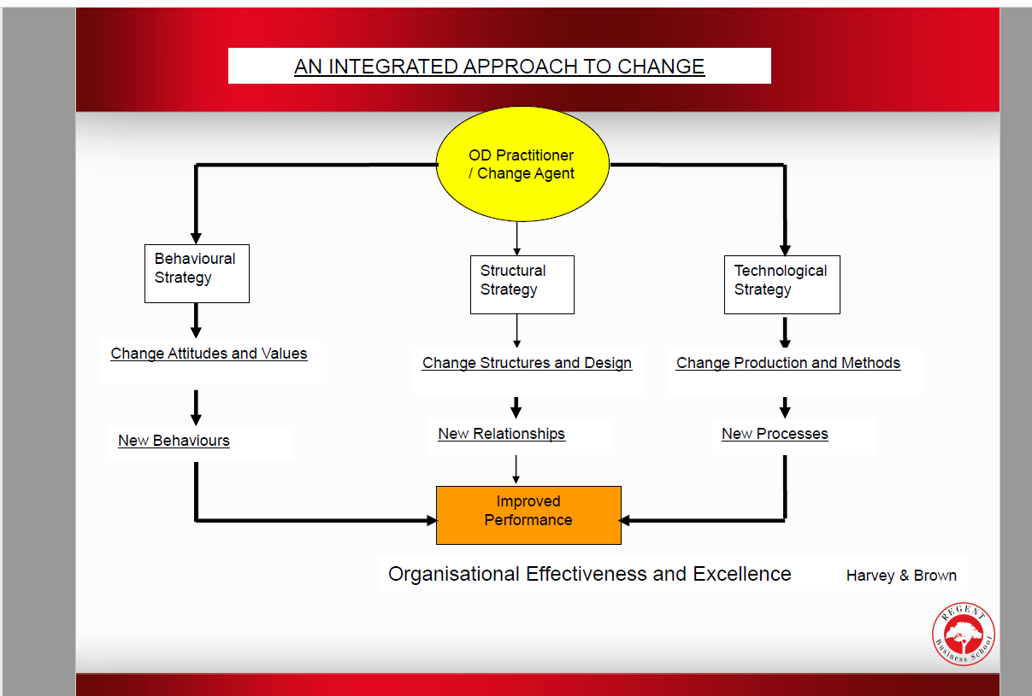

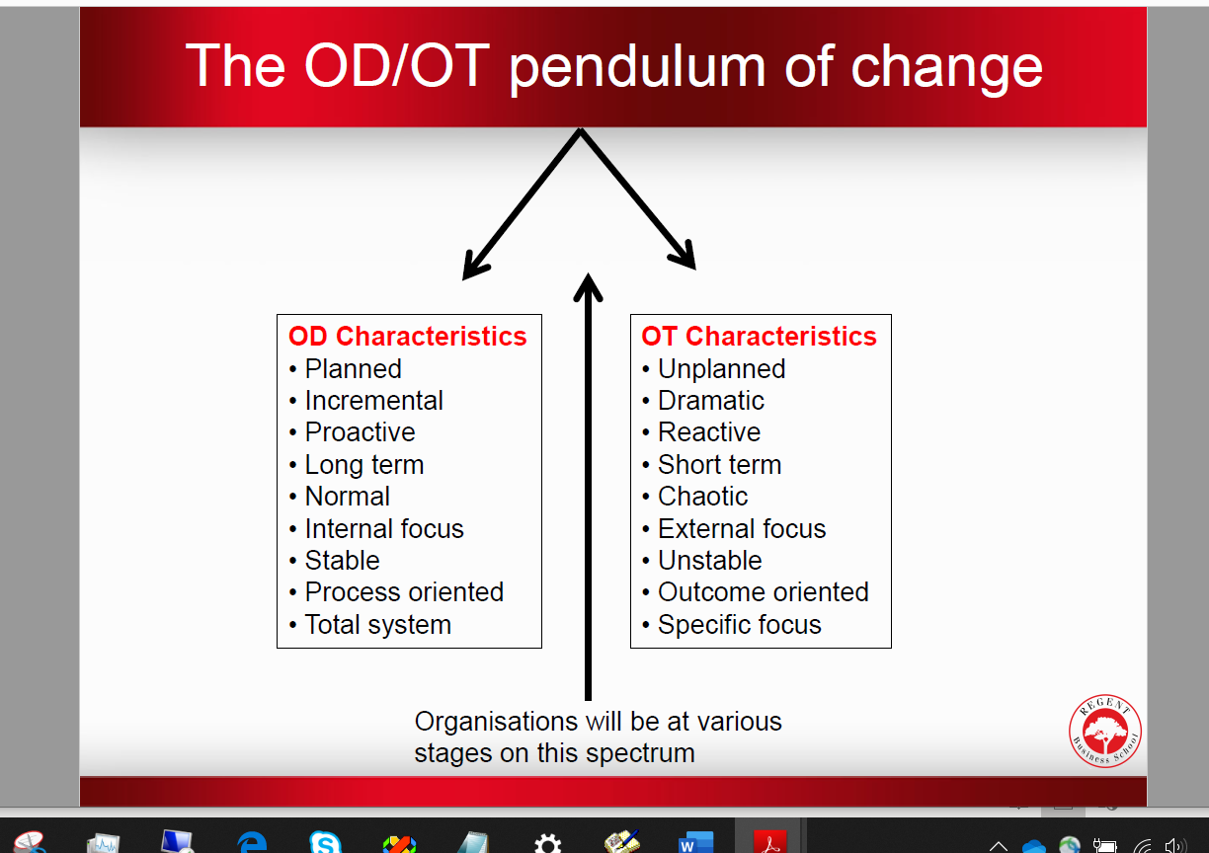

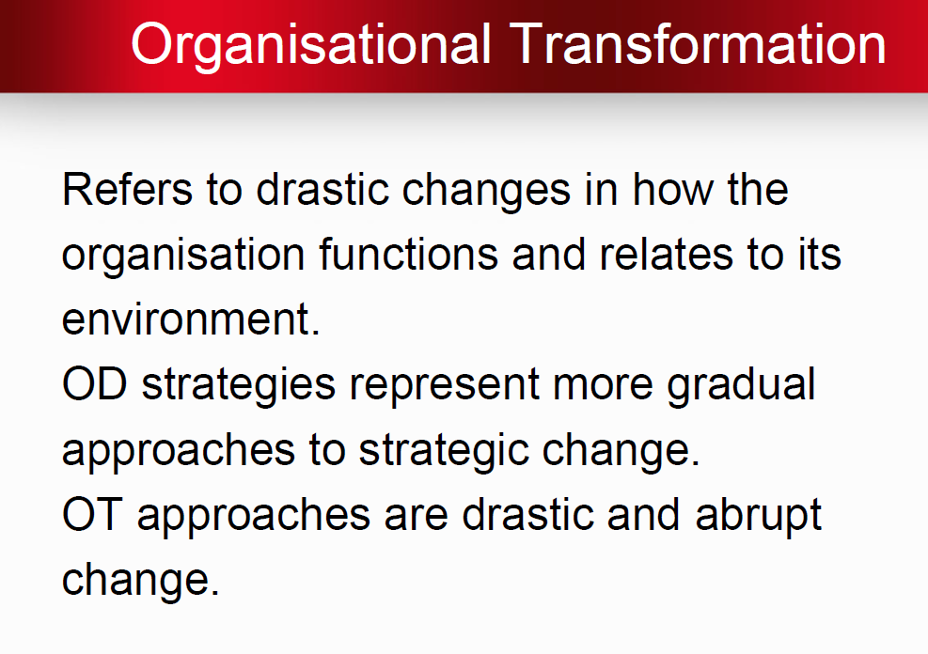

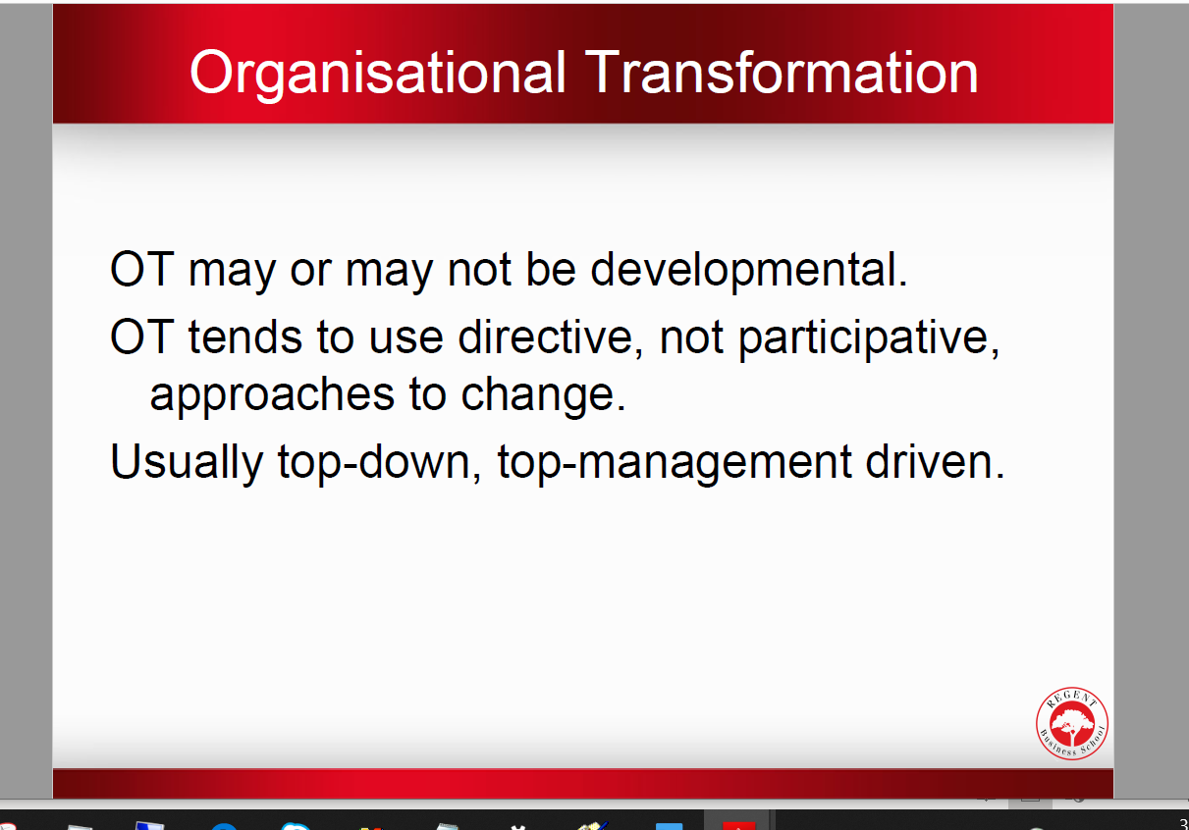

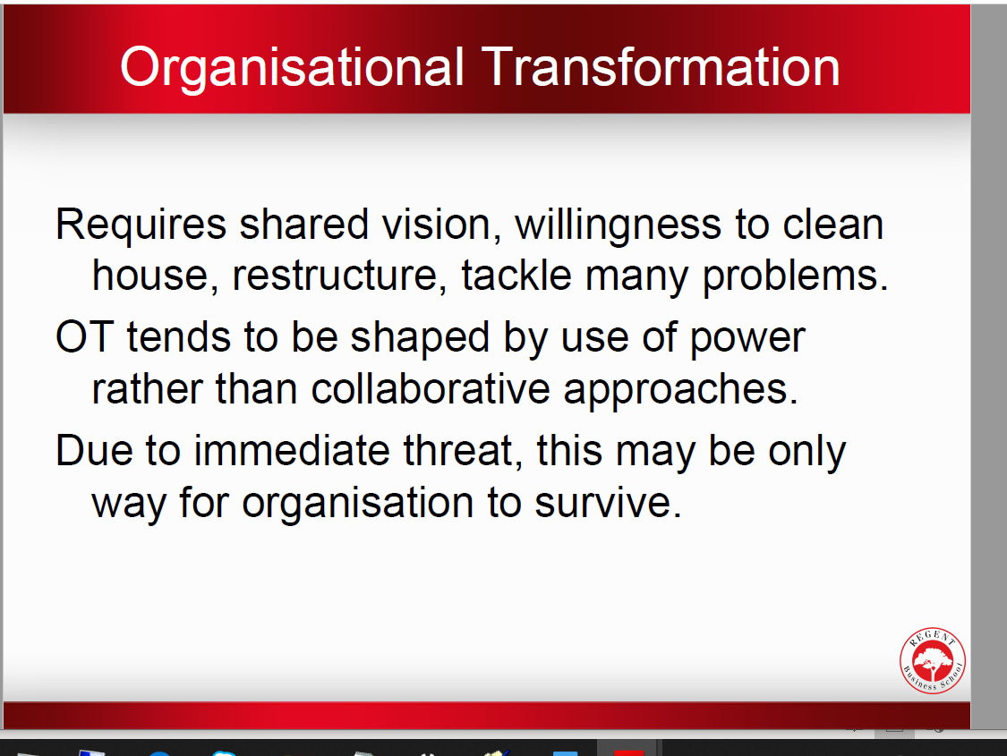

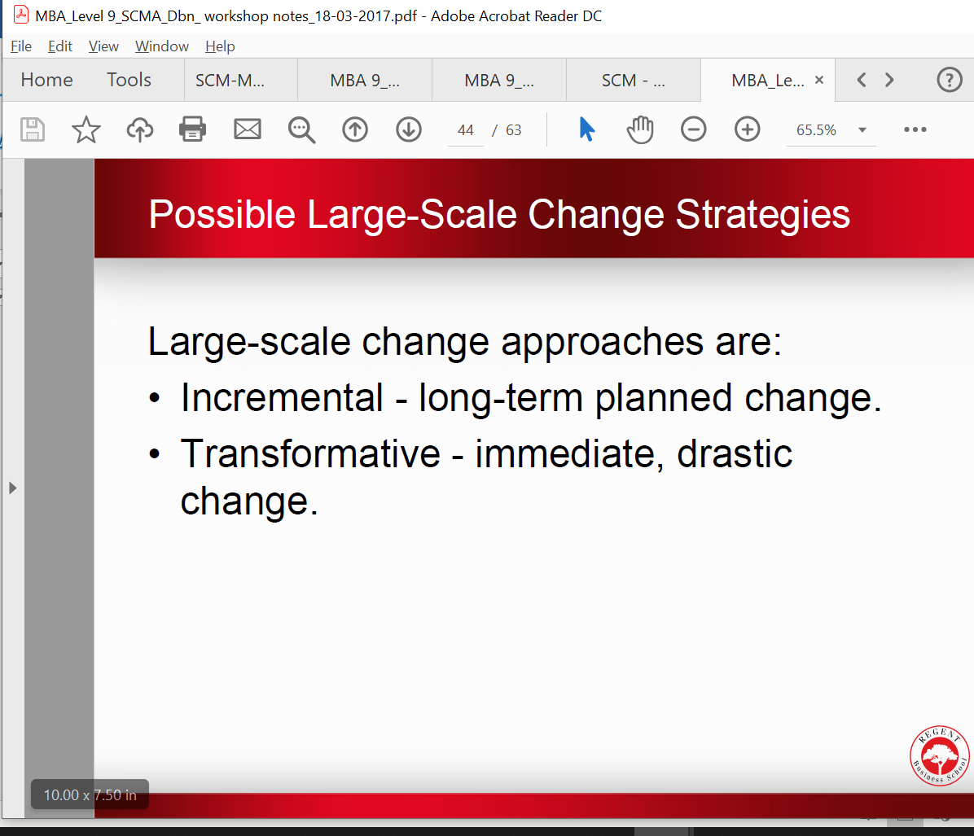

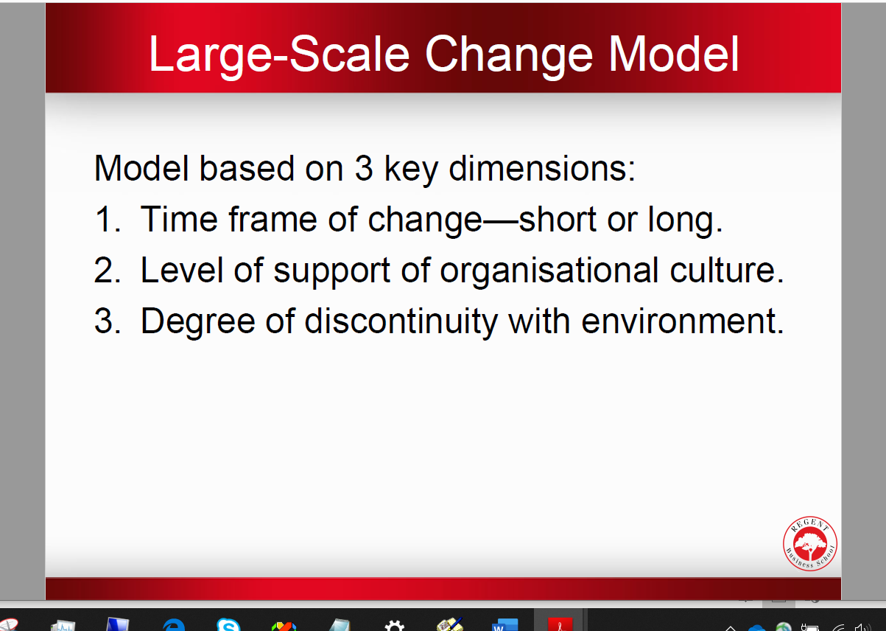

NBNBNBNBNBNB

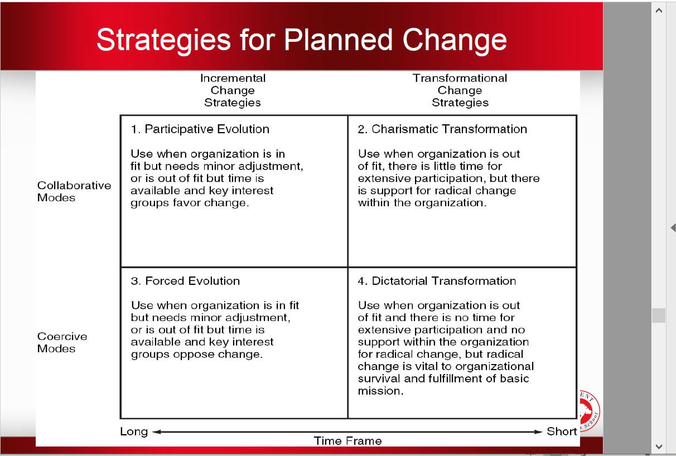

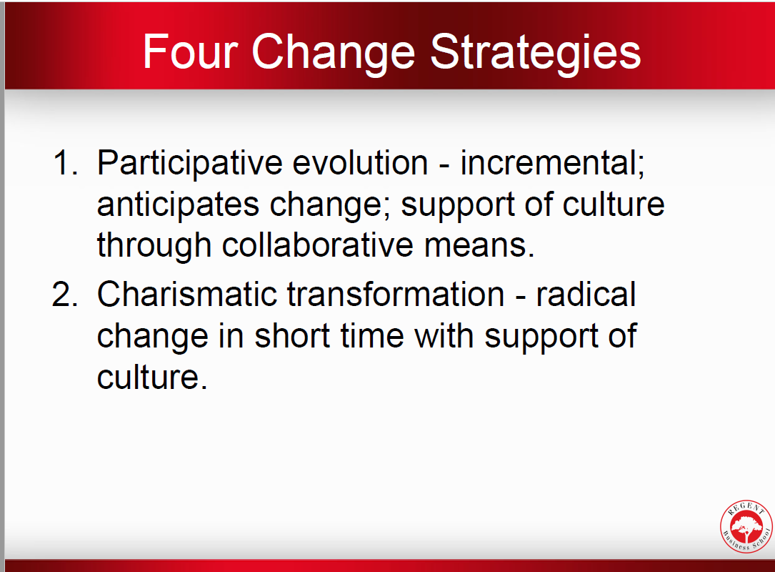

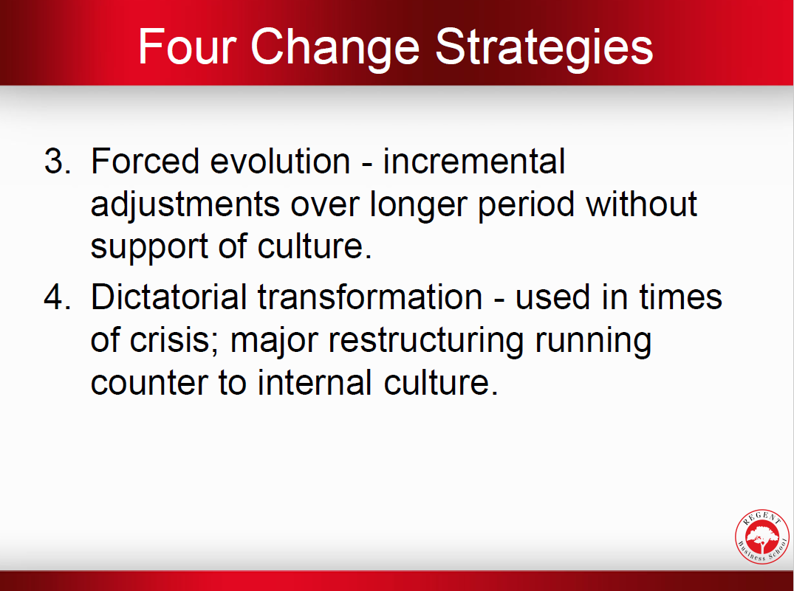

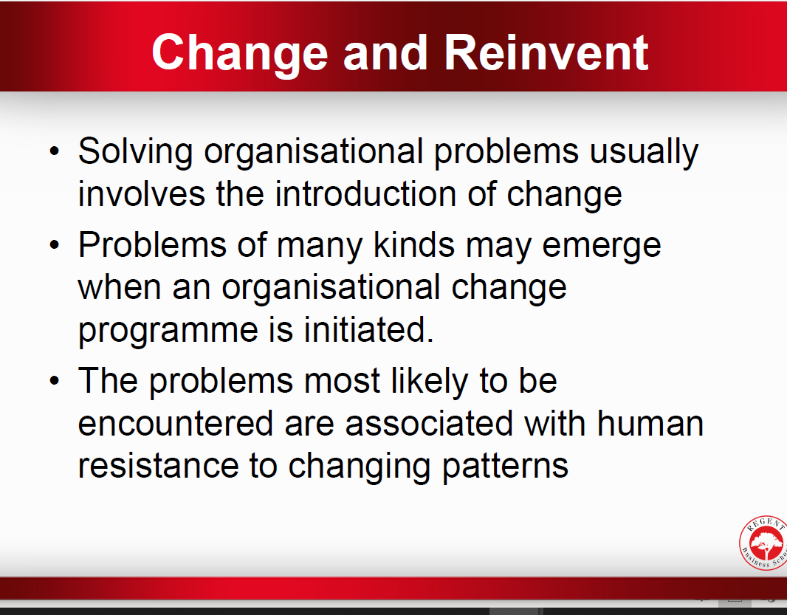

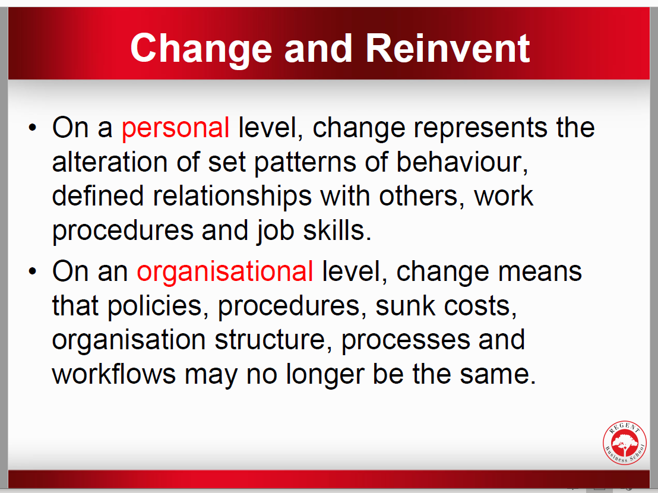

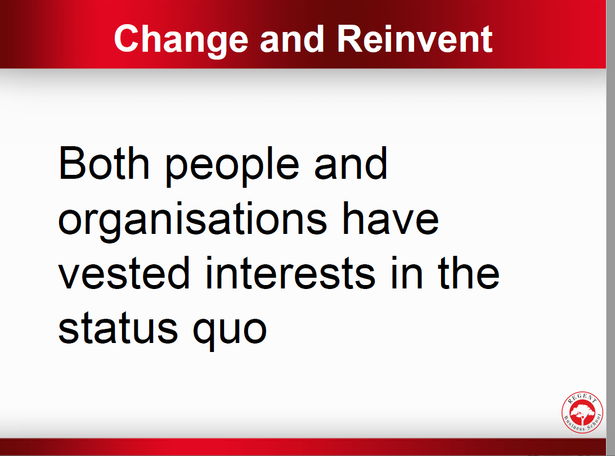

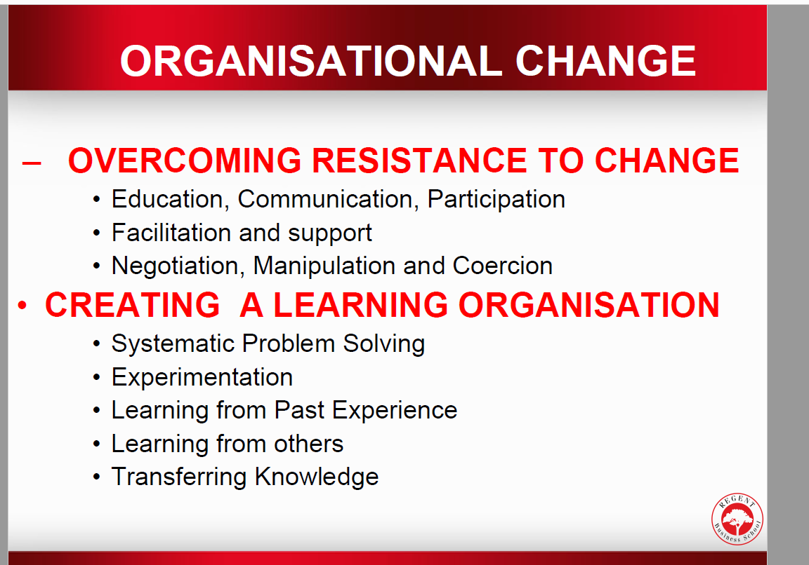

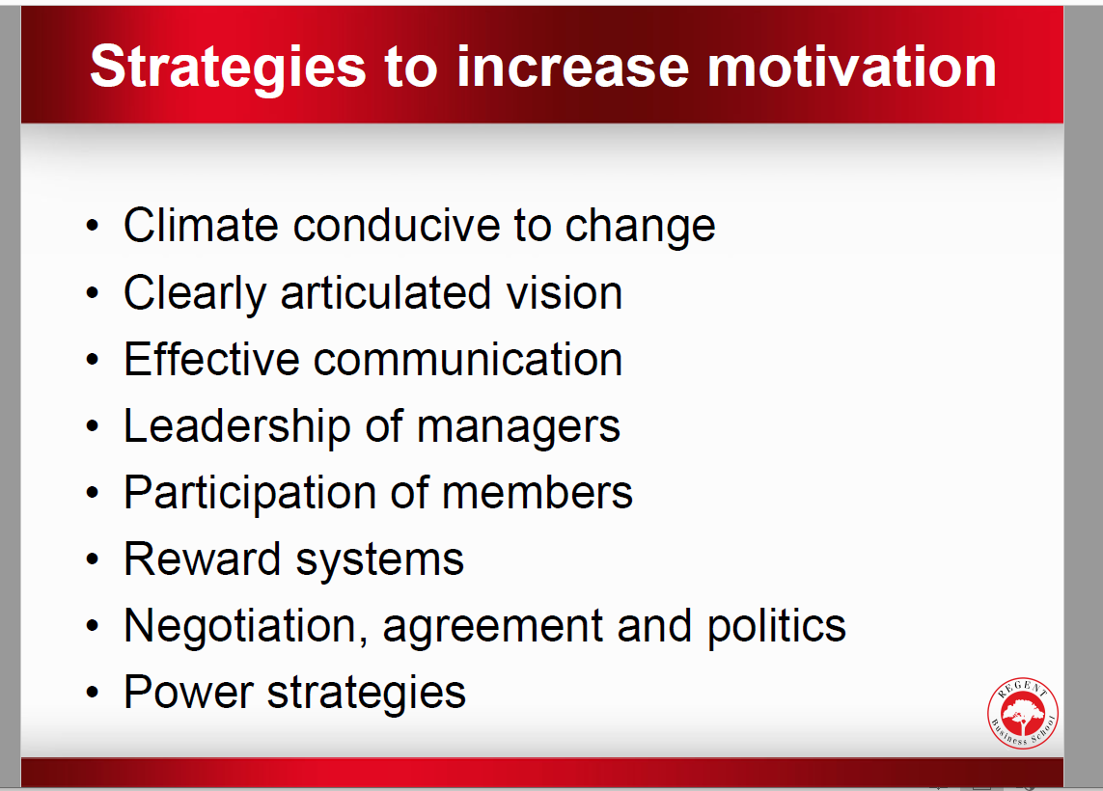

**Strategies for Recognising and Managing Resistance**

**QUESTION TWO [20]**

A strategy is a course of action to which valuable resources will be committed. The future of the organisation may be altered because of it; survival may be at risk. Strategy is implemented through the organisational architecture of an organisation.

With reference to this:

2.1 Discuss the reasons why strategy is crucial to an organisation and explain why strategic intent may be regarded as the first indispensable step in the strategic management process (8)

1.2 Strategic Options available to Fage

Option 1:

The Five Generic Competitive Strategies Thompson et al. (2006:134) identifies five generic competitive strategies:

1. A low-cost leadership strategy: appealing to a broad spectrum of customers based on being the overall low-cost provider of a product or service.

2. A broad differentiation strategy: seeking to differentiate the company’s product offering from rivals’ in ways that will appeal to a broad spectrum of buyers.

3. A best-cost provider strategy: giving customers more value for the money by combining an emphasis on low-cost with an emphasis on upscale differentiation; the target is to have the best (lowest) costs and prices relative to producers of products with comparable quality and features.

4. A focused or market niche strategy based on lower cost: concentrating on a narrower buyer segment and out-competing rivals by serving niche members at a lower cost than rivals.

5. A focused or market niche strategy based on differentiation: concentrating on a narrow buyer segment and out-competing rivals by offering niche members a customised product or service that meets their tastes and requirements better than rivals’ offerings.

Option 2:

Red oceans Strategy option:

Red oceans are existing market spaces, with known products, strategies and competitors. Low-price and quality are some of the factors that the competition is based-on. The market is overcrowded and the goal is to acquire more market shares every year. All actors’ positions are well-known and it is almost impossible for new entrants to settle and compete. Profit and growth are limited due to the strong competition.

Option 3: 8

Blue Ocean Strategy option:

To create a blue ocean is a necessity for companies who want to ‘move on’. Several factors as globalisation, technology, innovation, prices, and market shares are factors leading companies to choose their best solution: a blue ocean strategy. The strategy is to create a new demand and head in another direction from competition.

All these steps will help for formulating the blue ocean strategy by reconstructing the market boundaries.

The first step indicates that value innovation can be done between alternative industries. Indeed, opportunities will be created due to products and services, different forms but serving a shared goal.

The second step suggests that the creation of a blue ocean is possible by proposing a common key factor from all strategic groups. The third step points out that a blue ocean can be created by challenging established thoughts about who are the buyers and users.

The fourth step underlines the fact that companies need to find a complete solution for their products or services. For example, a restaurant can open a crèche for customer’s kids. The fifth step suggests adding emotion to products or services. The sixth step recommends identifying issues, trying to find solutions and forecast them

In order to develop a company’s strategic canvas, leaders will have to: a) Share their vision and make it understandable for all employees. Employees need to know the situation of the company, and its position in the marketplace. They need to share the vision in order to feel as a part of a bigger plan. b) Know their customers. A company must know their customers habits. This results in competitive advantage, since leaders will know the pros and cons of every product. c) Ask employee’s for their inputs into strategic decisions. This will assist in attaining ‘the buy-in’ of the strategy by employees, since they have a say in the direction it may pursue. d) Communicate with all services. A leader must keep his teams informed. A company operating a blue ocean should have two main goals about users: to keep their customers, but more importantly, to reach their non-customers. e) To reach beyond existing demand is one of the key components of achieving value innovation. To succeed, companies have to focus on existing customers and non-customers in order to maximise the size of the blue ocean.

According to Kim and Mauborgne (2005), “non-customers can be classified into three different tiers”: 9

The first tier, “Soon-to-be,” represents ‘future customers’ who are in search of improved or better products. Some factors may make these individuals reluctant to buy the initial product, but with some minor modifications to the product, customers will buy the revised product. This category also includes non-regular customers who choose your product since there is nothing better on the market. Companies should try to find out what customers want, so that their needs will be satisfied by newly adapted products, which in turn, may also attract new customers. A blue ocean will be created from this intervention. Additionally, non-customers provide better product feedback than existing customers.

The second tier, “Refusing,” represents non-customers who are of the opinion that the products companies offer is unaffordable or not adapted to their demands. The goal here is to address these concerns in order to expand the market.

The third tier, “Unexplored,” represents non-customers who have never used or explored your product or service. Indeed, their needs are fulfilled by other markets.

Best option for Fage

Based on the three options proposed above, the Blue Ocean Strategy will be the best option for the Fage company. By implementing the strategies proposed, Fage will be able to increase their market base, they will be able to retain and get new customers. Being able to get continual feedback will assist Fage to improve their product in order to satisfy their customers.

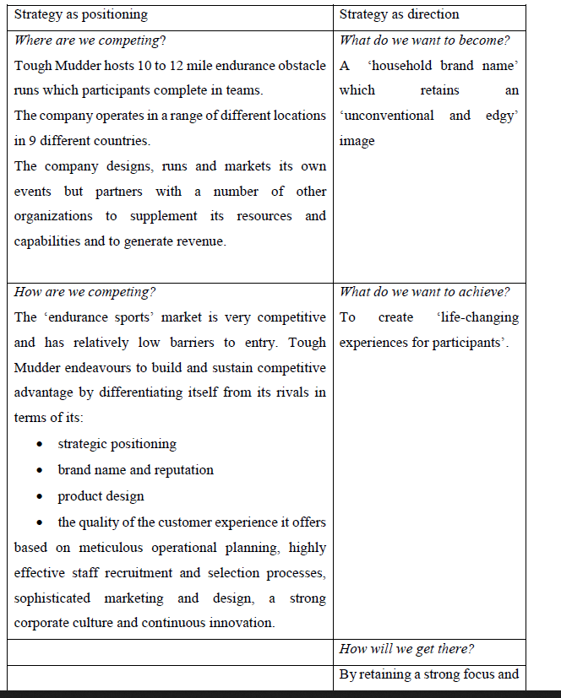

3.2

In my view, there is nothing wrong with the memorandum sent and the new strategies in the memorandum. Elop should have allowed an internal announcement by senior managers to the employees before sending it out as this leaked and was not well received by the employees especially knowing that they were going to lose their jobs. The employees should have been briefed by each line manager. Each senior manager should have allowed the employees to suggest ideas and also coming up with a strategy as they are people on the ground, they deal with Nokia customers and are also exposed to the latest technologies and would know what will work best. Getting feedback from employees would have given them a clear picture of customer needs. Nokia as a brand has managed to retain its customer base, they shouldn’t have completely changed their brand and adopt Microsoft completely and loose the brand. They should have continued with the Nokia brand but operating with a different software.

/////////////

Why has the strategy been successful?

Tough Mudder’s rapid growth both in terms of number of participants and number of events as a good indication that their strategy is a success. The company is one of the market leaders and has built a loyal customer base. The company has consistent long term goals outlined in the case study. The case study emphasises the founders’ focus and their recognition of the need for a clear mission and brand. The company’s core values guide the action and behaviour of the management team. The leaders of the company have a profound understanding of the competitive environment they are in. The management team clearly recognises the threat that competition poses and pays close attention to customer feedback in order to improve the customer experience and strives to continuous update and improve the design of its obstacle courses. Objective appraisal of resources- while the company seeks to build its resources and capabilities internally through the recruitment of knowledgeable, committed and enthusiastic individuals, it also recognises the advantages of partnering with other organizations.

2.2

Tough Mudder is experiencing strong competition from established rivals and the barriers to entry into this market are relatively low which means there is a potential threat from new entrants. In recent years endurance sports and military style fitness activities have increased in popularity (this is *an opportunity*) but the fitness industry, like many others, is subject to the vagaries of changing fads and fashion (this is *a challenge*). It seems reasonable to suggest that endurance sports might be income elastic; that is to say expenditure on this kind of activity is discretionary and something that individual and firms may choose to cut back on if they feel that “money is tight” (*a challenge*) or engage in when disposable incomes are rising (*an opportunity*). The obstacle courses are designed to present teams with physical and mental challenges but that is not without risk. Although the company has very well developed health and safety procedures, there is always a risk that a participant may injure themselves severely and that the company’s reputation could be damaged (*a challenge*). Social media is a double-13

edged sword – while the company has used it to great effect to develop its business, any shortcoming on its part would be disseminated very quickly.

The company strategy is to differentiate itself from its competitors not only in terms of the design of its obstacle courses, its events and its customer service but also in terms of its values and its connection with purpose and people. Having a distinctive ‘identity’ gives it a slight edge in an increasingly competitive market place and is one way of meeting the challenge of competition. Other suggestions might include: drawing on its brand image and distinctive capabilities to move into adjacent markets e.g. other types of team building, risk assessment for third parties, events management.

2.3

Strategic leadership is defined as the ability to anticipate, envision, maintain flexibility and to empower others to create strategic change as necessary (Hitt, Ireland and Hoskission, cited in Ehlers and Lazenby, 2007:217). Strategic leadership involves managing through others and influencing human behaviour in order to achieve goals. Strategic leadership is about leading entire organisations; it is about understanding entire organisations and the environments within which they operate and using this understanding to create strategic change through other people so as to position organisations in the environment for both short-term stability and long-term viability.

The key responsibilities of a strategic leader are:

• Developing an appropriate vision or strategic direction for the organisation

• Communicating the vision and strategic direction to all the employees

• Inspiring and motivating the employees to achieve the strategic objectives

• Designing appropriate reward systems and organizational structures

• Developing and maintaining an effective organizational culture. (Ehlers and Lazenby, 2007:223)

Key characteristics of good strategic leaders exercised by Will Dean 14

1. Vision, eloquence and consistency give a clear sense of direction; a clear and compelling vision of where the organisation should go. Eloquence to communicate the vision and energise people. Consistently articulate their vision until it becomes part of the culture.

2. Articulation of a business model Ability to identify and articulate the business model the company will use to attain its vision. A business model is the conception of how the various strategies that the company pursues fit together into a congruent whole.

3. Commitment Strong leaders demonstrate their commitment to their vision and business model by actions and words and often lead by example.

4. Being well informed Develop a network of formal and informal sources who keep them well informed about what is going on. Using informal and unconventional ways to gather information is wise because formal channels can be captured by special interests or by gatekeepers who may misrepresent the true state of affairs.

5. Willingness to delegate and empower Unless they delegate, leaders can become overloaded with responsibilities. Empowering subordinates is a good motivation tool. However, astute leaders recognise the need to maintain control over certain key decisions.

6. The astute use of power comes from control over important resources: budgets, capital, positions, information and knowledge. Astute leaders use these resources to acquire another critical resource – critically placed allies who can help attain strategic objectives. Strategic leaders must play the power game with skill and attempt to build consensus for their ideas rather than use their authority to force ideas through; they must act as members of a coalition or its democratic leaders rather than as dictators.

7. Emotional intelligence A bundle of psychological attributes – self-awareness, self-regulation, motivation, empathy and social skills.

As stated in the case study, Will Dean focuses upon key priorities as a leader. He believes in two things which is culture and strategy. Will Dean states the importance of having a vision which is known by his employees as are an important resource in the organisation. It is important in their organisation to know where they are going as a company and how they getting there by communicating the vision and long-term strategy of the company and ensuring that the employees are well glued on this. As a CEO, Will Dean also focuses on ensuring that his employees are motivated all the time and exercise the important of being responsible for 15

the company and thus encouraging ownership which is important in every business as this allows employees to go an extra mile and make a success of tasks given.

**Changing an organisation’s culture and climate is often related to the implementation of a new strategic direction that the organisation wishes to follow.**

* **Learn from internal and external sources**
* **Visioning - develop strategy** 
  + **Push vs. pull tools**
  + **What values does the strategy embrace?**
  + **What behaviors are needed?**

Nbnbnbnbnbnbnbnb

* **Learn from internal and external sources**
* **Visioning - develop strategy** 
  + **Push vs. pull tools**
  + **What values does the strategy embrace?**
  + **What behaviors are needed?**

**Incremental approaches**

**The Rational- Comprehensive Approach** The Rational-Comprehensive approach is closest to full, systematic corporate planning. Administrators work through policy alternatives and evaluate them against stated criteria. This is called the ‘Root method’.

**The Rational- Comprehensive Approach** The Rational-Comprehensive approach is closest to full, systematic corporate planning. Administrators work through policy alternatives and evaluate them against stated criteria. This is called the ‘Root method’.

**The Rational- Comprehensive Approach** The Rational-Comprehensive approach is closest to full, systematic corporate planning. Administrators work through policy alternatives and evaluate them against stated criteria. This is called the ‘Root method’.

Nbnbnbnbnbnnb

**The Rational- Comprehensive Approach** The Rational-Comprehensive approach is closest to full, systematic corporate planning. Administrators work through policy alternatives and evaluate them against stated criteria. This is called the ‘Root method’.

Gary Hamel in his article “Strategy as Revolution” (Harvard Business Review, JulyAugust 1996) says: “Giving planners’ responsibility for strategy is like asking a bricklayer to create Michelangelo’s Piéta”.

This implies that strategies which are well implemented are firstly professionally facilitated by external consultants.

These professionals are able to stimulate and channel the strategic thinking process to higher levels of insight and understanding. This, to a large extent, determines the effectiveness of the strategic planning process.

NBNBNBNBNBB

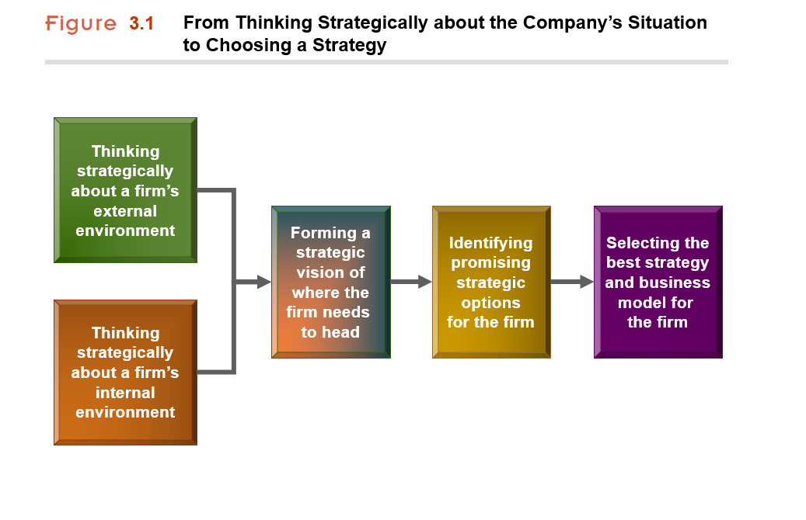

WHAT DO WE MEAN BY *STRATEGY*?

* What is our present situation?
  + Business environment and industry conditions
  + Firm’s financial and competitive capabilities
* Where do we want to go from here?
  + Creating a vision for the firm’s future direction
* How are we going to get there?
  + Crafting an action plan for heading the firm in the intended direction, staking out a market position, attracting customers, achieving the targeted financial and market performance, and getting the firm   
    where it wants to go is its *strategy*.

***Strategy is about competing differently from rivals—doing what competitors don’t do or, even better, doing what they can’t do!***

WHAT IS STRATEGY ABOUT?

* Strategy is all about ***How***:
  + ***How*** to attract and please customers.
  + ***How*** to compete against rivals.
  + ***How*** to position the firm in the marketplace.
  + ***How*** best to respond to changing economic   
     and market conditions.
  + ***How*** to capitalize on attractive opportunities   
     to grow the business.

***How*** to achieve the firm’s performance targets.

The Continuing Creation of Blue Oceans

* Blue Ocean Strategy provides a systematic approach to making the competition “irrelevant.”

*Refer to Gary Hamel, strategy consultant and London Business School.*

**Value Innovation: The Cornerstone of Blue Ocean Strategy**

* Value creation alone improves value but is not sufficient to make you stand out in the marketplace
* Innovation alone will often create a product that buyers are not willing to pay for
* Value innovation occurs only when companies align innovation with utility, price, and cost positions
* Value innovation:
  + Make the competition irrelevant
  + Create a leap in value for both buyers and your company
  + Open up new and uncontested market space

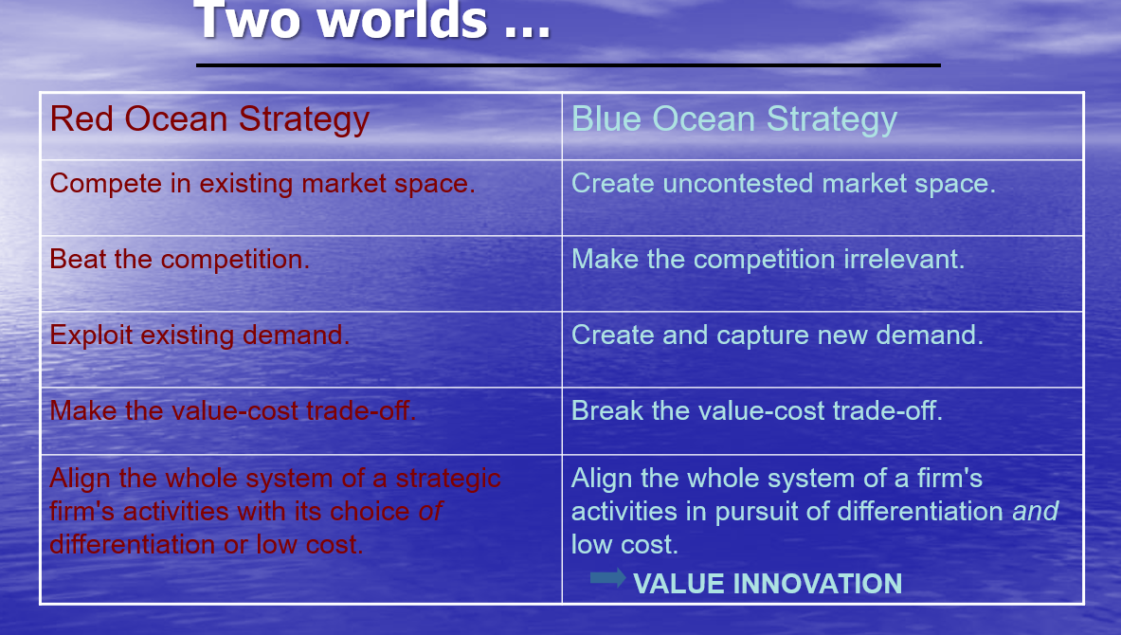

**Red oceans** represent all the industries in existence today. This is the known market space.

**Blue oceans** denote all the industries not in existence today. This is the unknown market space.

In the red oceans, industry boundaries are defined and accepted, and the competitive rules of the game are known. Here, companies try to outperform their rivals to grab a greater share of existing demand. As the market space gets crowed, prospects for profits and growth are reduced. Products become commodities, and cutthroat competition turns the red ocean bloody.

**Blue Oceans**, in contrast, are defined by untapped market space, demand creation, and the opportunity for highly profitable growth. Although some blue oceans are created well beyond existing industry boundaries, most are created from within red oceans by expanding existing industry boundaries. In blue oceans competition is irrelevant because the rules of the game are waiting to be set.

Logic of Blue Ocean Strategy is so called **value innovation** and is the cornerstone of Blue Ocean Strategy

Value innovation places equal emphasis on value and innovation. It is a new way of thinking about and executing strategy that results in the creation of a blue ocean and a break from the competition. Importantly, value innovation defies one of the most commonly accepted dogmas of competition-based strategy: The value-cost trade-off. 🡪 It is conventionally believed that companies can either create greater value to the customers at higher cost or create reasonable value at a lower cost. Here strategy is seen as making a choice between differentiation and low cost. In contrast , those that seek to create blue oceans pursue differentiation and low cost simultaneously.

Now turn the clock back only thirty years, How many industries of today's industries were then unknown? Mutual funds, cell phones, gas-fired electricity plants, biotechnology, discount retail, snowboards and coffee bars to name a few.

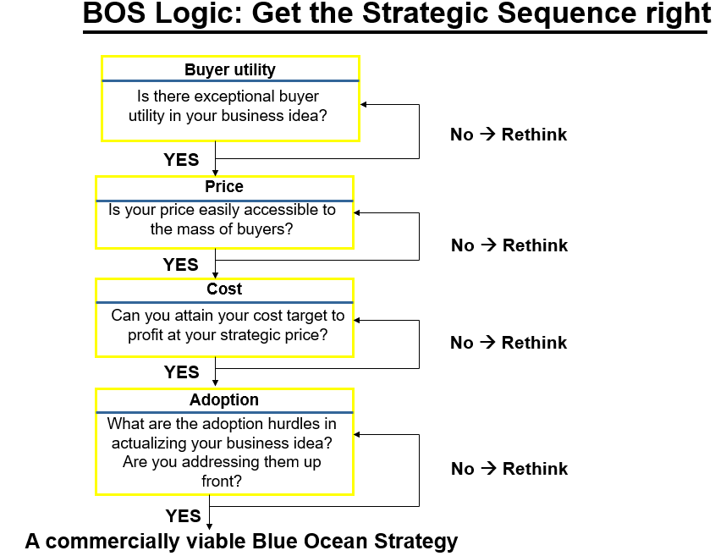

* This brings us to the fourth principle of the Blue Ocean Strategy: Get the strategic sequence right.
* As shown in this figure, companies need to build their Blue Ocean Strategy in the sequence of buyer utility, price, cost, and adoption.

The starting point is **buyer utility**. Does your offering unlock exceptional utility? Is there a compelling reason for the mass of people to buy it?

Absent this, there is no Blue Ocean potential to begin with. Here there are only two options. Park the idea, or rethink it until you reach an affirmative answer.

When you clear the exceptional utility bar, you advance to the second step: setting the **right strategic price**. Remember a company does not want to rely on price to create demand. The key question her is this: Is your offering priced to attract the mass of target buyers so that they have a compelling ability to pay for your offering? If it is not, they cannot buy it. Nor will the offering create irresistible market buzz.

These two steps address the revenue side of a company's business model.

Securing the profit side bring the third element: **cost**. Can you produce your offering at the target cost and still earn a healthy profit margin? Can you profit at the strategic price-the price easily accessible to the mass of target buyers? You should not let costs drive prices. Nor should you scale down utility because high costs block your ability to profit at the strategic price. When the target cost cannot be met, you must either forgo the idea because the Blue Ocean won't be profitable, or you must innovate your business model to hit the target cost. It is the combination of exceptional utility, strategic pricing, and target costing that allows companies to achieve value innovation-a leap in value for both buyers and companies.

The last step is to address **adoption** hurdles. What are the adoption hurdles in rolling out your idea? Have you addressed these up front? The formulation of Blue Ocean Strategy is complete only when you address adoption hurdles in the beginning to ensure the successful actualization of your idea. Adoption hurdles include, for example, potential resistance to the idea by retailers or partners. Because Blue Ocean Strategies represent a significant departure from red oceans, it is key to address adoption hurdles up front.

Value Innovation: The   
Cornerstone of Blue Ocean Strategy

* Creators of blue oceans follow value innovation
* Value Innovation
  + Equal emphasis on value and innovation
  + Defies value-cost trade-off of competition-based strategy
  + Successful value innovation:
    - Drives down costs while driving up buyers’ value
    - Uses a whole-system approach
    - Follows reconstructionist view

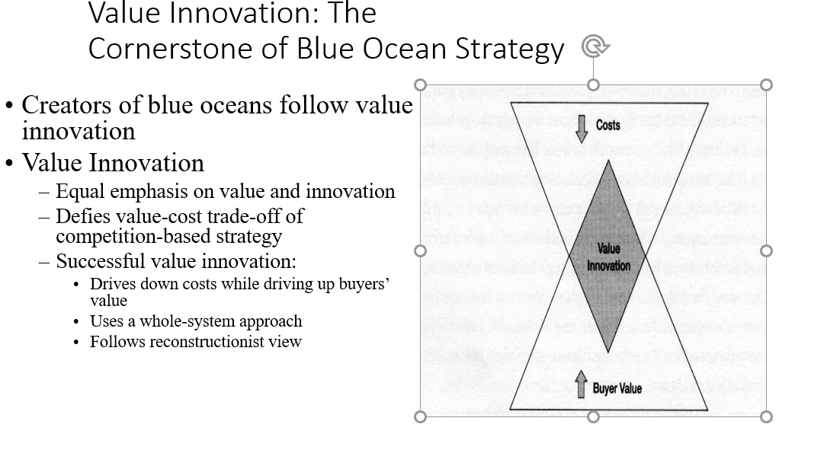

From Company and Industry to Strategic Move

* So just how can a company break out of the red

ocean of bloody competition?

* How can it create blue ocean?
* Is there a systematic approach to achieve this

and thereby sustain high performance?

NBNBBNBB

Value Innovation: The Cornerstone of Blue Ocean Strategy

* What consistently separates winners from losers in creating blue oceans is their approach to strategy.
* The firms caught in the red ocean followed a conventional approach of racing to beat the competition by building a defensible position within the existing industry order.
* The creators of blue oceans, don’t use the competition as their benchmark.
* Instead, they follow a different strategic logic -*value innovation*.
* Value innovation is the cornerstone of blue ocean strategy.
* Focus on making the competition irrelevant as opposed to focusing on beating our competition.
* Creating a leap in value for buyers and the firm by opening up new and uncontested market space.

The Six Principles of Blue Ocean Strategy

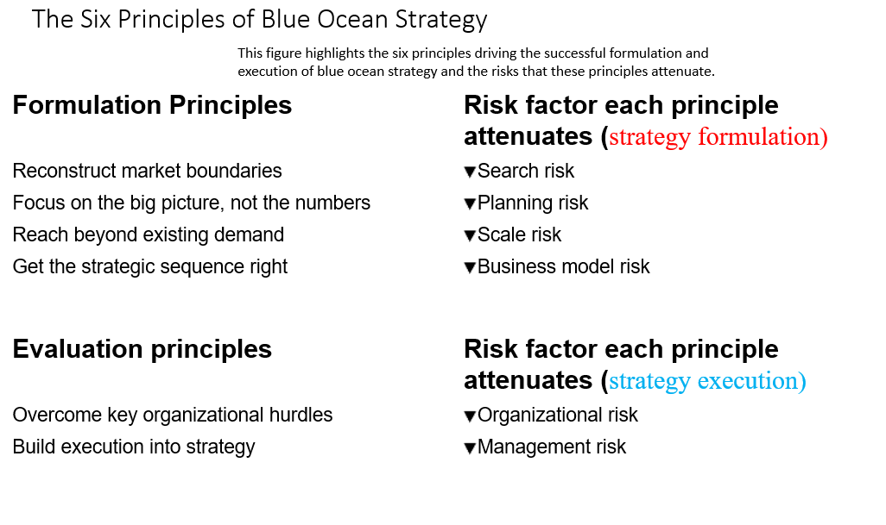

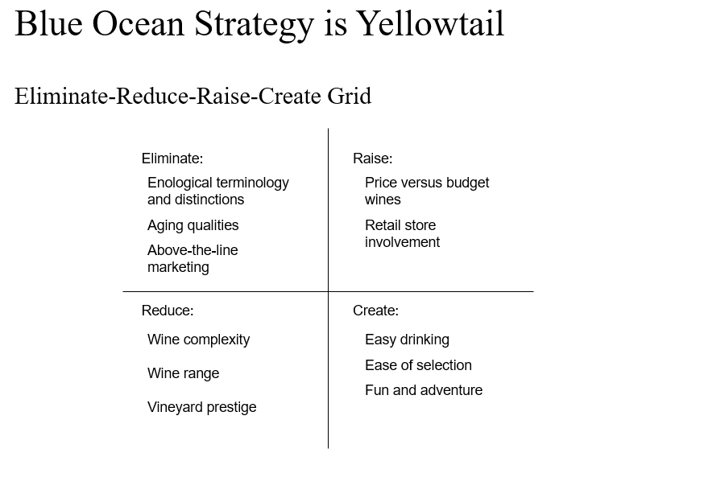

Three Characteristics of a Blue Ocean Strategy  
  
  
 1. Focus  
  
 2. Divergence  
  
 3. Compelling tagline  
  
  
  
These three characteristics serve as an initial litmus test of the commercial viability of the blue ocean ideas.

Nbnbnbbnb

Focus on the Big Picture; Not the Numbers

* Think of a typical strategic plan.
* It starts with a lengthy description of current industry conditions

and the competitive situation.

* Next is a discussion of how to increase market share, capture new

segments, cut costs, followed by an outline of numerous goals and

Initiatives.

* A full budget is attached as are lavish graphs and spreadsheets.
* The process usually culminates in the preparation of a bulky document

culled from a mishmash of data provided by people from various parts of

the organization who have conflicting agendas and poor communications.

* In this process, managers spend the majority of strategic thinking time

filling in boxes and running numbers instead of thinking blue ocean and

developing a clear picture on how to break from the competition.

* Students can see why very few strategic plans lead to the creation of

blue oceans or are translated into actions. Executives are paralyzed by

this muddle.

* Few employees even know what the strategy is.
* A closer look reveals that most plans don’t include a strategy at all but

rather a smorgasbord of tactics that individually make sense but collectively

don’t add up to a unified clear direction that sets the company apart – let

alone makes the competition irrelevant.

* Researchers and consultants have found that drawing a strategy canvas

not only visualizes a company’s current strategic position in the marketplace

but also helps to chart its future strategy.

* By building a firm’s strategic planning process around a strategy canvas,

a company and its managers focus their main attentions on the big picture

rather than becoming immersed in numbers and jargon and getting caught

up in operational details.

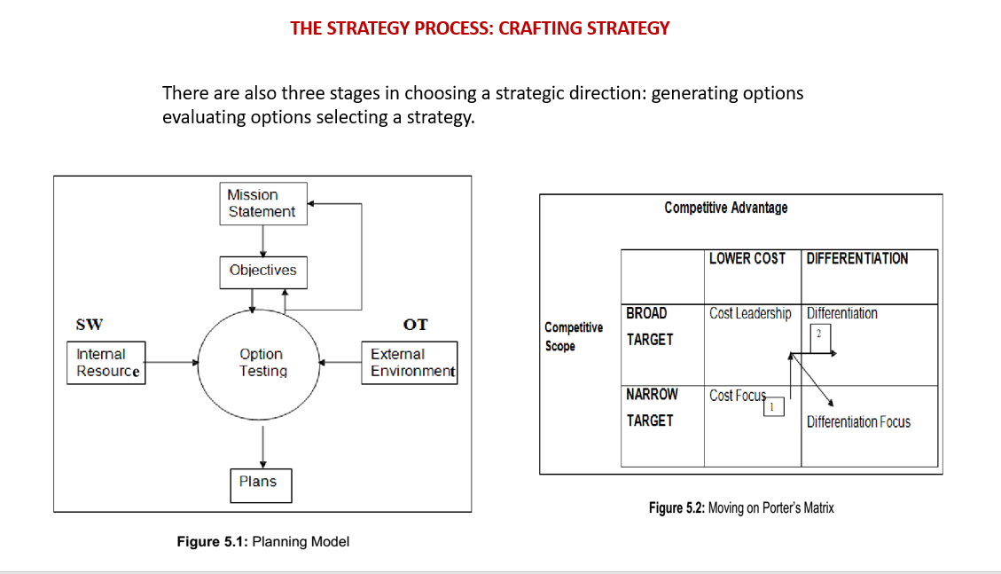

nbnbnbbnbbn

About Organization Development (OD)

Relatively new field of study – 50’s & 60’s

OD is about how organizations and people function and how to get them function better

Start Point – when the leader identifies an undesirable situation and seeks to change it.

Focus - Making organizations function better (total system change).

Orientation - Action (achieving results through planned activities).

No unifying theory – just models of practice

*OD is an organization improvement strategy*

///

**Strategy**

**Shared Vision**

**Corporate Culture**

**Values**

**Leverage**

**Strategies For Change Management**

**Empirical­ Rational**

People are rational and will follow their self -­interest once a change is revealed to them.

Change is  based on the communication of information and the proffering of incentives.

**Normative­ -Reductive**

People are social beings and adhere to cultural norms and values.

Change is based on redefining and reinterpreting existing norms and values, and developing people’s commitments to new ones

**Power­ - Coercive**

People are basically compliant and will generally do what they are told or can be made to do. Change is based on the exercise of authority and the imposition of sanctions.

**Environmental­ Adaptive**

People oppose loss and disruption, but they adapt readily to new circumstances. Change is based on building a new organization and gradually transferring people from the old one to the new one

**Degree of Resistance:** Strong resistance argues for a coupling of power-coercive and environmental - adaptive strategies. Weak resistance or concurrence argues for a combination of rational-empirical and normative-reductive strategies.

**Target Population:** Large populations argue for a mix of all four strategies, something for everyone so to speak.

**The High Stakes:** High stakes argue for a mix of all four strategies. When the stakes are high, nothing can be left to chance.

**Time Frame:** Short time frames argue for a power-coercive strategy. Longer time frames argue for a mix of rational-empirical. Normative- reductive, and environmental-adaptive strategies.

**Expertise:** Having adequate expertise in making change argues for a mix of the strategies outlined in the table above. The absence of expertise results in reliance on the power-coercive strategy.

**Dependency**: This is a classic double-edged sword. If the organisation is dependent on its people, management’s ability to command or demand is limited. Conversely, if people are dependent upon the organisation, their ability to oppose or resist is limited (Mutual dependency almost always signals a requirement for some level of negotiation).

///////////////////////

1. Create a new vision to direct the change and strategies for achieving the vision.
2. Create a new vision to direct the change and strategies for achieving the vision.

**Analyse the Organisation and its Need for Transformation/** **Strategic Change**  
operations / environment / SWOT / effect of proposed changes  
  
**Revolutionary changes are increasingly forcing organisations to restructure, reposition and redefine their boundaries**

**Denial**

*Observed behaviour:* Withdrawal, “business as usual”, dwelling on the past, lots of activity but not much gets done.

*Checklist:* it will be over real soon - apathy - numbness

*Management Strategy:*

* Confront individuals with information and let them know that the change will happen.
* Explain what to expect and suggest actions they can take to adjust to the change.

Give them time to let the impact sink in and then conduct regular planning sessions to involve all levels.

**Resistance**

*Observed behaviour:* Anger, blame, anxiety, depression, and drastic productivity drop “what’s the difference, this company doesn’t care anymore.”

*Checklist:* cannot sleep at night - anger and fights - withdrawal from the team - gave my all and look what it got me

*Management Strategy:*

* Listen, acknowledge feelings, and respond with empathy and support.
* Don’t try to talk people out of their feelings, or tell them to pull themselves together.

Accept their response and they will continue to tell you how they are feeling, which will help you address their concerns

**Exploration**

*Observed behaviour:* Over preparation, confusion, chaos, energy. “Let’s try this and what about this . . .” Lots of energy and new ideas but a lack of focus.

*Checklist:* over-preparation frustration - too many new ideas - have too much to do - cannot focus

*Management Strategy:*

* Focus on priorities and provide any needed training.
* Follow up on projects underway.
* Set short term goals.
* Conduct brainstorming, visioning and planning sessions

**Commitment**

*Observed behaviour:* Employees begin to work together. There is co-operation, and a better focus. “How can we work on this?” Those who are committed are looking for the next challenge.

*Checklist:* teamwork satisfaction clear focus and plan

*Management Strategy:*

* Set long term goals.
* Concentrate on team building.
* Create a mission statement.
* Validate and reward those responding to the change.
* Look ahead.

 In the management field ,strategic management  includes the implementation and formulation of important initiatives and goals taken by company's top managers on behalf of owners, depending on consideration of resources and an assessment of the external and internal environments where the company operates.

Strategic management offers general direction to a company and includes allocating resources to implement the plans , stating the company’s objectives, creating plans and policies to obtain those objectives.

Academics and practicing managers have developed numerous models and frameworks to assist in strategic decision-making in the context of complex environments and competitive dynamics.

Michael Porter identifies three principles underlying strategy:

creating a "unique and valuable  position"

making trade-offs by choosing "what not to do"

creating "fit" by aligning company activities with one another to support the chosen strategy

Corporate strategy involves answering a key question from a portfolio perspective: "What business should we be in?" Business strategy involves answering the question: "How shall we compete in this business?"

Management theory and practice often make a distinction between strategic management and operational management, with operational management concerned primarily with improving efficiency and controlling costs within the boundaries set by the organization's strategy.

Application

Strategy is described as "determination of the basic long-term goals of an enterprise, and the allocation of resources necessary ,and adoption of courses of action for carrying out these goals.???" **Strategies** are determined to clarify or define the organization, focus effort,

set direction, and offer guidance or consistency in response to the environment.

**Strategic management** includes the related concepts of strategic thinking and strategic planning . **Strategic planning** is analytical by nature and is referring to procedures that are formalized to produce the data and analyses utilized as inputs for **strategic thinking**, which combines the data which results in the strategy. Additionally strategic planning can refer to control mechanisms utilized in implementing the strategy when it is established. In some words, strategic planning takes place around the strategy making , strategic thinking activity or strategy formation process.

Strategy formulation of includes analyzing the environment where the company is operating, and therefore make a strategic decision series regarding how the company can compete. Formulation is ending with a series of objectives or goals and measures for the company to pursue.

Environmental analysis involves the:

remote external environment, involving technological, social, economic, the political, environmental and legal landscape ;

Industry environment, like

the competitive behavior of rival organizations,

the bargaining power of buyers/customers and suppliers,

threats from new entrants to the industry,

and the ability of buyers to substitute products ; and

?????????????????

Internal environment, about the weaknesses strengths of the organization's resources .

The answers to these and some many strategic questions are resulting in the organization's strategy and a series of specific short-term and long-term goals or objectives and related measures. He examined the strategic process and concluded it was much more fluid and unpredictable than people had thought. Because of this, he could not point to one process that could be called strategic planning.

Instead Mintzberg concluded that there are 5 kinds of strategies:

Strategy as perspective – in order to execute a strategy this depends on an ideological perspective of the company, natural extension of the mindset or "theory of the business" .

Strategy as ploy – a certain maneuver which intends to outwit a competitor;

Strategy as position – locating companies, products, or brands within the market,

depending on the conceptual framework of stakeholders or some consumers; a strategy is established primarily by factors outside the firm;

Strategy as pattern – a pattern which is consistent of previous behavior, with a strategy determined over time instead of intended or planned . Where the determined pattern is different from the intent, strategy is referred to as the emergent;

Strategy as plan – a directed course of action to obtain an intended set of objectives; the sama as the strategic planning concept;

In 1998, Mintzberg developed these five types of management strategy into 10 “schools of thought” and grouped them into three categories. The first group is normative. It consists of the schools of informal design and conception, the formal planning, and analytical positioning. The second group, consisting of six schools, is more concerned with how strategic management is actually done, rather than prescribing optimal plans or positions. The six schools are entrepreneurial, visionary, cognitive, learning/adaptive/emergent, negotiation, corporate culture and business environment. The third and final group consists of one school, the configuration or transformation school, a hybrid of the other schools organized into stages, organizational life cycles, or “episodes”.

Michael Porter defined strategy in 1980 as the "...broad formula for how a business is going to compete, what its goals should be, and what policies will be needed to carry out those goals" and the "...combination of the ends  for which the firm is striving and the means  by which it is seeking to get there." He continued that: "The essence of formulating competitive strategy is relating a company to its environment."

Historical development

Origins

The strategic management discipline originated in the 1950s and 1960s. Among the numerous early contributors, the most influential were Peter Drucker, Philip Selznick, Alfred Chandler, Igor Ansoff, and Bruce Henderson. The discipline draws from earlier thinking and texts on 'strategy' dating back thousands of years. Prior to 1960, the term "strategy" was primarily used regarding war and politics, not business.

Peter Drucker was a prolific management theorist and author of dozens of management books, with a career spanning five decades. He addressed fundamental strategic questions in a 1954 book The Practice of Management writing: "... the first responsibility of top management is to ask the question 'what is our business?' and to make sure it is carefully studied and correctly answered." He wrote that the answer was determined by the customer. He recommended eight areas where objectives should be set, such as market standing, innovation, productivity, physical and financial resources, worker performance and attitude, profitability, manager performance and development, and public responsibility.

In 1957, Philip Selznick initially used the term "distinctive competence" in referring to how the Navy was attempting to differentiate itself from the other services. This core idea was developed further by Kenneth R. Andrews in 1963 into what we now call SWOT analysis, in which the strengths and weaknesses of the firm are assessed in light of the opportunities and threats in the business environment. Ansoff wrote that strategic management had three parts: strategic planning; the skill of a firm in converting its plans into reality; and the skill of a firm in managing its own internal resistance to change.

Bruce Henderson, founder of the Boston Consulting Group, wrote about the concept of the experience curve in 1968, following initial work begun in 1965. The experience curve refers to a hypothesis that unit production costs decline by 20–30% every time cumulative production doubles. This supported the argument for achieving higher market share and economies of scale.

Porter wrote in 1980 that companies have to make choices about their scope and the type of competitive advantage they seek to achieve, whether lower cost or differentiation. The idea of strategy targeting particular industries and customers  with a differentiated offering was a departure from the experience-curve influenced strategy paradigm, which was focused on larger scale and lower cost. Porter revised the strategy paradigm again in 1985, writing that superior performance of the processes and activities performed by organizations as part of their value chain is the foundation of competitive advantage, thereby outlining a process view of strategy.

Management theorist Peter F Drucker wrote in 1954 that it was the customer who defined what business the organization was in.

Over time, the customer became the driving force behind all strategic business decisions. This marketing concept, in the decades since its introduction, has been reformulated and repackaged under names including market orientation, customer orientation, customer intimacy, customer focus, customer-driven and market focus.

Jim Collins wrote in 1997 that the strategic frame of reference is expanded by focusing on why a company exists rather than what it makes.

Nature of strategy

In 1985, Professor Ellen Earle-Chaffee summarized what she thought were the main elements of strategic management theory where consensus generally existed as of the 1970s, writing that strategic management: It is a hypothesis that total per unit costs decline systematically by as much as 15–25% every time cumulative production  doubles. It has been empirically confirmed by some firms at various points in their history. Costs decline due to a variety of factors, such as the learning curve, substitution of labor for capital, and technological sophistication. Author Walter Kiechel wrote that it reflected several insights, including:

A company can always improve its cost structure;

Competitors have varying cost positions based on their experience;

Firms could achieve lower costs through higher market share, attaining a competitive advantage; and

An increased focus on empirical analysis of costs and processes, a concept which author Kiechel refers to as "Greater Taylorism".

Kiechel wrote in 2010: "The experience curve was, simply, the most important concept in launching the strategy revolution...with the experience curve, the strategy revolution began to insinuate an acute awareness of competition into the corporate consciousness." Prior to the 1960s, the word competition rarely appeared in the most prominent management literature; U.S. companies then faced considerably less competition and did not focus on performance relative to peers. Further, the experience curve provided a basis for the retail sale of business ideas, helping drive the management consulting

industry.

Porter wrote in 1987 that corporate strategy involves two questions: 1) What business should the corporation be in? and 2) How should the corporate office manage its business units? He mentioned four concepts of corporate strategy; the latter three can be used together:

#Portfolio theory: A strategy based primarily on diversification through acquisition. The corporation shifts resources among the units and monitors the performance of each business unit and its leaders. Each unit generally runs autonomously, with limited interference from the corporate center provided goals are met.

#Restructuring: The corporate office acquires then actively intervenes in a business where it detects potential, often by replacing management and implementing a new business strategy.

#Transferring skills: Important managerial skills and organizational capability are essentially spread to multiple businesses. The skills must be necessary to competitive advantage.

#Sharing activities: Ability of the combined corporation to leverage centralized functions, such as sales, finance, etc. thereby reducing costs.

Industry structure and profitability

Porter developed a framework for analyzing the profitability of industries and how those profits are divided among the participants in 1980. In five forces analysis he identified the forces that shape the industry structure or environment. The framework involves the bargaining power of buyers and suppliers, the threat of new entrants, the availability of substitute products, and the competitive rivalry of firms in the industry. These forces affect the organization's ability to raise its prices as well as the costs of inputs  for its processes.

Porter wrote in 1985: "Competitive advantage cannot be understood by looking at a firm as a whole. It stems from the many discrete activities a firm performs in designing, producing, marketing, delivering and supporting its product. Each of these activities can contribute to a firm's relative cost position and create a basis for differentiation...the value chain disaggregates a firm into its strategically relevant activities in order to understand the behavior of costs and the existing and potential sources of differentiation." Core competency is part of a branch of strategy called the resource-based view of the firm, which postulates that if activities are strategic as indicated by the value chain, then the organization's capabilities and ability to learn or adapt are also strategic.

Strategic thinking

Strategic thinking involves the generation and application of unique business insights to opportunities intended to create competitive advantage for a firm or organization. It involves challenging the assumptions underlying the organization's strategy and value proposition. Mintzberg wrote in 1994 that it is more about synthesis  than analysis . It is about "capturing what the manager learns from all sources  and then synthesizing that learning into a vision of the direction that the business should pursue." Mintzberg argued that strategic thinking is the critical part of formulating strategy, more so than strategic planning exercises.

General Andre Beaufre wrote in 1963 that strategic thinking "is a mental process, at once abstract and rational, which must be capable of synthesizing both psychological and material data.

The strategist should a capacity for both synthesis and analysis ; analysis is important for assembling the data where he makes his diagnosis, synthesis so that he can produce from such data the diagnosis itself and the diagnosis actually amounts to a choice among alternative courses of action."

Will Mulcaster??? suggested that meanwhile much creative thought and research was devoted to generate alternative strategies, small amount of work was done on what impacts quality strategic decision to making and the effectiveness in with which are implemented. For example, in retrospect it can be seen that the financial crisis of 2008–9 could have been avoided if the banks had paid more attention to the risks associated with their investments, but how should banks change the way they make decisions to improve the quality of their decisions in the future? Mulcaster's Managing Forces framework addresses this issue by identifying 11 forces that should be incorporated into the processes of decision making and strategic implementation. The 11 forces are: Time; Opposing forces; Politics; Perception; Holistic effects; Adding value; Incentives; Learning capabilities; Opportunity cost; Risk and Style.

Strategic planning

**Strategic planning** is analytical by nature and is referring to procedures that are formalized to produce the data and analyses utilized as inputs for **strategic thinking**, which combines the data which results in the strategy. Additionally strategic planning can refer to control mechanisms utilized in implementing the strategy when it is established. In some words, strategic planning takes place around the strategy making , strategic thinking activity and strategy formation process.

Strategic planning is a way of administering the implementation and formulation of strategy. Strategic planning is analytical in nature and refers to formalized procedures to produce the data and analyses used as inputs for strategic thinking, which synthesizes the data resulting in the strategy. Strategic planning may also refer to control mechanisms used to implement the strategy once it is determined. In other words, strategic planning happens around the strategy formation process.

Environmental analysis

Porter wrote in 1980 that formulation of competitive strategy includes consideration of four key elements:

#Company strengths and weaknesses;

#Personal values of the key implementers

#Industry opportunities and threats; and

#Broader societal expectations. The fast changing business environment is too uncertain for us to find sustainable value in formulas of excellence or competitive advantage. Instead, scenario planning is a technique in which multiple outcomes can be developed, their implications assessed, and their likeliness of occurrence evaluated. According to Pierre Wack, scenario planning is about insight, complexity, and subtlety, not about formal analysis and numbers. The flowchart to the right provides a process for classifying a phenomenon as a scenario in the intuitive logics tradition.

Some business planners are starting to use a complexity theory approach to strategy. Complexity can be thought of as chaos with a dash of order. Chaos theory deals with turbulent systems that rapidly become disordered. Complexity is not quite so unpredictable. It involves multiple agents interacting in such a way that a glimpse of structure may appear.

Measuring and controlling implementation

Once the strategy is determined, various goals and measures may be established to chart a course for the organization, measure performance and control implementation of the strategy. Tools such as the balanced scorecard and strategy maps help crystallize the strategy, by relating key measures of success and performance to the strategy. These tools measure financial, marketing, production, organizational development, and innovation measures to achieve a 'balanced' perspective. Advances in information technology and data availability enable the gathering of more information about performance, allowing managers to take a much more analytical view of their business than before.

Additionally strategy can also be arranged as a series of "programs" or "initiatives" , any of which includes 1 or more projects. Different feedback and monitoring and mechanisms can also be determined , like consistent meetings among corporate and divisional management to control implementation.

An important strategic management component that is frequently overlooked during planning is evaluation. There are number of ways to evaluate if strategic plans and plans are achieved, one such method is Robert Stake's Responsive Evaluation.  provides a naturalistic and humanistic approach to program evaluation. In expanding beyond the goal-oriented or pre-ordinate evaluation design, responsive evaluation takes into consideration the program's background, conditions, and transactions among stakeholders. It is largely emergent, the design unfolds as contact is made with stakeholders.

Limitations

Meanwhile strategies are determined to focus effort, set direction, clarify or define the organization, and offer consistency or guidance in response to the environment,

In addition such elements mean that specific signals may be excluded from de-emphasized or consideration. Mintzberg?? wrote in nineteen eighty seven: "Strategy is a categorizing scheme where incoming stimuli may be dispatched or ordered ." Since a strategy is orienting the company in a specific direction or way , that direction might not match the environment effectively, over time or initially  as circumstances change. Mintzberg continued that "Strategy  is a force which resists change, not encouraging s it." Other theorists insist on

considering in turn objectives, an iterative approach, resources and implementation . I.e., a "...repetitive learning cycle  a linear progression towards a clearly defined final destination." Strategies should be able to adapt throughout the implementation reason being that "people rarely will proceed satisfactorily other than learning from past experience; and humble probes, serially modified on the basis of feedback, usually are the best method for such learning."

In 2000, Gary Hamel coined the term strategic convergence to explain the limited scope of the strategies that are utilized by rivals in significantly circumstances tat are different. He lamented that successful strategies are imitated by firms that do not understand that for a strategy to work, it must account for the specifics of each situation. Means are as likely to determine ends as ends are to determine means. The objectives that an organization might wish to pursue are limited by the range of feasible approaches to implementation.  In turn, the range of feasible implementation approaches is determined by the availability of resources.

Strategic themes

Different strategic approaches utilized throughout the industries  have grown over many years. Such involve the increasing usage of self-service approaches to lower cost, the

shift from product-driven demand to marketing- or customer-driven demand, changes in the corporate structure or value chain because of the internet and globalization.

Self-service

1 topic in strategic competition is the trend towards self-service, frequently allowed by technology, where clients are taking a role past performed by an employee to reduce costs for the organization and possibly prices.

Globalization and the virtual firm

One definition of globalization refers to the integration of economies due to technology and supply chain process innovation. Companies are no longer required to be vertically integrated . In other words, the value chain for a company's product may no longer be entirely within one firm; several entities comprising a virtual firm may exist to fulfill the customer requirement. For example, some companies have chosen to outsource production to third parties, retaining only design and sales functions inside their organization. Further, compared to traditional media like television, the internet has caused a major shift in viewing habits through on demand content which has led to an increasingly fragmented audience.

Author Phillip Evans said in 2013 that networks are challenging traditional hierarchies. Value chains may also be breaking up  where information aspects can be separated from functional activity. Data that is readily available for free or very low cost makes it harder for information-based, vertically integrated businesses to remain intact. Evans said: "The basic story here is that what used to be vertically integrated, oligopolistic competition among essentially similar kinds of competitors is evolving, by one means or another, from a vertical structure to a horizontal one. Why is that happening? It's happening because transaction costs are plummeting and because scale is polarizing. The plummeting of transaction costs weakens the glue that holds value chains together, and allows them to separate." He used Wikipedia as an example of a network that has challenged the traditional encyclopedia business model. Evans predicts the emergence of a new form of industrial organization called a "stack", analogous to a technology stack, in which competitors rely on a common platform of inputs, essentially layering the remaining competing parts of their value chains on top of this common platform.

Sustainability

In the recent decade, sustainability—or ability to successfully sustain a company in a context of rapidly changing environmental, social, health, and economic circumstances—has emerged as crucial aspect of any strategy development. Research focusing on corporations and leaders who have integrated sustainability into commercial strategy has led to emergence of the concept of "embedded sustainability" – defined by its authors Chris Laszlo and Nadya Zhexembayeva as "incorporation of environmental, health, and social value into the core business with no trade-off in price or quality—in other words, with no social or green premium." Laszlo and Zhexembayeva's research showed that embedded sustainability offers at least seven distinct opportunities for business value and competitive advantage creation: a) better risk-management, b) increased efficiency through reduced waste and resource use, c) better product differentiation, d) new market entrances, e) enhanced brand and reputation, f) greater opportunity to influence industry standards, and g) greater opportunity for radical innovation. Nadya Zhexembayeva's 2014 research further suggested that innovation driven by resource depletion can result in fundamental competitive advantages for a company's products and services, as well as the company strategy as a whole, when right principles of innovation are applied.

Strategy as learning

In 1990, Peter Senge, who had collaborated with Arie de Geus at Dutch Shell, popularized de Geus' notion of the "learning organization". The theory is that gathering and analyzing information is a necessary requirement for business success in the information age. To do this, Senge claimed that an organization would need to be structured such that:

People can continuously expand their capacity to learn and be productive.

New patterns of thinking are nurtured.

Collective aspirations are encouraged.

People are encouraged to see the "whole picture" together.

Senge identified five disciplines of a learning organization. They are:

Personal responsibility, self-reliance, and mastery – We accept that we are the masters of our own destiny. We make decisions and live with the consequences of them. When a problem needs to be fixed, or an opportunity exploited, we take the initiative to learn the required skills to get it done.

Mental models – We need to explore our personal mental models to understand the subtle effect they have on our behaviour.

Shared vision – The vision of where we want to be in the future is discussed and communicated to all. It provides guidance and energy for the journey ahead.

Team learning – We learn together in teams. This involves a shift from "a spirit of advocacy to a spirit of enquiry".

Systems thinking – We look at the whole rather than the parts. This is what Senge calls the "Fifth discipline". It is the glue that integrates the other four into a coherent strategy. For an alternative approach to the "learning organization", see Garratt, B. .

Geoffrey Moore  and R. Frank and P. Cook also detected a shift in the nature of competition. Markets driven by technical standards or by "network effects" can give the dominant firm a near-monopoly. The same is true of networked industries in which interoperability requires compatibility between users. Examples include Internet Explorer's and Amazon's early dominance of their respective industries. IE's later decline shows that such dominance may be only temporary.

Moore showed how firms could attain this enviable position by using E.M. Rogers' five stage adoption process and focusing on one group of customers at a time, using each group as a base for reaching the next group. The most difficult step is making the transition between introduction and mass acceptance. . If successful a firm can create a bandwagon effect in which the momentum builds and its product becomes a de facto standard.

Strategy as adapting to change

In 1969, Peter Drucker coined the phrase Age of Discontinuity to describe the way change disrupts lives. In an age of continuity attempts to predict the future by extrapolating from the past can be accurate. But according to Drucker, we are now in an age of discontinuity and extrapolating is ineffective. He identifies four sources of discontinuity: new technologies, globalization, cultural pluralism and knowledge capital.

In 1970, Alvin Toffler in Future Shock described a trend towards accelerating rates of change. He illustrated how social and technical phenomena had shorter lifespans with each generation, and he questioned society's ability to cope with the resulting turmoil and accompanying anxiety. In past eras periods of change were always punctuated with times of stability. This allowed society to assimilate the change before the next change arrived. But these periods of stability had all but disappeared by the late 20th century. In 1980 in The Third Wave, Toffler characterized this shift to relentless change as the defining feature of the third phase of civilization .

In 1978, Derek F. Abell  described "strategic windows" and stressed the importance of the timing  of any given strategy. This led some strategic planners to build planned obsolescence into their strategies.

In 1983, Noel Tichy wrote that because we are all beings of habit we tend to repeat what we are comfortable with. He wrote that this is a trap that constrains our creativity, prevents us from exploring new ideas, and hampers our dealing with the full complexity of new issues. He developed a systematic method of dealing with change that involved looking at any new issue from three angles: technical and production, political and resource allocation, and corporate culture.

In 1989, Charles Handy identified two types of change. "Strategic drift" is a gradual change that occurs so subtly that it is not noticed until it is too late. By contrast, "transformational change" is sudden and radical. It is typically caused by discontinuities  in the business environment. The point where a new trend is initiated is called a "strategic inflection point" by Andy Grove. Inflection points can be subtle or radical.

In 1990, Richard Pascale wrote that relentless change requires that businesses continuously reinvent themselves. His famous maxim is “Nothing fails like success” by which he means that what was a strength yesterday becomes the root of weakness today, We tend to depend on what worked yesterday and refuse to let go of what worked so well for us in the past. Prevailing strategies become self-confirming. To avoid this trap, businesses must stimulate a spirit of inquiry and healthy debate. They must encourage a creative process of self-renewal based on constructive conflict.

In 1996, Adrian Slywotzky showed how changes in the business environment are reflected in value migrations between industries, between companies, and within companies. He claimed that recognizing the patterns behind these value migrations is necessary if we wish to understand the world of chaotic change. In “Profit Patterns”  he described businesses as being in a state of strategic anticipation as they try to spot emerging patterns. Slywotsky and his team identified 30 patterns that have transformed industry after industry.

In 1997, Clayton Christensen  took the position that great companies can fail precisely because they do everything right since the capabilities of the organization also define its disabilities. Christensen's thesis is that outstanding companies lose their market leadership when confronted with disruptive technology. He called the approach to discovering the emerging markets for disruptive technologies agnostic marketing, i.e., marketing under the implicit assumption that no one – not the company, not the customers – can know how or in what quantities a disruptive product can or will be used without the experience of using it.

In 1999, Constantinos Markides reexamined the nature of strategic planning. He described strategy formation and implementation as an ongoing, never-ending, integrated process requiring continuous reassessment and reformation. Strategic management is planned and emergent, dynamic and interactive.

J. Moncrieff  stressed strategy dynamics. He claimed that strategy is partially deliberate and partially unplanned. The unplanned element comes from emergent strategies that result from the emergence of opportunities and threats in the environment and from "strategies in action" .

David Teece pioneered research on resource-based strategic management and the dynamic capabilities perspective, defined as “the ability to integrate, build, and reconfigure internal and external competencies to address rapidly changing environments". His 1997 paper  "Dynamic Capabilities and Strategic Management" was the most cited paper in economics and business for the period from 1995 to 2005.

In 2000, Gary Hamel discussed strategic decay, the notion that the value of every strategy, no matter how brilliant, decays over time.

Strategy as operational excellence

Quality

A large group of theorists felt the area where western business was most lacking was product quality. W. Edwards Deming, Joseph M. Juran, A. Kearney, Philip Crosby and Armand Feignbaum suggested quality improvement techniques such total quality management, continuous improvement, lean manufacturing, Six Sigma, and return on quality .

Contrarily, James Heskett, Earl Sasser, William Davidow, Len Schlesinger, A. Paraurgman, Len Berry, Jane Kingman-Brundage, Christopher Hart, and Christopher Lovelock, felt that poor customer service was the problem. They gave us fishbone diagramming, service charting, Total Customer Service, the service profit chain, service gaps analysis, the service encounter, strategic service vision, service mapping, and service teams. Their underlying assumption was that there is no better source of competitive advantage than a continuous stream of delighted customers.

Process management uses some of the techniques from product quality management and some of the techniques from customer service management. It looks at an activity as a sequential process. The objective is to find inefficiencies and make the process more effective. Although the procedures have a long history, dating back to Taylorism, the scope of their applicability has been greatly widened, leaving no aspect of the firm free from potential process improvements. Because of the broad applicability of process management techniques, they can be used as a basis for competitive advantage.

Carl Sewell, Frederick F. Reichheld, C. Gronroos, and Earl Sasser observed that businesses were spending more on customer acquisition than on retention. They showed how a competitive advantage could be found in ensuring that customers returned again and again. Reicheld broadened the concept to include loyalty from employees, suppliers, distributors and shareholders. They developed techniques for estimating customer lifetime value  for assessing long-term relationships. The concepts begat attempts to recast selling and marketing into a long term endeavor that created a sustained relationship . Customer relationship management  software became integral to many firms.

Reengineering

Michael Hammer and James Champy felt that these resources needed to be restructured. In a process that they labeled reengineering, firm's reorganized their assets around whole processes rather than tasks. In this way a team of people saw a project through, from inception to completion. This avoided functional silos where isolated departments seldom talked to each other. It also eliminated waste due to functional overlap and interdepartmental communications.

In 1989 Richard Lester and the researchers at the MIT Industrial Performance Center identified seven best practices and concluded that firms must accelerate the shift away from the mass production of low cost standardized products. The seven areas of best practice were:

Simultaneous continuous improvement in cost, quality, service, and product innovation

Breaking down organizational barriers between departments

Eliminating layers of management creating flatter organizational hierarchies.

Closer relationships with customers and suppliers

Intelligent use of new technology

Global focus

Improving human resource skills

The search for best practices is also called benchmarking. This involves determining where you need to improve, finding an organization that is exceptional in this area, then studying the company and applying its best practices in your firm.

Other perspectives on strategy

Strategy as problem solving

Professor Richard P. Rumelt described strategy as a type of problem solving in 2011. He wrote that good strategy has an underlying structure called a kernel. The kernel has three parts: 1) A diagnosis that defines or explains the nature of the challenge; 2) A guiding policy for dealing with the challenge; and 3) Coherent actions designed to carry out the guiding policy.

President Kennedy outlined these three elements of strategy in his Cuban Missile Crisis Address to the Nation of 22 October 1962:

#Diagnosis: "This Government, as promised, has maintained the closest surveillance of the Soviet military buildup on the island of Cuba. Within the past week, unmistakable evidence has established the fact that a series of offensive missile sites is now in preparation on that imprisoned island. The purpose of these bases can be none other than to provide a nuclear strike capability against the Western Hemisphere."

#Guiding Policy: "Our unswerving objective, therefore, must be to prevent the use of these missiles against this or any other country, and to secure their withdrawal or elimination from the Western Hemisphere."

#Action Plans: First among seven numbered steps was the following: "To halt this offensive buildup a strict quarantine on all offensive military equipment under shipment to Cuba is being initiated. All ships of any kind bound for Cuba from whatever nation or port will, if found to contain cargoes of offensive weapons, be turned back."

Active strategic management required active information gathering and active problem solving. In the early days of Hewlett-Packard, Dave Packard and Bill Hewlett devised an active management style that they called management by walking around . Senior HP managers were seldom at their desks. They spent most of their days visiting employees, customers, and suppliers. This direct contact with key people provided them with a solid grounding from which viable strategies could be crafted. Management consultants Tom Peters and Robert H. Waterman had used the term in their 1982 book In Search of Excellence: Lessons From America's Best-Run Companies. Some Japanese managers employ a similar system, which originated at Honda, and is sometimes called the 3 G's .

Creative vs analytic approaches

In 2010, IBM released a study summarizing three conclusions of 1500 CEOs around the world: 1) complexity is escalating, 2) enterprises are not equipped to cope with this complexity, and 3) creativity is now the single most important leadership competency. IBM said that it is needed in all aspects of leadership, including strategic thinking and planning.

Similarly, McKeown argued that over-reliance on any particular approach to strategy is dangerous and that multiple methods can be used to combine the creativity and analytics to create an "approach to shaping the future", that is difficult to copy.

Non-strategic management

A 1938 treatise by Chester Barnard, based on his own experience as a business executive, described the process as informal, intuitive, non-routinized and involving primarily oral, 2-way communications. Bernard says "The process is the sensing of the organization as a whole and the total situation relevant to it. It transcends the capacity of merely intellectual methods, and the techniques of discriminating the factors of the situation. The terms pertinent to it are "feeling", "judgement", "sense", "proportion", "balance", "appropriateness". It is a matter of art rather than science."

In 1973, Mintzberg found that senior managers typically deal with unpredictable situations so they strategize in ad hoc, flexible, dynamic, and implicit ways. He wrote, "The job breeds adaptive information-manipulators who prefer the live concrete situation. The manager works in an environment of stimulus-response, and he develops in his work a clear preference for live action."

In 1982, John Kotter studied the daily activities of 15 executives and concluded that they spent most of their time developing and working a network of relationships that provided general insights and specific details for strategic decisions. They tended to use "mental road maps" rather than systematic planning techniques.

Daniel Isenberg's 1984 study of senior managers found that their decisions were highly intuitive. Executives often sensed what they were going to do before they could explain why. He claimed in 1986 that one of the reasons for this is the complexity of strategic decisions and the resultant information uncertainty.

Zuboff claimed that information technology was widening the divide between senior managers  and operational level managers . She alleged that prior to the widespread use of computer systems, managers, even at the most senior level, engaged in both strategic decisions and routine administration, but as computers facilitated  routine processes, these activities were moved further down the hierarchy, leaving senior management free for strategic decision making.

In 1977, Abraham Zaleznik distinguished leaders from managers. He described leaders as visionaries who inspire, while managers care about process. He claimed that the rise of managers was the main cause of the decline of American business in the 1970s and 1980s. Lack of leadership is most damaging at the level of strategic management where it can paralyze an entire organization.

According to Corner, Kinichi, and Keats, strategic decision making in organizations occurs at two levels: individual and aggregate. They developed a model of parallel strategic decision making. The model identifies two parallel processes that involve getting attention, encoding information, storage and retrieval of information, strategic choice, strategic outcome and feedback. The individual and organizational processes interact at each stage. For instance, competition-oriented objectives are based on the knowledge of competing firms, such as their market share.

Strategy as marketing

The 1980s also saw the widespread acceptance of positioning theory. Although the theory originated with Jack Trout in 1969, it didn't gain wide acceptance until Al Ries and Jack Trout wrote their classic book Positioning: The Battle For Your Mind . The basic premise is that a strategy should not be judged by internal company factors but by the way customers see it relative to the competition. Crafting and implementing a strategy involves creating a position in the mind of the collective consumer. Several techniques enabled the practical use of positioning theory. Perceptual mapping for example, creates visual displays of the relationships between positions. Multidimensional scaling, discriminant analysis, factor analysis and conjoint analysis are mathematical techniques used to determine the most relevant characteristics  upon which positions should be based. Preference regression can be used to determine vectors of ideal positions and cluster analysis can identify clusters of positions.

In 1992 Jay Barney saw strategy as assembling the optimum mix of resources, including human, technology and suppliers, and then configuring them in unique and sustainable ways.

James Gilmore and Joseph Pine found competitive advantage in mass customization. Flexible manufacturing techniques allowed businesses to individualize products for each customer without losing economies of scale. This effectively turned the product into a service. They also realized that if a service is mass-customized by creating a "performance" for each individual client, that service would be transformed into an "experience". Their book, The Experience Economy, along with the work of Bernd Schmitt convinced many to see service provision as a form of theatre. This school of thought is sometimes referred to as customer experience management .

Information- and technology-driven strategy

Many industries with a high information component are being transformed. For example, Encarta demolished Encyclopædia Britannica  before it was in turn, eclipsed by collaborative encyclopedias like Wikipedia. The music industry was similarly disrupted. The technology sector has provided some strategies directly. For example, from the software development industry agile software development provides a model for shared development processes.

Peter Drucker conceived of the "knowledge worker" in the 1950s. He described how fewer workers would do physical labor, and more would apply their minds. In 1984, John Naisbitt theorized that the future would be driven largely by information: companies that managed information well could obtain an advantage, however the profitability of what he called "information float"  would disappear as inexpensive computers made information more accessible.

Daniel Bell  examined the sociological consequences of information technology, while Gloria Schuck and Shoshana Zuboff looked at psychological factors. Zuboff distinguished between "automating technologies" and "informating technologies". She studied the effect that both had on workers, managers and organizational structures. She largely confirmed Drucker's predictions about the importance of flexible decentralized structure, work teams, knowledge sharing and the knowledge worker's central role. Zuboff also detected a new basis for managerial authority, based on knowledge  which she called "participative management".

Maturity of planning process

McKinsey & Company developed a capability maturity model in the 1970s to describe the sophistication of planning processes, with strategic management ranked the highest. The four stages include:

#Financial planning, which is primarily about annual budgets and a functional focus, with limited regard for the environment;

#Forecast-based planning, which includes multi-year budgets and more robust capital allocation across business units;

#Externally oriented planning, where a thorough situation analysis and competitive assessment is performed;

#Strategic management, where widespread strategic thinking occurs and a well-defined strategic framework is used.

The benefits of high market share naturally led to an interest in growth strategies. The relative advantages of horizontal integration, vertical integration, diversification, franchises, mergers and acquisitions, joint ventures and organic growth were discussed. Other research indicated that a low market share strategy could still be very profitable. Schumacher, Woo and Cooper, Levenson, and later Traverso  showed how smaller niche players obtained very high returns.

Other influences on business strategy

Military strategy

In the 1980s business strategists realized that there was a vast knowledge base stretching back thousands of years that they had barely examined. They turned to military strategy for guidance. Military strategy books such as The Art of War by Sun Tzu, On War by von Clausewitz, and The Red Book by Mao Zedong became business classics. From Sun Tzu, they learned the tactical side of military strategy and specific tactical prescriptions. From von Clausewitz, they learned the dynamic and unpredictable nature of military action. From Mao, they learned the principles of guerrilla warfare. Important marketing warfare books include Business War Games by Barrie James, Marketing Warfare by Al Ries and Jack Trout and Leadership Secrets of Attila the Hun by Wess Roberts.

The four types of business warfare theories are:

Offensive marketing warfare strategies

Defensive marketing warfare strategies

Flanking marketing warfare strategies

Guerrilla marketing warfare strategies

The marketing warfare literature also examined leadership and motivation, intelligence gathering, types of marketing weapons, logistics and communications.

By the twenty-first century marketing warfare strategies had gone out of favour in favor of non-confrontational approaches. In 1989, Dudley Lynch and Paul L. Kordis published Strategy of the Dolphin: Scoring a Win in a Chaotic World. "The Strategy of the Dolphin" was developed to give guidance as to when to use aggressive strategies and when to use passive strategies. A variety of aggressiveness strategies were developed.

In 1993, J. Moore used a similar metaphor. Instead of using military terms, he created an ecological theory of predators and prey, a sort of Darwinian management strategy in which market interactions mimic long term ecological stability.

Author Phillip Evans said in 2014 that "Henderson's central idea was what you might call the Napoleonic idea of concentrating mass against weakness, of overwhelming the enemy. What Henderson recognized was that, in the business world, there are many phenomena which are characterized by what economists would call increasing returns—scale, experience. The more you do of something, disproportionately the better you get. And therefore he found a logic for investing in such kinds of overwhelming mass in order to achieve competitive advantage. And that was the first introduction of essentially a military concept of strategy into the business world. ... It was on those two ideas, Henderson's idea of increasing returns to scale and experience, and Porter's idea of the value chain, encompassing heterogenous elements, that the whole edifice of business strategy was subsequently erected."

Traits of successful companies

Like Peters and Waterman a decade earlier, James Collins and Jerry Porras spent years conducting empirical research on what makes great companies. Six years of research uncovered a key underlying principle behind the 19 successful companies that they studied: They all encourage and preserve a core ideology that nurtures the company. Even though strategy and tactics change daily, the companies, nevertheless, were able to maintain a core set of values. These core values encourage employees to build an organization that lasts. In Built To Last  they claim that short term profit goals, cost cutting, and restructuring will not stimulate dedicated employees to build a great company that will endure. In 2000 Collins coined the term "built to flip" to describe the prevailing business attitudes in Silicon Valley. It describes a business culture where technological change inhibits a long term focus. He also popularized the concept of the BHAG .

Arie de Geus  undertook a similar study and obtained similar results.

Will Mulcaster suggests that firms engage in a dialogue that centres around these questions:

Will the proposed competitive advantage create Perceived Differential Value?"

Will the proposed competitive advantage create something that is different from the competition?"

Will the difference add value in the eyes of potential customers?" – This question will entail a discussion of the combined effects of price, product features and consumer perceptions.

Will the product add value for the firm?" – Answering this question will require an examination of cost effectiveness and the pricing strategy.

See also

Balanced scorecard

Business analysis

Business model

Business plan

Concept-driven strategy

Cost overrun

Dynamic capabilities

Integrated business planning

Marketing

Marketing plan

Marketing strategies

Management

Management consulting

Military strategy

Morphological analysis

Overall equipment effectiveness

Real options valuation

Results-based management

Revenue shortfall

Strategy

Strategy dynamics

Strategic lenses

Strategic planning

Strategic Management Society

Strategy map

Strategy Markup Language

Strategy visualization

Value migration

Six Forces Model

Adversarial purchasing

References

Further reading

Cameron, Bobby Thomas. . .Strategic Leadership Review 4, 22–27.

David Besanko, David Dranove, Scott Schaefer, and Mark Shanley  Economics of Strategy, John Wiley & Sons,

Edwards, Janice et al. . BC Open Textbooks, 2014.

Kemp, Roger L. "Strategic Planning for Local Government: A Handbook for Officials and Citizens," McFarland and Co., Inc., Jefferson, NC, USA, and London, England, UK, 2008

Kvint, Vladimir  The Global Emerging Market: Strategic Management and Economics

Pankaj Ghemawhat - Harvard Strategy Professor:  Social Science History Network-Spring 2002

External links

- recent publications

- online library

Bibliography:

Wikipedia

@baygross

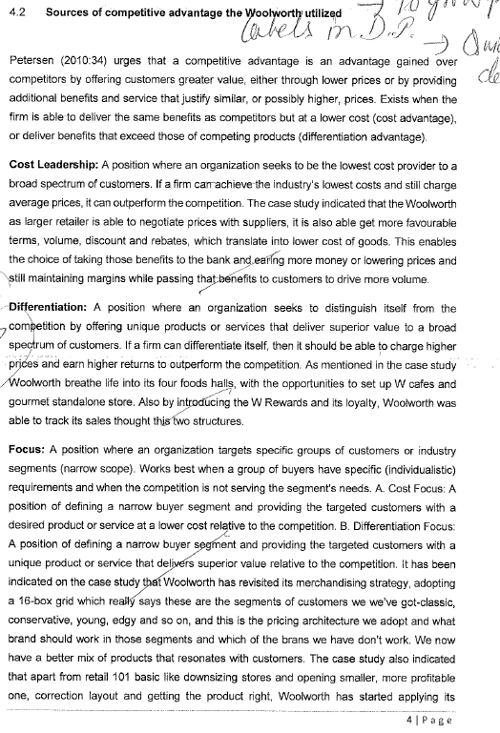

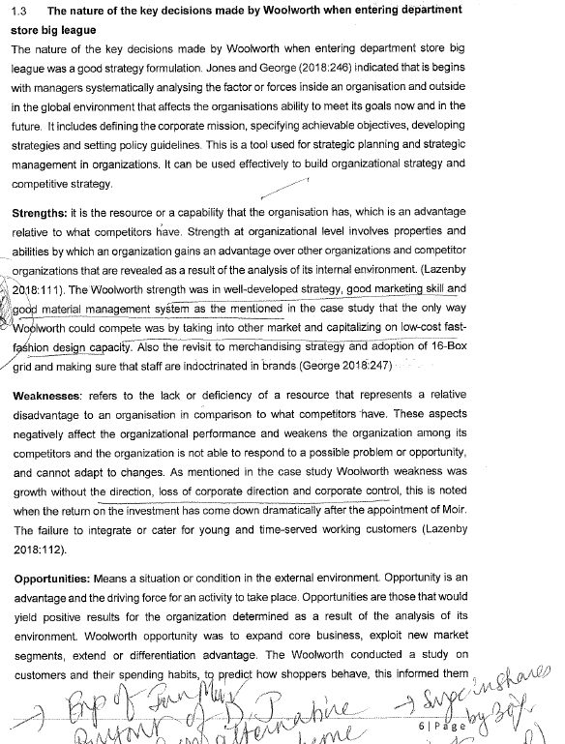

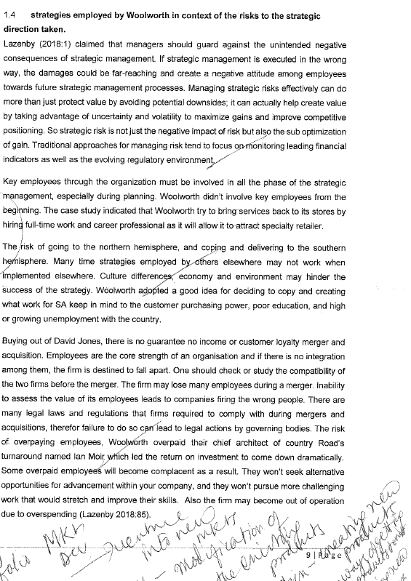



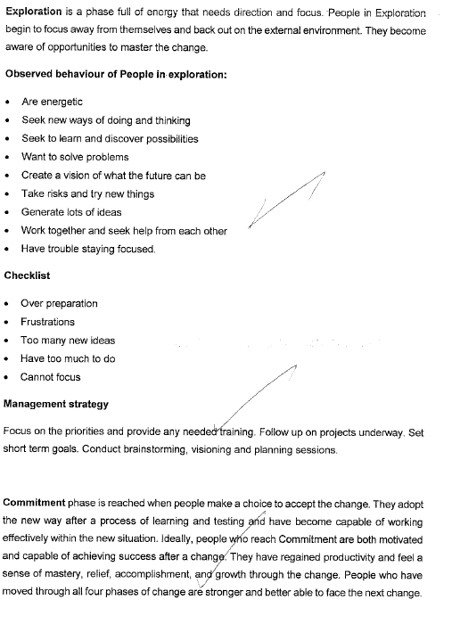



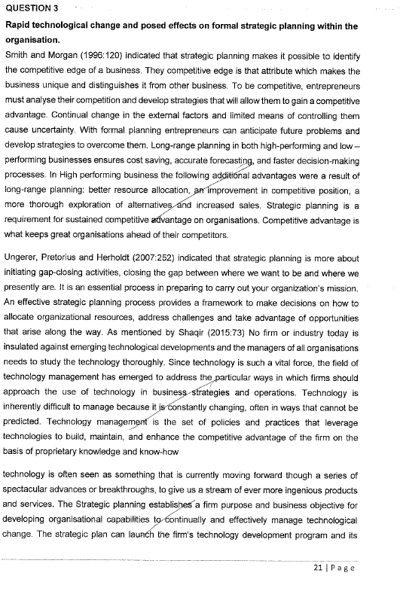

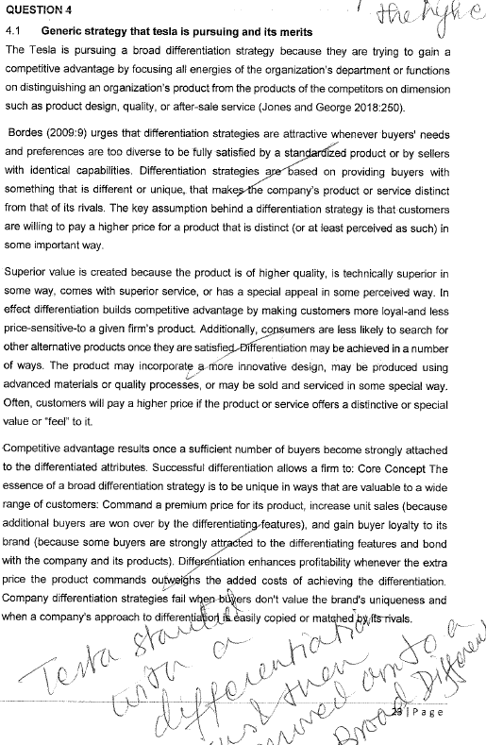

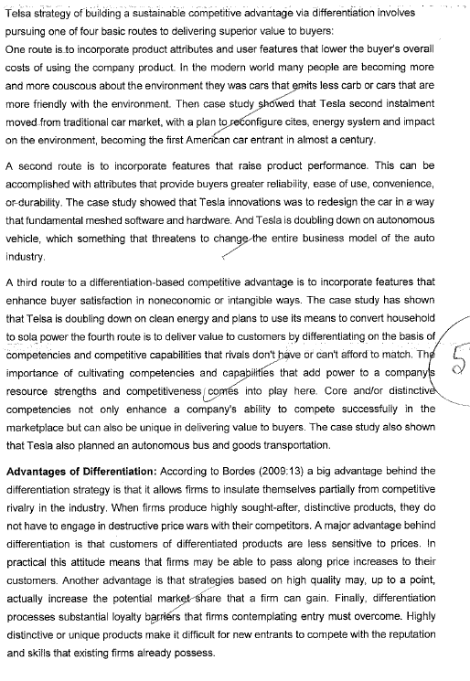

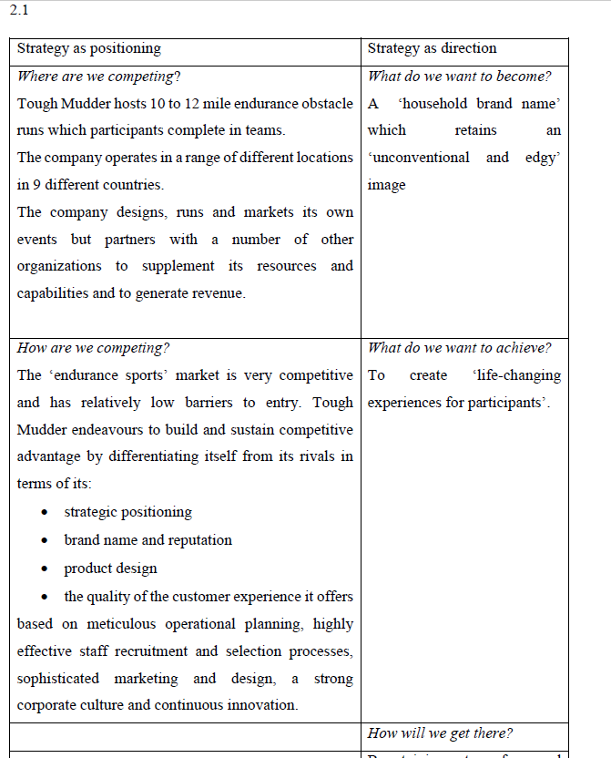

RRRRRRRRRRRRRRR

**Moving/changing**

This stage involves a shift in behavior of organizations by modifying system, process, technology and people. This phase can be explained in terms of compliance, identification and internalization (Rao and Hari Krishna 2002).

* + Compliance or force occurs when individuals are forced to change whether by reward or by punishment.
  + Internalization occurs when individuals are forced to encounter a situation that calls for new behavior.
  + Identification occurs when individuals recognize one among various models provided in the environment that is most suitable to their personality
* Plan for, create, and reward short-term “wins” that move the organization toward the new vision.

Develop enabling structures that facilitate and reinforce the transformation process. -scheduled workshops, training programs and creation of new structures and reward systems -symbolic changes

**Reinforce and Institutionalise the Transformation**

Provide (financial and human) resources for change. Give support to change agents. Develop new competencies and skills— offer more training and coaching. Reinforce desired behaviour- link rewards such as bonuses to particular types of activity or progress. Recognise top performers. Shape and reinforce a new culture that fits with the revitalised organisation

**Commitment**

*Observed behaviour:* Employees begin to work together. There is co-operation, and a better focus. “How can we work on this?” Those who are committed are looking for the next challenge.

*Checklist:* teamwork satisfaction clear focus and plan

*Management Strategy:*

* Set long term goals.
* Concentrate on team building.
* Create a mission statement.
* Validate and reward those responding to the change.
* Look ahead.

**Empirical­ Rational**

People are rational and will follow their self -­interest once a change is revealed to them.

Change is  based on the communication of information and the proffering of incentives.

SSSSSSSSSSSSSSSSSSSSSSSSSSSS

control systems

**Manager**

* **Implements control systems**
* **Performance measures**
* **Identifies variances**
* **Fixes variances**



* 1. Discuss the relationship between organizational structure, control systems, incentives and culture regarding the implementation of strategy. (12) REWARD

**Incentives and Rewards and Information Systems**

Rewards and incentives are the ways companies encourage good performance. A reward system which is clever might make staff feel good without paying them extra money.

Other companies utilize their intranets and web-sites to recognize high performers, offering them electronic badges which are showed on the social network to recognize staff as award recipients. Some companies reward staff with new technology. At 1 company , top performers receive new laptops every year, meanwhile lower performers receive the “hand-me-downs.”

It is simple easier designing complex incentive systems, like a team-based or shared incentives. One must keep it simple tracking contributions of the team members and, in [coexistence](https://www.bing.com/search?q=define+coexistence&FORM=DCTRQY) with qualitative inputs, assign rewards according to formulas that are complex. For

example, in the call center example, tracking metrics, such as “average time per call” and

“number of calls answered,” allows the manager to monitor agents’ performance. This

quantitative data makes comparisons easier, but it cannot account for qualitative

variables: for example, agents who spend more time handling calls may be providing

better customer service. Agents who know they will be evaluated by the volume of calls

they process may rush callers and provide poorer service in order to maximize their

performance according to the narrow metric. Agents providing the poorest service could

in fact be compensated best if the firm’s performance evaluation and compensation

strategy is linked only to such metrics. The manager must consider both the metrics and

qualitative data in assigning compensation and rewards.

**Incentives**

Managers must provide incentives and/or disincentives to assist employees in overcoming resistance to change. According to Klein and Sorra (1996): “The basis of challenge of innovation implementation is gaining intended members of the organization’ utilization of an innovation; to change employees users’ behavior”. 1 technique to encourage and cultivate targeted users’ effective use of an?????????????

ERP is to offer incentives (Klein and Sorra 1996). Dyson et al. (1997) found that administering incentives was

the most significant factor contributing to the effectiveness of a large US company’s reengineering effort (Dyson

et al. 1997). Other authors were detailing the kind of incentives which can be provided to employees . For instance Joshi and Lauer (1999) (see also Joshi 1991)??? State providing higher salary to individuals assigned to skilled jobs,

higher-level, or providing revised titles. [Furthermore](https://www.bing.com/search?q=define+furthermore&FORM=DCTRQY), overtime pay is recommended to cover for extra work throughout the changeover phase (Joshi and Lauer 1999). Other kinds of incentives involve praise by managers and supervisors (Joshi 1991; Joshi and Lauer 1999; Klein and Sorra 1996)????, ‘plush’ treatment during IS training, certificates of recognition, letters of merit, and cash awards,

Not only must incentives be provided to assist employees overcoming resistance to change, additionally incentives assist in retaining key implementation staff. A big issue linked with big projects, such as strategy implementations???, is the retention and acquisition of highly skilled employees (Skok and Legge 2002)???. Monetary rewards such as share options and bonuses , and also non-monetary rewards like career development and recognition facilitate the retention of important employees and shore up project continuity (Skok and Legge 2002)??.

//////////

N 18 March 2010 President Obama

signed the Hiring Incentives to

Restore Employment (HIRE) Act,

creating far-reaching client identification

and disclosure requirements for

every City bank, financial institution,

brokerage house and fund structure.

While the act is intended to boost US

employment through tax breaks for US

businesses, it also contains revenue-raising

provisions, which will give the IRS

“new tools to find and prosecute US individuals

that hide assets overseas”. These

latter provisions will impact financial

institutions across the globe.

tended to be led from

executive management in United Nations system organizations. Human resources

management departments and functions should play a greater role in the future, given that

they are typically the locus of expertise for staff selection, as well as for performance

management systems, incentives, training and learning. This would provide for continuity

and strengthening of change management over time. Executive heads should give greater

prominence to the role that their strategic human resources management functions play in

organizational change management. This would include promoting changes in individual

attitudes and behaviours, establishing mechanisms to reinforce these, and creating channels

to communicate feedback across the whole of the staff (recommendation 5).

233. While evidence supports the case that change management reforms should be led from

the top, they also need to be linked to and supported by a strategic and transformative human

resources function. The locus of expertise as regards staff selection, systems for performance

management, incentives, training and learning is often in human resources, yet this function

has to be transformed in a way that supports the change process and moves organizations

towards being agile, risk-taking and results-oriented.

Hayton's studies (2005) indicated that incentives will promote cooperation commitment, contribution of knowledge and voluntary behaviors by employees, especially in the area of superior technologies. This will, in the end, result in improvement (Hayton, 2005). Today, human resources are major tools for transformation, and guarantee the organizations' survival. The role of employee in the organization and the way they are viewed greatly contributes to the success or failure of the organization. With the beginning of the third millennium, the role of human resources becomes more significant and it is currently considered the only factor of success and sustainable competitive privilege in the organization. Despite this, human resources management in organizations faces many challenges, of which, one can refer to globalization, lack of skilled and committed workforce, pyramid of decision making, non-understanding of employees' needs, lack of programs, lack of meritocracy, discrimination, insufficient utilization of human resources, lack of motivation, lack of participation by employees, and lack of cooperation between employees and the organization. Studies have shown that training of employees will lead to the continuation and survival of the organization. Also, trained employees are more able to coordinate with changing environmental pressures. Therefore, the growth and survival of the organization and the organization's compatibility with environmental changes depend on the employees' development.

***Hypothesis 7.*** The findings of hypothesis 7 indicated that the strategic intelligence *is above the mean. Besides,* the t value for technology intelligence, competitive intelligence, human resources intelligence and information management intelligence was significant. These findings concord with Maccoby’s (2007) different definition for strategic intelligence. According to him, “successful leaders share five qualities including foresight, visioning with systems thinking, partnering and motivating and empowering”. Doing so, direct emotional communications among managers and employees, giving attention to various performances and providing proper and impartial incentives and rewards, organizational development, organizational responsibility and commitment can enhance the interpersonal skills competencies.

**Final Word**

The present research makes a statistical analysis of 4 governmental centers of Tehran which can be generalized to similar governmental organizations and centers. According to statistics, the use of strategic intelligence in competency-based management has been at an average level. However, the strategic intelligence has been used for quite a few exceptional components at a high level. On the other hand, since the respondents to the research questionnaire have been among organizational managers, it is likely that their choices have moved away reality. To achieve this objective, a set of suggestions and recommendations can be made such as analysis and changing organizational policies, recruiting efficient managers through a comprehensive planning, identification of qualified and experienced employees, annual evaluation of managers performance, reducing informal relations and office bureaucracy, removing governmental budgeting and capabilities scarcity, technology management, increasing managers authorities, providing incentives for efficient institutions from the government to create a competitive environment, and encouraging efficient working groups. Finally, the governmental institutions can possess a higher competency using governmental support and strategic intelligence of competent mangers which needs a serious planning and solemnity.



Organizational behavior is an interdisciplinary field of study that addresses individual, group and organizational behavior emerging in the early 1960s. Organizational behavior is a systematic study aiming to improve the ability to describe, predict, and direct the behavior control and change (Gholipour, 2007). Some experts have visualized a key and pivotal role for humans in promoting efficiency as humans can promote the quantity and quality of their work by increasing the incentives. Furthermore, they propose serious designs and use their creativity to remove problems. Indeed, this is a factor that can make changes in itself and its surroundings (Kalantari, 2012). Today, with the rapidly changing organizations, the managers look for ways of increasing the organizational commitment of the staff to achieve a competitive advantage in this manner because the staff can ensure the survival of the organization through their behavioral changes (Boodlaei et al., 1990). The behavior of the staff can affect customer satisfaction and this satisfaction is one of the main elements and requirements of management systems in enterprises and businesses. The efforts and the amount of time used to promote management tools by researchers, experts and managers of commercial organizations point to the fact that customer satisfaction is currently one of the most important factors in determining the success of an organization in business and profitability. Hence, the establishment and operation of measurement systems and customer satisfaction surveys are viewed as the most significant indicator in improving the performance and the most basic needs of modern organizations. In any case, this fact cannot be ignored that customers are the main motive for commercial and service organizations such as banks which seek major improvements in their path towards more progress. In other words, no business can survive without its customers. Therefore, it is vital to any organization to access a framework for understanding, analyzing, and evaluating customer satisfaction.

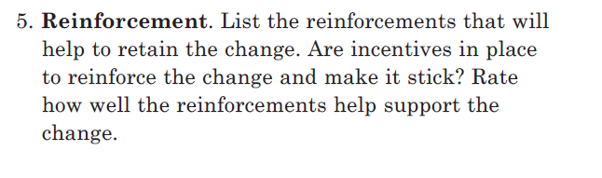

Managers can use a range of incentives to drive

behaviour to ensure that the objectives of the strategy are accomplished. The executive

who refuses to leave the implementation of strategy to chance has available diverse

means of encouraging behaviour that advances strategy and deterring behaviour that

does not (Andrews, 1999, p.102).

Tying rewards and incentives directly to the achievement of performance

objectives and good strategy execution.

A remuneration policy that has the necessary incentives to ensure that the individual interests of employees and executives are aligned with the corporate framework of risk appetite and that these are consistent with the evolution of the Bank’s long-term results.

Barriers to entry distort product markets and reduce the incentives for productivity and innovation,

which directly inhibit growth. Large and old firms continue to dominate the economy as well as

employment dynamics. New firm entry and effective rivalry among existing firms can generate

significant consumer welfare benefits.

The remuneration and incentives policy **includes performance variables that take into account the quality of the risk** and the Group’s long-term results.

Hansen *et al.* (1999) suggest that incentives are required to encourage staff to share knowledge

such as making knowledge sharing a factor in the employees’ performance review,

assessed by recording knowledge electronically or transferring it from person to person.

An example of how staff can be successfully incentivized is provided by ShareNet, a

knowledge management system at Siemens where contributors could collect points called

ShareNet shares, similar to frequent-flier miles. Users earned shares for entering knowledge

objects into the library (20 shares for a success story), answering urgent requests (3 shares),

re-using knowledge and rating one another’s contributions (single shares). In May 2000, the

top 50 point collectors were invited to New York for a conference on ShareNet. Redemption

of shares was possible against prizes such as text books, mobile phones, computers, PDAs,

business trips. One share was roughly equivalent to one euro at the time. Different countries

and business units were then compared on their success in generating shares.

(Eight-to-late, 2008) [6], explained that “project management has moved from the technical aspect of the profession to people-oriented factors as motivation, and there is a strong relationship between leadership and power and motivation”. Motivation in project management is viewed by [8] as the desire to respond to do something as it is interesting while the other is the desire to respond to do something because of the expected remuneration that is akin to the activity. He further explained that inclusive leadership or management style is contributory to intrinsic motivation whereas sole approach relies on extrinsic motivation.[4], emphasised that motivation schemes on construction site workers should not be centred on monetary incentives because it destroys intrinsic motivation, which makes construction site workers be less productive. He proposed that intrinsic motivation should be encouraged so that parallel positioning of incentive structures with motivation can result in successful projects for the client and economic and psychological advantage to the contractor.



Monitoring and review take particular importance in an outsourcing environment, both

for risk management and for contractual purposes. Once the decision has been taken to outsource

an activity, monitoring the quality of the services provided and the costs and risks

associated with their delivery provides an important means of identifying and consolidating

benefits. Monitoring of contractor performance and service quality against specified key

performance indicators determines whether stakeholder and organizational expectations are

being met. If delivery quality and risk management are linked appropriately to payments,

and with contractual terms that allow for sharing of efficiency benefits, there are incentives

for all parties to improve performance.

**Reward power** You reward desirable behavior with incentives or bonuses.

Notice the importance of incentives at each stage. The use of incentives at the start of the

relationship and throughout it are key to successful relationships. As we shall see in a later

section, e-mail is very important in permission marketing to maintain the dialogue between

company and customer.

*Figure 9.2* summarizes the

The challenge here is to motivate and reward the team that is tasked with growing

a new channel without upsetting other channels that may be experiencing slower

growth. The P&L attribution is a key factor but incentives can also help.

Most companies reward on total business performance to target first, followed by

an individual’s performance.

One way to motivate a channel team might be to introduce a middle-tier related to

the channel performance to target, a factor that will give them a boost if they see strong

growth in their area.

• Provide incentives for own employees to

engage with multitude of knowledge partners

(individuals, companies, communities)

• Re-distribution of risks and rewards

Thus, all open business models must include appropriate

incentives and control mechanisms to reduce fear and increase the

involvement and commitment of employees for the open innovation

practices of the company. As such, all open business models

must encompass (1) the search processes to identify external knowledge

sources, (2) provide incentives for external sources to contribute

knowledge input, (3) provide incentives for own employees to interact

with external parties, and (4) provide sufficient absorptive

capacity to integrate external knowledge input. Table 3 summarizes

our arguments.

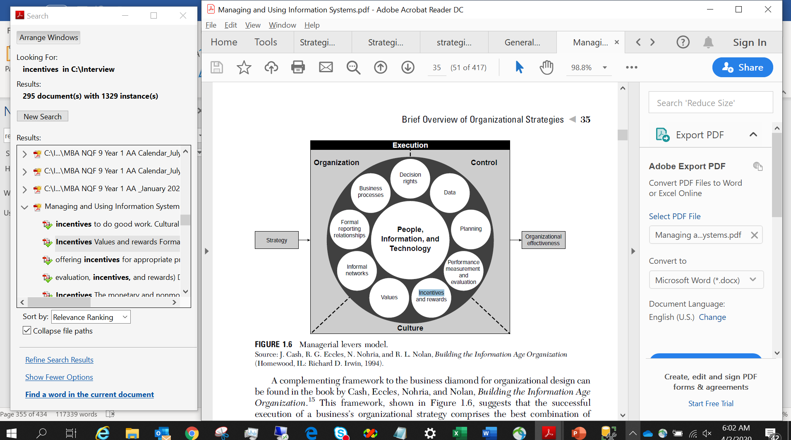

New governance forms need to be introduced into the business

model to support the company’s crowd-based innovation

strategy. On the one hand, the company needs to provide monetary

or non-monetary rewards for external participants to entice

potential contributions.6 On the other hand, the company needs to

provide incentives for its own employees to involve them in the open

innovation initiative. Often employees resist such initiatives out of

the fear of losing competencies and responsibilities. To entice employee’s

and management’s interest in the innovation contest as well

as to overcome the not-invented-here attitude, Keinz et al. (2012,

p. 17) stress the importance of incentive systems that build on the

outcome of the crowd-sourcing activity.

the extent and design of governance mechanisms to facilitate the

accessing and integration of external knowledge; for example,

the deeper external sources are integrated into the company’s

innovation activities, the higher the need for providing incentives

for employees to interact and share knowledge with external

parties.

For collaborations with leadusers,

Keinz et al. (2012) emphasize the importance of developing

competencies with regard to identifying lead-users and moderating

lead-user workshops. As lead-users themselves are the most

crucial success factor in lead-user projects, it becomes essential to

select the right lead-user for the company’s innovation projects,

engage with lead users in special workshops and to provide the appropriate

incentives for lead-users to participate in the project (Keinz

et al., 2012; von Hippel, Franke, & Prügl, 2009). Further, psychological

barriers, such as the not-invented-here syndrome as well as

The expectation is to create hyper transparency in

order to promote values and processes, support policies, provide support

for teamsto experimentwith newmethods, or outreach.Moreover,

leadership is necessary to protect the team culture and provide incentives

for external IT talents. The following figure summarizes the policy

andmanagement layer of the agile innovation management framework

MMMMMMMMMMMMMMMMMMMMMMMM

The triple combination of employee empowerment, an

unambiguous mission in which everyone is invested and clear

incentives is core to successful change efforts, he adds. “It took us

two years to bake these ingredients into our culture, but after that,

you just watch the transformation take off in your hands.”

Incentives The monetary and nonmonetary devices used to motivate

behavior within an organization.

In addition to focusing on organizational-level planning and control, the next three

subsections in this section focus on the individual level. An important part of management

control lies in making sure that individuals performappropriately. At the individual

level, IS can streamline the process of data collection (i.e., monitoring), and support

performance measurement and evaluation, as well as compensation through salaries,

incentives, and rewards.

Information technology affects managerial control mechanisms: planning, data, performance

measurement and evaluation, incentives and rewards.

In the face of such resistance, every possible effort has been made to increase the

response rate. Techniques employed included offering incentives in the form of gifts and

prizes, targeting those parents likely to complete the survey, and making the survey

instrument short.

Bnbbnbbbb

|  |
| --- |
| People are rational and will follow their self-interest once it is revealed to them. Change is based on the communication of information and the offering of incentives. |
| **Normative- Reductive** |



Second, public sector job benefits (salary, benefits, retirement, etc.) often cannot

compete with those of the private sector. In a good economy, the career development

options and incentives of public sector jobs fall short of those offered in the private

sector, resulting in a limited number of applicants for open positions. In contrast, in bad

economic times, a shortage of positions in the job market in general, increases the

number of applicants for open positions. A statement in the article, “Recruiting and

Retaining Information Technology Staff in Higher Education” (2000), reads, “There

appears to be a widespread, fatalistic view that competition with the private sector for IT

workers is a battle that higher education cannot win” (p. 5). Colleges need to highlight

benefits long gone from the private sector in order to retain talent. Factors like leave time

and defined pension plans may offset higher salary and other extrinsic motivation

Management should build a

coalition of supporters for any change initiative envisaged

by identifying opinion leaders and encourage them to

support the change at all levels. This will make the

implementation of the change easier and successful, since

the process of participation and decision making; will

let them to take direct ownership of the change process.

Moreover, reward and discipline (carrot and stick) should

be used as tools to achieve the organizational change**.**

These two primary tools for controlling employees: reward and disciplinary systems, are critically important in

the organizational change processes. The reward systems

can be used to generate and leverage change by valuing

specific outputs, behaviours and values. Reward systems

such as special incentives, finding new heroes, increase

in salaries, and award of bonuses and so on, can be an

effective way of signalling management’s commitment

to change. Motivation during a change initiative is about

rewarding the right behaviours. However, disciplinary

approaches (coercive measures) such as threatening

employees with loss of jobs or promotions or by firing

or transferring them can be used to overcome resistance

to change when management has given clear message of

the need for the change and has involve the employees.

However, this approach should be used sparingly

since, this approach can create anger in the people and

accordingly, the change may be sabotaged.

|  |
| --- |
| Implementation phase – an important phase that ensures that the factors that impact people (skills, authority, resources and incentives to processes and structure) are all aligned with the key objective. This phase includes commitment building and execution management. |

**(10) Motivator :** An entrepreneur is a motivator. He motivates his

workers by giving them incentives, and creation of team work in

order to get their whole-hearted cooperation. He is able to influence

people in the new business unit in the way that they will strive

willingly and enthusiastically toward the achievement of unit’s

goals.

Individuals with high

achievement orientation are not influenced by considerations of

money or any other external incentives. Profit and incentives are

merely yardsticks of measurement of success of entrepreneurs with

high achievement orientation. The achievement orientation can be

taught and increased by deliberate efforts. The struggle to achieve

more and more is taught to children by their parents. The

individuals with high achievement orientation take calculated risks

and can make decisions where there are incomplete information or

have tolerances for ambiguity. Psychologists call this behaviour as

Type-A behaviour.

In recent times, the term entrepreneurial management is often used

to signify that even managers working for master can (and should)

innovate and take decisions involving risks and uncertainties in the

same way as entrepreneurs are supposed to do. Only then will the

organisations they belong to will grow. And to bring in a sense of

involvement and commitment on the part of managers working in

corporate organisations systems of compensation and rewards like

stock option plans are created to evoke from the managers the right

responses through such incentives.

Nbnbnbnbbs

Companies can also provide incentives that use performance, not hours worked, as

the basis of rewards. If performance can be measured objectively, as it can in many

aspects of IT jobs, then it should not matter where employees do their work or how long

it takes. For example, if a technical writer can produce a high-quality publication at home

in one week, the company should accept the arrangement instead of insisting that the

writer come to the office and take two weeks to produce the publication. Objective

measures of work performance and incentives based on meeting those criteria are

important considerations.

reward power — Using incentives to induce people to do things

One innovative approach to hiring and retaining IT staff is to offer existing employees

incentives for helping recruit and retain personnel. For example, several consulting

companies give their employees one dollar for every hour worked by a new person

they helped recruit. This provides an incentive for current employees to help attract

new people and to keep all of them working at the company. Another approach to

attract and retain IT professionals is to provide benefits based on personal need.

For example, some people might want to work only four days a week or have the

option of working a couple of days a week from home. As it becomes more difficult to

find good IT professionals, organizations must become more innovative and proactive in

addressing this issue.

Reward power involves using incentives to induce people to do things.

Rewards can include money, status, recognition, promotions, and special work

assignments. Many motivation theorists suggest that only certain types of

rewards, such as work challenge, achievement, and recognition, truly induce

people to change their behavior or work hard.

Offer incentives for people to join the programs and do well in them (e.g., incentives

for achieving weight goals, winning sports team competitions, etc.).

Proactive organizations address current and future human resource needs by improving

benefits, redefining work hours and incentives, and finding future workers. Many organizations

have changed their benefits policies to meet worker needs. Most workers assume

that companies provide some perks, such as casual dress codes, flexible work hours, and

tuition assistance. Other companies might provide on-site day care, fitness club discounts,

or matching contributions to retirement savings. Google, the winner of Fortune’s 100 Best

Companies award in 2007, 2008, and 2012, provides employees with free gourmet meals

and doctors on site, a swimming spa and corporate gym, beach volleyball, Foosball, video

• Incentives: Virtual teams may require different types of incentives to accomplish

high-quality work on time. They do not have the benefit of physical

contact with their project managers or other team members, so it is important

to provide frequent positive incentives, such as a thank-you via e-mail or

phone, or even a bonus on occasion. Negative incentives, such as payment

withholding or fines, can also be effective if virtual team members are not

being productive.

2.4. Extrinsic motivators

There may be extrinsic motivators to contribute to F/OSS projects.

The most obvious one is that people develop F/OSS tools to

meet their own needs or accomplish work. Von Hippel (1988)

found that participants have strong incentives to create solutions

to their particular needs. Also, Lerner and Triole (2000) identified

two types of payoff for contributions, an immediate payoff (e.g.,

ability to use the product) and a delayed payoff (e.g., potential future

rewards in terms of recognition and reputation). Likewise,

one’s social stature within the F/OSS community can be related

to the performance in the group’s activity.

Lakhani and Wolf (2005) found that although financial

incentives are important for contributors, work enjoyment is a key intrinsic motivation for such devotion where creativity to improve

programming skills and enjoyment were revealed to be the

main factors that stimulate contributors’ work for free.

Other researchers have showed that contributors’ objectives are

to reveal their technical capabilities to obtain better job opportunities

for future prospects and the main incentives behind the volunteer

participation are for extrinsic benefits (Lerner & Tirole, 2000,

2002). Also, Riehle (2007) claimed that software developers strive

to become contributors in open source projects to acquire more

recognition, independence, and therefore to guarantee better future

as well as better careers.

Other researchers have showed that contributors’ objectives are

to reveal their technical capabilities to obtain better job opportunities

for future prospects and the main incentives behind the volunteer

participation are for extrinsic benefits (Lerner & Tirole, 2000,

2002). Also, Riehle (2007) claimed that software developers strive

to become contributors in open source projects to acquire more

recognition, independence, and therefore to guarantee better future

as well as better careers.

Several organizations, publications, and Web sites address the need for good staff

acquisition and retention. Enrollment in computer science and engineering programs

in U.S. colleges has dropped almost by half since 2000, and one-third of U.S. workers

were over the age of 50 by 2010. CIO’s researchers suggest that organizations rethink

hiring practices and incentives to hire and retain IT talent. For example, if it’s

important for IT employees to have strong business and communications skills,

organizations shouldn’t focus primarily on technical skills. A company could require

candidates to give a presentation to see how well they communicate and understand

the business. Also, organizations should focus on flexibility when negotiating perks.

According to the 2006 Compensation and Benefits Report by Hudson Highland Group,

one-third of IT workers said they value a flexible work schedule more than other

nontraditional benefits. “Employees are more willing to forgo additional cash in order

to have a more improved work-life balance,” said Peg Buchenroth, Hudson Highland

Group’s managing director of compensation and benefits.24 A 2010 report by the

same group stated, “Pressure is intensifying to improve staff development programs

and provide more flexible and stimulating working environments to ensure that staff

members are motivated and not tempted by more lucrative or interesting offers

elsewhere.”25

Gore says banks operate on three legs: fees, interest and

rewards. Some banks (like Capitec and the other newcomers) will offer competitive fees and attractive interest rates on accounts

but no rewards programme; while the large banks pay little

or no interest on current accounts but have decent rewards

programmes.

2.5. Network relationships

Research indicates that under most circumstances

cooperative, interpersonal and group

behavior results in superior performance [29].

However it is possible that competitive controversy

within generally competitive groups can

result in greater openness, knowledge and understanding

[30]. In terms of inter-organizational

processes, research indicates the benefits of partnering

with external suppliers [31]. Organizations

that can manage these aspects of competition and

cooperation continuously can benefit from employee employee

incentives and controls, as well as instill

change more effectively [18].

Institutions are an ensemble of rules that can create incentives to contribute

to the creation of value (e.g., incentives to organize, to innovate, to bear risk), and in this

way influence economy-wide division of labor arrangements (Foss & Garzarelli, 2007).

And different division of labor arrangements entail different increasing returns, which

are a fundamental determinant of economic growth. Increasing returns, which generally

emanate from increases in knowledge, in fact imply that output increases by a factor greater

than the corresponding increase in input. For example, if there’s knowledge reuse—as

is often the case in software code production (Haefliger, von Krogh, & Spaeth, 2008)—

output can, for example, be doubled without doubling an input, i.e., knowledge (Langlois,

1999).

Some of the most drastic changes came from within Lego’s organizational structure. After

racking up massive losses in 2004, Lego switched its employee pay structure, offering incentives

for appropriate product innovation and sales. Key Performance Indicators encourage product

innovation that catalyzed sales while decreasing costs. Development time dropped by 50% and

some manufacturing and distribution functions were moved to less expensive locations, but the

focus on quality remained. The creation of reusable parts alleviated some of the strain on Lego’s

supply chain, which in turn helped its bottom line.

together with management reform mechanisms and other performance agreements , implementation of strategy must be used to assist in creating the incentives that can align individual managers’ objectives with those of organization as a whole.

[Furthermore](https://www.bing.com/search?q=define+furthermore&FORM=DCTRQY) ·,leadership is important to protect the team culture and provide incentives for employees who support organizational structure and the culture of the organization. Management should drive employee engagement in the organization and work practices, utilizing creative incentives, techniques, and sophisticated communication.

Some factor that can have an impact on cultural readiness is that the strategy implementation was an

additional job task for the PLs and no effort had been made by the senior management to

reduce their existing workload. Definition of cultural readiness, means utilizing creative incentives to drive employee engagement in an organization

**Don't "expect" people to do the right thing**. While employees may want

to treat customers well, you can't just expect them to do it. Why not?

Because companies want their employees to do a lot of things. But

organizations often hone their measurements, incentives, and celebrations to

achieve short-term growth and profitability targets. So without any explicit

intervention on behalf of customer experience, the environment will push

employees to focus on just about anything except customer experience.

􀂄 **Clearly define good behavior**. Before you just adjust the environment, it's

important that you define/describe the type of behavior that you want from

people in every role. Do you want customer service reps to spend whatever

time they need to on the phone to solve a problem or do you want them to

cut down the average handle time on each call? The measurements,

incentives, and celebrations should be adjusted to reinforce those behaviors.

**Watch out for mixed messages**. You can only get consistent behaviors

from employees when all three levers (measurements, incentives, and

celebrations) are working together. If you celebrate things that are different

than what you measure, for instance, then employees aren't sure which

signals to follow.

• Performance Incentives

for all employees was

implemented

Specifically, due to their dominant position in the hierarchy, top

management can mandate and provide incentives to ensure that strategic utilization

of CRM technology is followed through. If top management fails to explain how

CRM advances the firm’s goals in terms of creating significant competitive

advantage and improving the efficiency of marketing processes, any initiative to

strategically utilize CRM is likely to be interpreted as a gimmick or a fad (Mankoff

2002). Therefore, we conjecture that buy-in mediates the impact of top management

championship practices on strategic utilization. As buy-in improves and users

become open-minded about using CRM, championship initiatives are taken seriously

leading to better strategic utilization.

Incentives

Use of rewards : Individuals that accept support and change must rewarded. Incentives include monetary incentives, promotions, feedback, recognition and praise. Rewarding workers for behaving in the manner which is intended is an effective way to facilitate change. It is especially important if a company is in the transition period to introduce the change. For instance is praising workers who are successfully learning how to utilize new equipment. Some example include is to provide feedback to a worker which will offer assurance uncertainty and assist to shape the desired behavior. It is practicable to reward employees who support change this is shaping the behavior and attitude of employees who resist.

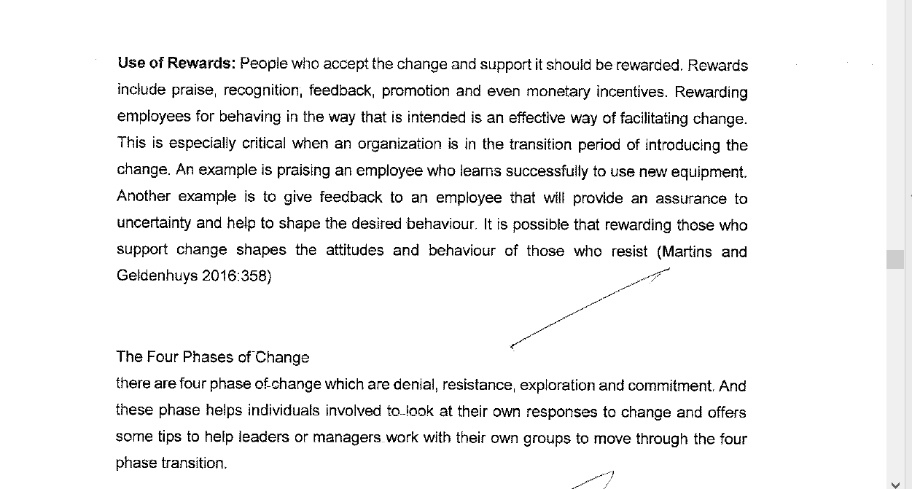

3.3

Schein (1990:111) provides one of the most widely quoted definitions of organisation culture as “(a) a pattern of basic assumptions, (b) invented, discovered, or developed by a given group, (c) as it learns to cope with its problems of external adaptation and internal integration, (d) that has worked well enough to be considered valid and, therefore (e) is to be taught to new members as the (f) correct way to perceive, think, and feel in relation to those problems.”

Bhattacharyya (2011: 268 - 269) emphasizes the following organisational culture change process: ƒ Identify the core values and beliefs ƒ Consider the subcultures within the 19

organisation ƒ List out the incongruence ƒ Establish new behavioural norms ƒ Repeat these steps over a long period of time.

**organisation’s processes and structures, including communication, decision-making, co-ordination of goals and objectives, the motivating climate and the quality of the physical work environment and,**

**finally, top management’s interest in the wellbeing of employees and organisation members.**

**Organisational Structures, Technology and Leadership**

Today’s new horizontal organisational structures make

Jaques’ time-span theory of hierarchy more important than ever before

**Organisational Structures, Technology and Leadership**

Today’s new horizontal organisational structures make

Jaques’ time-span theory of hierarchy more important than ever before.

Jaques argued that the higher a person was positioned in a hierarchy, assuming the individual possessed a corresponding level of cognitive complexity, acquired skills and knowledge (gained through experience) and presuming that individual valued the work he or she was tasked, the longer he could work to complete a task without supervision. The time span of a CEO of a major institution might be 15–20 years. This concept enabled him to describe a "requisite organization" as one in which each level in the hierarchy had its own distinctive time span. If an organization had too many levels, then their time spans overlapped. If a manager at a higher level was ill equipped in respect of his or her inherent mental processing capability, or lacked the required skills and knowledge the risk is they would interfere in the work of managers at a lower level generally propelled by their own anxiety and insecurity. The process of delegation would be undermined leading to organizational dysfunction.

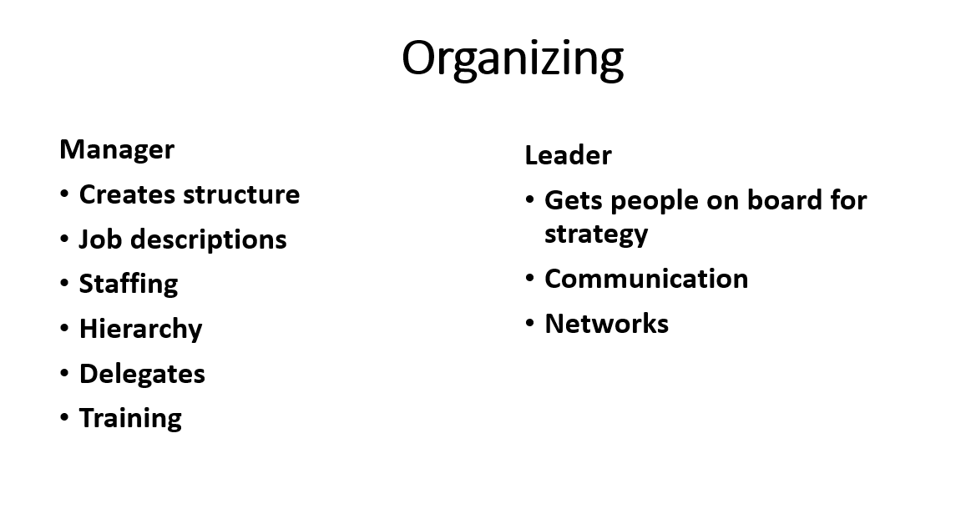

An organizational structure describe how activities like supervision, coordination, and

task allocation are directed toward the achievement of organizational aims.

Organizational structure has an impact on organizational action and offers the base on which standard operating routines and procedures rest. Organizational structure establishes which individuals are taking part in which decision-making processes, and there to what extent individual views shape the actions of the organizations. In addition organizational structure may be considered as the perspective or viewing glass via which individuals view their company and its environment.

A company may be structured in number of different ways, based on its goals. The structure of a company can establish the modes where it performs and operates.

Organizational structure enable expressed allocation of responsibilities for various processes and functions to various entities like the individual, workgroup, department and the branch.

Organizations must be caring, innovative, flexible and efficient so that it can [accomplish](https://www.bing.com/search?q=define+accomplish&FORM=DCTRQY) a sustainable competitive advantage.

Types

Pre-bureaucratic structures

Pre-bureaucratic  structures lack standardization of tasks. This structure is most common in smaller organizations and is best used to solve simple tasks, such as sales. The structure is totally centralized. The strategic leader makes all key decisions and most communication is done by one on one conversations. It is particularly useful for new  business as it enables the founder to control growth and development.

They are usually based on traditional domination or charismatic domination in the sense of Max Weber's tripartite classification of authority.

Bureaucratic structures

Weber  gives the analogy that “the fully developed bureaucratic mechanism compares with other organizations exactly as does the machine compare with the non-mechanical modes of production. Precision, speed, unambiguity, … strict subordination, reduction of friction and of material and personal costs- these are raised to the optimum point in the strictly bureaucratic administration.” Bureaucratic structures have a certain degree of standardization. They are better suited for more complex or larger scale organizations, usually adopting a tall structure. The tension between bureaucratic structures and non-bureaucratic is echoed in Burns and Stalker's distinction between mechanistic and organic structures.

The Weberian characteristics of bureaucracy are:

Clear defined roles and responsibilities

A hierarchical structure

Respect for merit

Bureaucratic structures have many levels of management ranging from senior executives to regional managers, all the way to department store managers. Since there are many levels, decision-making authority has to pass through more layers than flatter organizations. A bureaucratic organization has rigid and tight procedures, policies and constraints. This kind of structure is reluctant to adapt or change what they have been doing since the company started. Organizational charts exist for every department, and everyone understands who is in charge and what their responsibilities are for every situation. Decisions are made through an organizedaucratic structures, the authority is at the top and information is then flowed from top to bottom. This causes for more rules and standards for the company which operational process is watched with close supervision. Some advantages for bureaucratic structures for top-level managers are they have a tremendous control over organizational structure decisions. This works best for managers who have a command and control style of managing. Strategic decision-making is also faster because there are fewer people it has to go through to approve. A disadvantage in bureaucratic structures is that it can discourage creativity and innovation in the organization. This can make it hard for a company to adapt to changing conditions in the marketplace.

Post-bureaucratic

The post bureaucratic term is utilized in 2 senses in an organizational literature: 1 much more specific and 1 generic.

In a generic sense the post bureaucratic term is frequently utilized to define a number of ideas created since the nineteen eighties which certainly contrast themselves with idea of Weber ‘s kind bureaucracy. It may involve matrix management, culture management and total quality management amongst others. Nevertheless none of these left behind the core Bureaucracy tenets . the organization is still rule bound, legal type, authority is still Weber's rational, and

hierarchies are still existing. Heckscher???, suggesting along such lines, defines them as cleaned up bureaucracies, instead of a fundamental shift away from bureaucracy. Gideon Kunda???, in his classic culture management study at 'Tech' suggested that

' enforcement and codification of regulations and rules ,the reality of bureaucratic control - the formalization, - is not changing principle.....it is shifting concentration from organizational structure to the organization's culture'.

Another smaller group of theorists have developed the theory of the Post-Bureaucratic Organization., and Nelson Repenning revive an older interest in how structure and strategy relate in dynamic environments.

Functional structure

Organizational structure which is functional is a structure which is made up of activities like task allocation , supervision and coordination

. The organizational structure establishes how the company operates or performs . organizational structure term is referring to how individuals in a company are organized and to whom they are reporting to. 1 traditional way of arranging people is by function. Other general functions in a company involve accounting, human resources, marketing, and production.

This arranging of specialization is leading to operational efficiency, where workers are becoming specialists in their own realm of expertise. Simultaneously , the many typical issues with functional organizational structure is that communication in the organization may be instead of rigid, making the company inflexible and slow . Thus, lateral communication among functions is very essential , in order for information to be disseminated not just vertically, also horizontally in the company . Communication in a company with functional organizational structures may be rigid reason being the high degree of formalization and the standardized manners of operation .

As a whole, a functional organization is best suited as a producer of standardized goods and services at large volume and low cost. Coordination and specialization of tasks are centralized in a functional structure, which makes producing a limited number of products or services efficient and predictable. Moreover, efficiency can further be realized as functional organizations integrate their activities vertically so that products are sold and distributed quickly and at low cost. For instance, a small business could make components used in production of its products instead of buying them.

Even though functional units often perform with a high level of efficiency, their level of cooperation with each other is sometimes compromised. Such groups may have difficulty working well with each other as they may be territorial and unwilling to cooperate. The occurrence of infighting among units may cause delays, reduced commitment due to competing interests, and wasted time, making projects fall behind schedule. This ultimately can bring down production levels overall, and the company-wide employee commitment toward meeting organizational goals.

Divisional structure

The divisional structure or product structure consists of self-contained divisions. A division is a collection of functions which produce a product. It also utilizes a plan to compete and operate as a separate business or profit center. According to Zainbooks.com, divisional structure in America is seen as the second most common structure for organization today.

Employees who are responsible for certain market services or types of products are placed in divisional structure in order to increase their flexibility. Examples of divisions include regional, consumer type, and product type . The divisions may also have their own departments such as marketing, sales, and engineering.

The advantage of divisional structure is that it uses delegated authority so the performance can be directly measured with each group. This results in managers performing better and high employee morale. Another advantage of using divisional structure is that it is more efficient in coordinating work between different divisions, and there is more flexibility to respond when there is a change in the market. Also, a company will have a simpler process if they need to change the size of the business by either adding or removing divisions. When divisional structure is utilized more specialization can occur within the groups. When divisional structure is organized by product, the customer has their own advantages especially when only a few services or products are offered which differ greatly. When using divisional structures that are organized by either markets or geographic areas they generally have similar functions and are located in different regions or markets. This allows business decisions and activities coordinated locally.

The disadvantages of the divisional structure is that it can support unhealthy rivalries among divisions. This type of structure may increase costs by requiring more qualified managers for each division. Also, there is usually an over-emphasis on divisional more than organizational goals which results in duplication of resources and efforts like staff services, facilities, and personnel.

Matrix structure

The matrix structure groups employees by both function and product simultaneously. A matrix organization frequently uses teams of employees to accomplish work, in order to take advantage of the strengths, as well as make up for the weaknesses, of functional and decentralized forms. An example would be a company that produces two products, "product a" and "product b". Using the matrix structure, this company would organize functions within the company as follows: "product a" sales department, "product a" customer service department, "product a" accounting, "product b" sales department, "product b" customer service department, "product b" accounting department.

Weak/functional matrix: A project manager with only limited authority is assigned to oversee the cross- functional aspects of the project. The functional managers maintain control over their resources and project areas.

Balanced/functional matrix: A project manager is assigned to oversee the project. Power is shared equally between the project manager and the functional managers. It brings the best aspects of functional and projectized organizations. However, this is the most difficult system to maintain as the sharing of power is a delicate proposition.

Strong/project matrix: A project manager is primarily responsible for the project. Functional managers provide technical expertise and assign resources as needed.

There are advantages and disadvantages of the matrix structure. Some of the disadvantages include tendencies towards anarchy, power struggles and 'sinking' to group and division levels. Matrices increase the complexity of the chain of command, which can present problems because of the differentiation between functional managers and project managers. This, in turn, can be confusing for employees to understand who is next in the chain of command. An additional disadvantage of the matrix structure is higher manager to worker ratio that results in conflicting loyalties of employees. However, the matrix structure also has significant advantages that make it valuable for companies to use. The matrix structure may improve upon the "silo" critique of functional management in that it aims to diminish the vertical structure of functional and create a more horizontal structure which allows the spread of information across task boundaries to happen much quicker. It aims to allow specialization to increase depth of knowledge and allows individuals to be chosen according to project needs.

Organizational circle

The flat structure is common in small companies . As companies grow they tend to become more complex and hierarchical, which lead to an expanded structure, with more levels and departments.

However, in rare cases, such as the examples of Valve, GitHub, Inc. and 37signals, the organization remains very flat as it grows, eschewing middle managers.  All of the aforementioned organizations operate in the field of technology, which may be significant, as software developers are highly skilled professionals, much like lawyers. Senior lawyers also enjoy a relatively high degree of autonomy within a typical law firm, which is typically structured as a partnership rather than a hierarchical bureaucracy. Some other types of professional organizations are also commonly structured as partnerships, such as accountancy companies and GP surgeries.

Often, growth would result in bureaucracy, the most prevalent structure in the past. It is still, however, relevant in former Soviet Republics, China, and most governmental organizations all over the world. Shell Group used to represent the typical bureaucracy: top-heavy and hierarchical. It featured multiple levels of command and duplicate service companies existing in different regions. All this made Shell apprehensive to market changes, leading to its incapacity to grow and develop further. The failure of this structure became the main reason for the company restructuring into a matrix.

Starbucks is one of the numerous large organizations that successfully developed the matrix structure supporting their focused strategy. Its design combines functional and product based divisions, with employees reporting to two heads.

Some experts also mention the multinational design, common in global companies, such as Procter & Gamble, Toyota and Unilever. This structure can be seen as a complex form of the matrix, as it maintains coordination among products, functions and geographic areas.

With the growth of the internet, and the associated access that gives all levels of an organization to information and communication via digital means, power structures have begun to align more as a wirearchy, enabling the flow of power and authority to be based not on hierarchical levels, but on information, trust, credibility, and a focus on results.

In general, over the last decade, it has become increasingly clear that through the forces of globalization, competition and more demanding customers, the structure of many companies has become flatter, less hierarchical, more fluid and even virtual.

Team

1 of the latest organizational structures created in the twentieth century is team and team building, or the related concept of team development. In businesses that are small, the structure of the team may described the entire organization. Meanwhile an organization is constituted as a group of people that synergize individual competencies to accomplish new dimensions, the organizational structure quality revolves around the team competencies in totality. For e.g. any one of the largest natural-foods grocer, the Whole Foods Market stores, in the United State creating a strategy which is focused, is an autonomous profit center made up of an average of ten self-managed teams, meanwhile leaders of the team in each region and every store are also a team. Bureaucratic organizations which are larger may also benefit from the team flexibility. DaimlerChrysler , Motorola, and Xerox are all among the organizations which are actively using teams to perform tasks.

Network

Another modern structure is network. While business giants risk becoming too clumsy to proact, act and react efficiently, the new network organizations contract out any business function, that can be done better or more cheaply. In essence, managers in network structures spend most of their time coordinating and controlling external relations, usually by electronic means. H&M is outsourcing its clothing to a network of 700 suppliers, more than two-thirds of which are based in low-cost Asian countries. Not owning any factories, H&M can be more flexible than many other retailers in lowering its costs, which aligns with its low-cost strategy. The potential management opportunities offered by recent advances in complex networks theory have been demonstrated including applications to product design and development, and innovation problem in markets and industries.

Virtual

Virtual organization is defined as being closely coupled upstream with its suppliers and downstream with its customers such that where one begins and the other ends means little to those who manage the business processes within the entire organization.

A special form of boundaryless organization is virtual. Hedberg, Dahlgren, Hansson, and Olve  consider the virtual organization as not physically existing as such, but enabled by software to exist. The virtual organization exists within a network of alliances, using the Internet. This means while the core of the organization can be small but still the company can operate globally be a market leader in its niche. According to Anderson, because of the unlimited shelf space of the Web, the cost of reaching niche goods is falling dramatically. Although none sell in huge numbers, there are so many niche products that collectively they make a significant profit, and that is what made highly innovative Amazon.com so successful.

Hierarchy-community phenotype model

In the 21st century, even though most, if not all, organizations are not of a pure hierarchical structure, many managers are still blind to the existence of the flat community structure within their organizations.

The business is no longer just a place where people come to work. For most of the employees, the firm confers on them that sense of belonging and identity –– the firm has become their “village”, their community. The firm of the 21st century is not just a hierarchy which ensures maximum efficiency and profit; it is also the community where people belong to and grow together, where their affective and innovative needs are met.

Lim, Griffiths, and Sambrook  developed the Hierarchy-Community Phenotype Model of Organizational Structure borrowing from the concept of Phenotype from genetics. "A phenotype refers to the observable characteristics of an organism. It results from the expression of an organism’s genes and the influence of the environment. The expression of an organism’s genes is usually determined by pairs of alleles. Alleles are different forms of a gene. In our model, each employee’s formal, hierarchical participation and informal, community participation within the organization, as influenced by his or her environment, contributes to the overall observable characteristics  of the organization. In other words, just as all the pair of alleles within the genetic material of an organism determines the physical characteristics of the organism, the combined expressions of all the employees’ formal hierarchical and informal community participation within an organization give rise to the organizational structure. Due to the vast potentially different combination of the employees’ formal hierarchical and informal community participation, each organization is therefore a unique phenotype along a spectrum between a pure hierarchy and a pure community  organizational structure." the early theorists of organizational structure, Taylor, Fayol, and Weber "saw the importance of structure for effectiveness and efficiency and assumed without the slightest question that whatever structure was needed, people could fashion accordingly. Organizational structure was considered a matter of choice... When in the 1930s, the rebellion began that came to be known as human relations theory, there was still not a denial of the idea of structure as an artifact, but rather an advocacy of the creation of a different sort of structure, one in which the needs, knowledge, and opinions of employees might be given greater recognition." However, a different view arose in the 1960s, suggesting that the organizational structure is "an externally caused phenomenon, an outcome rather than an artifact."

In the 21st century, organizational theorists such as Lim, Griffiths, and Sambrook  are once again proposing that organizational structure development is very much dependent on the expression of the strategies and behavior of the management and the workers as constrained by the power distribution between them, and influenced by their environment and the outcome.

Operational and informal

The organizational structure which is created might not [coexist](https://www.bing.com/search?q=define+coexist&FORM=DCTRQY) with the facts, that evolve in operational action. This divergence lowers performance, if growing as an incorrect organizational structure can obstruct cooperation and therefore hamper the completion of orders in due time and within limits of budgets and resources.

Organizational structures must adaptive when it comes to processing requirements, focusing on optimizing the input to output and ratio of effort .

Configurations of organizational structure according to Mintzberg

Parts of organization

Henry Mintzberg considers five main parts of organization:

Strategic apex

Middle line

Operating core

Technostructure

Support staff

An additional element is organisational ideology. Its leader coordinates the work using direct supervision. Support staff, helping the professionals to do their job, is numerous. Professionals participate in administrative work, thus there are many committees. Such structure is common for universities, hospitals, law firms.

Diversified Configuration or Divisionalized form consists of several parts having high autonomy. Such structure is common for old, large organizations.

Innovative Configuration or Adhocracy gathers the specialists of different fields into teams for specific tasks. Such organizations are common when environment is complex and dynamic. Mintzberg considers two types of such organization: operating adhocracy and administrative adhocracy. Operating adhocracy solves innovative problems for its clients. Examples of such organisation can be advertising agency or firm that develops the prototypes of products. Administrative adhocracy has teams solving problems for the organization itself. As an example of such organization Mintzberg gives NASA when it worked on Apollo program.

Missionary organisation coordinates the work through organisational ideology. Formal rules in such organization are not numerous. Such organizations are decentralized, the differences between levels are not significant.

Political configuration happens when the power is mostly used through workplace politics.

Bibliography

Lawrence B. Mohr, Explaining Organizational Behavior. The Limits and Possibilities of Theory and Research., Jossey-Bass Publishers, 1982.

See also

References

Bibliography:

Wikipedia

@baygross

///////////////////////////////////////////

Managers must design a suitable reward systems and organizational structures

CCCCCCCCCCCCCCCCCCCCCCC

Manifestations of Culture Schein 1990) identified three fundamental levels at which the culture manifests itself:

1. the observable artefacts: including the physical layout, dress code, manner of address, the smell and feel of the place, its emotional intensity, company records, products, statements of philosophy, and annual reports;

2. the values: including norms, ideologies, charters, philosophies, why certain observed phenomena happen the way they do;

3. the unconscious assumptions: the taken-for-granted, underlying, and usually unconscious assumptions that determine perceptions, thought processes, feelings, and behaviour.

Culture refers to beliefs, values and attitude held by management and their employees (Passenheim, 2010). Any business like Nokia may have inherent attitudes which do not support change. A change of strategy, structure and technology make it necessary for people (employees) to change their knowledge, behaviour and attitudes. If this is not implemented correctly this can inhibit cultural change in an organisation. Through better training on strategic changes to be implemented in an organisation and allowing employees to accept and adopt to the changes can help facilitate change in an organisation. There are steps to be followed when it comes to approaching cultural changes to avoid obstacles (Passenheim, 2010):

• Analyze the cultural situation

• Accept the cultural barrier, do not ignore it

• Work against it with a communication mechanism or integration methods

Cultural change facilitators: Communication the need for change is important. This can be done by developing a business case outlining the reasons for change. Evaluate the readiness for change in the organisation. Ensuring that people support the change, understand the change and are involved in the plans for change. Better communication between the different stakeholders affected by the change. This can be done face to face or in groups to ensure everyone understands. Review the change by putting control measure to check the progress on changes made, areas of improvement.

Cultural change inhibitors

Insufficient problem awareness: this is the reasoning behind any change in an organisation. There are triggers for change processes which are extensively discussed with the management. Awareness arises of existing problems and the necessity to make changes. Workers/employees must have transparent view of the situation of the company, must be informed of the problems and planned changes

I **Primary Mechanisms:**

1. **What leaders pay attention to, measure and control.**
2. **How leaders react to critical incidents and organisational crises.**
3. **Deliberate role modelling and coaching.**
4. **Operational criteria for allocating rewards and status.**
5. **Operational criteria for recruitment, selection, promotion, retirement and excommunication.**

integration Phase: this process follows the successful implementation of the intended changes. It focuses on consolidating and stabilising the adopted changes. Key Change Management Process: Reinforcing new behaviours through positive feedback and reward systems. Reduction of reliance on consultants. Diffusion of the successful aspects of the change process throughout the organisation. Training managers and employees to constantly monitor the change and to improve upon it.

• **The rewards for success are too low**

The rewards for success are usually not enough because very few organisations provide adequate rewards for success. In most cases the rewards are less than those available to entrepreneurs. The incentive systems need to be reviewed upwards.

**Positive attitude**

Entrepreneurs remain positive despite setbacks and failure. They sometimes get discouraged when situations are not favourable, but they accept this and still remain positive. Difficulties are usually encountered with periods of stress. Whilst rewards do come eventually, not everyone should become an entrepreneur.

**4.5. The Importance of entrepreneurs**

Entrepreneurs occupy a central position in an economy. It is the entrepreneurs who serve as the spark plug in the economy's engine, activating and stimulating different economic activities. Most nations worldwide can trace their economic success to efforts at encouraging and rewarding the entrepreneurial spirit. A society is prosperous only to the degree to which it rewards and encourages entrepreneurial activity because it is the entrepreneurs and their activities that are the critical determinant of the level of success, prosperity, growth and opportunity in any economy. The most dynamic societies in the world are the ones that have the most entrepreneurs, plus the economic and legal structure to encourage and motivate entrepreneurs to greater activities (Tracy, 2005).

Excellent rewards & recognition….Honey is a zero risk business opportunity.

At the heart of the family business are its distinctive values and beliefs – its culture. Whilst family culture can be a tremendous asset for the business, it can also create the potential for conflict. The problem arises when there are differences between the family and business cultures. Families exist primarily to take care of and nurture family members, whereas businesses exist to profitably generate goods and services. The family culture is based on emotion emphasizing loyalty, caring and sharing. It is inward looking and lasts a lifetime. In contrast, business culture is unemotional, task-orientated and is based on self-interest. It is outward-looking, rewarding performance and penalizing lack of performance. Conflict between the two cultures is unlikely at start-up but, as the organization grows and time passes, the potential for conflict increases (Burns, 2007:416).

Reward performance

**Nepotism** – is a major disadvantage associated with family businesses. Nepotism can refer to tolerance of inept family members as managers, inequitable reward systems and difficulties in attracting professional management. In view of the fact that the family has the power to pursue its own objectives, these may not always align to acceptable business practice. As a consequence, a family member who is incompetent may be promoted or the salaries of family members may be established above market rates.

Process definitions of entrepreneurship focus on how the entrepreneurial process is navigated and cover the different components in the process as it relates to individuals, businesses and society. Venter et al (2015:8) illustrate this by the definition of Hisrich and Peters (1998): “Entrepreneurship is the process of creating something new with value by devoting the necessary time and effort, assuming the accompanying financial, psychic and social risks, and receiving the resulting rewards of monetary and personal satisfaction and independence.”

///////////////////

NBNBNBNBNBN

The following elements are important in **creating and sustaining an organisation's culture** (Coetsee, 2000: 56):  
**Primary Mechanisms:**

1. **What leaders pay attention to, measure and control.**
2. **How leaders react to critical incidents and organisational crises.**
3. **Deliberate role modelling and coaching.**
4. **Operational criteria for allocating rewards and status.**
5. **Operational criteria for recruitment, selection, promotion, retirement and excommunication.**

**Secondary Articulation and Reinforcement Mechanisms:**

1. **The organisation’s design and structure.**
2. **Organisational systems and procedures.**
3. **Design of physical spaces, facades and symbols.**
4. **Formal statements of organisation philosophy, convictions, strategies (i.e. vision, mission and values)**

**Changing Corporate Culture**

**Changing an organisation’s culture and climate is often related to the implementation of a new strategic direction that the organisation wishes to follow.**

**Changing the climate cannot be done directly since climate represents an amalgam of perceptions, attitudes and expectations.**

**In other words, climate should be seen as a *result* or *output;* so efforts to influence climate must be directed ‘upstream’ at areas such as the**

**organisation’s processes and structures, including communication, decision-making, co-ordination of goals and objectives, the motivating climate and the quality of the physical work environment and,**

**finally, top management’s interest in the wellbeing of employees and organisation members.**

What is Culture?

* Values, norms, guiding beliefs, and understandings that are shared by members of an organization
  + Taught to new members as the correct way to think, feel, and behave
* Organizational culture exists at two levels
  + Observable symbols
  + Underlying values

**Definition of Organisational Culture**

Schein (1990:111) provides one of the most widely quoted definitions of organisation culture as “

1. a **pattern** of basic assumptions,
2. invented, discovered, or developed by a given group, …
3. as it learns to cope with its problems of external adaptation and internal integration,….
4. that has worked well enough to be considered valid and, therefore …
5. is to be taught to new members as the ….

correct way to perceive, think, and feel in relation to those problems.”

Lundberg has painstakingly constructed a combination of the major themes that are contained in numerous definitions and has put forward a possible consensus reflection of Organisational Culture:

**“It is a shared, common frame of reference**,

i.e., it is largely taken for granted and is shared by a significant portion of organisation members

**it is acquired and governs,**

i.e., it is socially learned and transmitted by members and provides them with rules for their organisational behaviour

**it endures over time,**

i.e., it can be found in any fairly stable social unit of any size, as long as it has a reasonable history

**it is symbolic,**

i.e., it is manifested in observable things such as language, behaviour, and things to which we attribute meanings

**it is at its core typically invisible and determinant,**

i.e., it is ultimately comprised of a configuration of deeply buried values and assumptions it is modifiable, but not easily so.

**Other definitions** of corporate culture are listed below:

**Observed behavioural regularities when people interact**

**The norms that evolve in working groups**

**The dominant values espoused by an organisation**

**The philosophy that guides an organisation’s policies**

**The rules of the game for getting along in the organisation**

**A system of shared values in an organisation**

**A system of shared meaning in an organisation**

**The way we do things around here**

Emergence and Purpose of Culture

***Provides sense of organizational identity***

Two critical functions in organizations:

* + 1. To integrate members so they know how to relate to one another
    2. To help organization adapt to external environment

***Internal Integration*** – collective identity and know how to work together

***External Adaption*** – how the organization meets goals and deals with outsiders

**Culture Strength and Organizational Subcultures**

* ***Culture strength*** is the degree of agreement among members of an organization about specific values
* ***Subcultures*** reflect the common problems, goals, and experiences of a team or department
* *Different departments may have their own norms*

Organizational Culture, Learning, and Performance

* Culture is important to learning and innovation during challenging times
* Strong adaptive cultures often incorporate the following values:
  + 1. The whole is more important than the parts
    2. Equality and trust are primary values
    3. The culture encourages risk taking, change, and improvement

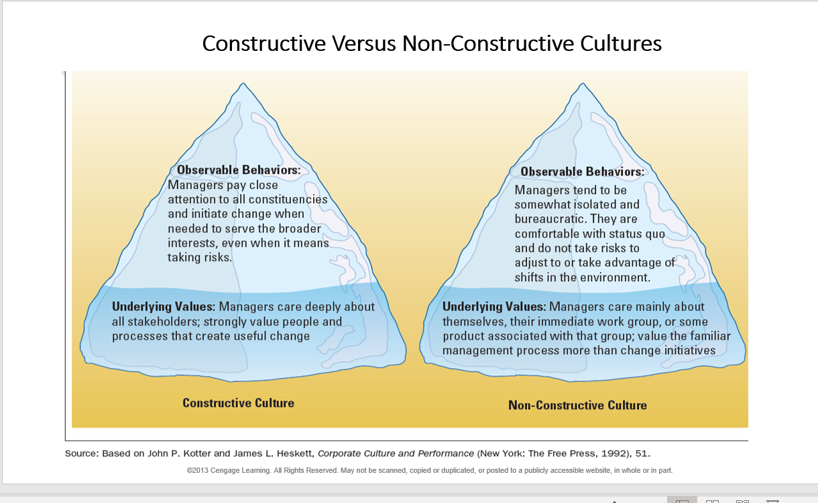

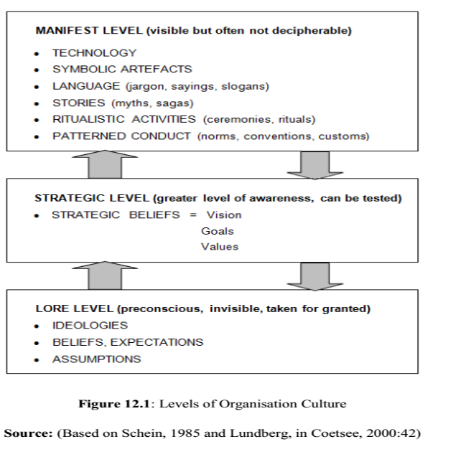

 Organizational culture contains behaviors and values which is contributing to the unique psychological and social environment of a business . The organizational culture impact the manner people interact, the context within which knowledge is created, the resistance they will have towards certain changes, and ultimately the way they share  knowledge. Organizational culture represents the collective values, beliefs and principles of organizational members. It may also be influenced by factors such as history, type of product, market, technology, strategy, type of employees, management style, and national culture. Culture includes the organization's vision, values, norms, systems, symbols, language, assumptions, environment, location, beliefs and habits.  

Ravasi and Schultz  characterise organizational culture as a set of shared assumptions that guide behaviors. It is also the pattern of such collective behaviors and assumptions that are taught to new organizational members as a way of perceiving and, even thinking and feeling. Thus organizational culture affects the way people and groups interact with each other, with clients, and with stakeholders. In addition, organizational culture may affect how much employees identify with an organization.

Schein, Deal and Kennedy, and Kotter  advanced the idea that organizations often have very differing cultures as well as subcultures. Although a company may have its "own unique culture," in larger organizations there are sometimes co-existing or conflicting subcultures because each subculture is linked to a different management team. Flamholtz and Randle  suggest that one can view organizational culture as "corporate personality."

They define it as it consisting of the values, beliefs, and norms which influence the behavior of people as members of an organization.

Origins

The term of culture in the organizational context was first introduced by Dr. Elliott Jaques in his book The Changing Culture of a Factory, in 1951. This is the published report of "a case study of developments in the social life of one industrial community between April, 1948 and November 1950". The "case" is a publicly held British company engaged principally in the manufacture, sale, and servicing of metal bearings. The study is concerned with the description, analysis, and development of the corporate group behaviours.

According to Dr. Elliott Jaques "the culture of the factory is its customary and traditional way of thinking and doing of things, which is shared to a greater or lesser degree by all its members, and which new members must learn, and at least partially accept, in order to be accepted into service in the firm..." Together they make an organizational culture or credo:

Fair and just treatment for everyone, including fair pay based upon equitable pay differentials for level of work and merit recognition related to personal effectiveness appraisal.

Leadership interaction between managers and subordinates, including shared context, personal effectiveness appraisal, feedback and recognition, and coaching.

Clear articulation of accountability and authority to engender trust and confidence in all working relationships.

Articulation of long-term organizational vision through direct communication from the top.

Opportunity for everyone individually or through representatives to participate in policy development.

Work for everyone at a level consistent with their level of potential capability, values and interests.

Opportunity for everyone to progress as his or her potential capability matures, within the opportunities available

The role of managerial leadership at every organizational level is to make these organizational values operationally real.

Usage

Organizational culture refers to culture in any type of organization including that of schools, universities, not-for-profit groups, government agencies, or business entities. In business, terms such as corporate culture and company culture are often used to refer to a similar concept. The term corporate culture became widely known in the business world in the late 1980s and early 1990s. Corporate culture was already used by managers, sociologists, and organizational theorists by the beginning of the 80s. The related idea of organizational climate emerged in the 1960s and 70s, and the terms are now somewhat overlapping.

If organizational culture is seen as something that characterizes an organization, it can be manipulated and altered depending on leadership and members. Culture as root metaphor sees the organization as its culture, created through communication and symbols, or competing metaphors. Culture is basic, with personal experience producing a variety of perspectives. Rosauer outlines the three manageable ingredients which  guide business culture:

# employee

# the work  waste

# the customer

Rosauer writes that the Three Bell Curves methodology aims to bring leadership, their employees, the work and the customer together for focus without distraction, leading to an improvement in culture and brand. He states: "If a methodology isn't memorable, it won't get used. The Three Bell Curves Methodology is simple  but execution requires strong leadership and diligence. Culture can be guided by managing the ingredients." Reliance of the research and findings of Sirota Survey Intelligence, which has been gathering employee data worldwide since 1972, the Lean Enterprise Institute, Cambridge, MA, and Fred Reichheld/Bain/Satmetrix research relating to NetPromoterScore.

Typology of cultural types

Typology refers to the "study of or analysis or classification based on types or categories." Organizational culture and climate may be erroneously used interchangeably. Organizational culture has been described as an organization's ideals, vision, and mission, whereas climate is better defined as employees' shared meaning related to the company's policies and procedures and reward/consequence systems. Many factors, ranging from depictions of relative strength to political and national issues, can contribute to the type or types of culture that can be observed in organizations and institutions of all sizes. Below are examples of organizational culture types.

Strong and weak typology of organizational culture

Flamholtz and Randle state that: "A strong culture is one that people clearly understand and can articulate. A weak culture is one that employees have difficulty defining, understanding, or explaining."

Strong culture is said to exist where staff respond to stimulus because of their alignment to organizational values. In such environments, strong cultures help firms operate like well-oiled machines, engaging in outstanding execution with only minor adjustments to existing procedures as needed.

Conversely, there is weak culture where there is little alignment with organizational values, and control must be exercised through extensive procedures and bureaucracy.

Research shows that organizations that foster strong cultures have clear values that give employees a reason to embrace the culture. A "strong" culture may be especially beneficial to firms operating in the service sector since members of these organizations are responsible for delivering the service and for evaluations important constituents make about firms. Organizations may derive the following benefits from developing strong and productive cultures:

Better aligning the company towards achieving its vision, mission, and goals

High employee motivation and loyalty

Increased team cohesiveness among the company's various departments and divisions

Promoting consistency and encouraging coordination and control within the company

Shaping employee behavior at work, enabling the organization to be more efficient

Irving Janis defined groupthink as "a mode of thinking that people engage in when they are deeply involved in a cohesive in-group, when the members' strivings for unanimity override their motivation to realistically appraise alternative courses of action." This is a state in which even if group members have different ideas, they do not challenge organizational thinking. As a result, innovative thinking is stifled. Groupthink can lead to lack of creativity and decisions made without critical evaluation. Groupthink can occur, for example, when group members rely heavily on a central charismatic figure in the organization or where there is an "evangelical" belief in the organization's values. Groupthink can also occur in groups characterized by a friendly climate conducive to conflict avoidance.

Healthy

Organizations should strive for what is considered a "healthy" organizational culture in order to increase productivity, growth, efficiency and reduce counterproductive behavior and turnover of employees. A variety of characteristics describe a healthy culture, including:

Acceptance and appreciation for diversity

Regard for fair treatment of each employee as well as respect for each employee's contribution to the company

Employee pride and enthusiasm for the organization and the work performed

Equal opportunity for each employee to realize their full potential within the company

Strong communication with all employees regarding policies and company issues

Strong company leaders with a strong sense of direction and purpose

Ability to compete in industry innovation and customer service, as well as price

Lower than average turnover rates

Investment in learning, training, and employee knowledge

Additionally, performance oriented cultures have been shown to possess statistically better financial growth. Such cultures possess high employee involvement, strong internal communications and an acceptance and encouragement of a healthy level of risk-taking in order to achieve innovation. Additionally, organizational cultures that explicitly emphasize factors related to the demands placed on them by industry technology and growth will be better performers in their industries.

According to Kotter and Heskett,

Another relevant concept is the notion of "cultural functionality". Specifically, some organizations have "functional" cultures while others have  "dysfunctional" cultures. A "functional" culture is a positive culture that contributes to an organization's performance and success. A "dysfunctional" culture is one that hampers or negatively affects an organization's performance and success.

Management types of communication

There are many different types of communication that contribute in creating an organizational culture:

Metaphors such as comparing an organization to a machine or a family reveal employees' shared meanings of experiences at the organization.

Stories can provide examples for employees of how to or not to act in certain situations.

Rites and ceremonies combine stories, metaphors, and symbols into one. Several different kinds of rites affect organizational culture:

Rites of passage: employees move into new roles

Rites of degradation: employees have power taken away from them

Rites of enhancement: public recognition for an employee's accomplishments

Rites of renewal: improve existing social structures

Rites of conflict reduction: resolve arguments between certain members or groups

Rites of integration: reawaken feelings of membership in the organization

Reflexive comments are explanations, justifications, and criticisms of our own actions. This includes:

Plans: comments about anticipated actions

Commentaries: comments about action in the present

Accounts: comments about an action or event that has already occurred

Fantasy Themes are common creative interpretations of events that reflect beliefs, values, and goals of the organization. They lead to rhetorical visions, or views of the organization and its environment held by organization members.

Bullying culture type

Bullying is seen to be prevalent in organizations where employees and managers feel that

they have the support, or at least implicitly the blessing, of senior managers to carry on their abusive

and bullying behaviour. Furthermore, new managers will quickly come to view this form of behaviour as

acceptable and normal if they see others get away with it and are even rewarded for it.

When bullying happens at the highest levels, the effects may be far reaching. That people may be bullied irrespective of their organisational status or rank, including senior managers, indicates the possibility of a negative ripple effect, where bullying may be cascaded downwards as the targeted supervisors might offload their own aggression on their subordinates. In such situations, a bullying scenario in the boardroom may actually threaten the productivity of the entire organisation.

Tribal type of culture

David Logan and coauthors have proposed in their book Tribal Leadership that organizational cultures change in stages, based on an analysis of human groups and tribal cultures. They identify five basic stages:

#Life sucks ;

#My life sucks ;

#I'm great ;

#We are great, but other groups suck  and

#Life is great .

This model of organizational culture provides a map and context for leading an organization through the five stages.

Personal culture

Organizational culture is taught to the person as culture is taught by his/her parents thus changing and modeling his/her personal culture. Indeed, employees and people applying for a job are advised to match their "personality to a company's culture" and fit to it. Some researchers even suggested and have made case studies research on personality changing.

National culture type

Corporate culture is used to control, coordinate, and integrate company subsidiaries. However differences in national cultures exist contributing to differences in the views on management. Differences between national cultures are deep rooted values of the respective cultures, and these cultural values can shape how people expect companies to be run, and how relationships between leaders and followers should be, resulting in differences between the employer and the employee regarding expectations.  Perhaps equally foundational; observing the vast differences in national copyright  laws suggests deep rooted differences in cultural attitudes and assumptions about property rights and sometimes about the desired root function, place, or purpose of corporations relative to the population.

Multiplicity

Xibao Zhang  carried out an empirical study of culture emergence in the Sino-Western international cross-cultural management  context in China. Field data were collected by interviewing Western expatriates and Chinese professionals working in this context, supplemented by non-participant observation and documentary data. The data were then analyzed objectively to formulate theme-based substantive theories and a formal theory.

The major finding of this study is that the human cognition contains three components, or three broad types of "cultural rules of behavior", namely, Values, Expectations, and Ad Hoc Rules, each of which has a mutually conditioning relationship with behavior. The three cognitive components are different in terms of the scope and duration of their mutual shaping of behavior. Values are universal and enduring rules of behavior; Expectations, on the other hand, are context-specific behavioral rules; while Ad Hoc Rules are improvised rules of behavior that the human mind devises contingent upon a particular occasion. Furthermore, they need not be consistent, and frequently are not, among themselves. Metaphorically, they can be compared to a multi-carriage train, which allows for the relative lateral movements by individual carriages so as to accommodate bumps and turns in the tracks. In fact, they provide a "shock-absorber mechanism", so to speak, which enables individuals in SW-ICCM contexts to cope with conflicts in cultural practices and values, and to accommodate and adapt themselves to cultural contexts where people from different national cultural backgrounds work together over extended time. It also provides a powerful framework which explains how interactions by individuals in SW-ICCM contexts give rise to emerging hybrid cultural practices characterized by both stability and change.

One major theoretical contribution of this "multi-carriage train" perspective is its allowance for the existence of inconsistencies among the three cognitive components in their mutual conditioning of behavior. This internal inconsistency view is in stark contrast to the traditional internal consistency assumption explicitly or tacitly held by many culture scholars. The other major theoretical contribution, which follows logically from the first one, is to view culture as an overarching entity which is made of a multiplicity of Values, Expectations, and Ad Hoc Rules. This notion of one  culture to an organization leads to the classification of culture along its path of emergence into nascent, adolescent, and mature types, each of which is distinct in terms of the pattern of the three cognitive components and behavior.

Effects

Research suggests that numerous outcomes have been associated either directly or indirectly with organizational culture.  A healthy and robust organizational culture may provide various benefits, including the following:

Competitive edge derived from innovation and customer service

Consistent, efficient employee performance

Team cohesiveness

High employee morale

Strong company alignment towards goal achievement

Although little empirical research exists to support the link between organizational culture and organizational performance, there is little doubt among experts that this relationship exists. Organizational culture can be a factor in the survival or failure of an organization – although this is difficult to prove given that the necessary longitudinal analyses are hardly feasible. The sustained superior performance of firms like IBM, Hewlett-Packard, Procter & Gamble, and McDonald's may be, at least partly, a reflection of their organizational cultures.

A 2003 Harvard Business School study reported that culture has a significant effect on an organization's long-term economic performance. The study examined the management practices at 160 organizations over ten years and found that culture can enhance performance or prove detrimental to performance. Organizations with strong performance-oriented cultures witnessed far better financial growth. Additionally, a 2002 Corporate Leadership Council study found that cultural traits such as risk taking, internal communications, and flexibility are some of the most important drivers of performance, and may affect individual performance. Furthermore, innovativeness, productivity through people, and the other cultural factors cited by Peters and Waterman  also have positive economic consequences.

Denison, Haaland, and Goelzer  found that culture contributes to the success of the organization, but not all dimensions contribute the same. It was found that the effects of these dimensions differ by global regions, which suggests that organizational culture is affected by national culture. Additionally, Clarke  found that a safety climate is related to an organization's safety record.

Organizational culture is reflected in the way people perform tasks, set objectives, and administer the necessary resources to achieve objectives. Culture affects the way individuals make decisions, feel, and act in response to the opportunities and threats affecting the organization.

Adkins and Caldwell  found that job satisfaction was positively associated with the degree to which employees fit into both the overall culture and subculture in which they worked.  A perceived mismatch of the organization's culture and what employees felt the culture should be is related to a number of negative consequences including lower job satisfaction, higher job strain, general stress, and turnover intent.

It has been proposed that organizational culture may affect the level of employee creativity, the strength of employee motivation, and the reporting of unethical behavior, but more research is needed to support these conclusions.

Organizational culture also affects recruitment and retention. Individuals tend to be attracted to and remain engaged in organizations that they perceive to be compatible. Additionally, high turnover may be a mediating factor in the relationship between culture and organizational performance. Deteriorating company performance and an unhealthy work environment are signs of an overdue cultural assessment.

Change

When a company is not possessing a healthy culture or needs other type organizational culture change, changing process maybe daunting. Organizational culture may slow down change efforts, particularly where workers know their roles and expectations which they must play in a company. It is corroborated by Mar??  who suggests that seventy percent of all change efforts are failing reason being the culture of an compnay's employees. 1 important reason this type of change is complex is that the organizational structures and organizational cultures where they are embedded, are frequently reflecting the "imprint" of previous periods in a persistent manner and show remarkable inertia levels . Change of culture can be essential to offer better customer service, rescale the organization, refocus the company goals, make improvements to the organization, affect employee behavior, lower employee turnover, and/or accomplish certain organization’s results and goals . Change of culture is impacted by many elements, involving the company’s management and history, the nature and size of the workforce, technology changes, change in industry standards, the industry competitors and external environment.

and.

There are a number of methodologies specifically dedicated to organizational culture change such as Peter Senge's Fifth Discipline. There are also a variety of psychological approaches that have been developed into a system for specific outcomes such as the Fifth Discipline's "learning organization" or Directive Communication's "corporate culture evolution." Ideas and strategies, on the other hand, seem to vary according to particular influences that affect culture.

Burman and Evans  argue that it is 'leadership' that affects culture rather than 'management', and describe the difference. When one wants to change an aspect of the culture of an organization one has to keep in consideration that this is a long-term project. Corporate culture is something that is very hard to change and employees need time to get used to the new way of organizing. For companies with a very strong and specific culture it will be even harder to change.

Prior to a cultural change initiative, a needs assessment is needed to identify and understand the current organizational culture. This can be done through employee surveys, interviews, focus groups, observation, customer surveys where appropriate, and other internal research, to further identify areas that require change. The company must then assess and clearly identify the new, desired culture, and then design a change process.

Cummings & Worley  give the following six guidelines for cultural change, these changes are in line with the eight distinct stages mentioned by Kotter :

# Formulate a clear strategic vision . In order to make a cultural change effective a clear vision of the firm's new strategy, shared values and behaviors is needed. This vision provides the intention and direction for the culture change .

# Display top-management commitment . It is very important to keep in mind that culture change must be managed from the top of the organization, as willingness to change of the senior management is an important indicator . The top of the organization should be very much in favor of the change in order to actually implement the change in the rest of the organization. De Caluwé & Vermaak  provide a framework with five different ways of thinking about change.

# Model culture change at the highest level . In order to show that the management team is in favor of the change, the change has to be notable at first at this level. The behavior of the management needs to symbolize the kinds of values and behaviors that should be realized in the rest of the company. It is important that the management shows the strengths of the current culture as well; it must be made clear that the current organizational culture does not need radical changes, but just a few adjustments.  underlying assumptions), which undermines attempts to categorize and define organizational culture.

Research and models

Several methods have been used to classify organizational culture. While there is no single "type" of organizational culture and organizational cultures vary widely from one organization to the next, commonalities do exist and some researchers have developed models to describe different indicators of organizational cultures. Some are described below:

Hofstede

Hofstede  looked for differences between over 160 000 IBM employees in 50 different countries and three regions of the world, in an attempt to find aspects of culture that might influence business behavior. He suggested things about cultural differences existing in regions and nations, and the importance of international awareness and multiculturalism for their own cultural introspection. Cultural differences reflect differences in thinking and social action, and even in "mental programs", a term Hofstede uses for predictable behavior. Hofstede relates culture to ethnic and regional groups, but also organizations, professional, family, social and subcultural groups, national political systems and legislation, etc.

Hofstede suggests the need for changing "mental programs" with changing behavior first, which will lead to value change. Though certain groups like Jews and Gypsies have maintained their identity through centuries, their values show adaptation to the dominant cultural environment.

Hofstede demonstrated that there are national and regional cultural groupings that affect the behavior of organizations and identified four dimensions of culture  in his study of national cultures:

Power distance  – Different societies find different solutions regarding social inequality. Although invisible, inside organizations power inequality of the "boss-subordinate relationships" is functional and according to Hofstede reflects the way inequality is addressed in the society. "According to Mulder's Power Distance Reduction theory subordinates will try to reduce the power distance between themselves and their bosses and bosses will try to maintain or enlarge it", but there is also a degree to which a society expects there to be differences in the levels of power. A high score suggests that there is an expectation that some individuals wield larger amounts of power than others. A low score reflects the view that all people should have equal rights.

Uncertainty avoidance is the way of coping with uncertainty about the future. Society copes with it with technology, law and religion, and according to Hofstede organizations deal with it with technology, law and rituals, or in two ways – rational and non-rational, with rituals being the non-rational. Hofstede listed some of the rituals as the memos and reports, some parts of the accounting system, a large part of the planning and control systems, and the nomination of experts.

Individualism vs. collectivism – disharmony of interests on personal and collective goals . Hofstede raises the idea that society's expectations of Individualism/Collectivism will be reflected by the employee inside the organization. Collectivist societies will have more emotional dependence on members in their organizations; when in equilibrium an organization is expected to show responsibility to members. Extreme individualism is seen in the US. In fact, collectivism in the US is seen as "bad". Other cultures and societies than the US will therefore seek to resolve social and organizational problems in ways different from American ways. Hofstede says that a capitalist market economy fosters individualism and competition, and depends on it, but individualism is also related to the development of the middle class. Some people and cultures might have both high individualism and high collectivism. For example, someone who highly values duty to his or her group does not necessarily give a low priority to personal freedom and self-sufficiency.

Masculinity vs. femininity – reflects whether a certain society is predominantly male or female in terms of cultural values, gender roles and power relations.

Long- Versus Short-Term Orientation

These dimensions refer to the effect of national cultures on management, and can be used to adapt policies to local needs.

In a follow up study, another model This is done through an instrument like Organizational Culture Profile  to measure employee commitment.

# Work-hard, play-hard culture: This has rapid feedback/reward and low risk resulting in: Stress coming from quantity of work rather than uncertainty. High-speed action leading to high-speed recreation. Examples: Restaurants, software companies.

# Power culture: concentrates power among a small group or a central figure and its control is radiating from its center like a web. Power cultures need only a few rules and little bureaucracy but swift in decisions can ensue.

# Role culture: authorities are delegated as such within a highly defined structure. These organizations form hierarchical bureaucracies, where power derives from the personal position and rarely from an expert power. Control is made by procedures, strict roles descriptions and authority definitions. These organizations have consistent systems and are very predictable. This culture is often represented by a "Roman Building" having pillars. These pillars represent the functional departments.

# Task culture: teams are formed to solve particular problems. Power is derived from the team with the expertise to execute against a task. This culture uses a small team approach, where people are highly skilled and specialized in their own area of expertise. Additionally, these cultures often feature the multiple reporting lines seen in a matrix structure.

# Person culture: formed where all individuals believe themselves superior to the organization. It can become difficult for such organizations to continue to operate, since the concept of an organization suggests that a group of like-minded individuals pursue organizational goals. However some professional partnerships operate well as person cultures, because each partner brings a particular expertise and clientele to the firm.

Kim Cameron and Robert Quinn

Kim Cameron and Robert Quinn  conducted research on organizational effectiveness and success. Based on the Competing Values Framework, they developed the Organizational Culture Assessment Instrument that distinguishes four culture types.

Competing values produce polarities like flexibility vs. stability and internal vs. external focus – these two polarities were found to be most important in defining organizational success. The polarities construct a quadrant with four types of culture:

Clan culture  – A friendly workplace where leaders act like father figures.

Adhocracy culture  – A dynamic workplace with leaders that stimulate innovation.

Market culture  – A competitive workplace with leaders like hard drivers

Hierarchy culture  – A structured and formalized workplace where leaders act like coordinators.

Cameron and Quinn designated six characteristics of organizational culture that can be assessed with the Organizational Culture Assessment Instrument .

Clan cultures are most strongly associated with positive employee attitudes and product and service quality. Market cultures are most strongly related with innovation and financial effectiveness criteria. The primary belief in market cultures that clear goals and contingent rewards motivate employees to aggressively perform and meet stakeholders' expectations; a core belief in clan cultures is that the organization's trust in and commitment to employees facilitates open communication and employee involvement. These differing results suggest that it is important for executive leaders to consider the match between strategic initiatives and organizational culture when determining how to embed a culture that produces competitive advantage. By assessing the current organizational culture as well as the preferred situation, the gap and direction to change can be made visible as a first step to changing organizational culture.

Robert A. Cooke

Robert A. Cooke defines culture as the behaviors that members believe are required to fit in and meet expectations within their organization. The Organizational Culture Inventory measures twelve behavioral norms that are grouped into three general types of cultures:

Constructive cultures, in which members are encouraged to interact with people and approach tasks in ways that help them meet their higher-order satisfaction needs.

Passive/defensive cultures, in which members believe they must interact with people in ways that will not threaten their own security.

Aggressive/defensive cultures, in which members are expected to approach tasks in forceful ways to protect their status and security.

Constructive cultures

In constructive cultures, people are encouraged to be in communication with their co-workers, and work as teams, rather than only as individuals. In positions where people do a complex job, rather than something simple like a mechanical task, this culture is efficient.

# Achievement: completing a task successfully, typically by effort, courage, or skill   – Based on the need to attain high-quality results on challenging projects, the belief that outcomes are linked to one's effort rather than chance and the tendency to personally set challenging yet realistic goals. People high in this style think ahead and plan, explore alternatives before acting and learn from their mistakes.

# Self-actualizing: realization or fulfillment of one's talents and potentialities – considered as a drive or need present in everyone   – Based on needs for personal growth, self-fulfillment and the realization of one's potential. People with this style demonstrate a strong desire to learn and experience things, creative yet realistic thinking and a balanced concern for people and tasks.

# Humanistic-encouraging: help others to grow and develop  – Reflects an interest in the growth and development of people, a high positive regard for them and sensitivity to their needs. People high in this style devote energy to coaching and counselling others, are thoughtful and considerate and provide people with support and encouragement.

# Affiliative: treat people as more valuable than things  – Reflects an interest in developing and sustaining pleasant relationships. People high in this style share their thoughts and feelings, are friendly and cooperative and make others feel a part of things.

Organizations with constructive cultures encourage members to work to their full potential, resulting in high levels of motivation, satisfaction, teamwork, service quality, and sales growth. Constructive norms are evident in environments where quality is valued over quantity, creativity is valued over conformity, cooperation is believed to lead to better results than competition, and effectiveness is judged at the system level rather than the component level. These types of cultural norms are consistent with  the objectives behind empowerment, total quality management, transformational leadership, continuous improvement, re-engineering, and learning organizations.

Passive/defensive cultures

Norms that reflect expectations for members to interact with people in ways that will not threaten their own security are in the Passive/Defensive Cluster.

The four Passive/Defensive cultural norms are:

Approval

Conventional

Dependent

Avoidance

In organizations with Passive/Defensive cultures, members feel pressured to think and behave in ways that are inconsistent with the way they believe they should in order to be effective. People are expected to please others  and avoid interpersonal conflict. Rules, procedures, and orders are more important than personal beliefs, ideas, and judgment. Passive/Defensive cultures experience a lot of unresolved conflict and turnover, and organizational members report lower levels of motivation and satisfaction.

Aggressive/defensive cultures

This style is characterized with more emphasis on task than people. Because of the very nature of this style, people tend to focus on their own individual needs at the expense of the success of the group. The aggressive/defensive style is very stressful, and people using this style tend to make decisions based on status as opposed to expertise.

# Oppositional – This cultural norm is based on the idea that a need for security that takes the form of being very critical and cynical at times. People who use this style are more likely to question others work; however, asking those tough question often leads to a better product. Nonetheless, those who use this style may be overly-critical toward others, using irrelevant or trivial flaws to put others down.

# Power – This cultural norm is based on the idea that there is a need for prestige and influence. Those who use this style often equate their own self-worth with controlling others. Those who use this style have a tendency to dictate others opposing to guiding others' actions.

# Competitive – This cultural norm is based on the idea of a need to protect one's status. Those who use this style protect their own status by comparing themselves to other individuals and outperforming them. Those who use this style are seekers of appraisal and recognition from others.

# Perfectionistic – This cultural norm is based on the need to attain flawless results. Those who often use this style equate their self-worth with the attainment of extremely high standards. Those who often use this style are always focused on details and place excessive demands on themselves and others.

Organizations with aggressive/defensive cultures encourage or require members to appear competent, controlled, and superior. Members who seek assistance, admit shortcomings, or concede their position are viewed as incompetent or weak. These organizations emphasize finding errors, weeding out "mistakes" and encouraging members to compete against each other rather than competitors. The short-term gains associated with these strategies are often at the expense of long-term growth.

In a study by Harvard researchers on units of the US intelligence system, a giver culture turned out to be the strongest predictor of group effectiveness.

Eric Flamholtz

Eric Flamholtz  has identified and validated a model of organizational culture components that drive financial results . The model consist of five identified dimensions of corporate culture: 1) treatment of customers, 2) treatment of people, 3) performance standards and accountability, 4) innovation and change, and 5) process orientation. These five dimensions have been confirmed by factor analysis  in addition, Flamholtz has published empirical research that show the impact of organizational culture on financial performance . Flamholtz has also proposed that organizational  culture is not just an asset in the economic sense; but is also an "asset" in the conventional accounting sense . Flamholtz and Randle have also examined the evolution of organizational culture at different stages of organizational growth .

Ethical frameworks and evaluations of corporate culture

Four organizational cultures can be classified as apathetic, caring, exacting, and integrative.

An apathetic culture shows minimal concern for either people or performance.

A caring culture exhibits high concern for people but minimal concern for performance issues.

An exacting culture shows little concern for people but a high concern for performance.

An integrative culture combines a high concern for people and performance.

A cultural audit is an assessment of an organization's values.

See also

References

Notes

Burman, R. and Evans, A.J.  "", Defence Aviation Safety Centre Journal, pp. 22–27.

Cameron, Kim S. & Quinn, Robert E., Diagnosing and Changing Organizational Culture: Based on the Competing Values Framework, Prentice Hall,, reprinted

Cummings, Thomas G. & Worley, Christopher G., Organization Development and Change, 8th Ed., South-Western College Pub.

Denison, Daniel R.  Corporate culture and organizational effectiveness, Wiley.

Denison, Daniel R., Haaland, S. and Goelzer, P.  "Corporate Culture and Organizational Effectiveness: Is Asia Different from the Rest of the World?" Organizational Dynamics, pp. 98–1 09

Flamholtz, Eric, ". "Corporate Culture and the Bottom Line’" European Management Journal, 19, 268-275.

Flamholtz, Eric,"La Cultura empresarial y La cuenta des resultos. Harvard Deusto Business Review, mar./Apr. 2002, 62–69.

Flamholtz, E.G. and Narasimhan-Kannan, Rangapriya . "Differential Impact of Culture upon Financial Performance: An Empirical investigation," European Management Journal, 23, pp. 50–64.

Flamholtz, Eric. "Conceptualizing and Measuring Human Capital of the Third Kind: Corporate Culture," Journal of Human Resource Costing & Accounting, 9  pp. 78–93.

Flamholtz, Eric G and Randle, Yvonne, "Corporate Culture: The Ultimate Strategic Advantage," Stanford University Press, Stanford California, pp. 5–6 and 26–27.

Flamholtz, Eric and Randle Yvonne,. "Implications of organizational Life Cycles for Corporate Culture and Climate," Chapter 13 in B. Schneider and K. Barbera, The oxford Handbook of organizational Climate and Culture, Oxford Library of psychology, Oxford university press, 2014, pp. 235–265.

Handy, Charles B., Oxford University Press

Harrison, Roger  Understanding your organisation's character, Harvard Business Review

Hofstede, Geert, Beverly Hills, CA, Sage Publications, reprinted 1984

Hofstede, Geert, ., McGraw-Hill Professional

McGuire, Stephen J.J. . "Entrepreneurial Organizational Culture: Construct Definition and Instrument Development and Validation, Ph.D. Dissertation", The George Washington University, Washington, DC.

Mulder, Mauk  The daily power game, Martinus Nijhoff Socìal Sciences Division

Parker, M.  Organizational Culture and Identity, London: Sage.

Parsons, Talcott, Shils, Edward, Toward a General Theory of Action, reprinted as Parsons, Talcott, Shils, Tolman, Stouffer and Kluckhohn et al.,, Transaction Publishers, 2001

Peters and Waterman . In Search of Excellence. Harper & Row .

Stoykov, Lubomir . Фирмената култура и комуникация, Stopanstvo, Sofia.

Zhang, Xibao . Values, Expectations, Ad Hoc Rules, and Culture Emergence in International Cross Cultural Management Contexts. New York: Nova Science Publishers.

Further reading

Black, Richard J.  Organizational Culture: Creating the Influence Needed for Strategic Success, London UK,

Boddy, C. R.  Corporate Psychopaths: Organizational Destroyers, Palgrave Macmillan

Hartnell, C. A., Ou, A. Y., & Kinicki, A. . "Organizational Culture and Organizational Effectiveness: A Meta-Analytic Investigation of the Competing Values Framework's Theoretical Suppositions." Journal of Applied Psychology .

Jex, Steven M. Jex & Britt, Thomas W.  Organizational Psychology, A Scientist-Practitioner Approach, John Wiley & Sons, .

Kleinbaum, Rob and Aviva . Creating a Culture of Profitability, Probabilistic Publishing, .

O'Donovan, Gabrielle . The Corporate Culture Handbook: How to Plan, Implement and Measure a Successful Culture Change Programme, The Liffey Press,

Papa, Michael J., et al. . Organizational Communication Perspectives and Trends . Sage Publications.

Phegan, B.  Developing Your Company Culture, A Handbook for Leaders and Managers, Context Press,

Sopow, E. . Corporate personality disorder. Lincoln Neb.: iUniverse.

Luthans, F. & Doh Jonathan, P. . "International Management, Culture, Strategy and Behavior" . Mc Graw Hill

External links

– From the Education Resources Information Center Clearinghouse on Higher Education Washington, DC.

Corporate executives discussing the importance of building a healthy, effective organizational culture

Bibliography:

Wikipedia

@baygross

**QUESTION THREE [20]**

“Corporate social responsibility is a hard-edged business decision. Not because it is a nice thing to do or because people are forcing us to do it…. Because it is good for our business”

**(Niall Fitzgerald – Deputy Chairman of Thomson Reuters and former CEO of Unilever)**

With reference to the above, critically discuss the business case for corporate social responsibility (CSR) and environmentally sustainable business practices.

<https://www.youtube.com/watch?v=vs7gmuE4um0>

CSR is a kind of international private business self-regulation meanwhile when it was practicable to define describe corporate social responsibility as a corporate ethic strategy or internal organizational policy or, that time is gone as different international laws were created and different organizations have utilized their authority to drive it beyond industry-wide or even individual even initiatives. Meanwhile it was taken into consideration as a part of corporate self-regulation for a while, over the past ten years or so it moved greatly from decisions of voluntary at a individual organizations level , to mandatory schemes at international, national ,and regional levels.????

Considered at the organizational level, corporate social responsibility is normally perceived as a policy of private firm. [Essentially](https://www.bing.com/search?q=define+essentially&FORM=DCTRQY), it should be integrated into and align with a business model to be successful. With other models, a company’s implementation of corporate social responsibility is going beyond agreement with requirements that are regulatory and it is engaging in "actions that come into sight to further other social good, beyond the firm’s interests and which is required by law". The choices of 'going beyond', failing to comply, and 'complying' with the law, are 3 distinct strategic choices of an organization. Meanwhile in some areas like labor or environmental regulations, workers might decide to comply with the law, or move beyond the law, some companies can decide to flout the law. Such companies take on plain legal risks. The nature of the legal risk, nevertheless, is changing if awareness is focusing on soft law. Soft law can cause legal liability especially if businesses is making claims that are misleading regarding some practices, ethical credentials or their sustainability

. Generally, businesses can decide to engage in corporate social responsibility for ethical or strategic purposes. From a strategic point of view , the objective is increasing shareholder trust and long-term profits via high ethical standards and positive public relations to lower legal and business risk by taking accountability for actions of the corporate. Strategies of corporate social responsibility motivate the organization to create a positive impact on the stakeholders and environment which include communities, investors, employees, consumers and others. From an ethical point of view, other businesses can accept corporate social responsibility practices an policies because of senior management ethical beliefs . For e.g., a Chief Executive Officer can believe that a harm which caused to the environment is ethically objectionable.

Proponents suggest that companies are increasing long-term profits by operating with a perspective of corporate social responsibility, meanwhile critics suggest that corporate social responsibility is distracting from businesses' economic role. A research done in two thousand compared current econometric studies of the relationship among financial and social performance, deciding that the contradictory outcome of past researches reporting neutral, negative, and positive financial effect, were caused by flawed empirical analysis and suggested when the research is specified properly,??? Corporate social responsibility is having a neutral effect on financial outcomes. Critics were questioning "unrealistic expectations" and other times the "lofty" in Corporate social responsibility or that Corporate social responsibility is just a an attempt, or window-dressing to pre-empt the governments role to monitor powerful multinational corporations. Together with such critical point of view, sociological and political institutionalists decided to be interested in corporate social responsibility in the context of theories of capitalism, neoliberalism, and globalization. Other institutionalists looked at corporate social responsibility as a capitalist legitimacy form and specifically point out what started as a social movement [versus](https://www.bing.com/search?q=define+versus&FORM=DCTRQY) [unrestrained](https://www.bing.com/search?q=define+unrestrained&FORM=DCTRQY) corporate power was changed by companies into a "risk management" and a "business model" device, frequently with questionable outcome.

Corporate social responsibility is titled to support a company’s mission and also serving as a guide to what the organization is representing for its clients. Business ethics is the applied ethics part which is examining ethical , moral problems or ethical principles which may arise in an environment of the business. ISO 26000 is the acknowledged international standard for Corporate social responsibility. Public sector companies stick to triple bottom line . It is broadly believed that corporate social responsibility sticks to the same principles, yet with no act of legislation which is formal.

Terminology

Corporate social responsibility is also called responsible business, conscious capitalism, corporate citizenship, corporate conscience, corporate sustainability, or sustainable business.

Since the nineteen sixties , CSR drew awareness from a group of stakeholders and businesses . A broad selection of definitions were created yet with little consensus. Part of the issue with definitions has increased because of different interests that were represented. A government official can view it as voluntary regulation, an NGO activist may see it as 'greenwash' , while a business person can define corporate social responsibility as a business strategy.

.

" Additionally, disagreement regarding definition can arise from the disciplinary approach."

CSR is defined by Sheehy as "international private business self-regulation." Meanwhile Carroll did not define corporate social responsibility, yet easily arguing for classification of activities, Sheehy created a definition different after the science philosophy the philosophy branch of utilized it for defining phenomena.

Carroll decided to extend CSR from the legal responsibility and traditional economic to philanthropic and ethical responsibility to respond to the growing worries on ethical issues in businesses, is sharing a belief which states that marketing local products can obtain consumer trust. Nevertheless, environmental efforts received negative perspectives with a belief that it will have an impact on client’s service. Oppewal et al??.  discovered that not all activities of corporate social responsibility are attracting consumers. They suggested that retailers are concentrating on 1 activity. Becker-Olsen???  discovered that when social initiative are made by the organization, it is not positioned with some organization goals it can result in a negative impact. Additionally Mohr et al.  and Groza et al.??   emphasize the significance of reaching the consumer.

Other commentators identified a difference among the Anglo-Saxon, the Continental European

And the Canadian approaches to corporate social responsibility. It is said that in in South Africa it is making a positive contribution to social needs like education and health care; for Germans it offers secure employment; and for Chinese consumers, a socially responsible company is making high-quality, safe products.

---------------

. Even within Europe, the discussion about CSR is very heterogeneous.

A more common approach to CSR is corporate philanthropy. This includes monetary donations and aid given to nonprofit organizations and communities. Donations are made in areas such as the arts, education, housing, health, social welfare and the environment, among others, but excluding political contributions and commercial event sponsorship.

Another approach to CSR is to incorporate the CSR strategy directly into operations, such as procurement of Fair Trade tea and coffee.

Creating shared value or CSV is based on the idea that corporate success and social welfare are interdependent. A business needs a healthy, educated workforce, sustainable resources and adept government to compete effectively. For society to thrive, profitable and competitive businesses must be developed and supported to create income, wealth, tax revenues and philanthropy. The Harvard Business Review article "Strategy & Society: The Link between Competitive Advantage and Corporate Social Responsibility" provided examples of companies that have developed deep linkages between their business strategies and CSR. CSV acknowledges trade-offs between short-term profitability and social or environmental goals, but emphasizes the opportunities for competitive advantage from building a social value proposition into corporate strategy. CSV gives the impression that only two stakeholders are important – shareholders and consumers.

Many companies employ benchmarking to assess their CSR policy, implementation and effectiveness. Benchmarking involves reviewing competitor initiatives, as well as measuring and evaluating the impact that those policies have on society and the environment, and how others perceive competitor CSR strategy.

Cost-benefit analysis

In competitive markets cost-benefit analysis of CSR initiatives can be examined using a resource-based view . According to Barney, "formulation of the RBV, sustainable competitive advantage requires that resources be valuable, rare, inimitable  and non-substitutable ." A firm introducing a CSR-based strategy might only sustain high returns on their investment if their CSR-based strategy could not be copied . However, should competitors imitate such a strategy, that might increase overall social benefits. Firms that choose CSR for strategic financial gain are also acting responsibly.

RBV presumes that firms are bundles of heterogeneous resources and capabilities that are imperfectly mobile across firms. This imperfect mobility can produce competitive advantages for firms that acquire immobile resources. McWilliams and Siegel  examined CSR activities and attributes as a differentiation strategy. They concluded that managers could determine the appropriate level of investment in CSR by conducting cost benefit analysis in the same way that they analyze other investments. Reinhardt  found that a firm engaging in a CSR-based strategy could only sustain an abnormal return if it could prevent competitors from imitating its strategy.

Moreover, when it comes to cost benefit analysis, one should look at Waddock and Graves, who showed that corporate social performance was positively linked to financial performance, meaning that the benefit of being socially responsible outweigh the costs. McWilliams and Siegel  noted that Waddock and Graves had not taken innovation into account, that companies that did CSR were also very innovative, and that the innovation drove financial performance, not CSR. Hull and Rothenberg  then found that when companies are not innovative, a history of CSR does in fact help financial performance.

Scope

Initially, CSR emphasized the official behaviour of individual firms. Later, it expanded to include supplier behaviour and the uses to which products were put and how they were disposed of after they lost value.

Supply chain

In the twenty first century, CSR in the supply chain attracted awareness from stakeholders and businesses. Company’s supply chain is a process where different companies including logistics providers , customers and suppliers are working together to offer a value services and package of products to the end user, which is the client.

Corporate social irresponsibility within the supply chain has significantly impacted the companies reputation , which leads to more cost in solving issues. For example , incidents such as the twenty thirteen Savar building collapse, that killed more than one thousand individuals, has pushed organizations to take into consideration the effects of their operations on the environment and society . Simultaneously, the twenty thirteen scandal of horse meat in the UK had an impact on many food retailers, involving Tesco, which is the biggest retailer in the UK, which lead to dismissal of the supplier. CSR from both the retailers and the suppliers had a huge impact on the stakeholders that lost trust for affected business entities, and besides a fact that other times this is not directly tackled by the organizations, they are becoming responsible to their stakeholders. Such surrounding problems are prompting supply chain management to take into consideration the CSR accountability context. Wieland and Handfield ???? state that organizations that require to involve social responsibility in their reviews of component quality. They emphasized the utilization of technology to improve visibility allover the supply chain.

Corporate social initiatives

Corporate social responsibility involves 6 kinds of corporate social initiatives:

Organizations are not having a profit motive if they take part in in community volunteering and corporate philanthropy. Simultaneously, the corporate social initiatives that are not yet used may be e.g. of cause marketing, where there is both a profit motive and societal interest.

Implementation

Corporate social responsibility can be a separate unit reporting to the board of directors or the CEO, can be based within the public relations departments or business development of a company, or human resources.

Engagement plan

An engagement plan may help in reaching intended audience. A CSR team or individual plans the objectives and goals of the company. Like any other company’s activity, a defined budget is demonstrating scales and commitment of program's relative importance.

Accounting, auditing and reporting

Social accounting is a communication of environmental and social impact of an organization’s economic actions to specific interest groups to society at large and in the society.

Social accounting is emphasizing notion of corporate responsibility . Crowther?? Describe social accounting as "an approach of reporting company’s activities that stresses the requirement to pinpoint socially relevant behavior, the establishment of those to whom the organization is responsible for the development of suitable reporting techniques and measures, and its social performance . "

Reporting standards and guidelines are serving frameworks for social reporting, auditing and

accounting:?????????/

AccountAbility's AA1000 standard, based on John Elkington's triple bottom line  reporting

The Prince's Accounting for Sustainability Project's Connected Reporting Framework

The Fair Labor Association conducts audits based on its Workplace Code of Conduct and posts audit results on the FLA website.

The Fair Wear Foundation verifies labour conditions in companies' supply chains, using interdisciplinary auditing teams.

Global Reporting Initiative's Sustainability Reporting Guidelines

Economy for the Common Good's Common Good Balance Sheet

GoodCorporation's standard developed in association with the Institute of Business Ethics

Synergy Codethic 26000 Social Responsibility and Sustainability Commitment Management System  Requirements—Ethical Business Best Practices of Organizations—the necessary management system elements to obtain a certifiable ethical commitment management system. The standard scheme has been built around ISO 26000 and UNCTAD Guidance on Good Practices in Corporate Governance. The standard is applicable by any type of organization.;

Earthcheck Certification / Standard

Social Accountability International's SA8000 standard

Standard Ethics Aei guidelines

The ISO 14000 environmental management standard

The United Nations Global Compact requires companies to communicate on their progress, and to describe the company's implementation of the Compact's ten universal principles.

The United Nations Intergovernmental Working Group of Experts on International Standards of Accounting and Reporting  provides voluntary technical guidance on eco-efficiency indicators, corporate responsibility reporting, and corporate governance disclosure.

The FTSE Group publishes the FTSE4Good Index, an evaluation of CSR performance of companies.

Ethical Quote is used to track reputation of the world's biggest organizations on Corporate Social Responsibility, Governance, Social, Environmental, sustainability and ethics.

The Islamic Reporting Initiative  is a not-for-profit organization which leads the creation of the IRI framework; the guiding integrated CSR reporting framework based on Islamic principles and values.

In nations such as France, legal requirements for social accounting, auditing and reporting exist, though international or national agreement on meaningful measurements of social and environmental performance has not been achieved. Many companies produce externally audited annual reports that cover Sustainable Development and CSR issues, but the reports vary widely in format, style, and evaluation methodology . Critics dismiss these reports as lip service, citing examples such as Enron's yearly "Corporate Responsibility Annual Report" and tobacco companies' social reports.

In South Africa, as of June 2010, all companies listed on the Johannesburg Stock Exchange  were required to produce an integrated report in place of an annual financial report and sustainability report. An integrated report reviews environmental, social and economic performance alongside financial performance. This requirement was implemented in the absence of formal or legal standards. An Integrated Reporting Committee  was established to issue guidelines for good practice.

One of the reputable institutions that capital markets turn to for credible sustainability reports is the Carbon Disclosure Project, or CDP.

Verification

CSR and its resulting efforts and reports must be verified by the buyer of goods and services. The reporting , auditing , accounting, resources offer the basis for consumers to verify that the products are socially sustainable. Because of an increased awareness of the requirement for corporate social responsibility, most industries created their own verification resources. They involve companies like Kimberly Process, International Cocoa Initiative, and Forest Stewardship Council. The UN Global Compact offers frameworks not just for verification, but as well as to report violations of human rights in corporate supply chains.

Ethics training    NBNBNBNBNB

The growth of ethics training within companies, part of it required by regulation of government, has assisted with the spreading Corporate social responsibility. The purpose of this training is to assist workers to make ethical decisions if the answers are not clear. The more direct advantage is lowering the possibility of damaged reputations, fines, and "dirty hands" for breaking moral norms or the laws . Companies get increased workers pride and loyalty in the company .

Common actions    NBNBNBNNB

Community involvement: it may involve to raise money for engaging in fair trade practices,

supporting local economic growth, employing local workers, sponsoring local events, providing volunteers, local charities, etc.

Common Corporate social responsibility actions involve:

Ethical marketing: Organizations which ethically market to buyers place more value on their clients and respect them as individuals who are ends in themselves. Organizations are not trying to falsely or manipulate advertise to potential buyers. It is essential for organizations which are trying to be viewed as ethical.

Environmental sustainability: this may include 'greener' supply chains, reusable materials, renewable energy, water management, waste management, recycling, supporting Environmental Design and Leadership in Energy building standards and lowering paper use.

Human capital enhancement: Organizations offer more resources for capacity building of local workers , involving language classes, adult basic education, professional and technical training.

Social license to operate

Social License to Operate can be determined as a contractual grounds for the legitimacy of activities and projects company is involved in. It refers to the level of support and approval of a company's activities by its stakeholders. Displaying commitment to CSR is one way to achieve social license, by enhancing a company's reputation.

As stated in Enduring value: the Australian minerals industry framework for sustainable development the concept of the 'social license to operate', then defined simply as obtaining and maintaining broad community support and acceptance. Unless a company earns and maintains that license social license holders may intend to block project developments; employees may leave the company for a company that is a better corporate citizen: and companies may be under ongoing legal challenge.

In research of Requisite Organization Dr Elliott Jaques defines Social License to Operate for the company as the social contract the company has with the social license holders  for them to manifest positive intention to support the business short- and long-term objectives by "providing managerial leadership that nurtures the social good and also gives the foundation for sustainable growth in organizational results."

The primary objective for the companies is to obtain and maintain the Social License to Operate. Based on the Requisite Organization research of Dr. Elliott Jaques to achieve this goal a company needs to:

Identify the business strategy and business objectives

Identify the social license holders  for every business objectives

Identify the support that the company desires to achieve from the social license holders by specifying for every business objective social license elements

Quantitatively measure the intention  of the social license holders to support the business objectives

Identify the factors that negatively impact the intention of the social license holders to support the business objectives

Develop the Social License Development Strategy to remove the negative factors and ensure positive intention of all the social license holders to support all the business objectives of the company.

Perform ongoing monitoring and quantitative measurement of changes in the Social License to Operate of the company

Potential business benefits

A large body of literature exhorts business to adopt non-financial measures of success . While CSR benefits are hard to quantify, Orlitzky, Schmidt and Rynes found a correlation between social/environmental performance and financial performance.

The business case for CSR within a company employs one or more of these arguments:

Triple bottom line

"People, planet and profit", also known as the triple bottom line, form one way to evaluate CSR.

"People" refers to fair labour practices, the community and region where the business operates.

"Planet" refers to sustainable environmental practices. Profit is the economic value created by the organization after deducting the cost of all inputs, including the cost of the capital .

Overall, trying to balance economic, ecological and social goals are at the heart of the triple bottom line.

This measure was claimed to help some companies be more conscious of their social and moral responsibilities. However, critics claim that it is selective and substitutes a company's perspective for that of the community. Another criticism is about the absence of a standard auditing procedure.

The term was coined by John Elkington in 1994. particularly within the competitive graduate student market. Potential recruits often consider a firm's CSR policy. CSR can also help improve the perception of a company among its staff, particularly when staff can become involved through payroll giving, fundraising activities or community volunteering. CSR has been credited with encouraging customer orientation among customer-facing employees.

CSR is known for impacting employee turnover. Several executives suggest that employees are their most valuable asset and that the ability to retain them leads to organization success. Socially responsible activities promote fairness, which in turn generate lower employee turnover. On the other hand, if an irresponsible behavior is demonstrated by a firm, employees may view this behavior as negative. Proponents argue that treating employees well with competitive pay and good benefits is seen as a socially responsible behavior and therefore reduces employee turnover. Executives have a strong desire for building a positive work context that benefits CSR and the company as a whole. This interest is driven particularly by the realization that a positive work environment can result in desirable outcomes such as more favorable job attitudes and increased work performance.

The IBM Institute for Business Value conducted a survey of 250 business leaders worldwide in 2008. The survey found out that businesses have assimilated a much more strategic view, and that 68% companies reported are utilizing CSR as an opportunity and part of a sustainable growth strategy. The authors noted that while developing and implementing a CSR strategy represents a unique opportunity to benefit the company. However, only 31% of businesses surveyed engaged their employees on the company's CSR objectives and initiatives. The survey's authors also stated that employee engagement on CSR initiatives can be a powerful recruitment and retention tool. As a result, employees tend to discard employers with a bad reputation.

Risk management

Managing risk is an important executive responsibility. Reputations that take decades to build up can be ruined in hours through corruption scandals or environmental accidents.

These draw unwanted attention from regulators, courts, governments and media. CSR can limit these risks.

Brand differentiation

CSR can help build customer loyalty based on distinctive ethical values. Some companies use their commitment to CSR as their primary positioning tool, e.g., The Co-operative Group, The Body Shop and American Apparel.

Some companies use CSR methodologies as a strategic tactic to gain public support for their presence in global markets, helping them sustain a competitive advantage by using their social contributions as another form of advertising.

Companies that operate strong CSR activities tend to drive customer's attention to buy products or services regardless of the price. As a result, this increases competition among firms since customers are aware of the company's CSR practices. These initiatives serve as a potential differentiator because they not only add value to the company, but also to the products or services. Furthermore, firms under intense competition are able to leverage CSR to increase the impact of their distribution on the firm's performance. Lowering the carbon footprint of a firm's distribution network or engaging in fair trade are potential differentiators to lower costs and increase profits. In this scenario, customers can observe the company's commitment to CSR while increasing company sales.

Whole Foods' marketing and promotion of organic foods have had a positive effect on the supermarket industry. Proponents assert that Whole Foods has been able to work with its suppliers to improve animal treatment and quality of meat offered in their stores. They also promote local agricultures in over 2,400 independent farms to maintain their line of sustainable organic produce. As a result, Whole Foods' high prices do not turn customers away from shopping. In fact, they are pleased buying organic products that come from sustainable practices.

According to a Harvard Business Review article, there are three theaters of practice in which CSR can be divided. Theater one focuses on philanthropy, which includes donations of money or equipment to non-profit organizations, engagement with communities' initiatives and employee volunteering. This is characterized as the "soul" of a company, expressing the social and environmental priorities of the founders. The authors assert that companies engage in CSR because they are an integral part of the society. The Coca-Cola Company contributes with $88.1 million annually to a variety of environmental educational and humanitarian organization. Another example is PNC Financial Services' "Grow Up Great" childhood education program. This program provides critical school readiness resources to underserved communities where PNC operates.

On the other hand, theater two focuses on improving operational effectiveness in the workplace. The researchers assert that programs in this theater strive to deliver social or environmental benefits to support a company's operation across the value chain by improving efficiency. Some of the examples mentioned include sustainability initiatives to reduce resource use, waste, and emission that could potentially reduce costs. It also calls for investing in employee work conditions such as health care and education which may enhance productivity and retention. Unlike philanthropic giving, which is evaluated by its social and environmental return, initiatives in the second theater are predicted to improve the corporate bottom line with social value. Bimbo, the largest bakery in Mexico, is an excellent example of this theater. The company strives to meet social welfare needs. It offers free educational service to help employees complete high school. Bimbo also provides supplementary medical care and financial assistance to close gaps in the government health coverage. Ang found that relationship building through providing additional services rather than price cutting is what businesses in Asia feel more comfortable with as a strategy during an economic crisis. Regarding direct research about strategies in cross-cultural crisis management, scholars found that CSR strategies could make effects through empirical case studies of involving multinational businesses in China. They found that meeting local stakeholders' social expectations can mitigate the risk of crises. The strategy utilized by Arla Foods works and has helped the company in regaining the most of its lost market share among many countries in the Middle East. Arla Foods founded a funding for children with cancer and they donated ambulances to refugees in Lebanon. As what Arla Foods did, they tried to contribute to solve social problems of children's access to health care which were local priorities. Other researchers analyzed the case of multinational enterprise strategies under the context of conflicts between Lebanon and Israel. During the conflict, many companies stressed seeking to help the local community. In the post-conflict stage, managers highlighted their philanthropic programs and contributions, in terms of monetary in-kind donations to the refugees or businesses that were directly affected. For example, Citibank has provided monetary assistance to some local businesses affected by the war. Another activity did by a Lebanon company was a fund-raising campaign.

Criticisms and concerns

CSR concerns include its relationship to the purpose of business and the motives for engaging in it.

Nature of business

Milton Friedman and others argued that a corporation's purpose is to maximize returns to its shareholders and that obeying the laws of the jurisdictions within which it operates constitutes socially responsible behavior.

While some CSR supporters claim that companies practicing CSR, especially in developing countries, are less likely to exploit workers and communities, critics claim that CSR itself imposes outside values on local communities with unpredictable outcomes.

Better governmental regulation and enforcement, rather than voluntary measures, are an alternative to CSR that moves decision-making and resource allocation from public to private bodies. However, critics claim that effective CSR must be voluntary as mandatory social responsibility programs regulated by the government interferes with people's own plans and preferences, distorts the allocation of resources, and increases the likelihood of irresponsible decisions.

Motives

Some critics believe that CSR programs are undertaken by companies to distract the public from ethical questions posed by their core operations. They argue that the reputational benefits that CSR companies receive  demonstrate the hypocrisy of the approach. Moreover, some studies find that CSR programs are motivated by corporate managers' personal interests at the cost of the shareholders so they are a type of an agency problem in corporations.

Others have argued that the primary purpose of CSR is to provide legitimacy to the power of businesses. As wealth inequality is perceived to be increasing it has become increasingly necessary for businesses to justify their position of power. Bakan is one of the most prominent critics of the conflict of interest between private profit and public good, and his argument is summarised by Haynes that "a corporate calculus exists in which costs are pushed onto both workers, consumers and the environment". CSR spending may be seen in these financial terms, whereby the higher costs of socially undesirable behaviour are offset by a CSR spending of a lower amount. Indeed, it has been argued that there is a "halo effect" in terms of CSR spending. Research has found that firms that had been convicted of bribery in the US under the Foreign Corrupt Practices Act  received more lenient fines if they had been seen to be actively engaging in comprehensive CSR practices. It was found that typically either a 20% increase in corporate giving or a commitment to eradicating a significant labour issue, such as child labour, was equated to a 40% lower fine in the case of bribing foreign officials.

Aguinis and Glavas conducted a comprehensive review of CSR literature, covering 700 academic sources from numerous fields including organizational behaviour, corporate strategy, marketing and HRM. It was found that the primary reason for firms to engage in CSR were the expected financial benefits associated with CSR, rather than being motivated a desire to be responsible to society.

Ethical ideologies

CEOs' political ideologies are evident manifestations of their different personal views. Each CEO may exercise different powers according to their organizational outcomes. In fact, their political ideologies are expected to influence their preferences for the CSR outcomes. Proponents argue that politically liberal CEOs will envision the practice of CSR as beneficial and desirable to increase a firm's reputation. They tend to focus more on how the firm can meet the needs of the society. As a consequence, they will advance with the practice of CSR while adding value to the firm. On the other hand, property rights may be more relevant to conservative CEOs. Since conservatives tend to value free markets, individualism and call for a respect of authority, they will not likely envision this practice as often as those identifying as liberals might.

The financials of the company and the practice of CSR also have a positive relationship. Moreover, the performance of a company tends to influence conservatives more likely than liberals. While not seeing it from the financial performance point of view, liberals tend to hold a view that CSR adds to the business triple bottom line. For instance, when the company is performing well, they will most likely promote CSR. If the company is not performing as expected, they will rather tend to emphasize this practice because they will potentially envision it as a way to add value to the business. In contrast, politically conservative CEOs will tend to support the practice of CSR if they hold a view that it will provide a good return to the financials of the company. In other words, this type of executives tend to not see the outcome of CSR as a value to the company if it does not provide anything in exchange. Sometimes companies use CSR to direct public attention away from other, harmful business practices. For example, McDonald's Corporation positioned its association with Ronald McDonald House and other children's charities as CSR while its meals have been accused of promoting poor eating habits.

Acts which may initially appear to be altruistic CSR may have ulterior motives. The funding of scientific research projects has been used as a source of misdirection by firms. Prusiner, who discovered the protein responsible of CJD and won the 1997 Nobel prize in Medicine, thanked the tobacco company RJ Reynolds for their crucial support. RJ Reynolds funded the research into CJD. Proctor states that "the tobacco industry was the leading funder of research into genetics, viruses, immunology, air pollution" anything which formed a distraction from the well-established research linking smoking and cancer.

Research has also found that corporate social marketing, a form of CSR promoting societal good, is being used to direct criticism away from the damaging practices of the alcohol industry. It has been shown that adverts which supposedly encourage responsible drinking simultaneously aim to promote drinking as a social norm. Companies may engage in CSR and social marketing in this case to prevent more stringent government legislation on alcohol marketing.

Controversial industries

Industries such as tobacco, alcohol or munitions firms make products that damage their consumers or the environment. Such firms may engage in the same philanthropic activities as those in other industries. This duality complicates assessments of such firms with respect to CSR.

Stakeholder influence

One motivation for corporations to adopt CSR is to satisfy stakeholders beyond those of a corporation's shareholders.

Branco and Rodrigues  describe the stakeholder perspective of CSR as the set of views of corporate responsibility held by all groups or constituents with a relationship to the firm. In their normative model, the company accepts these views as long as they do not hinder the organization. The stakeholder perspective fails to acknowledge the complexity of network interactions that can occur in cross-sector partnerships. It relegates communication to a maintenance function, similar to the exchange perspective.

Ethical consumerism

The rise in popularity of ethical consumerism over the last two decades can be linked to the rise of CSR. Consumers are becoming more aware of the environmental and social implications of their day-to-day consumption decisions and in some cases make purchasing decisions related to their environmental and ethical concerns.

One issue with the consumer's relationship with CSR is that it is much more complex than it first appears. In their paper on the consumer and CSR, Janssen and Vanhamme looked into a phenomenon that they termed the "CSR-Consumer Paradox". This describes the mismatch that occurs where consumers report that they would only buy from companies with good social responsibility. A survey by Cohn & Wolfe found that globally over 60% of consumers want to buy from responsible companies. However, Janssen and Vanhamme reported that less than 4% of average household expenditure in the UK in 2010 was ethical. This indicates that there is a clear discrepancy between consumer beliefs and intentions, and actual consumer behaviour, so that when it comes down to their actual purchase behaviour, CSR has a much lesser impact than consumers initially say it does.

One theory put forward for explaining the "CSR-Consumer Paradox" is that of "bystander apathy" or the bystander effect. This theory stems from the social psychology works of Darley and Latané and states that the likelihood of an individual acting in a given situation is greatly reduced if other bystanders do nothing even if that individual strongly believes in a certain course of action. In terms of explaining the CSR-Consumer Paradox, this theory would suggest an "If they do not care then why should I?" mentality. So even if a consumer is against the use of sweatshops or wants to support green causes, they may continue to make purchases from companies that are socially irresponsible just because other consumers seem apathetic towards the issue.

A second explanation issued by Janssen and Vanhamme is that of reciprocal altruism. This is a key concept in evolutionary psychology that is argued to fuel all human behaviour: people only do something if they can get something back in return. In the case of CSR and ethical consumerism, however, consumers get very little in return for their investment. Ethically sourced or manufactured products are typically higher in price due to greater costs. However, the reward for consumers is not much different from that of a non-ethical counterpart. Therefore, evolutionary speaking making an ethical purchase is not worth the higher cost to the individual even if they believe in supporting ethically, environmentally and socially beneficial causes.

Socially responsible investing

Shareholders and investors, through socially responsible investing, are using their capital to encourage behavior they consider responsible. However, definitions of what constitutes ethical behavior vary. For example, some religious investors in the US have withdrawn investment from companies that violate their religious views, while secular investors divest from companies that they see as imposing religious views on workers or customers.

Public policies    NBNBNBNB

Other national governments are promoting environmentally and socially accountable corporate practices. The heightened government roles in corporate social responsibility has facilitated the creation of many corporate social responsibility policies and programs. Different governments in Europe decided to push organizations to create sustainable corporate practices. Additionally Germany determined the German Trade Union Confederation in nineteen forty nine to [farther](https://www.bing.com/search?q=define+farther&FORM=DCTRQY) promote corporate social responsibility; the confederation is representing the interests of forty five million employees in Germany. Wage , job security are growing with the industry growth are important aspects of collective bargaining in the German labor system.????

There is a higher percentage of workers in unions in countries like Sweden and Iceland which have more Social-Democratic elements in their Nordic Model than the U.S. and the U.K.

The U.S. and the U.K are Liberal Market Economies  and the German economy falls under Collective Market Economy  which are Varieties of Capitalism. In comparison with the U.S. which covers 25.5% of its blue and white-collar workforce under collective bargaining and the U.K. that covers 29% of its workforce, Germany covers a significantly higher 57% of its workforce under collective bargaining. CSR efforts and policies are different among countries, responding to the complexity and diversity of governmental, corporate and societal roles. Some studies have claimed that the role and effectiveness of these actors were case-specific.

The 'Heilbronn Declaration' is a voluntary agreement of enterprises and institutions in Germany especially of the Heilbronn-Franconia region signed on 15 September 2012. The approach of the 'Heilbronn Declaration' targets the decisive factors of success or failure, the achievements of the implementation and best practices regarding CSR. A form of responsible entrepreneurship shall be initiated to meet the requirements of stakeholders' trust in economy. It is an approach to make voluntary commitments more binding.

In opposition to mandated CSR regulation, Researchers Armstrong & Green suggest that all regulation is "harmful", citing regulation as the cause for North Korea's low economic freedom and per capita GDP. They further claim without source that "There is no form of market failure, however egregious, which is not eventually made worse by the political interventions intended to fix it," and conclude "there is no need for further research on regulation in the name of social responsibility."

Laws

In the 1800s, the US government could take away a firm's license if it acted irresponsibly. Corporations were viewed as "creatures of the state" under the law. In 1819, the United States Supreme Court in Dartmouth College vs. Woodward established a corporation as a legal person in specific contexts. This ruling allowed corporations to be protected under the Constitution and prevented states from regulating firms. Recently countries included CSR policies in government agendas. The required information included:

CSR/SRI policies

How such policies are implemented in practice

Results and management expectations

CSR/SRI is voluntary in Denmark, but if a company has no policy on this it must state its positioning on CSR in financial reports.

In 1995, item S50K of the Income Tax Act of Mauritius mandated that companies registered in Mauritius paid 2% of their annual book profit to contribute to the social and environmental development of the country. In 2014, India also enacted a mandatory minimum CSR spending law. Under Companies Act, 2013, any company having a net worth of 500 crore or more or a turnover of 1,000 crore or a net profit of 5 crore must spend 2% of their net profits on CSR activities. The rules came into effect from 1 April 2014.

The only mandatory CSR law in the world thus far was passed by the Indian parliament in 2013 as Article 135 of the Companies Law. According to that bill, all firms with net worth above 5 billion rupees, turnover over 10 billion rupees, or net profit over 50 million rupees  are required to spend at least 2% of their annual profits . The law requires that all businesses affected establish a CSR committee to oversee the spending. Prior to this law's passage, CSR laws applied to public sector companies only.

Unlike global definitions of CSR which are in the triple bottom line, corporate citizenship, sustainable business, business responsibility and closed-loop realm, in India CSR is a philanthropic activity. What has changed since formalizing it in 2014 is the shift in focus from institution building  to focusing on community development.

Crises and their consequences

Crises have encouraged the adoption of CSR. The CERES principles were adopted following the 1989 Exxon Valdez incident. Other examples include the lead paint used by toy maker Mattel, which required the recall of millions of toys and caused the company to initiate new risk management and quality control processes. Magellan Metals was found responsible for lead contamination killing thousands of birds in Australia. The company ceased business immediately and had to work with independent regulatory bodies to execute a cleanup. Odwalla experienced a crisis with sales dropping 90% and its stock price dropping 34% due to cases of E. coli. The company recalled all apple or carrot juice products and introduced a new process called "flash pasteurization" as well as maintaining lines of communication constantly open with customers.

Geography

Corporations that employ CSR behaviors do not always behave consistently in all parts of the world. Conversely, a single behavior may not be considered ethical in all jurisdictions. E.g., some jurisdictions forbid women from driving, while others require women to be treated equally in employment decisions.

UK retail sector

A 2006 study found that the UK retail sector showed the greatest rate of CSR involvement. Many of the big retail companies in the UK joined the Ethical Trading Initiative, an association established to improve working conditions and worker health.

Tesco  reported that their 'essentials' are 'Trading responsibility', 'Reducing our Impact on the Environment', 'Being a Great Employer' and 'Supporting Local Communities'. J Sainsbury employs the headings 'Best for food and health', 'Sourcing with integrity', 'Respect for our environment', 'Making a difference to our community', and 'A great place to work', etc.

The four main issues to which UK retail these companies committed are environment, social welfare, ethical trading and becoming an attractive workplace.

Anselmsson and Johansson  assessed three areas of CSR performance: human responsibility, product responsibility and environmental responsibility. Martinuzzi et al. described the terms, writing that human responsibility is "the company deals with suppliers who adhere to principles of natural and good breeding and farming of animals, and also maintains fair and positive working conditions and work-place environments for their own employees. Product responsibility means that all products come with a full and complete list of content, that country of origin is stated, that the company will uphold its declarations of intent and assume liability for its products. Environmental responsibility means that a company is perceived to produce environmental-friendly, ecological, and non-harmful products". Jones et al.  found that environmental issues are the most commonly reported CSR programs among top retailers.

CSR and US corporations updates

An article published in Forbes.com last September 2017 mentioned the yearly study of Boston-based reputation management consulting company Reputation Institute  which rates the top 10 US corporations in terms of corporate social responsibility. RI monitors social responsibility reputations by focusing on perception of consumers regarding company governance, positive impact on the community and society, and treatment of the workforce. It rates each criterion with the firm's proprietary RepTrak Pulse platform. Forbes identified the companies as Lego, Microsoft, Google, Walt Disney Company, BMW Group, Intel, Robert Bosch, Cisco Systems, Rolls-Royce Aerospace, and Colgate-Palmolive. NBNBNBNBNBNB

According to the corporate social responsibility Journal, the generation of millennials across the globe assist propel brands toward social responsibility. Most millennials are trying to conduct business with trademarks and organizations which employ ethical business practices, sustainable manufacturing processes, and pro-social themes. Nielsen Holdings has published its Annual Global Corporate Sustainability Report in twenty seventeen focusing on sustainability and as well as global responsibility. Nielsen's 2015 report indicated that sixty six percent of buyers can spend more on products which come from brands that are sustainable. The other eighty one percent are expecting their preferred corporate institutions to [disclose](https://www.bing.com/search?q=define+disclose&FORM=DCTRQY) in public their statements regarding corporate citizenship?????

The National Association on the Advancement of Colored People  through its chief executive officer Derrick Johnson shared the organization's insights on how American corporations can help in the realization of social justice. According to the article from Yahoo News, the NAACP has been engaged in a crusade for racial justice and economic opportunities during the last 109 years. This organization believes all citizens in the United States must be held liable in ensuring democracy works for all people.

Texts

United Nations Guiding Principles on Business and Human Rights

OECD Guidelines for Multinational Enterprises

See also

References

Notes

Sources

Books

Journals and magazines

Web

External links

Bibliography:

Wikipedia

@baygross

///////////////////////////////////////

Dear Student

Listed below are assignment guidelines: Those specific to your assignment questions as well as general guidelines.

1. The assignment should not exceed 8000 words.

2. The assignment covers all areas of the syllabus, emphasising the need for students to integrate the knowledge across the various chapters in the module guide and the prescribed textbooks.

3. Students must focus on responding to the requirements of each question; this requires an analysis of each question in order to ascertain these requirements.

4. Students must present relevant information in their responses, correctly referenced, in a logical and coherent manner so that the question is answered.

5. Question 1 is a case study and students are reminded that the answers to case study questions are not necessarily found in the case study. The case study presents a scenario and the questions require that this scenario (or context) be considered.

**6. Question 1:**

6.1 Question 1.1 requires a SWOT analysis of a challenger bank and a traditional bank. These can be presented in a table. However, students must not use one word bullets in each of the quadrants.

6.2 In question 1.2 a justified response is required to the statement.

6.3 In question 1.3, begin by explaining what a business model is before presenting an evaluation of the business model of any one of the challenger banks.

6.4 Question 1.4 requires a critical discussion of the entry ’strategies’ employed by the challenger banks.

6.5 There are two parts to question 1.5:

6.5.1. In question 1.5.1 the discussion must focus on what strategies the traditional banks can employ to counter the challenger banks.

6.5.2 Question 1.5.2 requires a discussion of the elements of change management that the traditional banks should undertake in responding to the challenger banks.

7**. Question 2:**

7.1 In question 2.1, students discuss why strategy is important to any organisation and explain why strategic intent is the first step of the strategic management process(SMP). Students should begin by defining the concepts of strategy and strategic intent before discussing the reasons why strategy is crucial. Reference should also be made to the SMP when explaining why strategic intent is important.

7.2 Question 1.2 requires a discussion of each of the mentioned drivers of strategy implementation – organisational structure, control systems, reward systems and organisational culture.

8. **Question 3:**

This question requires a critical discussion of why CSR and sustainable business practices make good business sense.

**Questions:**

1.1 Undertake a SWOT analysis of a challenger bank and a traditional ‘big four’ bank. (16)

1.2 “The big four banks have long operated as if they were an informal cartel”.

Do you agree with this view? Justify your answer. (6)

1.3 Evaluate the business model of the challenger banks mentioned in the article. (12)

1.4 Critically discuss the ‘entry’ strategies of the challenger banks. (9)

1.5 “it will be the big four who will bear the brunt of the industry disruption”.

About this view:

1.5.1 Discuss, with reasons, the strategies the ‘big four’ banks should adopt. (8)

1.5.2 Discuss the elements of change management that the ‘big four’ banks should undertake to counter the threat of the challenger banks. (9)

**QUESTION TWO [20]**

A strategy is a course of action to which valuable resources will be committed. The future of the organisation may be altered because of it; survival may be at risk. Strategy is implemented through the organisational architecture of an organisation.

With reference to this:

2.1 Discuss the reasons why strategy is crucial to an organisation and explain why strategic intent may be regarded as the first indispensable step in the strategic management process (8)

2.2 Discuss the relationship between organisational structure, control systems, incentives and culture regarding the implementation of strategy. (12)

**QUESTION THREE [20]**

“Corporate social responsibility is a hard-edged business decision. Not because it is a nice thing to do or because people are forcing us to do it…. Because it is good for our business”

**(Niall Fitzgerald – Deputy Chairman of Thomson Reuters and former CEO of Unilever)**

With reference to the above, critically discuss the business case for corporate social responsibility (CSR) and environmentally sustainable business practices.

//////////

Spewak, S. & Hill, S., 1993. *Enterprise Architecture Planning, Developing a Blueprint for Data, Application, and Technology.* New York, NY: John Wiley & Sons.

Stamper, B., 2014. Enabling retention of organisational memory through social networking. *Thesis: MBA, Gordon Institute of Business Science.*

Struck, V., Buckl, S., Matthes, F. & Schweda, C., 2010. ENTERPRISE ARCHITECTURE MANAGEMENT FROM A KNOWLEDGE MANAGEMENT PERSPECTIVE – RESULTS FROM AN EMPIRICAL STUDY. *MCIS 2010 Proceedings. Paper 84..*

Syynimaa, N., 2015. Enterprise Architecture Adoption Method for Higher Education Institutions. *Doctor of Philosophy Dissertation - Henley Business School University of Reading.*

Tamm, T., Seddon, P., Shanks, G. & Reynolds, P., 2011. Delivering Business Value Through Enterprise Architecture. *Journal of Enterprise Architecture,* pp. 1-15.

Tamm, T. et al., 2015. How an Australian Retailer Enabled Business Transformation Through Enterprise Architecture. *MIS Quarterly Executive,* 14(4), pp. 181-193.

Tang, A., Han, J. & Chen, P., 2004. A comparative analysis of architecture frameworks. *Software Engineering Conference, 2004. 11th Asia-Pacific. IEEE, 2004.,* pp. 640-647.

Tang, L. & Hon, C., 2006. IMPROVING ORGANIZATIONAL EFFECTIVENESS THROUGH KM AND QIT. *Proceedings of the 11th Annual Conference of Asia Pacific Decision Sciences Institute, Hong Kong,* pp. 465-474.

Tavakol, M. & Dennick, R., 2011. Making sense of Cronbach’s alpha. *International Journal of Medical Education,* Volume 2, pp. 53-55.

The Open Group, 2011. *TOGAF Version 9.1.* 1st ed. Zaltbommel: Van Haren Publishing.

Tow, W., Venable, J. & Dell, P., 2015. *Developing a Theory of Knowledge Identification Effectiveness in Knowledge Management.,* s.l.: s.n.

Trinskjær, J., 2009. *Combining Enterprise Architecture and ERP Systems. (Doctoral dissertation, Master’s thesis, the IT University of Copenhagen).,* s.l.: the IT University of Copenhagen.

Urbaczewski, L. & Mrdalj, S., 2006. A COMPARISON OF ENTERPRISE ARCHITECTURE FRAMEWORKS. *Issues in Information Systems,* VII(2), pp. 18-23.

van den Berg, H., 2013. Three shapes of organisational knowledge. *Journal of Knowledge Management,* 17(2), pp. 159-174.

Van Der Raadt, B., Bonnet, M., Schouten, S. & Van Vliet, H., 2010. The relation between EA effectiveness and stakeholder satisfaction. *Journal of Systems and Software,* 83(10), pp. 1954-1969.

Van Der Raadt, B., Schouten, S. & Van Vliet, H., 2008. *Stakeholder perception of enterprise architecture. In Software Architecture.* Berlin Heidelberg: Springer.

Bezroukov, N. (1998). The idea of dynamic licensing. http://www.

softpanorama.org/Copyright/License_classification/dynamic

_licensing.shtml.

Campbell, J. (2007). Open source software—clarifying the IP

trail. http://www.talentfirstnetwork.com.

De Paoli, S., & D’Andrea, V. (2008). How artefacts rule webbased

communities: Practices of free software development.

*International Journal of Web Based Communities, 4*(2),

199–219.

Fan, B., Aitken, A., & Koenig, J. (2004). Open source intellectual

property and licensing compliance: A survey

and analysis of industry best practices. http://olliancegroup.

com/opensource/compliance_best_practices.php.

Free Software Foundation (1991). GNU general public license.

http://www.gnu.org/licenses/old-licenses/gpl-2.0.html.

Free Software Foundation (2009). Various licenses and comments

about them. http://www.gnu.org/philosophy/licenselist.

html.

Gangadharan, G. R., D’Andrea, V., Iannella, R., & Weiss, M.

(2007a). ODRL service licensing profile (ODRL-S). In *Proceedings*

*of the 5th international workshop for technical, economic,*

*and legal aspects of business models for virtual goods*.

**REFERENCES**

Amblee, N., and Bui, T. Harnessing the influence of social proof in online shopping: the effect of elec-tronic word-of-mouth on sales of digital microproducts. *International Journal of Electronic Com-merce*, 16, 2, 2011, 91-114.

Anderson, M., Brusa, J., Price, J., and Sims, J. Turning “like” to “buy”: social media emerges as a com-merce channel. Booz and Company, New York, NY, 2011. Available at www.booz.com/global/ home/what_we_think/reports_and_white_papers/ic-display/49009342?tid=39964387&pg=all.

Bhattacharjee, N., and Oreskovic, A. Analysis: Groupon fights for its life as daily deals fade. Reuters, November 12, 2012. Available at www.reuters.com/article/2012/11/12/us-groupon-dailydeals-idUSBRE8AB05120121112.

Binns, J. What are brands focusing on right now? "conversational marketing." *Apparel*, March 14, 2012. Available at apparel.edgl.com/case-studies/What-Are-Brands-Focusing-on-Right-Now---Conversational-Marketing-79172.

Boxall, P., and Purcell, J. *Strategy and Human Resource Management*, 2nd ed. Palgrave Macmillan, New York, NY, 2007.

Briggs, J. What you recommend may not be what I want. The Other Media, July 1, 2011. Available at www.othermedia.com/blog/jonathan-briggs-in-nma-what-you-recommend-may-not-be-what-i-want,361,TA.html.

Chen, H., Chiang, R.H.L., and Storey, V.C. Business intelligence and analytics: from big data to big im-pact. *MIS Quarterly*, 36, 4, 2012, 1165-1188.

*Crain's Chicago Business*. Groupon co-founders sound off on social commerce. October 10, 2012. Avail-able at www.chicagobusiness.com/section/multimedia?project=Chicago%20Business%20Today &title=Groupon%20co-founders%20sound%20off%20on%20social%20commerce&template=mobile.

Curty, R., and Zhang, P. Social commerce: looking back and forward. In *Proceedings of the American Society for Information Science and Technology Annual Conference*, New Orleans, LA, October 2011.18

Ghose, A., and Ipeirotis, P. The EconoMining project at NYU: studying the economic value of user-generated content on the Internet. *Journal of Revenue and Pricing Management*, 8, 2-3, 2009, 241-246.

Griffith, E. Can social shopping finally take off? *Adweek*, November 22, 2011. Available at www.adweek.com/news/advertising-branding/can-social-shopping-finally-take-136611.

Grönroos, C. From marketing mix to relationship marketing: towards a paradigm shift in marketing. *Management Decision*, 32, 4, 1994, 4-20.

Henderson, J.C., and Venkatraman, N. Strategic alignment: leveraging information technology for trans-forming organizations. *IBM Systems Journal*, 32, 1, 1993, 472-484.

Huang, Z., and Benyoucef, M. From e-commerce to social commerce: a close look at design features. *Electronic Commerce Research and Applications*, 12, 2, 2013, in press.

IBM. Social commerce defined. Yorktown Heights, NY, 2009. Available at socialcommerceto-day.com/documents/IBM2009.pdf.

IBM. Black Friday report 2012: IBM digital analytics benchmark. Somer, NY, 2012. Available at www-01.ibm.com/software/marketing-solutions/benchmark-reports/benchmark-2012-black-friday.pdf.

Kahin, B., and Nesson, C. B*orders in Cyberspace:Information Policy and the Global Information Infra-structure*, 1st ed.. MIT Press, Cambridge, MA, 1997.

Kim, S., and Park, H. Effects of various characteristics of social commerce (s-commerce) on consumers' trust and trust performance. *International Journal of Information Management*, 33, 2013, in press.

Kotler, P., Roberto, N., and Lee, N. *Social Marketing: Improving the Quality of Life*. Sage, Thousand Oaks, CA, 2002.

Lee, H., and Choi, B. Knowledge management enablers, processes, and organizational performance: an integrative view and empirical examination. *Journal of Management Information Systems*, 20, 1, 2003, 179-223.

Leitner, P., and Grechenig, T. Scalable social software services: towards a shopping community model based on analyses of established web service components and functions. In R. Sprague (ed.), *Pro-ceedings of the 42nd Hawaii International Conference on System Sciences*, IEEE Computer Society Press, Washington, DC, 2009, 1-10.

Liang, T.P., and Turban, E. Introduction to the special issue on social commerce: a research framework for social commerce. *International Journal of Electronic Commerce*, 16, 2, 2011, 5-13.

Marsden, P., 2010. A new age of enlightenment. *Marketing*, January 13, 2010. Available at www.socialcommercetoday.com/downloads/Marsden_Marketing_Forward_Thinking_Jan-10.pdf.

McCarthy, E.J. *Basic Marketing*. Richard D. Irwin, IL, 1964.

O'Reilly, T. What is Web 2.0? design patterns and business models for the next generation of software. O'Reilly, September 30, 2005. Available at oreilly.com/web2/archive/what-is-web-20.html#mememap.

Saundage, D., and Lee, C.Y. Social commerce activities: a taxonomy. In P. Seltsikas, D. Bunker, L. Daw-son, and M. Indulska (eds.), *Proceedings of the 22nd Australasian Conference on Information Sys-tems*, Sydney, Australia, November 30-December 2, 2011.

Schectman, J. Black Friday online shopping less social. *Wall Street Journal*, November 23, 2012. Availa-ble at blogs.wsj.com/cio/2012/11/23/black-friday-online-shopping-less-social.19

Stephen, A.T., and Toubia, O. Deriving value from social commerce networks. *Journal of Marketing Re-search*, 47, 2, 2010, 215-228.

Sun, H. Designing for social commerce experience as cultural consumption. In *Proceedings of the 4th International Conference on Internationalization, Design and Global Development*. Springer-Verlag, Berlin, Germany, 2011, 402-406.

Sun, X., Zhao, Y., and Zhu, Q. Understanding the niche strategies adopted by social commerce websites. In *Proceedings of the 2012 International Conference on Information Management, Innovation Man-agement and Industrial Engineering*, IEEE Computer Society Press, Washington, DC, 2012, 418-421.

Wang, C., and Zhang, P. The evolution of social commerce: an examination from the people, business, technology, and information perspective. *Communication of the Association for Information Systems*, 31, 5, 2012, 105-127.

References

AGRAWAL, R., T. IMIELINSKI and A. SWAMI (1993) Mining

association rules between sets of items in large databases, in

Proceedings of the 1993ACMSIGMODInternational Conference

on Management of Data, Washington, DC: ACM, 207–16.

ARINZE, B. (1994) Selecting appropriate forecasting models using

rule induction, Omega, 22 (6), 647–58.

BLANNING, R.W. (1993) Relational division in information

management, Decision Support Systems, 9 (4), 313–24.

BLANNING, R.W. (1994) A relational algebra for propositional

logic, Decision Support Systems, 11 (2), 211–18.

BLANNING, R.W. (2003) Model building process, in Encyclopedia of

Information Systems, H. Bidgoli (ed.), San Diego, CA: Academic

Press, Vol. 3, pp. 181–91.

BRATKO, I., B.CESTNIK and I.KONONENKO (1996) Attribute-based

learning, AI Communications, 9 (1), 27–32.

CALLAHAN, J.D. and S.W. SORENSEN (1991) Rule induction for

group decisions with statistical data _ an example, Journal of the

Operational Research Society, 42 (3), 227–34.

CRAWFORD, C.M. (1994) New Products Management, Burr Ridge,

IL: Irwin.

DOMINGOS, P. (1996) Unifying instance-based and rule-based

induction, Machine Learning, 24 (2), 141–68.

GOLDBERG, D.E. (1994) Genetic and evolutionary algorithms come

of age, Communications of the ACM, 37 (3), 113–19.

JOHN, G.H., P. MILLER and R. KERBER (1996) Stock selection

using rule induction, IEEE Expert, 11 (5), 52–8.

Kolodner, J.L. (ed.) (1993) Case-based Learning, Boston, MA:

Kluwer Academic.

LANGLEY, P. and H.A. SIMON (1995) Applications of machine

learning and rule induction, Communications of the ACM, 38

(11), 55–64.

MAK, B. and R.W. BLANNING (1998) An empirical measure of

element contribution in neural networks, IEEE Transactions on

Systems, Man and Cybernetics, 28 (4), 561–4.

MAK, B. and T. BUI (1996)Modeling experts consensual judgments

for new product entry timing, IEEE Transactions on Systems,

Man and Cybernetics, 26 (9), 659–67.

MAK, B. and T. MUNAKATA (2002) Rule extraction from expert

heuristics: a comparative study of rough sets with neural

networks and ID3, European Journal of Operational Research,

136 (1), 212–29.

MAK, B., T. BUI and R.W. BLANNING (1996) Aggregating and

updating experts’ knowledge: an experimental evaluation of five

classification techniques, Expert Systems with Applications,

10 (2), 233–41.

MARAKAS, G.M. (2003) Decision Support Systems in the 21st

Century, Upper Saddle River, NJ: Prentice Hall.

MICHALSKI, R.S. (1990) Learning flexible concepts: fundamental

ideas and a method based on two-tiered representation, in

Machine Learning: An Artificial Intelligence Approach, Vol. 3,

Y. Kodratoff and R.S.Michalski (eds), San Mateo, CA: Morgan

Kaufmann.

MICHALSKI, R.S., I. BRATKO and M. KUBAT (eds) (1998) Machine

Learning and Data Mining: Methods and Application, Chichester:

Wiley.

MOTODA, H., R. MIZOGUCHI, J. BOOSE and B. GAINES (1991)

Knowledge acquisition for knowledge-based systems, IEEE

Expert, 6 (4), 53–64.

PAWLAK, Z. (1997) Rough set approach to knowledge-based decision

support, European Journal of Operational Research, 99, 48–57.

QUINLAN, J.R. (1993) C4.5: Programs for Machine Learning, San

Mateo, CA: Morgan Kaufmann.

RUMELHART, D., J. MCCLELLAND and the PDP RESEARCH

GROUP (1986) Parallel Distributed Processing: Explorations in

the Microstructure of Cognition, Vol. I: Foundations, Boston,

MA: MIT Press, 329.

RUMELHART,D., B.WIDROWandM.A. LEHR (1994) The basic ideas

in neural networks, Communications of the ACM, 37 (3), 86–92.

SMYTH, P. and R.M. GOODMAN (1991) Rule induction using

information theory, in Knowledge Discovery in Databases, G.

Piatetsky-Shapiro and W.J. Frawley (eds), Menlo Park, CA:

AAAI Press, 159–76.

TICKLE, A., R.ANDREWS,M. GOLEA and J.DIEDERICH (1998) The

truth will come to light: directions and challenges in extracting

the knowledge embedded within trained artificial neural

networks, IEEE Transactions on Neural Networks, 9 (6),

1057–68.

TSUMOTO, S. (1998) Automated extraction of medical expert system

rules from clinical databases based on rough set theory,

Information Sciences, 112 (1–4), 67–84.

WEISS, S.M. and N. INDURKHYA (1993) Optimized rule induction,

IEEE Expert, 8 (6), 61–9.

ZHANG, J. and R.S. MICHALSKI (1995) An integration of rule

induction and exemplar-based learning for graded concepts,

Machine Learning, 21 (3), 235–67.

SSSSSSSSSSSSSSSSSSSSSSSSSSSSSSSSSSSSSSSSSSSSSSSSSSSSSSSSSSSS

**Signs of Competitive Strength**

Important resource strengths, core competencies, and competitive capabilities

A distinctive competence in a competitively important value chain activity

Strong market share (or a leading market share)

A pace-setting or distinctive strategy

Growing customer base and customer loyalty

Above average market visibility

In a favourably situated strategic group

Well positioned in attractive market segments

Strongly differentiated products

Cost advantages

Above average profit margins

Above average technological and innovation capability

A creative, entrepreneurial alert management

In position to capitalise on emerging market opportunities

TTTTTTTTTTTTTTTTTTTTTTTTTTTTTTTTTTTTTTTTTTTTTTTTTTTTTTTTTTTTTTTT

**POTENTIAL EXTERNAL THREATS TO A COMPANY’S WELL-BEING**

Likely entry of potent new competitors

Loss of sales to substitute products

Slowdowns in market growth

Adverse shifts in foreign exchange rates and trade policies of foreign governments

Costly new regulatory requirements

Vulnerability to recession and business cycle

Growing bargaining power of customers or suppliers

A shift in buyer needs and tastes away from the industry’s product

Vulnerability to industry driving forces

WWWWWWWWWWWWWWWWWWWWWWWWWWWWWWWWWWWW

**Signs of Competitive Weakness**

Confronted with competitive disadvantages

Losing ground to rival firms

Below average growth in revenues

Short on financial resources

A slipping reputation with customers

Trailing in product development and product innovation capability

In a strategic group destined to lose ground

Weak in areas where there is the most market potential

A higher cost producer

Too small to be a major factor in the market place

Not in good position to deal with emerging threats

Weak product quality

Lacking skills, resources, and competitive capabilities in key areas

Weaker distribution capability than rival

PPPPPPPPPPPPPPPPPPPPPPPPPPPPPPPPPPPPPPPPPPPPs

**POTENTIAL COMPANY OPPORTUNITIES**

Serving additional customer groups or expanding into new geographic markets or product segments

Expanding the company’s product line to meet a broader range of customer needs

Transferring company skills or technological know-how to new products or businesses

Integrating forward or backward

Falling trade barriers in attractive foreign markets

Openings to take market share away from rival firms

Ability to grow rapidly because of strong increases in market demand

Acquisition of rival firms

Alliances or joint ventures that expand the firm’s market coverage and competitive capability

Openings to exploit emerging new technologies

Market openings to extend the company’s brand name or reputation to new geographic areas

**PPPPPPPPPPPPPPPPPPPPPPPPPPPPPPPPPPPPPPPPPPPPPPPPPPPPPP**

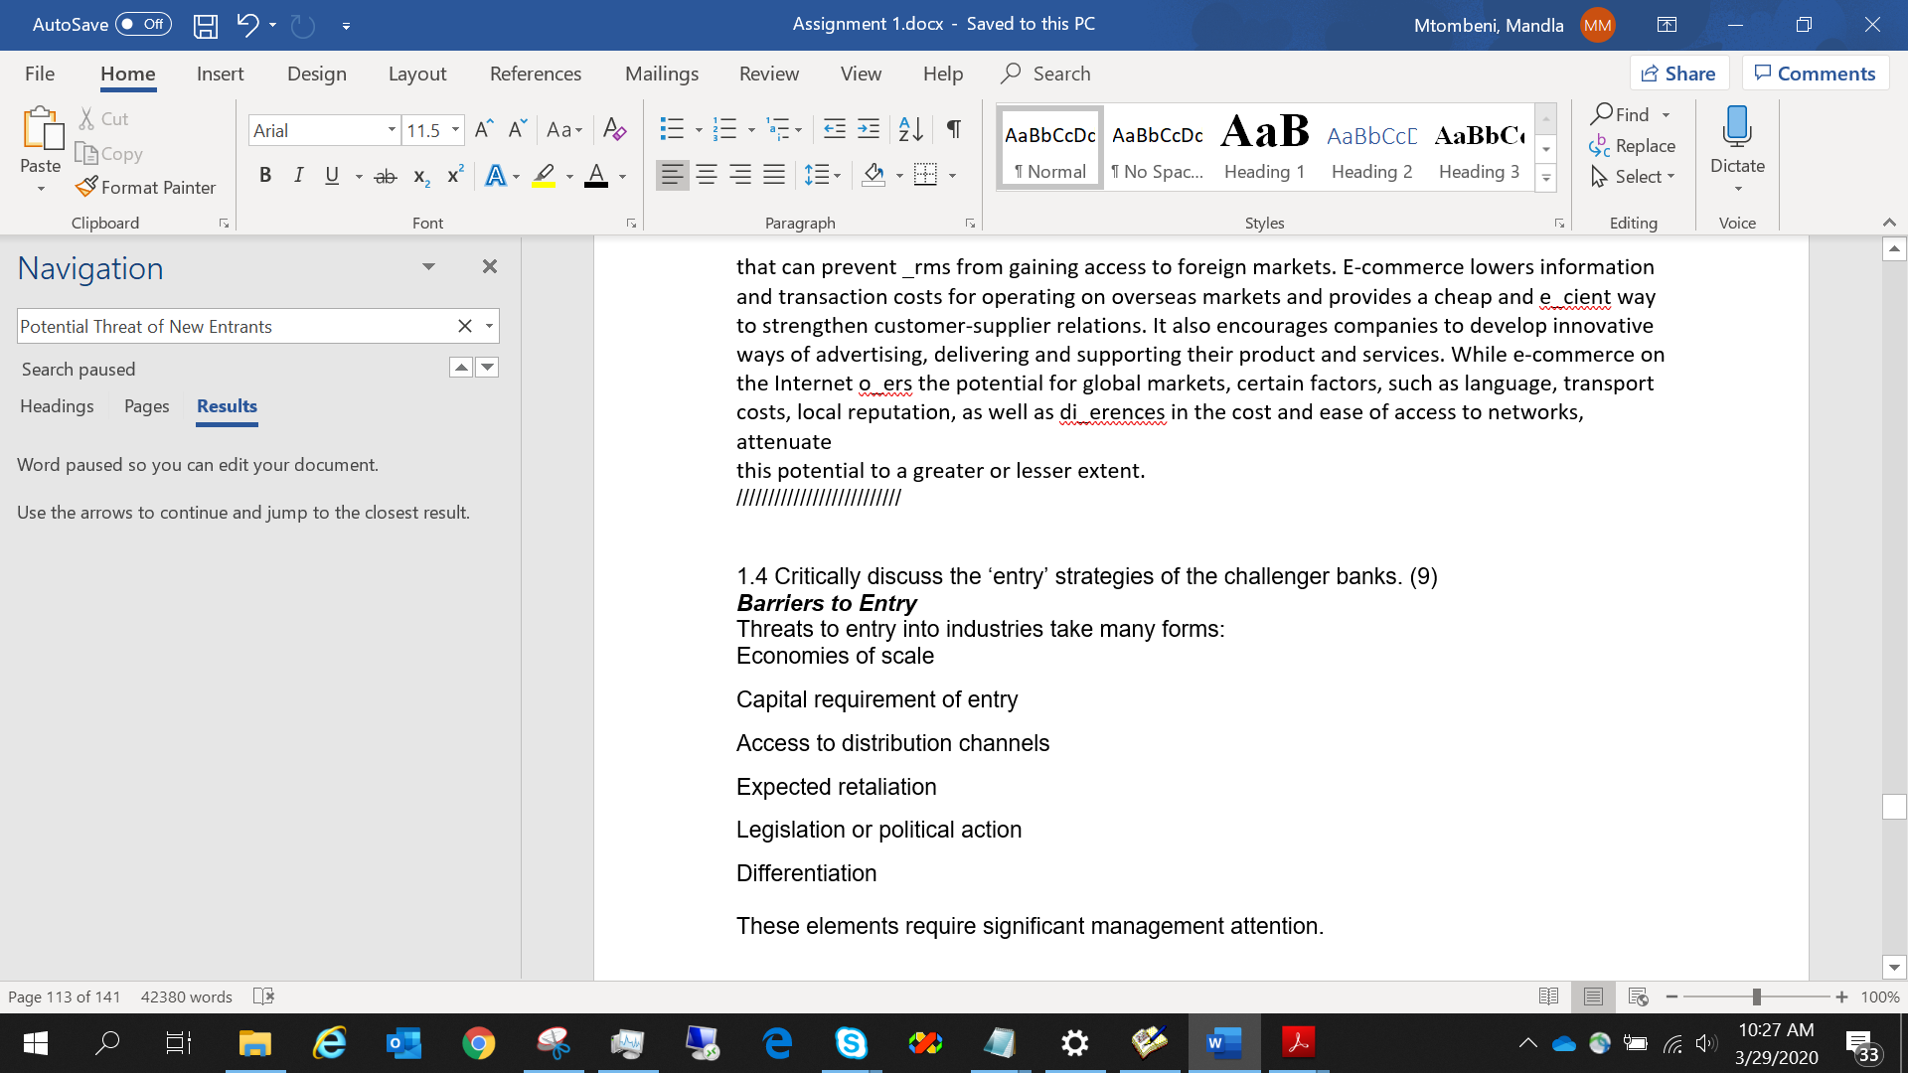

**References**

Financial Times 2013 . ‘Osborne speech: Reform of banking’ , February 4th , www.ft.com/cms/s/0/

dc756e8c-6ec4–11e2-9ded-00144feab49a.html#axzz2v4xtmvf3 (accessed 5 March 2014) . French , S. , Leyshon , A. and Meek , S. 2013 . *The Changing Geography of British Bank and Building Society Branch*

*Networks, 2003–2013* , The University of Nottingham , School of Geography . Furash , E. E. 1993 . Banking’s critical cross-roads . *The Bankers Magazine* . March-April , pp. 20 – 26 . King , B. 2011 . *Branch Today, Gone Tomorrow: the case for the death of branch banking* , Marshall Cavendish :

Singapore . Offi ce of Fair Trading 2009 . *Personal current accounts in the UK: A follow up report* , (available at www.oft.gov.uk

—— 2013a . ‘OFT says major changes still needed in personal current account market, press release January

25, 2013’ , available at www.oft.com —— 2013b . *Evaluating the impact of the 2008 OFT market study and UTCCR test case into personal current*

*accounts* , available at www.oft.gov.uk Worthington , S. and Welch , P. 2011 . Banking without the banks . *International Journal of Bank Marketing* , 29 ( 2 ),

pp. 190 – 201 . Worthington , S. and Durkin , M. 2012 . Co-destruction of value in context: Cases from retail banking . *The*

*Marketing Review* , 12 ( 3 ), pp. 291 – 307 .

SSSSSSSSSSSSSSSSSSSSSSTTTTTTTTTTTTTTTTTTTTTTTTRRRRRRRRRRRRRRRRRRRRRR

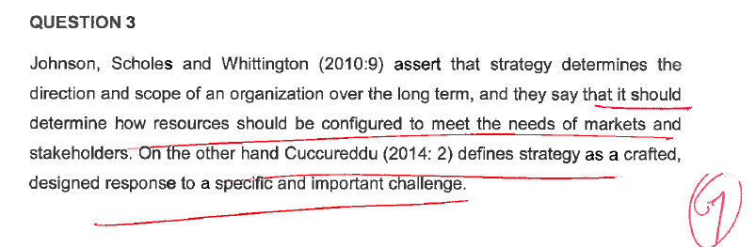

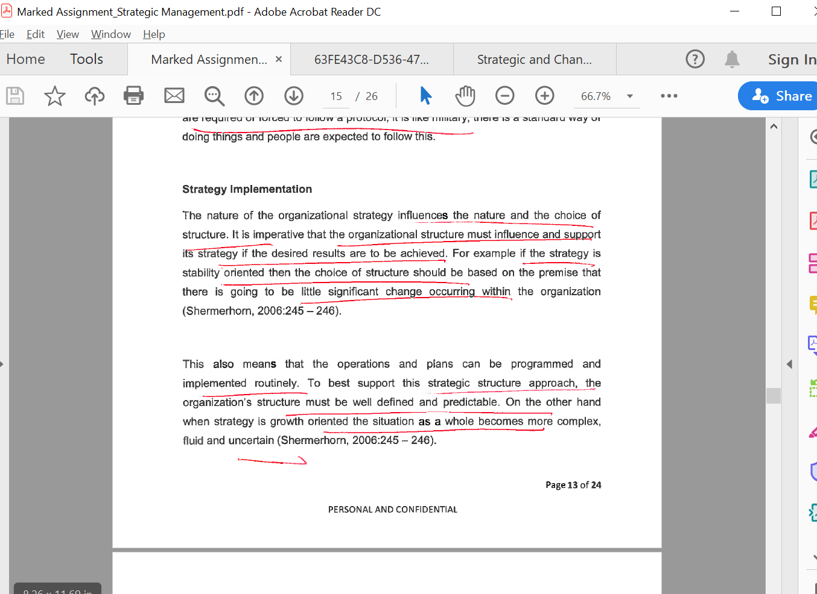

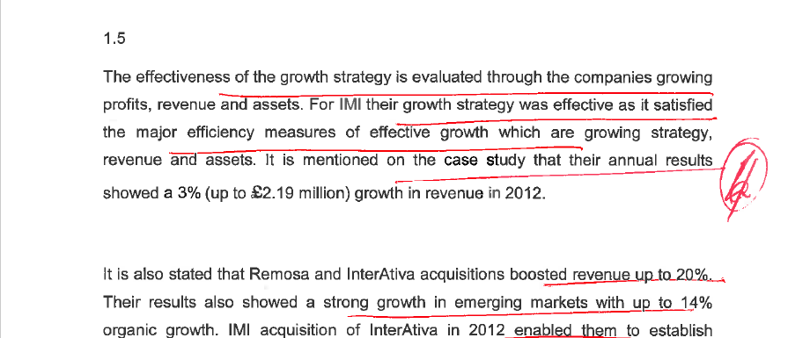

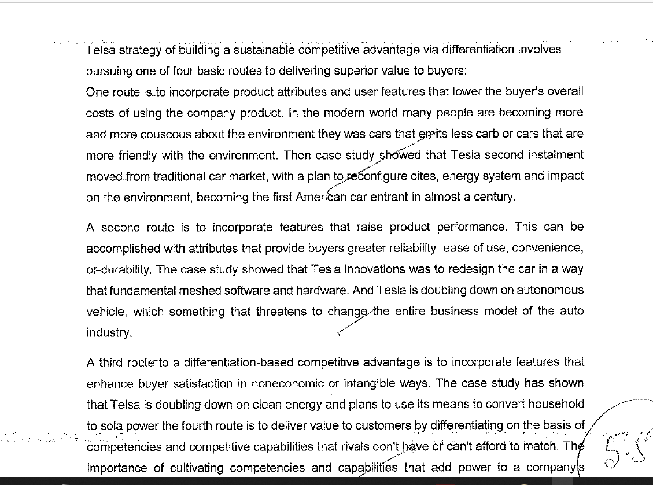

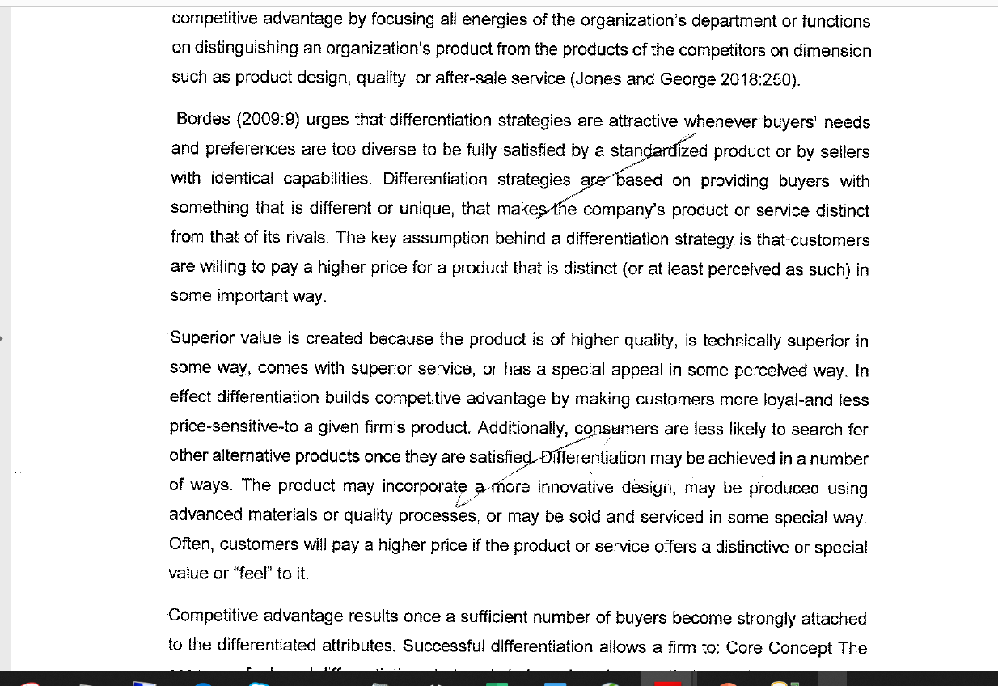

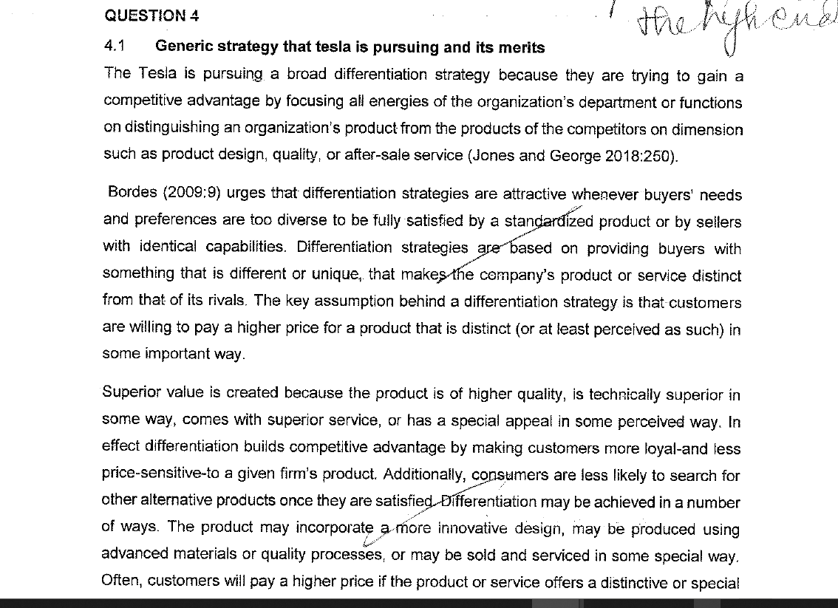

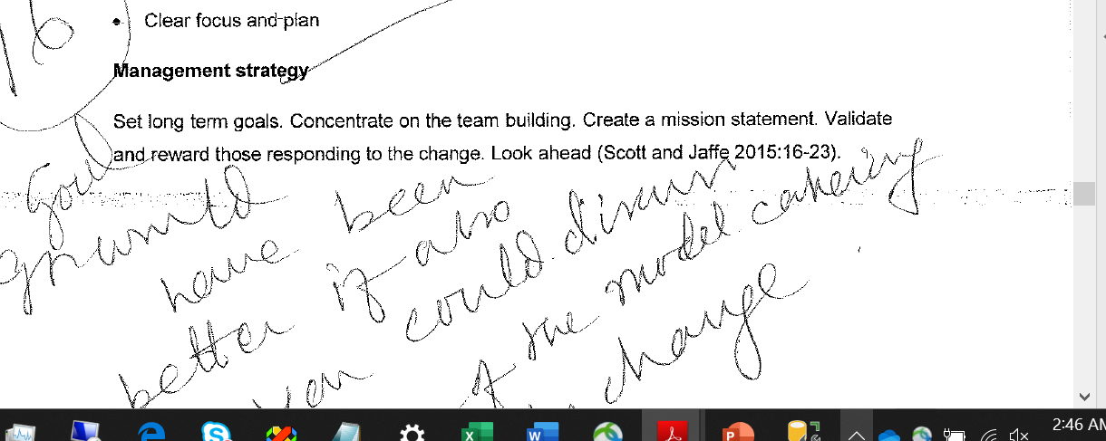

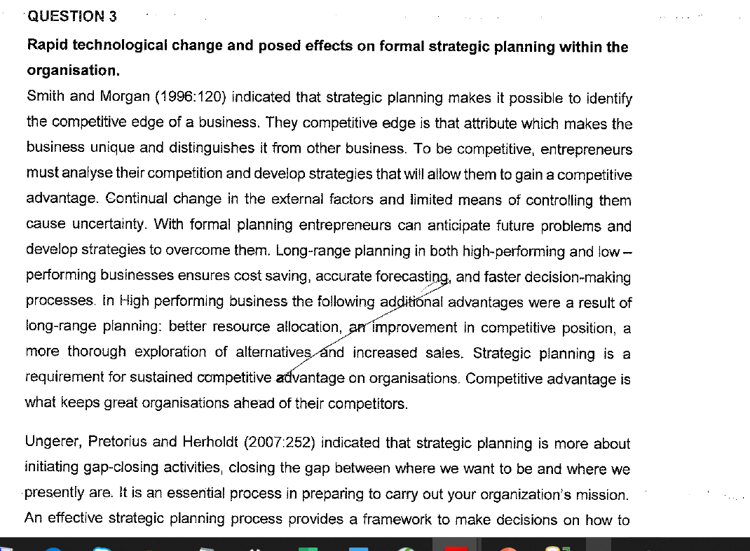

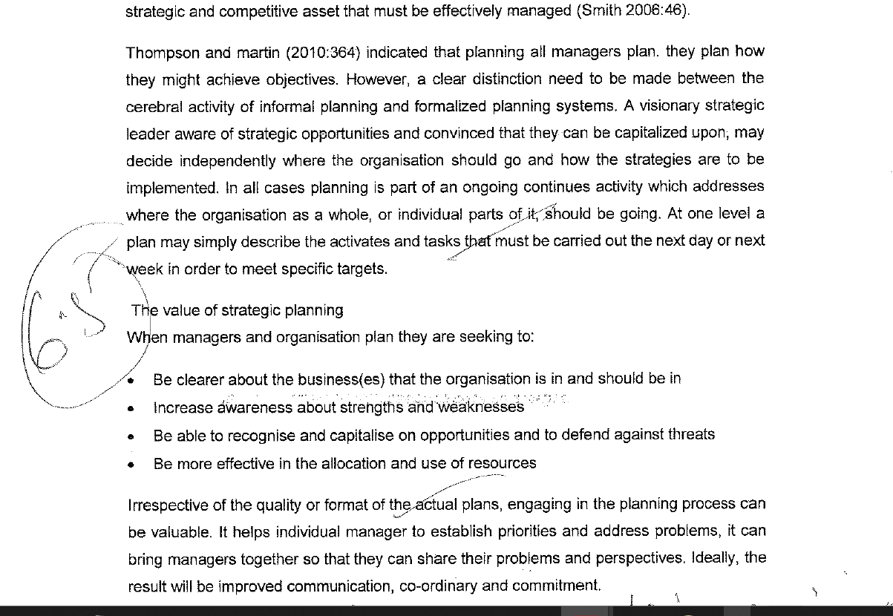

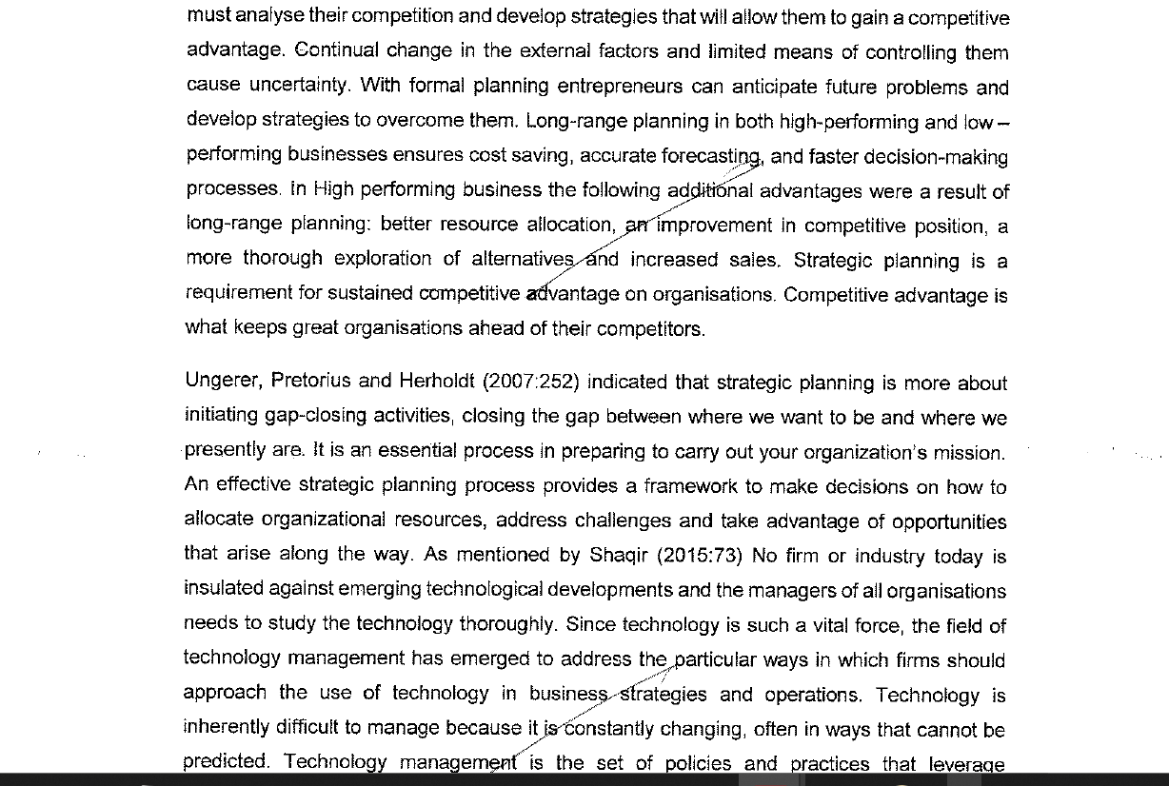

BBBBBBBBBBBBBBBBBBBBBBBBBB

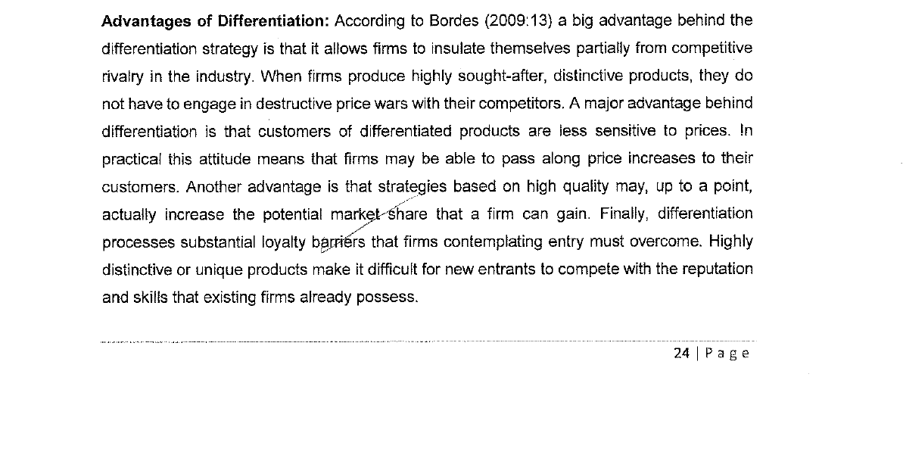

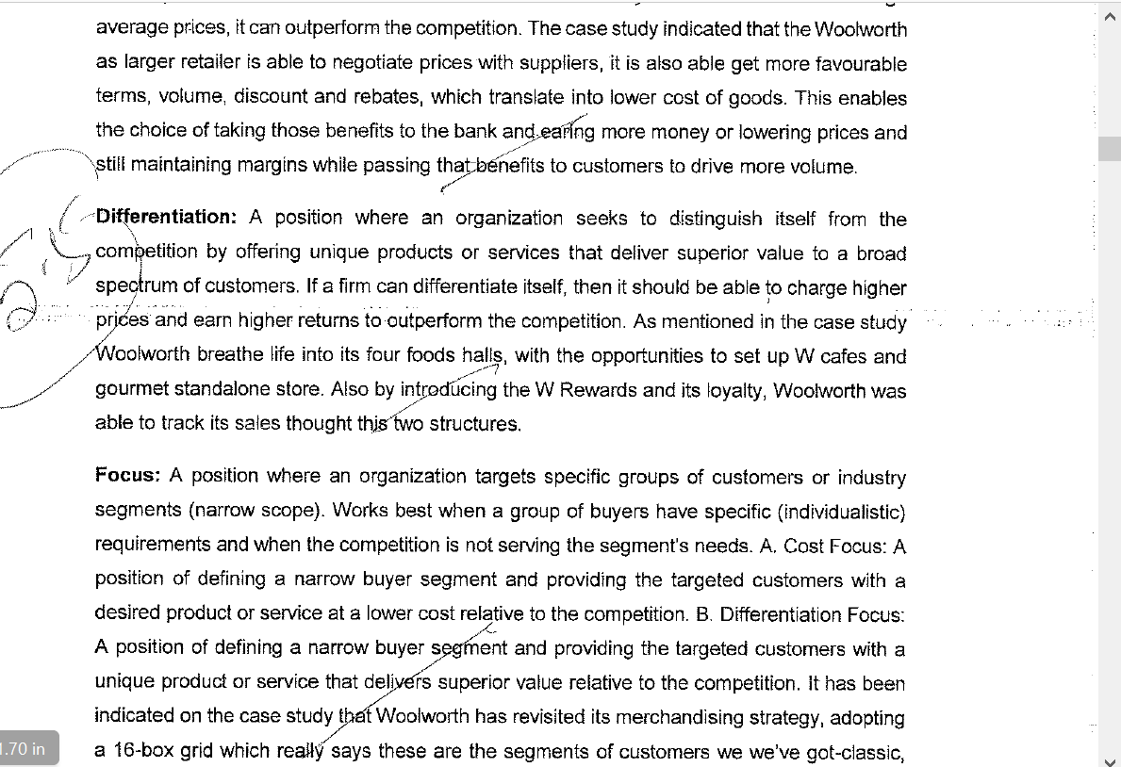

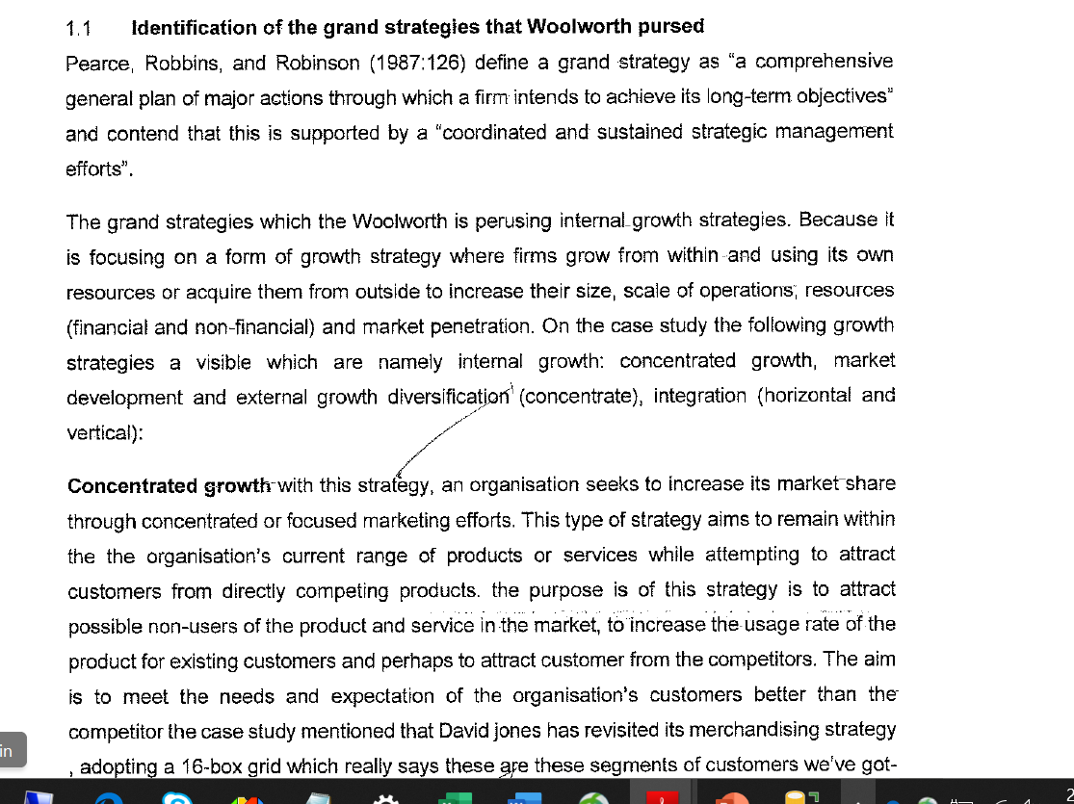

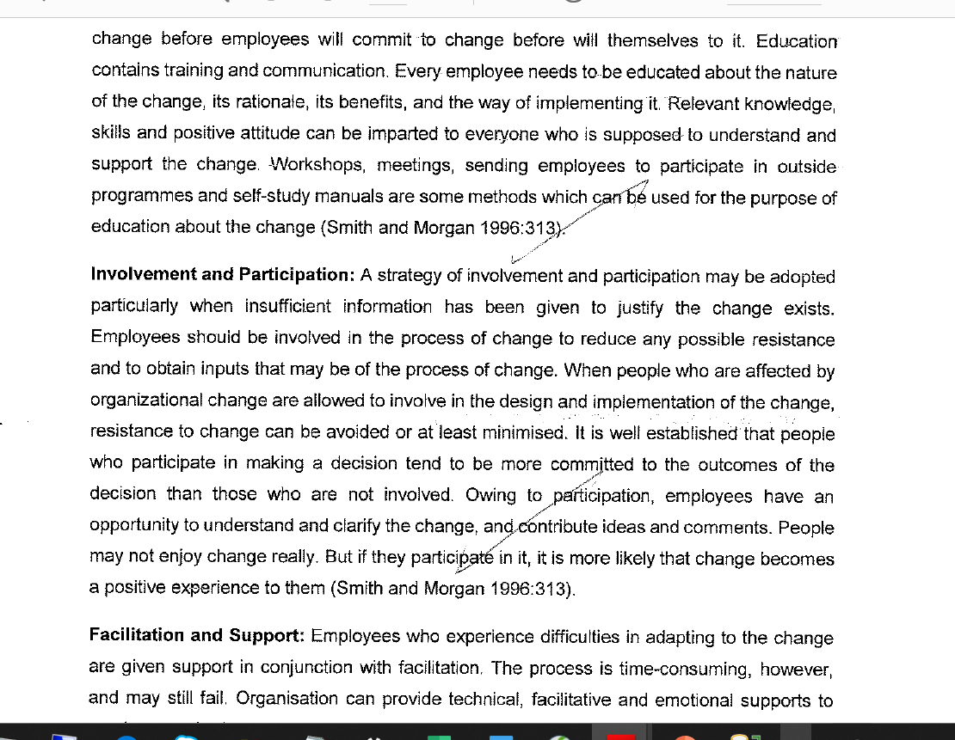

RRRRRRRRRRRRRRRRRRRRRRRRRRR

CCCCCCCCCCCCCCCCCCCCCCCCCCCCCCCCCCCCCCCCCCCCCCCC

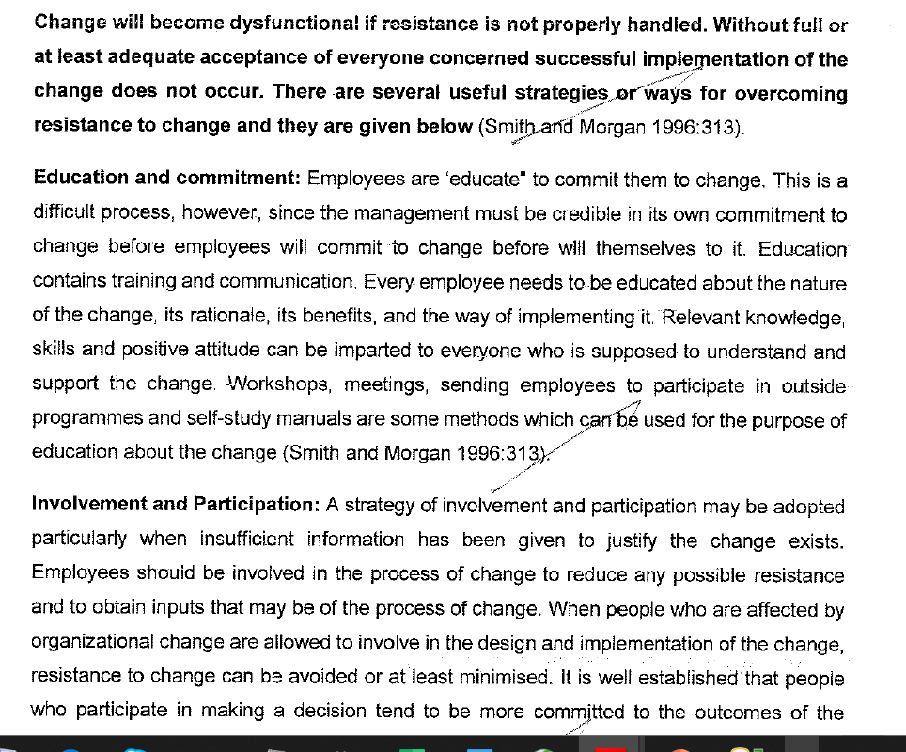

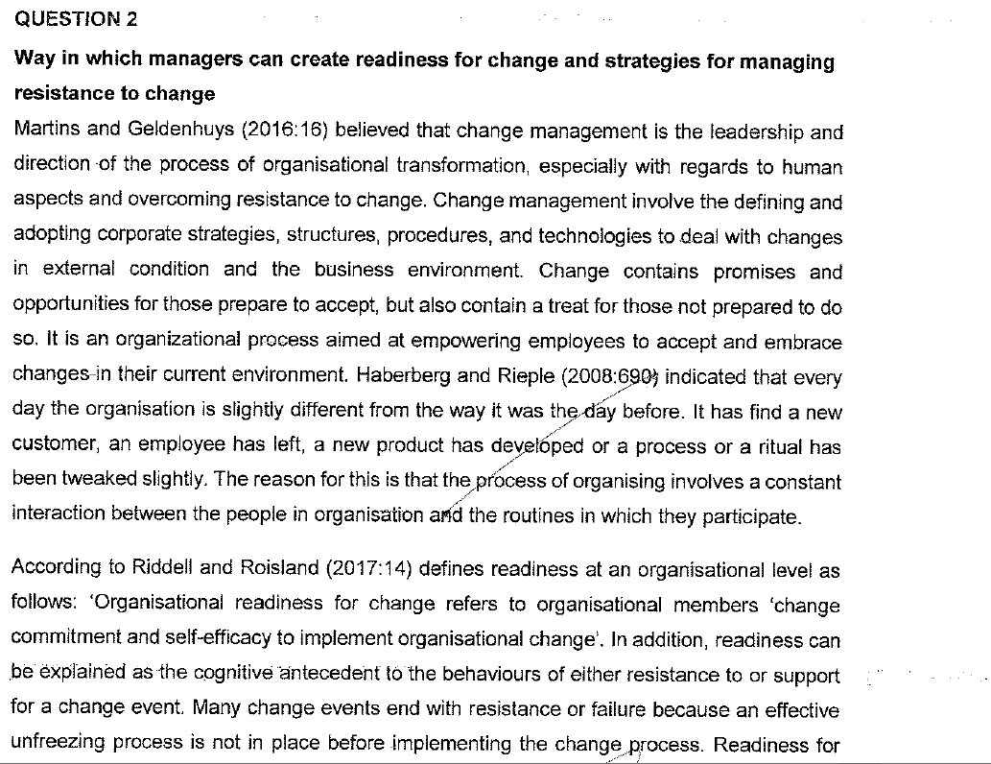

BBBBBBBBBBBBBBBBBBBBBBBBBB

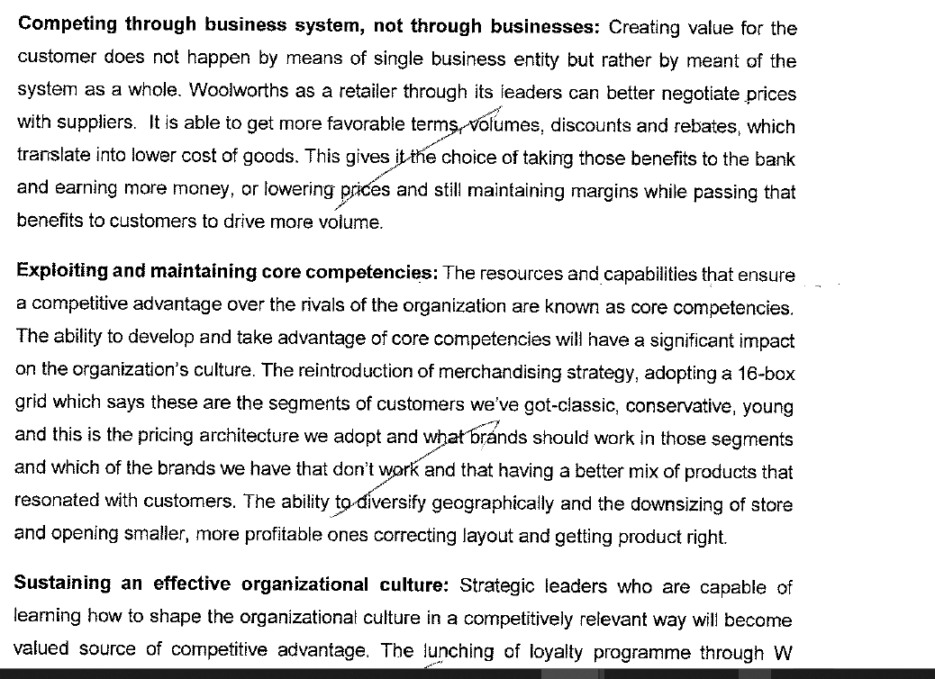

SSSSSSSSSSSSSSSSSSSSS

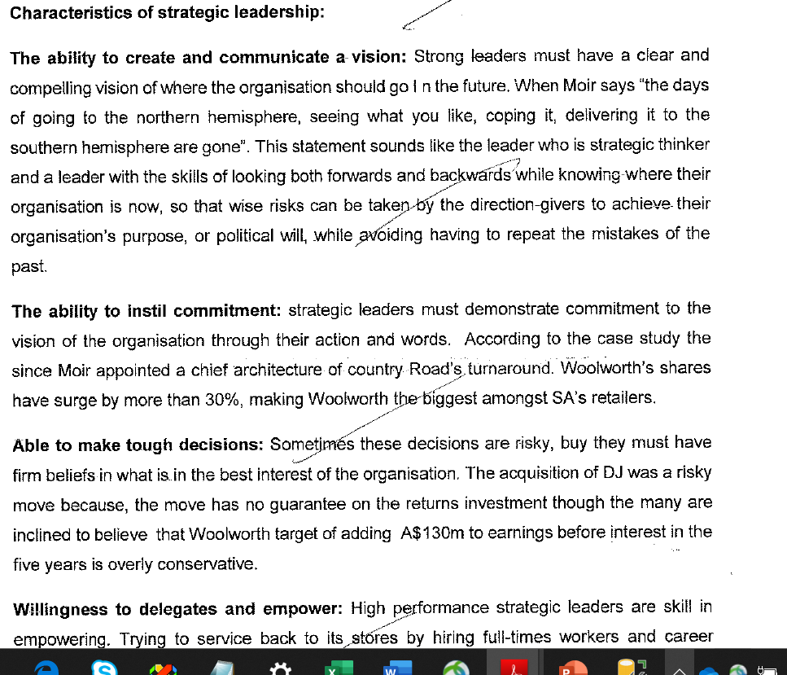

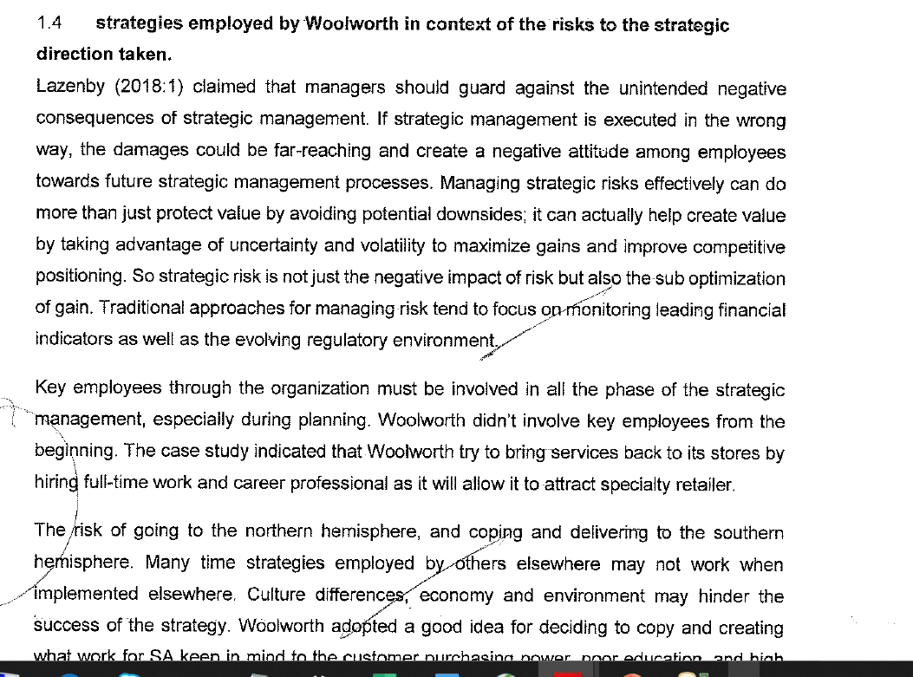

WWWWWWWWWWWWWWWWWWWW

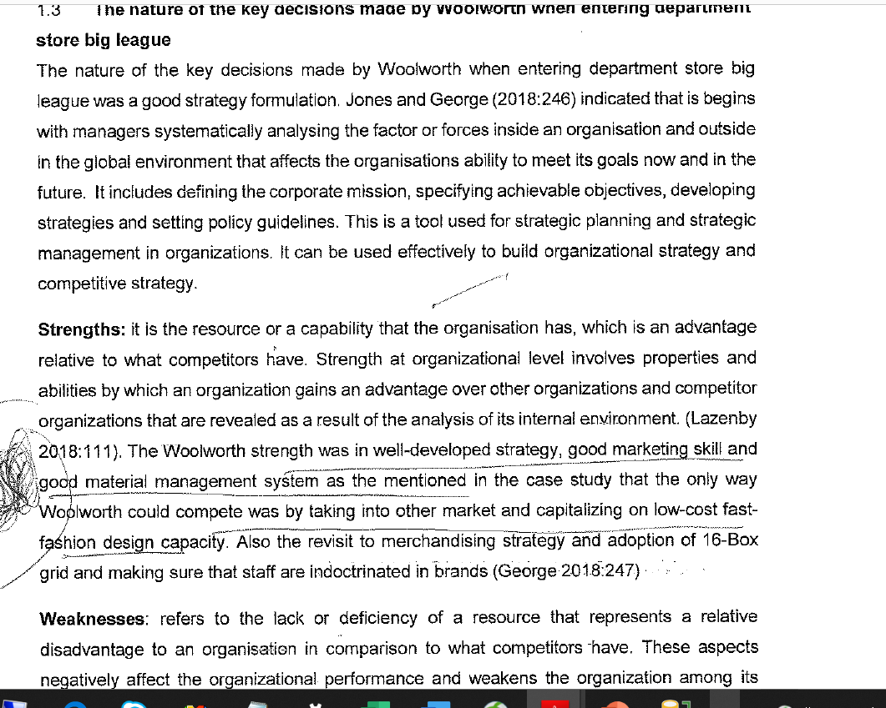

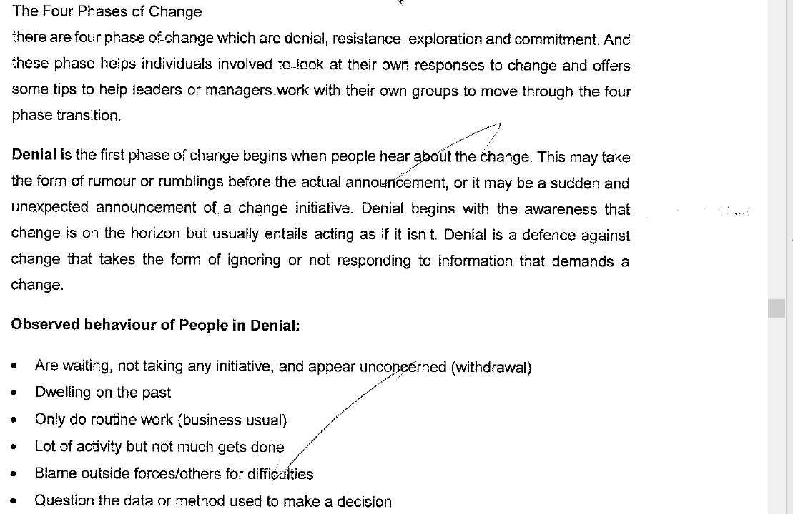

**REFERENCES**

Alchian, A. A. (1977). Some economics of property rights. In Idem (Ed.), Economic forces at work

(pp. 127–149). Indianapolis: Liberty Fund, Inc. (Originally published in 1965, Il Politico, 30(4),

816–829.).

Ames, E., & Rosenberg, N. (1965). The progressive division and specialization of industries. Journal

of Development Studies, 1(4), 363–383.

Anonymous. (2007, June 9–15). Lessons from Apple: What other companies can learn from California’s

master of innovation. The Economist, 383(8532), 11.

Aoki, M. (2007). Endogenizing institutions and institutional changes. Journal of Institutional Economics,

3(1), 1–31.

Arora, A., Gambardella, A., &Rullani, E. (1997). Division of labor and the locus of inventive activity.

Journal of Management and Governance, 1(1), 123–140.

Arrow, K. J. (1962). Economic welfare and the allocation of resources to invention. In R. R. Nelson

(Ed.), The rate and direction of inventive activity: Economic and social factors (pp. 609–625).

Princeton: Princeton University Press.

Avgerou, Ch. (1998). How can IT enable economic growth in developing countries? Information

Technology for Development, 8(1), 15–28.

Babbage, Ch. (1835). On the economy of machinery and manufactures (4th edition). London: Charles

Knight.

Baetjer, H. Jr. (1998). Software as capital. An economic perspective on software engineering. Los

Alamitos, CA: IEEE Computer Society.

Benkler, Y. (2002). Coase’s penguin, or, Linux and the nature of the firm. Yale Law Journal, 112(3),

369–446.

Bresnahan, T. F., & Gambardella, A. (1998). The division of inventive labor and the extent of the

market. In E. Helpman (Ed.), General purpose technologies and economic growth (pp. 253–281).

Cambridge, MA: MIT Press.

Buchanan, J. M., & Yoon, Y. J. (1999). Generalized increasing returns, Euler’s Theorem, and competitive

equilibrium. History of Political Economy, 31(3), 511–523.

Conway, M. E. (1968). How do committees invent? Datamation, 14(4), 28–31.

Dalle, J.-M., & David, P. A. (2004). The allocation of software development resources in open source

production mode. In J. Feller, B. Fitzgerald, S. A. Hissam, & K. Lakhani (Eds.), Perspectives on

free and open source software (pp. 297–328). Cambridge, MA: MIT Press.

David, P. A. (1985). Clio and the economics of QWERTY. American Economic Review, Papers and

Proceedings, 75(2), 332–337.

Dosi, G. (1982). Technological paradigms and technological trajectories: A suggested interpretation

of the determinants and directions of technical change. Research Policy, 11(3), 147–162.

Eunice, J. (1998, May 11). Beyond the cathedral, beyond the bazaar. Retrieved May 3, 2007, from

http://www.illuminata.com/cgi-local/pub.cgi?docid=cathedral

Foss, N. J. (1998). The new growth theory: Some intellectual growth accounting. Journal of Economic

Methodology, 5(2), 223–246.

Foss, N. J., & Garzarelli, G. (2007). Institutions as knowledge capital: Ludwig M. Lachmann’s

interpretative institutionalism. Cambridge Journal of Economics, 31(5), 789–804.

Garzarelli, G. (2004). Open-source software and the economics of organization. In J. Birner & P.

Garrouste (Eds.), Markets, information and communication (pp. 47–62). London and New York:

Routledge.

Garzarelli, G. (2006). Cognition, incentives, and public governance: Laboratory federalism from the

organizational viewpoint. Public Finance Review, 34(3), 235–257.

*Information Technology for Development DOI: 10.1002/itdj*

*OPEN SOURCE SOFTWARE AND ECONOMIC GROWTH 133*

Garzarelli, G. (2008, in press). The organizational approach of capability theory. Review of Political

Economy.

Greif, A. (2006). Institutions and the path to the modern economy: Lessons from medieval trade.

Cambridge, UK: Cambridge University Press.

Haefliger, S., von Krogh, G., & Spaeth, S. (2008). Code reuse in open-source software. Management

Science, 54(1), 180–193.

Hayek, F. A. von (1945). The use of knowledge in society. American Economic Review, 35(4),

519–530.

Hayek, F. A. von (1982). Law, legislation and liberty. Volume 1: Rules and order (first published in

one volume with corrections and revised preface in 1982). London: Routledge. (Volume 1 first

published 1973.)

Hurst, J. W. (1967). Law and the conditions of freedom in the nineteenth-century United States.

Madison, Milwaukee, and London: The University of Wisconsin Press.

Krichel, Th., & Zimmerman, Ch. (2005). The economics of open bibliographic data provision (Working

paper 2005–01). University of Connecticut, Storrs, Department of Economics. Retrieved May

3, 2007, from http://ideas.repec.org/p/uct/uconnp/2005-01.html

Lakhani, K. R., & von Hippel, E. (2003). How open source software works: “Free” user-to-user

assistance. Research Policy, 32(6), 923–943.

Langlois, R. N. (1988). Economic change and the boundaries of the firm. Journal of Institutional and

Theoretical Economics, 144(4), 635–657.

Langlois, R. N. (1999). Scale, scope, and the reuse of knowledge. In S. C. Dow & P. E. Earl

(Eds.), Economic organization and economic knowledge: Essays in honor of Brian J. Loasby (pp.

239–254). Cheltenham: Edward Elgar.

Langlois, R. N. (2003). Cognitive comparative advantage and the organization of work: Lesson from

Herbert Simon’s vision of the future. Journal of Economic Psychology, 24(2), 167–187.

Langlois, R. N., & Garzarelli, G. (2008, in press). Of hackers and hairdressers: Modularity and the

organizational economics of open-source collaboration. Industry and Innovation.

Langlois, R. N., & Robertson, P. L. (1996). Stop crying over spilt knowledge: A critical look at the

theory of spillovers and technical change. Paper presented at the MERIT conference on Innovation,

Evolution and Technology, August 25–27, Maastricht, the Netherlands. Retrieved May 3, 2007,

from http://www.lib.uconn.edu/Economics/Working/lang964.html

Leijonhufvud, A. (1986). Capitalism and the factory system. In R. N. Langlois (Ed.), Economics

as a process: essays in the new institutional economics (pp. 203–223). New York: Cambridge

University Press.

Lerner, J., & Tirole, J. (2002). Some simple economics of open-source. Journal of Industrial Economics,

50(2), 197–234.

Liebowitz, S. J., & Margolis, S. E. (1990). The fable of the keys. Journal of Law and Economics,

33(1), 1–25.

Lucas, R. E. (1988). On the mechanics of economic development. Journal of Monetary Economics,

22(1), 3–42.

Marglin, S. A. (1974). What do bosses do? The origin and functions of hierarchy in capitalist

production. Review of Radical Political Economics, 6(2), 60–112.

Miller,M. S.,&Drexler,K. E. (1988).Markets and computation: Agoric open systems. InB.A.Huberman

(Ed.), The Ecology of computation (pp. 133–176). Amsterdam: North-Holland. The authors

consulted the webbed version of this work available at: http://www.agorics.com/agorpapers.html.

Nelson, R. R., &Winter, S. G. (1977). In search of useful theory of innovation. Research Policy, 6(1),

36–76.

North, D. C. (1990). Institutions, institutional change and economic performance. New York:

Cambridge University Press.

Raymond, E. S. (2001). The cathedral and the bazaar. Musings on Linux and open source by an

accidental revolutionary (revised edition). Sebastopol, CA: O’Reilly & Associates, Inc.

Robertson, P. L.&Alston, L. J. (1992). Technological choice and the organization ofwork in capitalist

firms. Economic History Review (New Series), 45(2), 330–349.

Romer, P. M. (1986). Increasing returns and long-run growth. Journal of Political Economy, 94(5),

1002–1037.

Rosenberg, N. (1960). Some institutional aspects of the Wealth of Nations. Journal of Political

Economy, 68(6), 557–570.